**SENTIMENT ANALYSIS FOR MARKETING**

**Sentiment Analysis:**

Sentiment Analysis is also known as opinion mining. It’s an automated text analysis technique used to extract aggregated emotional information from the given text. In other words, it’s used to analyze the emotions of the comments, opinions, user feedback, or any other data set.

**Project Introduction :**

Building a Project by loading and preprocessing the dataset. Performing a simple EDA on the dataset I gathered from IMDB on the reviews on first ever successful live action of an anime "One Piece". Is this live action successful or not we will find out after the EDA

**Program :**

Input [1]:

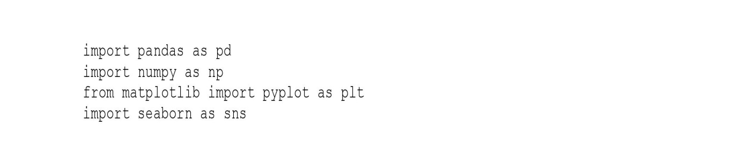

Input [2]:

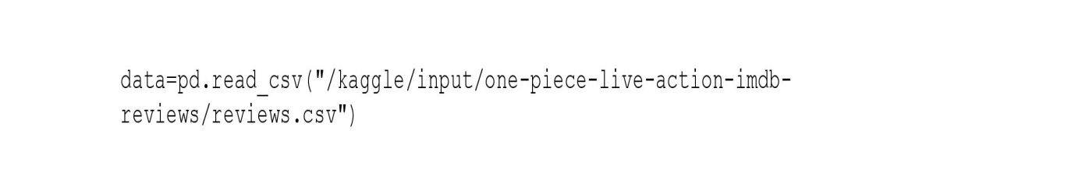

Input [3]:



Output [3]:

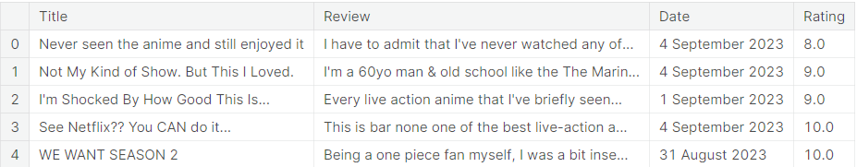

Input [4]:



Output [4]:



Input [5]:



Input [6]:



Output [6]:

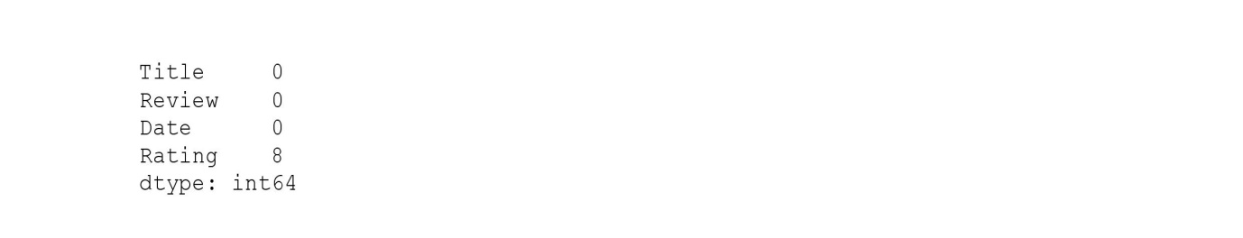

Input [7]:



Input [8]:



Input [9]:



Input [10]:



Output[10]:

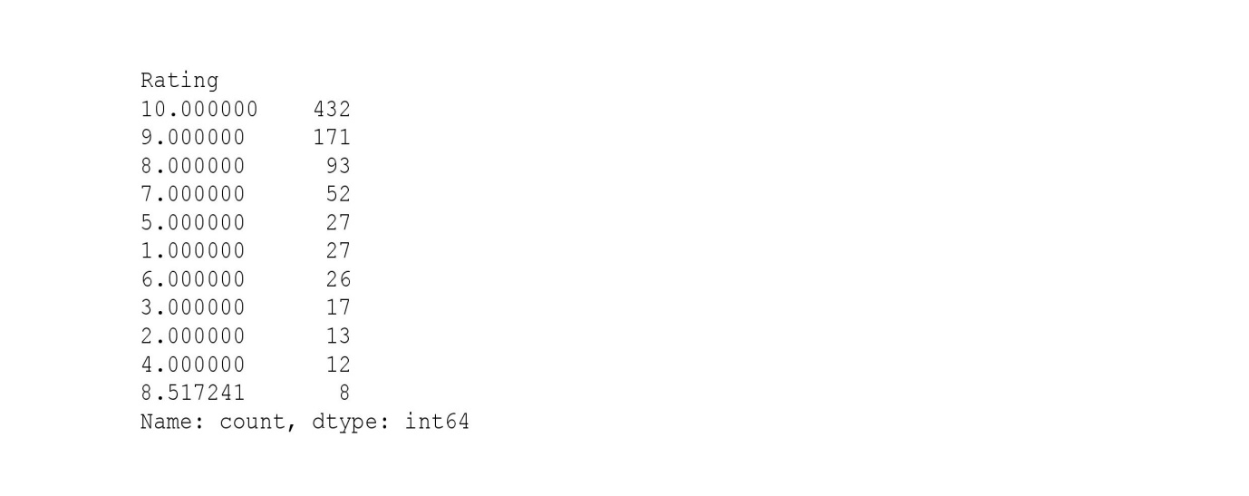

Input [11]:



Output [11]:

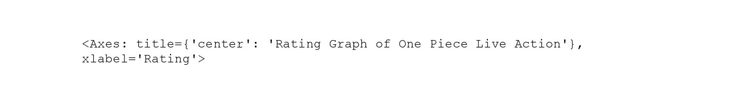

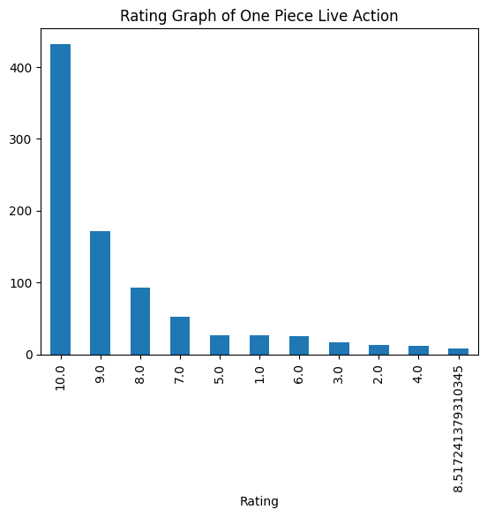

Input [12]:



Output [12]:

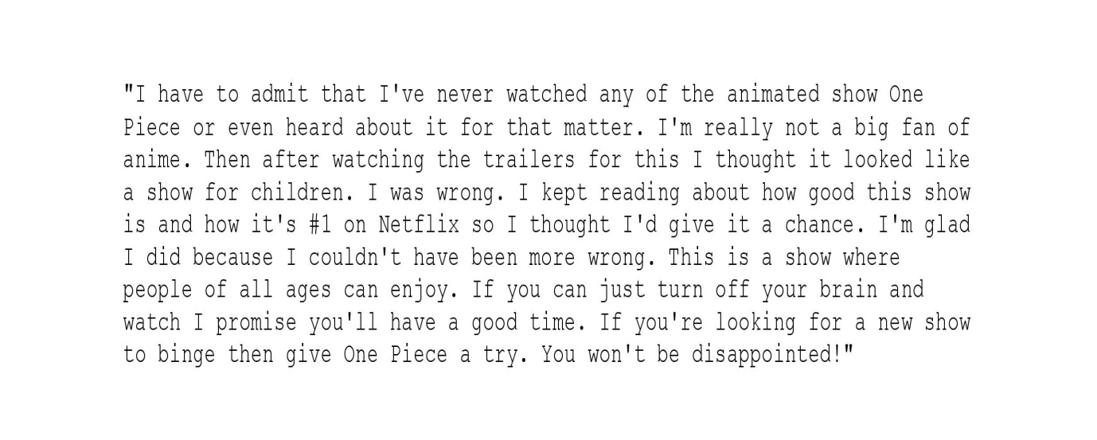

**Conclusion:**

In conclusion, building a sentiment analysis project through dataset loading and preprocessing is a fundamental undertaking in NLP and ML. It entails dataset selection, text cleaning, model development, and evaluation to create a potent sentiment analysis tool with versatile applications, from understanding customer feedback to informing decision-making in various sectors.