**SENTIMENT ANALYSIS FOR MARKETING**

**Sentiment Analysis:**

Sentiment Analysis is also known as opinion mining. It’s an automated text analysis technique used to extract aggregated emotional information from the given text. In other words, it’s used to analyze the emotions of the comments, opinions, user feedback, or any other data set.

**Program :**

Input [13]:



Input [14]:



Input [15]:



Output [15]:

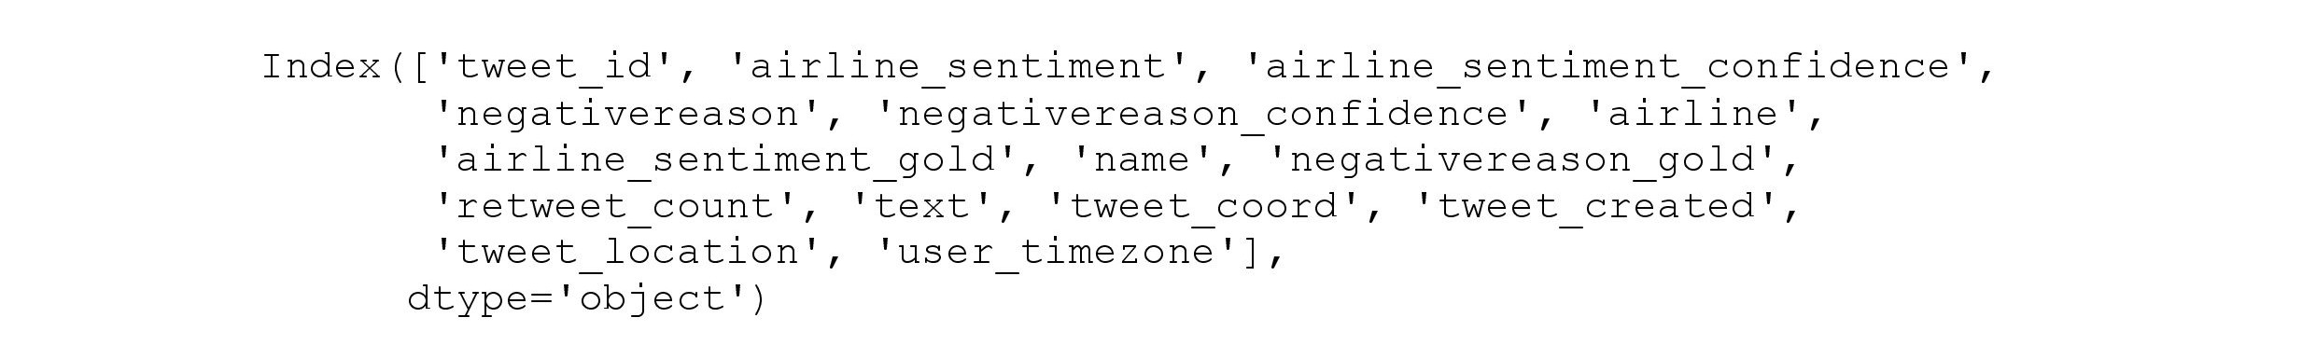

Input [16]: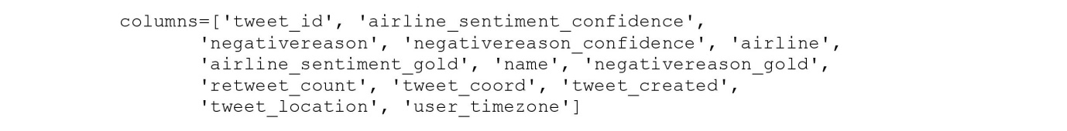

Input [17]:

Input [18]:

Output [18]:

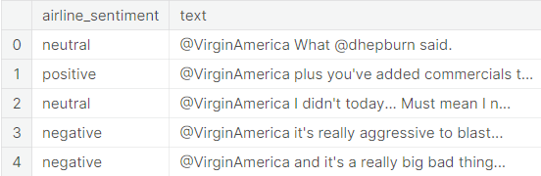

Input [19]:

Output [19]:



Input [20]:

Input [21]:

Output [21]:

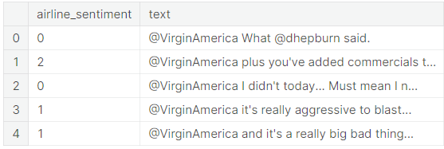

Input [22]: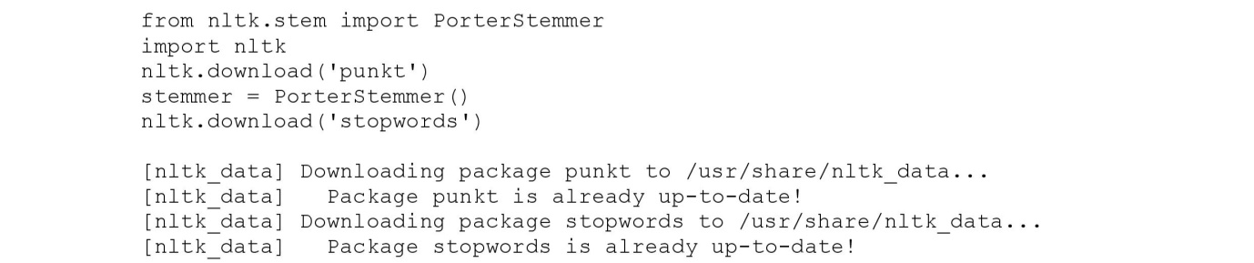

Output [22]:



Input [23]:

Input [24]:

Input [25]: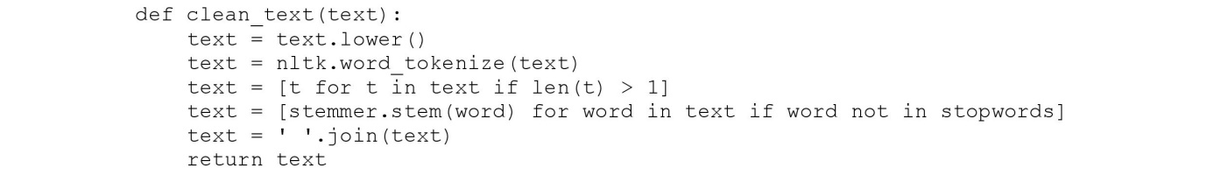

Input [26]:

Input [27]:

Input [28]:

Input [29]:

Input [30]:

Input [31]:

Input [32]:

Output [32]:



Input [33]:

Input [34]:

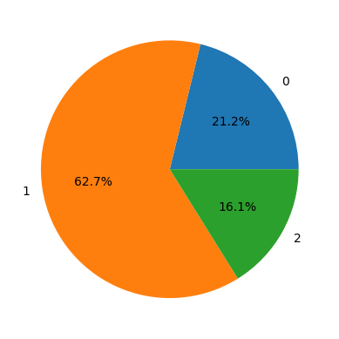

Input [34]:

Input [35]:



Input [36]:

Output [36]:



Input [37]:

Output [37]:



Input [38]:

Input [39]:

Output [39]:



Input [40]:

Output [40]:



Input [41]:

Input [42]:

