**SENTIMENT ANALYSIS FOR MARKETING**

**Sentiment Analysis:**

Sentiment Analysis is also known as opinion mining. It’s an automated text analysis technique used to extract aggregated emotional information from the given text. In other words, it’s used to analyze the emotions of the comments, opinions, user feedback, or any other data set.

**Project Introduction :**

Building a Project by loading and preprocessing the dataset. Performing a simple EDA on the dataset I gathered from IMDB on the reviews on first ever successful live action of an anime "One Piece". Is this live action successful or not we will find out after the EDA

**Program :**

Input [1]:

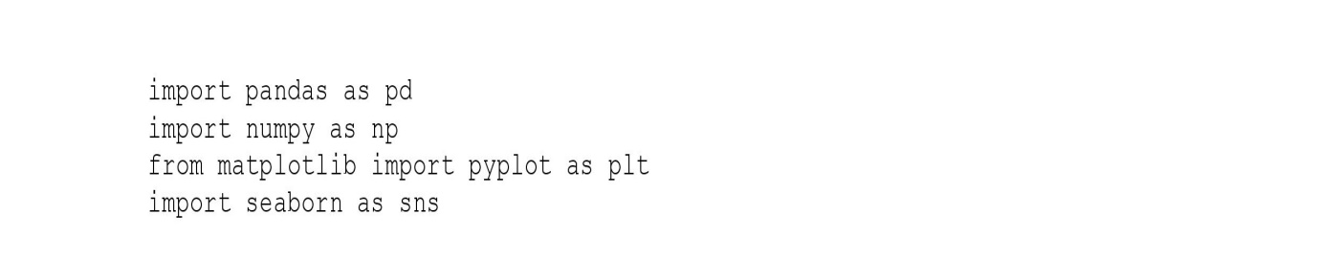

Input [2]:

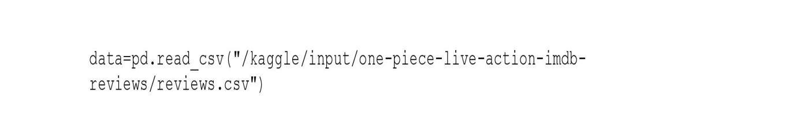

Input [3]:



Output [3]:

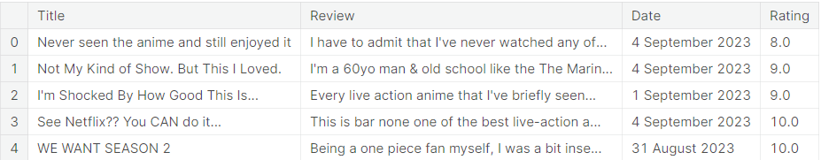

Input [4]:



Output [4]:



Input [5]:



Input [6]:



Output [6]:

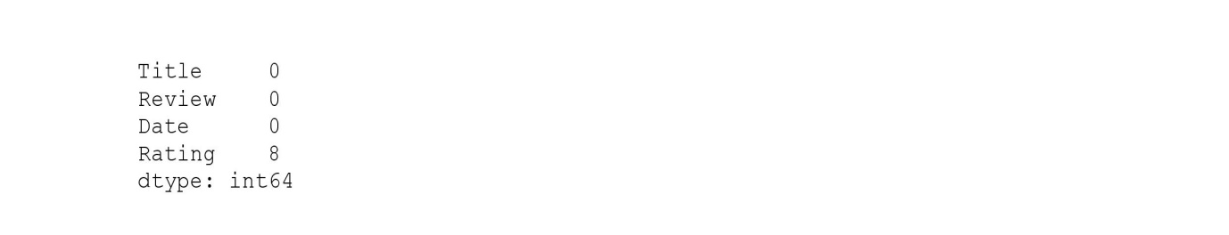

Input [7]:



Input [8]:



Input [9]:



Input [10]:



Output[10]:

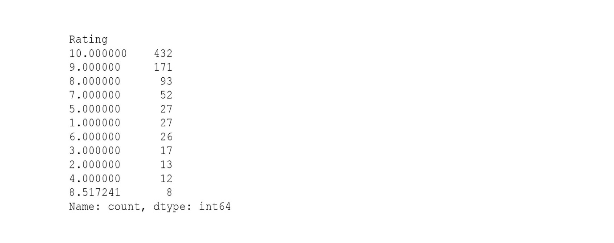

Input [11]:



Output [11]:

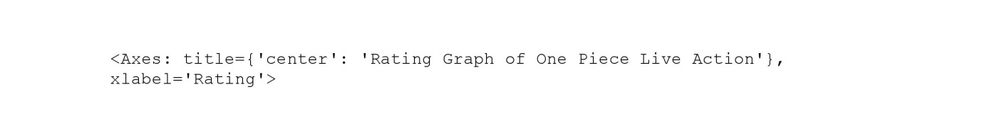

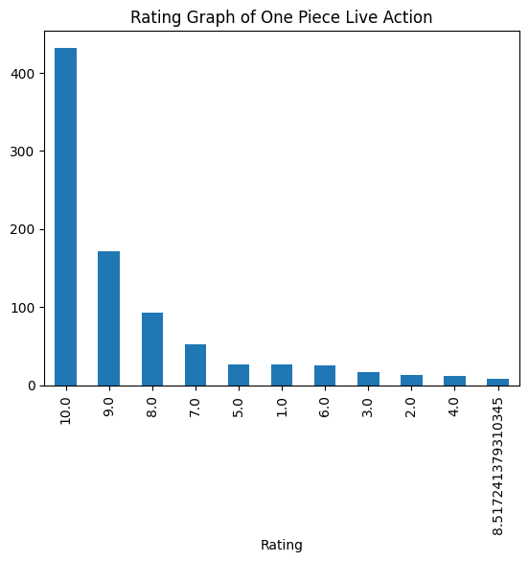

Input [12]:



Output [12]:

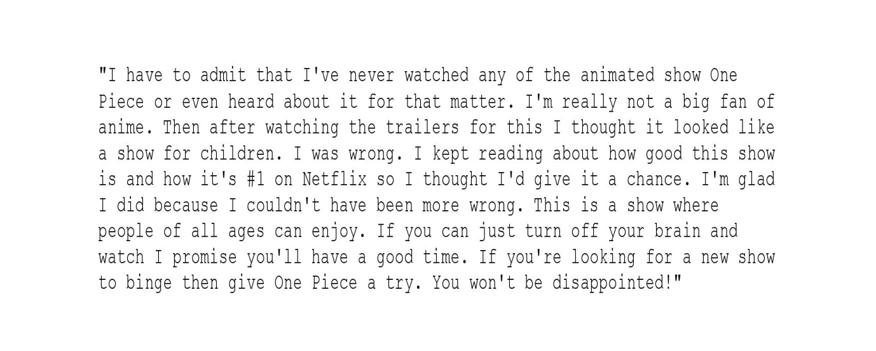

Input [13]:



Input [14]:



Input [15]:



Output [15]:

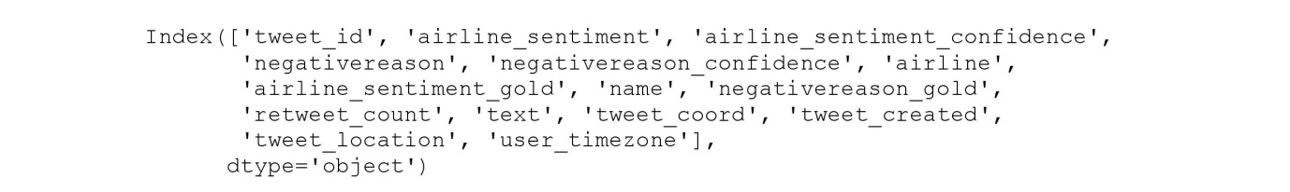

Input [16]:

Input [17]:

Input [18]:

Output [18]:

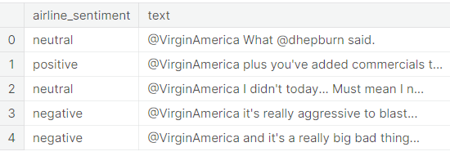

Input [19]:

Output [19]:



Input [20]:

Input [21]:

Output [21]:

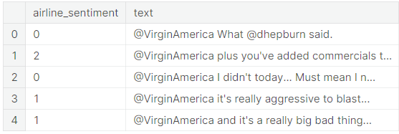

Input [22]: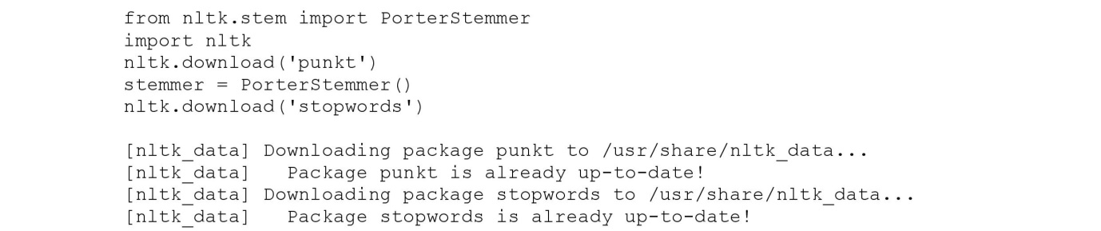

Output [22]:



Input [23]:

Input [24]:

Input [25]: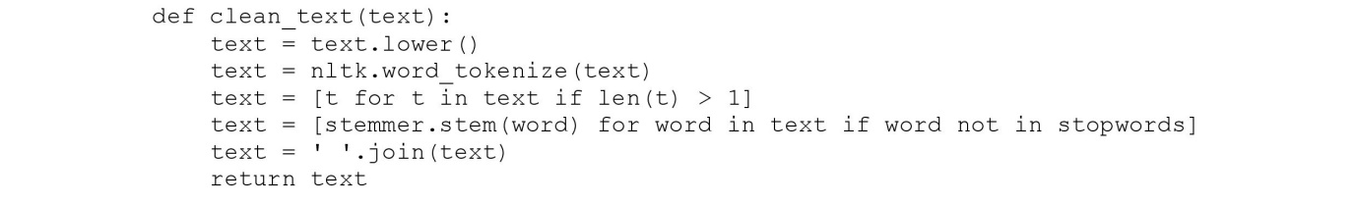

Input [26]:

Input [27]:

Input [28]:

Input [29]:

Input [30]:

Input [31]:

Input [32]:

Output [32]:



Input [33]:

Input [34]:

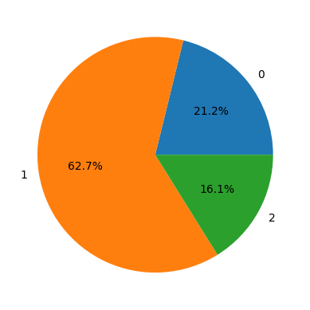

Input [34]:

Input [35]:



Input [36]:

Output [36]:



Input [37]:

Output [37]:



Input [38]:

Input [39]:

Output [39]:



Input [40]:

Output [40]:



Input [41]:

Input [42]:

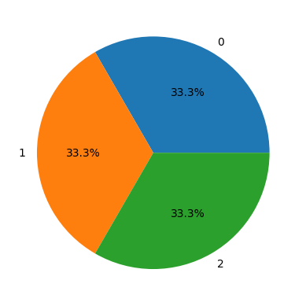

Input [43]:



Input [44]:



Input [45]:



Output [45]:

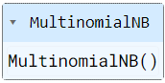

Input [46]:



Input [47]:



Output [47]:

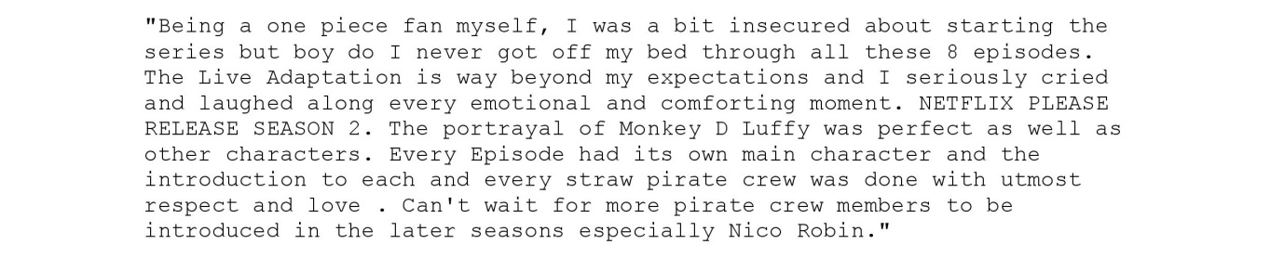

Input [48]:



Output [48]:



Input [49]:



Input [50]:



Input [51]:



Output [51]:



Input [52]:



Input [53]:



Output [53]:



Input [54]:



Input [55]:



Output [55]:

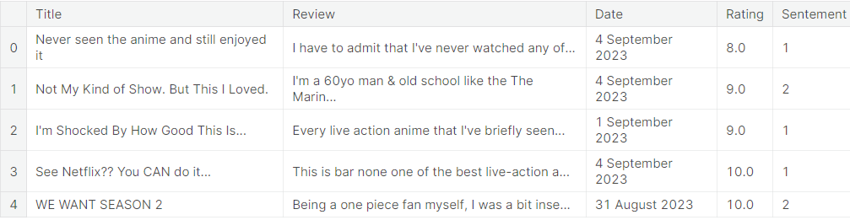

Input [56]:



Input [57]:



Output [57]:

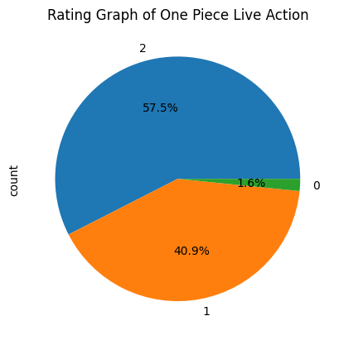

**Conclusion :**

So more than half reviews are positive that means the Series "One Piece Live Adaption" is definitely a success. There are many things to consider like here i used a simple naive bays model so may be the sentiment on review on One Piece may not be that accurate as the data on which we train a model consist of small text while our data contain reviews of large sentence so feel free to try different things to see what you can get out if the data.