AWS Project — VPC & Networking
Assignment 1 — a custom VPC built from scratch, with public and private subnets, correct internet routing and EC2 instances deployed across both tiers.

Objective

This assignment focuses on building cloud networking fundamentals from the ground up: a custom VPC spanning a public and private subnet, with correct routing for internet access and instances deployed across both tiers.

Success criteria for this assignment:
- A custom VPC (e.g. 10.0.0.0/16) containing one public subnet and one private subnet.
- An Internet Gateway attached to the VPC, and a NAT Gateway (with an Elastic IP) deployed in the public subnet to provide outbound internet access for the private subnet.
- A public route table with a default route (0.0.0.0/0) via the Internet Gateway, and a private route table with a default route via the NAT Gateway.
- A public EC2 instance launched in the public subnet with a public IP, and a private EC2 instance launched in the private subnet with no public IP.
- Security groups configured so the public EC2 instance allows SSH/HTTP only from the administrator's IP, while the private EC2 instance allows access only from trusted internal sources (e.g. the public EC2 instance or a Bastion host) — never directly from the internet.
- (Bonus) A Bastion Host deployed to provide secure access into the private EC2 instance, and CloudWatch monitoring enabled on the instances.

Planning & Architecture
Before touching the console, the network was sketched out as a diagram based on assignment 1 requirements. So the VPC, subnets, gateways and routing relationships were clear before any resource was actually created. This diagram gives a high level overview of the architecture, finer details are covered in the surrounding text.

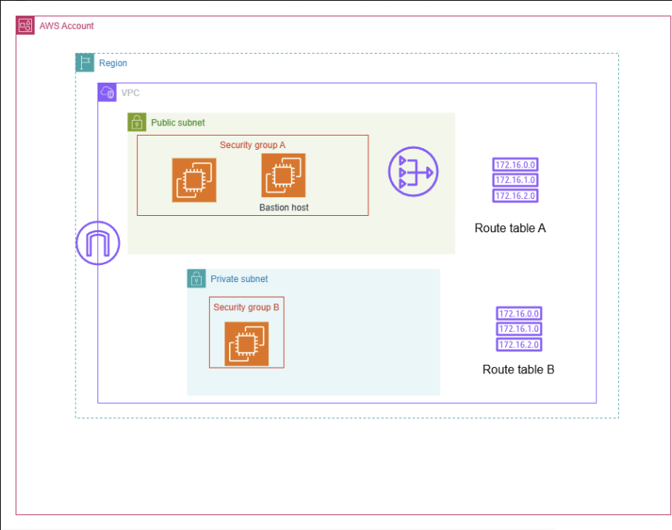
Figur 0

1. Creating the VPC
The VPC was the first resource created, with everything else built on top of it step by step.
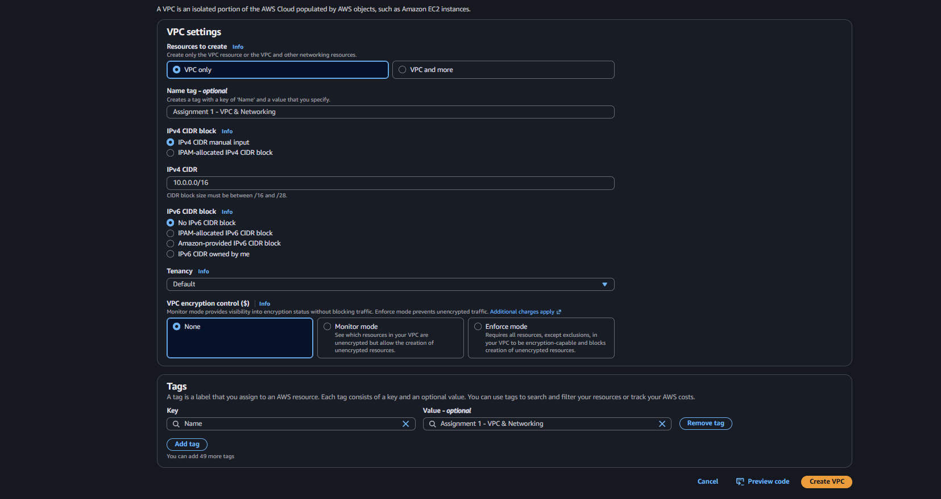
Figur 1
VPC creation form — CIDR block 10.0.0.0/16, Default tenancy, no encryption control, tagged "Assignment 1 - VPC & Networking"
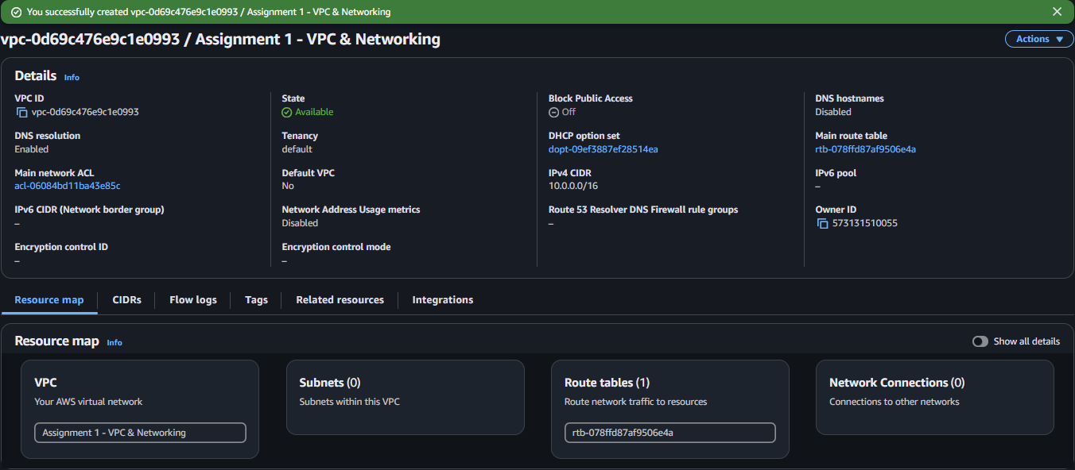
Figur 2
VPC created successfully — resource map showing the new VPC with no subnets or gateways yet

2. Creating the Public Subnet
The public subnet was created first; the private subnet was planned to follow the same process, differing only in its route table.
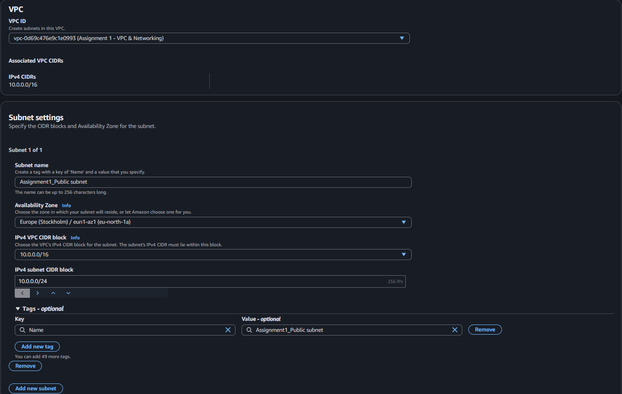
Figur 3
Public subnet creation — Assignment1_Public subnet, 10.0.0.0/24, eu-north-1a
A /24 block provides 256 addresses, but AWS reserves 5 of them (network address, VPC router, DNS, a future-use reservation, and the broadcast address), leaving 251 usable addresses — from 10.0.0.4 to 10.0.0.254.

3. Private Subnet — CIDR Planning
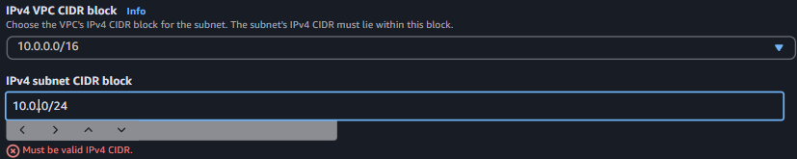
Figur 4
Initial attempt to reuse 10.0.0.0/24 for the private subnet — rejected as an invalid/overlapping CIDR
This produced a useful lesson: since the VPC is a /16, the first two octets (10.0) are fixed, but the third octet is free to choose per subnet. Reusing 10.0.0.0/24 for a second subnet meant asking for the exact same 256 addresses already claimed by the public subnet — a full overlap, not a partial one. Changing the third octet gives a completely separate, non overlapping /24 block within the same /16 VPC. IP range 10.0.7.4 to 10.0.7.254.
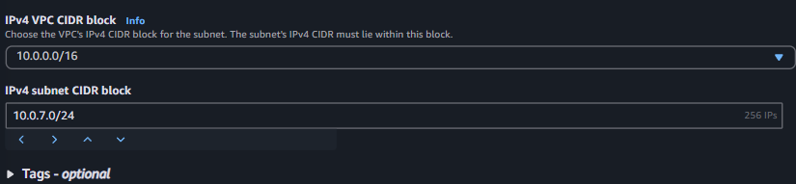
Figur 5
Corrected private subnet CIDR — 10.0.7.0/24, a distinct block within the 10.0.0.0/16 VPC

4. Internet Gateway
An Internet Gateway is what allows two way traffic between the VPC and the internet, for any resource that has a public or Elastic IP.
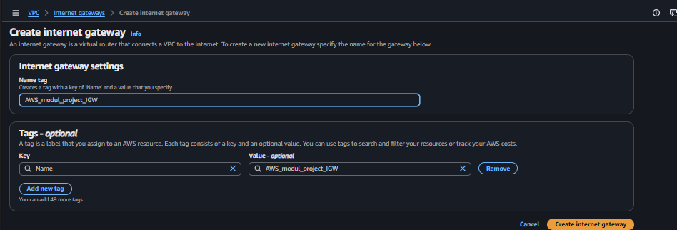
Figur 6
Creating the Internet Gateway — AWS_modul_project_IGW
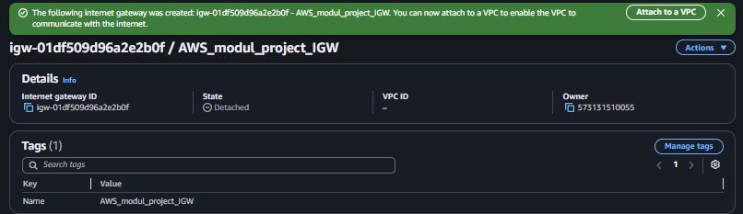
7
Internet Gateway created — initial state: Detached
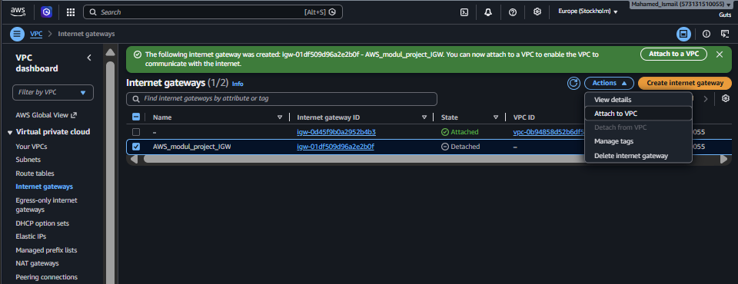
Figur 8
Attaching the Internet Gateway to the VPC
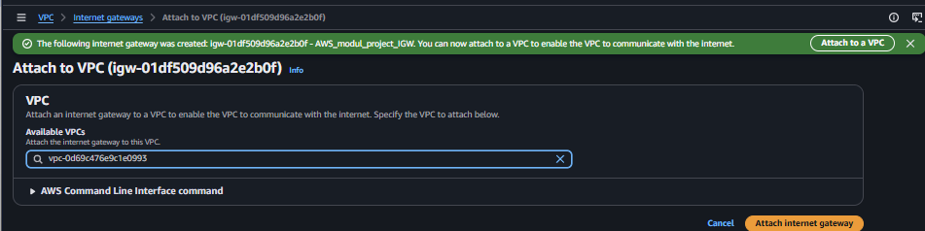
Figur 9
Selecting the VPC to attach the Internet Gateway to
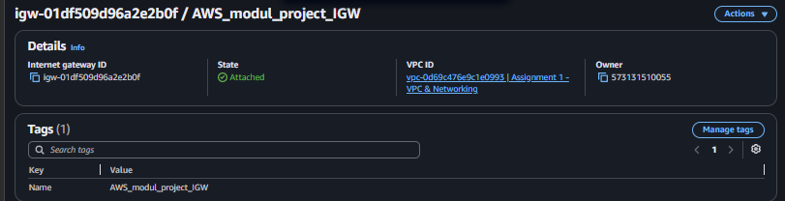
10
Internet Gateway confirmed Attached to the VPC

5. Elastic IP
An Elastic IP was allocated to give the NAT Gateway a fixed public address to use when sending traffic out to the internet on behalf of the private subnet.
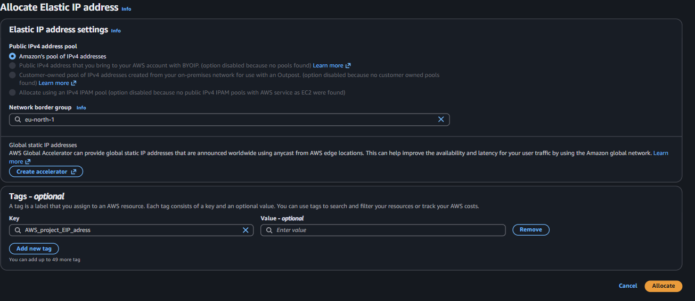
Figur 11
Allocating an Elastic IP address (Zonal, matching the region's network border group)
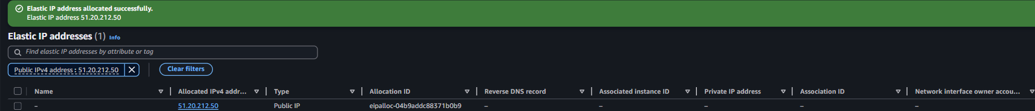
Figur 12
Elastic IP successfully allocated

6. NAT Gateway
The NAT Gateway sits in the public subnet and acts as a router for the private instances: when a private EC2 reaches out to the internet, the NAT Gateway translates its private IP to the NAT Gateway's own private IP and the Internet Gateway then translates that address to the NAT Gateway's public Elastic IP. A Zonal scope was used since this project doesn't need to scale across multiple Availability Zones.
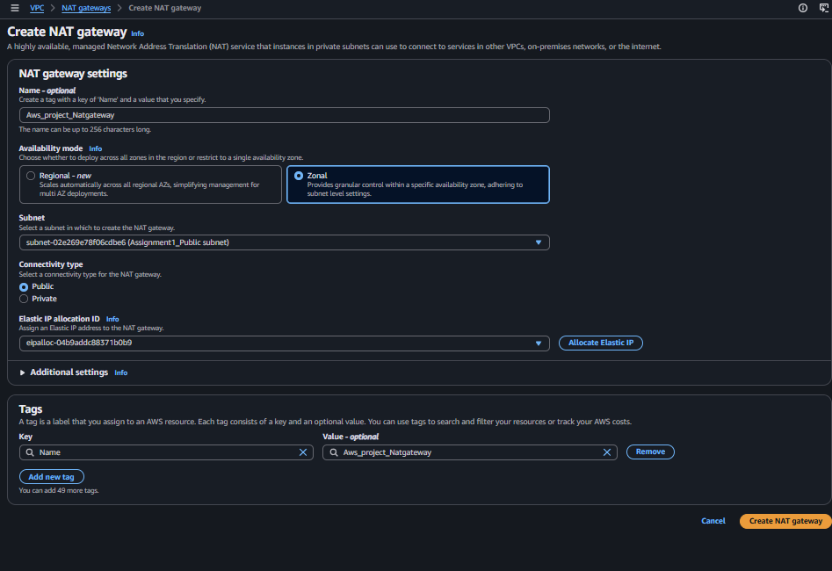
Figur 13
Creating the NAT Gateway — Zonal, in the public subnet, with the allocated Elastic IP attached
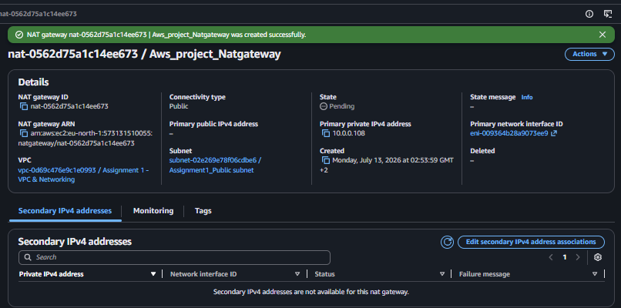
Figur 14
NAT Gateway created — Aws_project_Natgateway, status Pending → Available

7. Route Tables
A route table was created for the public subnet, to control how traffic is routed to and from the internet.
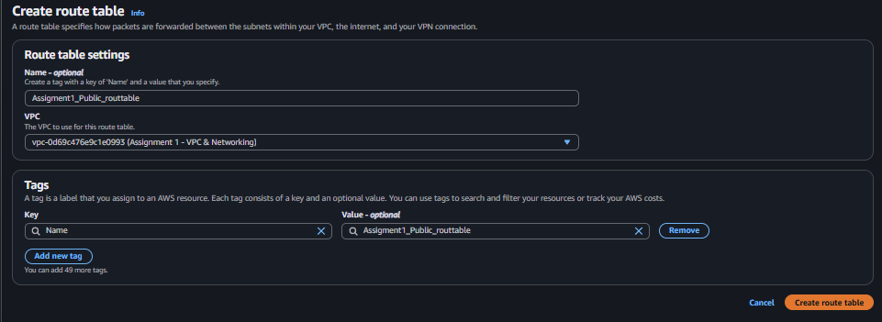
Figur 15
Creating the public route table — Assigmnet1_Public_routtable
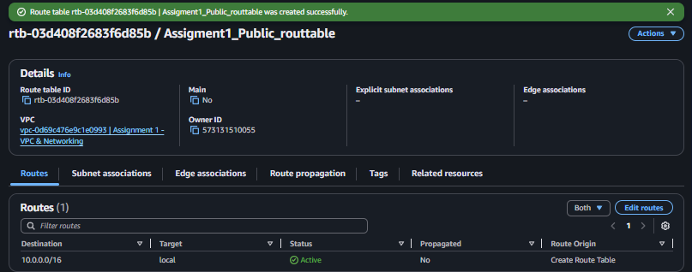
Figur 16
Route table created — only the automatic local route (10.0.0.0/16) present so far

7.1 Associating the Public Route Table
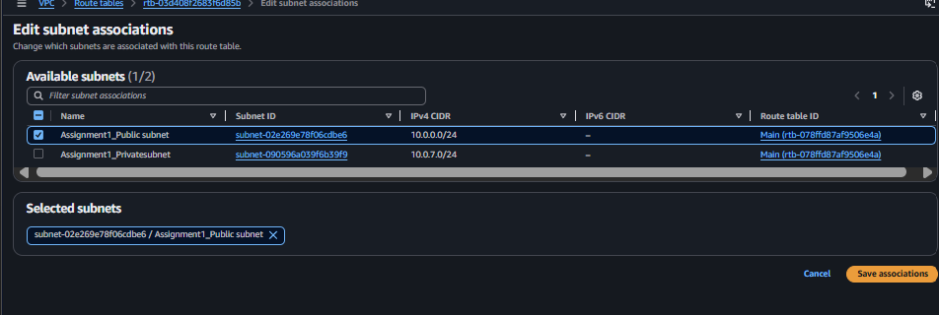
Figur 16
Associating the public route table with Assignment1_Public subnet
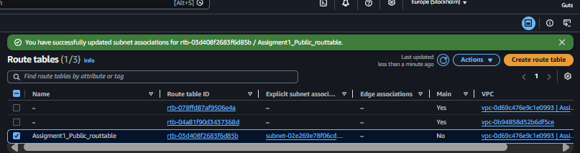
Figur 17
Route tables list confirming the public subnet association

7.2 Private Route Table
The same process was repeated for the private subnet, using a separate route table so its default route could point to the NAT Gateway instead of the Internet Gateway.
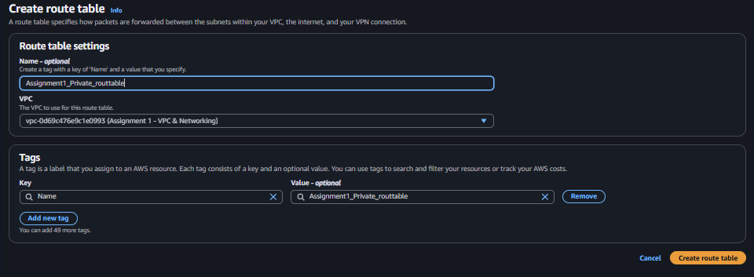
Figur 18
Creating the private route table — Assignment1_Private_routtable
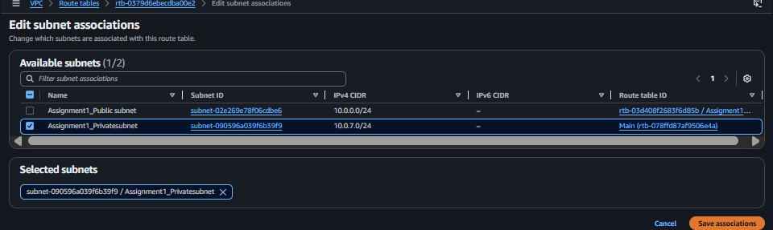
Figur 19
Associating the private route table with Assignment1_Privatesubnet
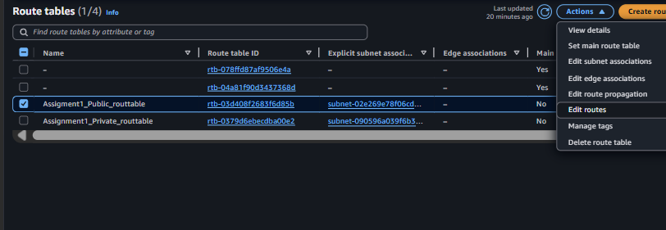
Figur 20
Route tables list showing both custom route tables and their subnet associations

7.3 Public Route Table Rules
A default route (0.0.0.0/0) was added pointing to the Internet Gateway, so any traffic not destined for the VPC's own address range is sent to the internet from the public subnet.
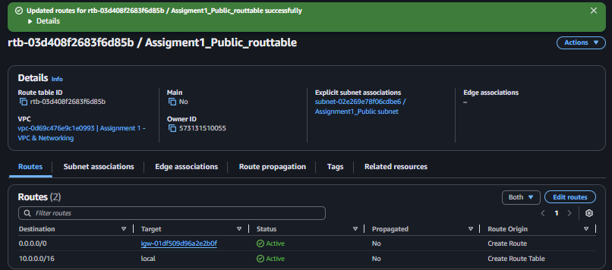
Figur 21
Editing routes on the public route table
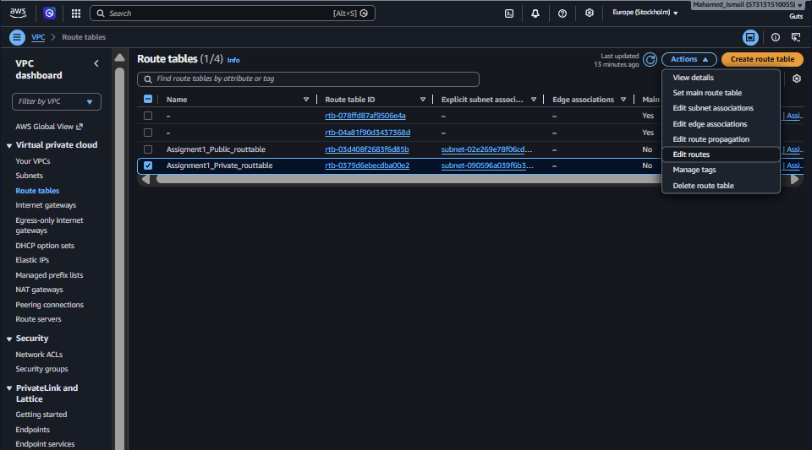
Figur 22
Public route table updated — 0.0.0.0/0 → Internet Gateway, status Active

7.4 Private Route Table Rules
A default route (0.0.0.0/0) was added pointing to the NAT Gateway, giving the private subnet safe, outbound only internet access without exposing it to inbound connections.
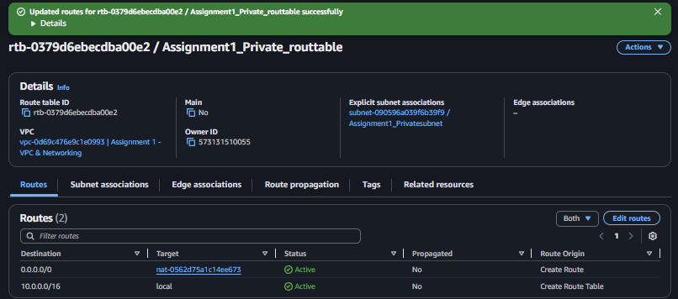
Figur 23
Private route table updated — 0.0.0.0/0 → NAT Gateway, status Active

8. Launching the Public EC2 Instance
With routing in place, the public and private EC2 instances were launched next. We started with the public one first, since it was gonna be easier to implement based on our architecture (figure 0).
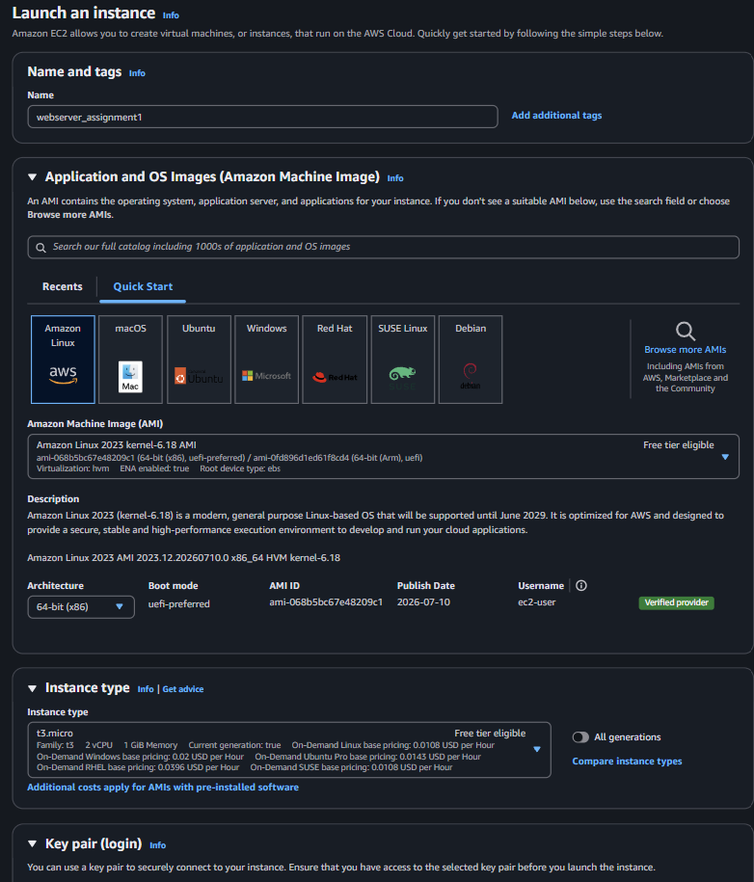
Figure 24
Launching the public EC2 instance — Amazon Linux 2023, t3.micro
All EC2 instances in this project use the smallest available compute size (t3.micro), both to minimize cost and because the architecture doesn't require significant processing power(Figure 24). Network settings placed the instance in the custom VPC's public subnet with an auto-assigned public IP enabled and a new Security Group was created with two inbound rules: SSH (22) and HTTP (80), both restricted to the admin's own IP only(Figure 25). We restricted access to a single IP address to reduce the attack surface and limit the number of potential attack sources.
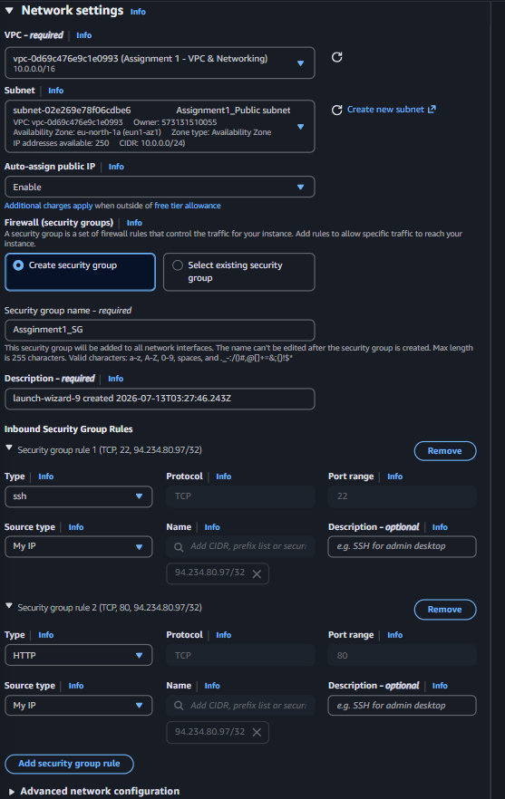
Figur 25
Network settings for the public EC2 — Auto-assign public IP: Enable; inbound rules for SSH and HTTP restricted to My IP

9. Verifying the Public EC2
The instance was tested by connecting over SSH (port 22):
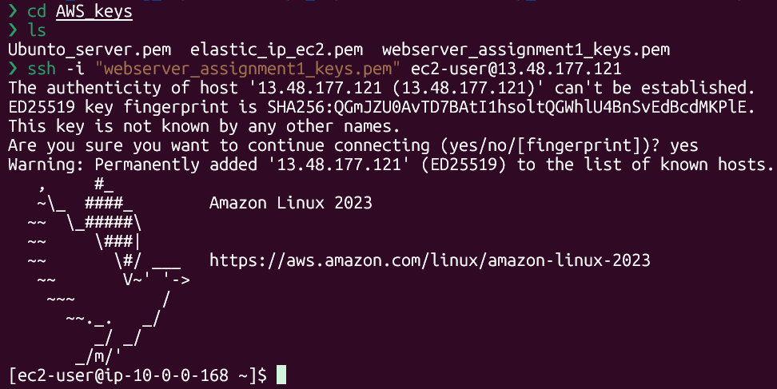
Figur 26
Successful SSH connection to the public EC2 instance

9.1 Troubleshooting — HTTP "Connection Refused"
An HTTP request to the instance returned 'connection refused' rather than a timeout. This distinction was used to isolate the cause: a timeout would mean traffic never reached the instance (pointing to the route table, IGW, Security Group, or NACL), while 'refused' means the packet did reach the instance and the OS itself replied that nothing was listening on that port — an application-layer issue, not a networking one. To verify this, I used nc (netcat) to confirm the finding: no software was installed to answer on port 80, meaning my EC2 had no process listening on that port — in other words, no web server was running."
Figur 27
Testing port 80 from the local machine with netcat — connection refused
Figur 28
Testing port 80 locally on the instance itself (localhost) — also refused, confirming no web server was installed
This confirmed that the entire network path routing, Security Group, and NACL was already working correctly and the only missing piece was a web server actually listening on port 80.

10. Bastion Host
A dedicated EC2 instance was launched in the public subnet to act as a bastion (jump box) for reaching the private instance, rather than reusing the existing public server.
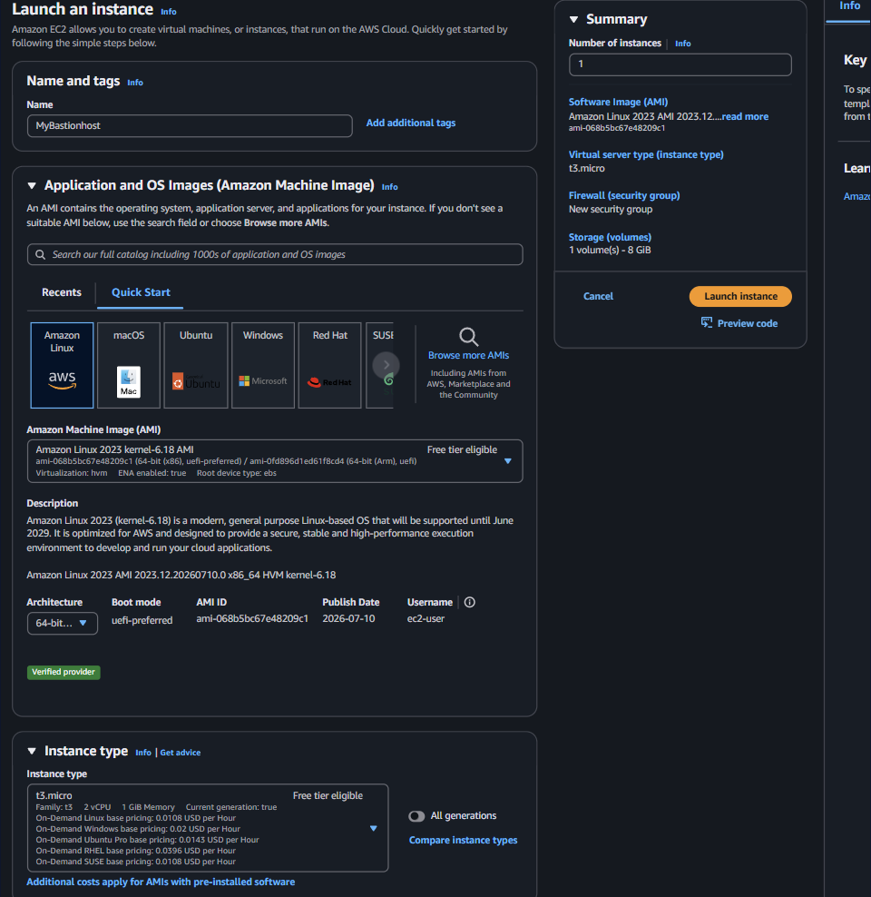
Figur 29
Launching the bastion host instance — MyBastionhost
Its Security Group only allows SSH (22), restricted to the admin's own IP no HTTP rule added because bastion's objective is only secure connectivity to my private instances.
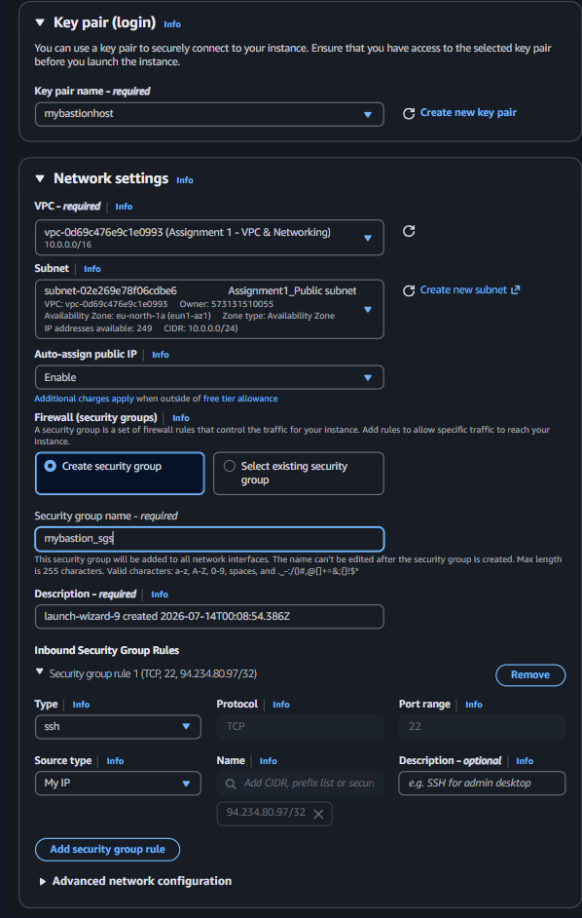
Figur 30
Bastion host network settings and Security Group — SSH only, source My IP
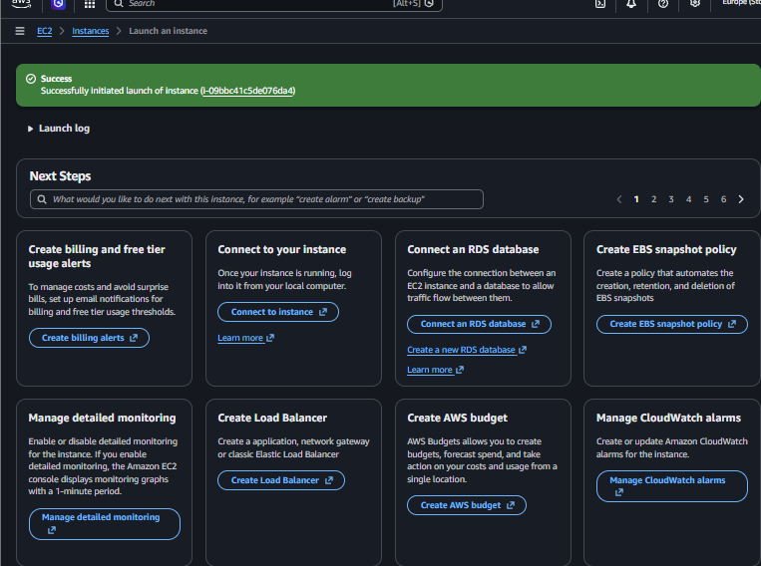
Figur 30
Bastion host launched successfully

11. Launching the Private EC2 Instance
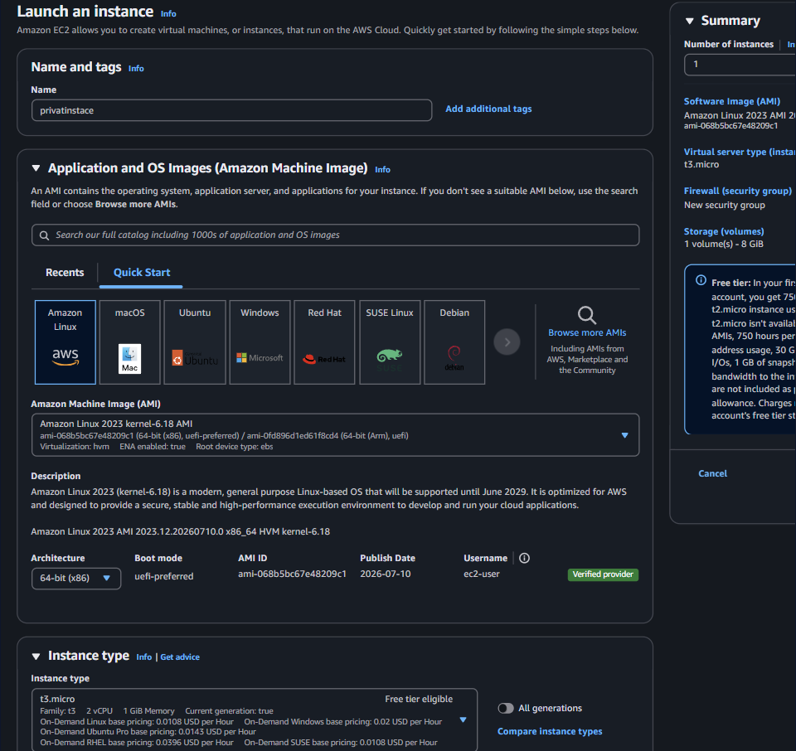
Figur 31
Launching the private EC2 instance — privatinstace
The instance was placed in the private subnet (the one without a route to the Internet Gateway) with auto-assigned public IP disabled. Its Security Group allows SSH only from the bastion's Security Group — referenced by ID rather than by IP — so the rule stays valid even if the bastion is ever replaced or its IP changes (for example, after a reboot), instead of needing to be manually updated each time.
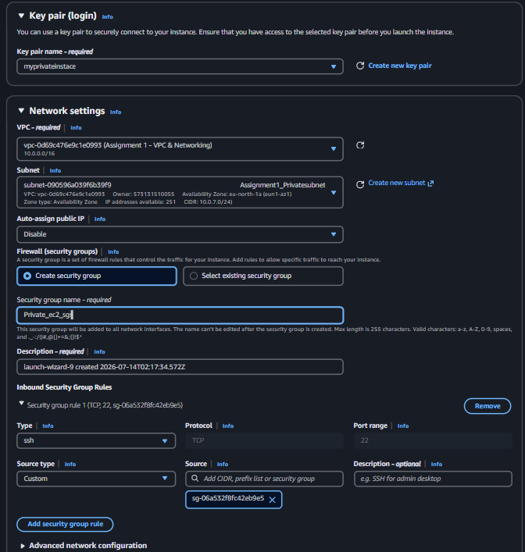
Figur 32
Private EC2 network settings — no public IP; Security Group inbound rule sourced from the bastion's Security Group ID

12. Secure Access via SSH Agent Forwarding
Rather than copying the private EC2's key onto the bastion host — which would leave a sensitive private key sitting on a second machine's disk — SSH agent forwarding was used instead. This keeps the private key only on the local machine: the local ssh-agent holds the key in memory and signs authentication challenges on behalf of the bastion when it connects onward to the private instance, without the key itself ever being copied anywhere.
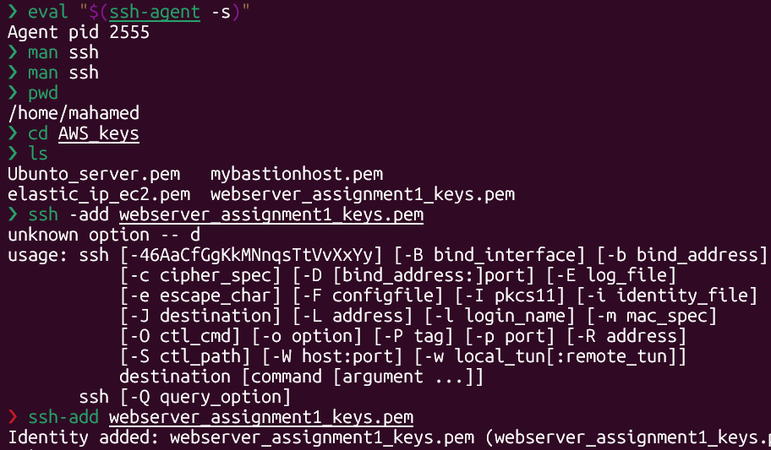
Figur 33
Private EC2 key pair and Security Group configuration
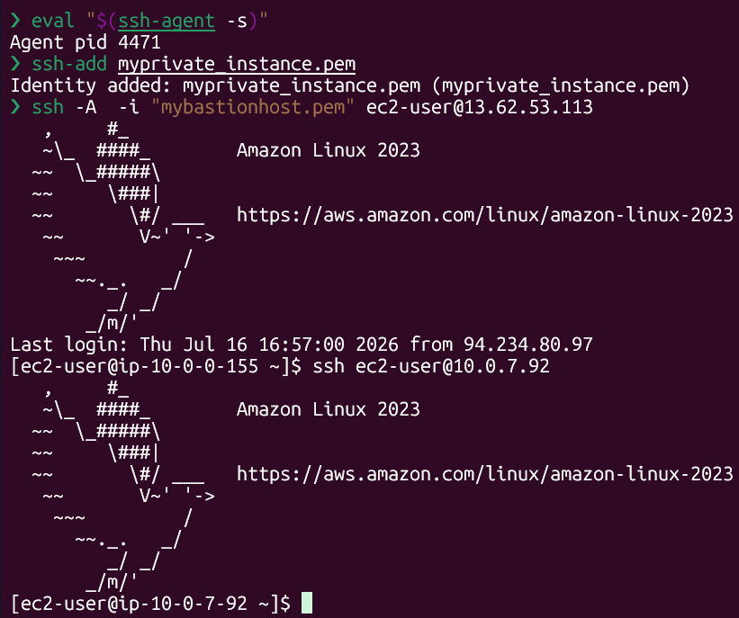
Figur 34
Loading the private EC2's key into the local ssh-agent (ssh-add)
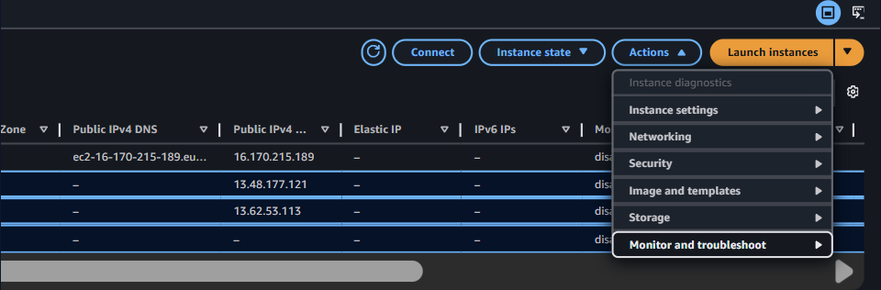
Figur 35
Full connection chain: local machine → bastion (with agent forwarding, -A) → private EC2 (no key file needed on the bastion)

Verifying internet access from private instance
Based o n my architecture, I used nat to safely access the internet by blocking connections and hiding my instance ip with nat.
I verified internet access with ping 8 8 8 8 this is standard test to see if device is connected tp the internet i basically send packets to googles dns servers.

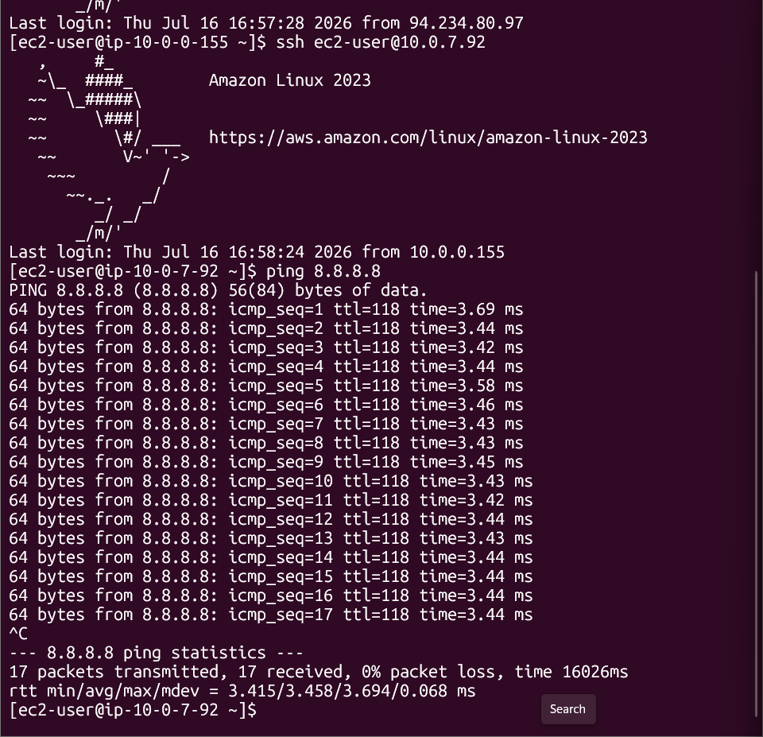
Figur 36

13. CloudWatch Monitoring

CloudWatch monitoring was enabled on the instances to track their health and performance.
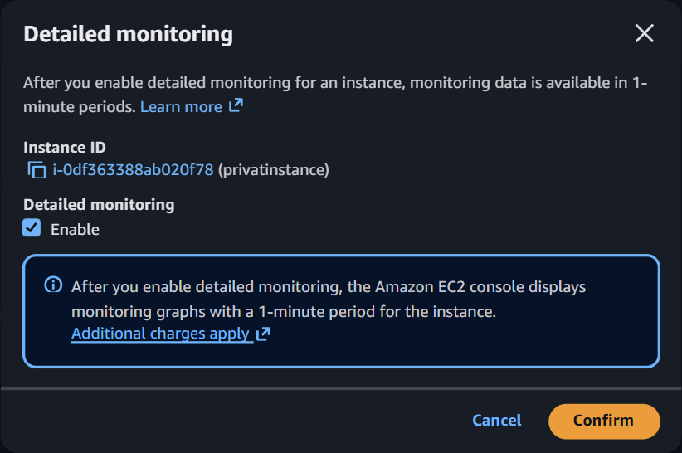
Figur 37
EC2 instance list — accessing Monitor and troubleshoot for detailed monitoring
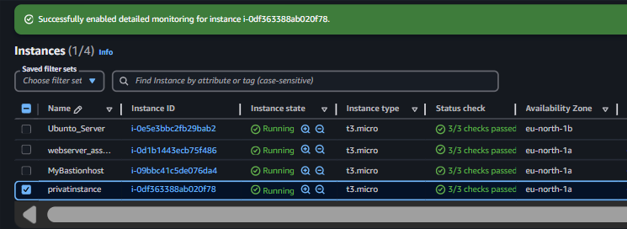
‘Figur 38
Detailed monitoring enabled — confirmed across all four running instances (public EC2, private EC2, bastion, and additional server)

Conclusion
This project resulted in a fully segmented custom VPC with distinct public and private subnets, correct default routing for each (Internet Gateway for the public subnet, NAT Gateway for the private subnet), least-privilege Security Groups — including Security-Group-to-Security-Group referencing for the bastion host — and a bastion-host access path secured with SSH agent forwarding rather than key copying. Along the way, real issues were diagnosed methodically: a CIDR overlap during subnet planning, and a "connection refused" on the public instance that was correctly traced to a missing web server rather than a networking fault, using the timeout-vs-refused distinction and netcat to confirm it at each layer.

