Department of Information Technology
Faculty of Computing
The Islamia University of Bahawalpur



Software Requirement Specifications

Detecting Temporal Learning Patterns Using Recurrence Quantification Analysis (RQA)

Submitted by
Mahameer Muhammad
F22BINFT1M01065

Submitted to
Dr. Mustafa Hameed

Summary

This project analyzes learners’ performance and behavior over time using Recurrence Quantification Analysis (RQA), a mathematical technique for identifying repeating patterns in time-series data. By applying RQA to educational datasets, the system detects stable learning phases, recurring mistakes, and sudden changes in student performance. The frontend is built with Flutter, while a Python-based RQA model runs on a cloud backend to process and visualize learning patterns effectively.
The project addresses the lack of insight in conventional learning systems, which typically report only final scores or averages. By revealing the temporal dynamics of learning, educators can better understand study habits, optimize teaching strategies, and create more adaptive learning environments.

.

Table of Contents
1. Introduction 4
1.1. Purpose 4
1.2. Scope 4
1.3. Product Perspective 4
1.4. User Characteristics 4
1.5. Similar apps and systems/Literature Review 4
1.6. Proposed Technologies 4
2. Requirements 5
2.1. Function Requirements 5
2.1.1. Sign Up 5
2.2. Non-Functional Requirements 5
3. Use Cases and Flow of Processes 6
3.1. Use Case 1 7
4. References 8

- Introduction
This Software Requirements Specification (SRS) document details the functional and non-functional requirements, as well as the use cases, for the Temporal Learning Pattern Detection System using Recurrence Quantification Analysis. The core objective of the project is to develop a mobile-based learning analytics platform capable of detecting and visualizing temporal patterns in student learning trajectories through advanced mathematical analysis. The system leverages a Flutter mobile application integrated with a Python FastAPI backend that implements Recurrence Quantification Analysis (RQA) algorithms to process educational time series data. The RQA engine is designed to compute quantitative metrics including recurrence rate, determinism, laminarity, and entropy, enabling the classification of learning patterns as regular, chaotic, periodic, or transitional. Once implemented, the system will enable educators to analyze student performance data over time through an intuitive mobile interface, offering data-driven insights into learning dynamics that traditional analytics methods cannot reveal.

  - Purpose
The purpose of this project is to develop a mobile learning analytics system capable of detecting temporal patterns in student learning trajectories using Recurrence Quantification Analysis (RQA). The system will be designed to process educational time series datasets containing student performance data over time, enabling it to identify learning patterns such as regular progression, chaotic behavior, periodic cycles, or transitional phases. The goal is to provide educators with an accessible and powerful platform for understanding learning dynamics, enabling early intervention for at-risk students, and improving pedagogical strategies based on temporal pattern analysis.
  - Scope
The scope of this project involves developing a mobile-based learning analytics platform capable of analyzing temporal patterns in student performance data through Recurrence Quantification Analysis. The system will leverage the PyRQA library and mathematical techniques from nonlinear dynamics to compute metrics such as recurrence rate, determinism, laminarity, and entropy from educational time series data. The platform will be integrated with a Flutter mobile application connected to a FastAPI backend deployed on cloud infrastructure to facilitate real-time analysis and visualization. The project encompasses uploading and validating student datasets, performing phase space reconstruction and recurrence plot generation, computing RQA metrics, classifying learning patterns, and presenting results through interactive visualizations including recurrence plots, metric dashboards, and comparison views.
  - Product Perspective
The Temporal Learning Pattern Detection System will act as an intelligent analytics module within educational data platforms. It operates as a mobile-first solution where a Flutter app sends datasets to a Python-based RQA engine that processes and visualizes temporal learning patterns. Through cloud integration, the system provides educators with real-time, interactive insights into student learning trajectories. It strengthens educational analytics by uncovering temporal dynamics missed by traditional methods, supporting early risk detection, personalized interventions, and data-driven understanding of learning behavior.
  - User Characteristics
- Primary users include educators, academic advisors, and educational researchers.
- Users can enter individual student records or import multiple datasets through the mobile app.
- They can select students for analysis, compare learning trajectories, and view RQA-based visualizations.
- The interface is designed to be intuitive and accessible, requiring no advanced mathematical or technical skills.
- Users only need basic familiarity with entering student performance data.
- The system helps users interpret complex RQA metrics through clear visuals and explanations.
- Overall, the goal is to provide a powerful yet user-friendly tool that converts complex analytics into actionable educational insights for proactive student support.
  - Similar apps and systems/Literature Review
- Existing tools for time-series analysis—such as MATLAB, R packages, and Python libraries like pyRQA—offer recurrence plots and statistical analysis but:
- require programming knowledge,
- are mostly desktop-based, and
- lack mobile accessibility.
- Python RQA tools provide accurate metric calculations but are limited to script-based use and do not offer user-friendly interfaces.
- Some mobile apps support basic time-series visualization, but none implement advanced techniques like RQA.
- Research in fields such as biomedical analysis and financial forecasting has used RQA to understand complex temporal behaviors, but these solutions:
- need technical expertise,
- do not support real-time interaction, and
- are not mobile-focused.
- The proposed system fills these gaps by offering:
- a Flutter mobile application,
- connected to a FastAPI backend that performs RQA computations,
- providing interactive, real-time visualizations that are accessible to non-technical users.
  - Proposed Technologies
The proposed project will leverage the following technologies:
- Flutter Framework: Cross-platform mobile application development framework for building the iOS and Android user interface, enabling seamless interaction with the analytics system.
- Python FastAPI: High-performance backend framework for building RESTful APIs, handling dataset uploads, processing requests, and serving RQA analysis results.
- PyRQA Library: Specialized Python library for performing Recurrence Quantification Analysis, including phase space reconstruction, recurrence plot generation, and computation of RQA metrics (recurrence rate, determinism, laminarity, entropy).
- NumPy & Pandas: Python libraries for numerical computations, data manipulation, and time series preprocessing.
- Optional Local/Cloud Storage:
SQLite or cloud databases may be used if storing historical analysis results or user datasets is required. For simple analysis, storage is optional as RQA computations are performed on-the-fly.
- Visualization Libraries: Flutter charting packages for creating interactive recurrence plots, metric dashboards, and temporal performance visualizations within the mobile interface.

- Requirements
The system will allow users to input or import student learning data through the mobile app and send it to the backend for processing. The backend will perform RQA to generate recurrence plots, compute key metrics, and classify learning patterns. Results will be shown in real time through clear visualizations. The system will validate and preprocess data, support analysis of multiple students, enable comparison of learning trajectories, and provide options to export the results.

  - Function Requirements
The functional requirements specify the core operations of the system. Users will be able to input or import student learning data through the mobile app, which the backend will analyze using RQA to detect temporal learning patterns. The platform will display recurrence plots, metric values, and pattern classifications through real-time interactive visualizations. It will automatically validate and preprocess the data to ensure compatibility with RQA computations. The system will also allow multiple students’ data to be analyzed together, support comparison of learning trajectories, and offer metric explanations and export options. These requirements ensure smooth performance and provide educators with a clear and accessible tool for understanding learning dynamics over time.

2.1.1. Enter Student Learning Data
- Id: FR001
- Title: Enter Student Learning Data
- Description: The system shall allow users to enter student performance data by either manually inputting individual student records or importing multiple students' learning data at once through the mobile application.

2.1.2. Data Validation and Preprocessing
- Id: FR002
- Title: Data Validation and Preprocessing
- Description: The system shall validate entered student learning data for required information (student identification, timestamp, performance score) and preprocess data for RQA analysis readiness.

2.1.3. Student Data Management and Display
- Id: FR003
- Title: Student Data Management and Display
- Description: The system shall provide functionality to view, browse, search, and filter all students with their performance summaries, analysis status, and detailed individual information through an intuitive interface.

2.1.4. RQA Analysis Configuration and Execution
- Id: FR004
- Title: RQA Analysis Configuration and Execution
- Description: The system shall allow users to configure RQA parameters (embedding dimension, time delay, threshold) and perform Recurrence Quantification Analysis on student time series data, computing metrics including recurrence rate, determinism, laminarity, and entropy.

2.1.5. Pattern Classification
- Id: FR005
- Title: Pattern Classification
- Description: The system shall classify learning trajectories as regular, chaotic, periodic, or transitional based on computed RQA metrics and provide interpretable insights about learning patterns.

2.1.6. Results Visualization
- Id: FR006
- Title: Results Visualization
- Description: The system shall display analysis results through interactive visualizations including recurrence plots, metric dashboards with explanations, temporal performance charts, and pattern interpretation details.

2.1.7. Student Comparison
- Id: FR007
- Title: Student Comparison
- Description: The system shall enable side-by-side or overlay comparison of multiple students' learning patterns with comparative visualizations, metric analysis tables, and highlighted differences.

2.1.8. Export and Reporting
- Id: FR008
- Title: Export and Reporting
- Description: The system shall allow users to export analysis results, visualizations, comparison reports, and student data in shareable formats for documentation and communication purposes.

2.1.9. System Configuration
- Id: FR009
- Title: System Configuration
- Description: The system shall provide settings functionality allowing users to customize application preferences including theme, language, default analysis parameters, and backend server configuration.

2.1.10. Dashboard and Quick Access
- Id: FR010
- Title: Dashboard and Quick Access
- Description: The system shall provide a centralized dashboard displaying student data summary, recent analyses, quick action buttons, and navigation to all major features for efficient workflow.

  - Non-Functional Requirements
The system must be reliable, efficient, and user-friendly. It should provide RQA analysis results quickly, scale to multiple students with extensive data, and ensure accurate, reproducible computations. The interface must be easy to use without requiring advanced mathematical knowledge. The system should be maintainable and extensible for future enhancements, while ensuring security and privacy of student data according to relevant standards.

● Performance: RQA analysis should be completed within a reasonable timeframe proportional to the amount of student learning data being analyzed.
● Scalability: The system must maintain consistent performance when processing student learning data ranging from small groups to large cohorts with extended learning histories.
● Accuracy: RQA computations must be mathematically correct, producing reproducible results consistent with established RQA methodologies.
● Usability: Users interact through an intuitive mobile interface with minimal effort; no expertise in mathematics or RQA is required to interpret results.
● Maintainability: Backend code and RQA algorithms should be modular and easily updatable for future enhancements or additional metrics.
● Security & Privacy: All student data must be protected during transmission and processing; compliance with educational data privacy regulations.
● Reliability: System should remain operational with cloud deployment ensuring high availability and minimal downtime.
● Interpretability: Analysis results must be presented with clear explanations, making complex RQA metrics understandable to non-technical users.

- Use Cases and Flow of Processes
Use cases are the formal representation of process flow defined by functional requirements. This section provides a flow of events for the Temporal Learning Pattern Detection System, including system-level use cases with their actors as described in the requirements chapter.

  - Enter Student Learning Data
ID | UC001
Name | Enter Student Learning Data
Description | This use case describes the process of entering student performance data either by importing multiple students at once or manual entry
Requirements | FR001, FR002, FR003
Actor(s) | Educator, Academic Advisor, Researcher, System
Precondition | User has access to the mobile application and has student performance information available
Postcondition | Student learning data is validated, stored in the database, and displayed on the dashboard
Basic flow | - The educator accesses the data entry feature and selects either import multiple students or manual single entry option.  - The system receives the data file or manual entries, validates format and required fields, and displays processing progress.  - The system stores validated student learning data in the cloud database and performs data preprocessing for analysis readiness.  - The system displays a summary of entered data and updates the dashboard with new student count and information.

3.2 View Student List
ID | UC002
Name | View Student List
Description | This use case describes how users browse all students with summary statistics and analysis status
Requirement(s) | FR003
Actor(s) | Educator, Academic Advisor
Precondition | Student learning data has been entered and stored in the system
Postcondition | User views complete student list with performance summaries and can select students for further actions
Basic Flow | - The educator navigates to the View Students feature from the dashboard.  - The system retrieves all students from the active class and displays student cards showing identification, performance summary, and analysis status.  - The educator can browse, search, or filter students by various criteria such as performance level or analysis status.  - The educator selects a student card to view detailed information and the system navigates to the student detail screen.

3.3 View Individual Student Details and Configure Analysis
ID | UC003
Name | View Individual Student Details and Configure Analysis
Description | This use case describes viewing detailed student information and configuring RQA analysis parameters
Requirement(s) | FR003, FR004, FR006
Actor(s) | Educator, Academic Advisor, Researcher
Precondition | Student exists in the system with sufficient performance data for analysis
Postcondition | Student details are displayed and analysis parameters are configured for processing
Basic Flow | - The educator selects a student from the list and the system retrieves complete performance history and displays student details.  - The system shows performance statistics, visual timeline chart, and existing analysis status with key trends and patterns.  - The system displays an RQA analysis configuration section with adjustable parameters for embedding dimension, time delay, and threshold.  - The educator reviews information, configures analysis parameters or uses defaults, and initiates the pattern analysis process.

3.4 Perform RQA Analysis
ID | UC004
Name | Perform RQA Analysis
Description | This use case describes the execution of RQA computation on student learning data
Requirement(s) | FR004, FR005
Actor(s) | Educator, Academic Advisor
Precondition | Student has sufficient performance data and analysis parameters are configured
Postcondition | RQA metrics are computed, learning pattern is classified, results are stored and displayed
Basic flow | - The educator initiates analysis and the system displays a processing screen with progress indicators and stages.  - The backend performs phase space reconstruction, computes distance matrix, and generates the recurrence plot visualization.  - The system calculates RQA metrics including recurrence rate, determinism, laminarity, and entropy, then classifies the learning pattern.  - The system stores analysis results with timestamp in the database and navigates to the analysis results display screen.

3.5 View Analysis Results Overview
ID | UC005
Name | View Analysis Results Overview
Description | This use case describes viewing the overview tab of analysis results with pattern classification and key insights
Requirement(s) | FR005, FR006
Actor(s) | Educator, Academic Advisor
Precondition | RQA analysis has completed successfully for the selected student
Postcondition | User views comprehensive overview of learning pattern with classification and insights
Basic flow | - Analysis completes and the system navigates to Analysis Results screen with the Overview tab displayed by default.  - The system displays learning pattern classification badge, descriptive explanation, and key insights derived from RQA metrics.  - The system shows thumbnail recurrence plot visualization and performance timeline chart with trend indicators.  - The educator reviews overview information and can navigate to detailed pattern or metrics tabs, export report, or compare with other students.

3.6 View RQA Metrics
ID | UC006
Name | View RQA Metrics
Description | This use case describes viewing detailed quantitative RQA metrics with explanations and visual indicators
Requirement(s) | FR005, FR006
Actor(s) | Educator, Academic Advisor
Precondition | User is viewing analysis results for a student
Postcondition | User reviews comprehensive RQA metrics with interpretations for understanding learning patterns
Basic flow | - The educator taps the Metrics tab on the Analysis Results screen.  - The system displays RQA metrics cards showing recurrence rate, determinism, laminarity, and entropy with numerical values and visual bar indicators.  - Each metric includes an explanation of meaning, interpretation guidelines, and relative level indicators showing high, medium, or low classifications.  - The educator can access detailed explanations for each metric, export metrics data, or navigate to compare this student with others.

3.7 Compare Multiple Students
ID | UC007
Name | Compare Multiple Students
Description | This use case describes selecting and comparing learning patterns and metrics of multiple students side-by-side
Requirement(s) | FR007
Actor(s) | Educator, Academic Advisor
Precondition | Multiple students have been analyzed with RQA and results are available
Postcondition | Comparison results are displayed highlighting key differences and similarities in learning patterns
Basic flow | - The educator accesses the Compare Students feature and the system displays a selection screen with all analyzed students.  - The educator selects multiple students for comparison and the system validates selection and retrieves analysis results for all selected students.  - The system generates comparison visualization showing side-by-side recurrence plots, metrics comparison table, and highlights key differences in pattern classifications.  - The educator reviews comparative analysis with recommendations, can switch between side-by-side and overlay views, and can export the comparison report.

3.8 View Recent Analyses from Dashboard
ID | UC008
Name | View Recent Analyses from Dashboard
Description | This use case describes quick access to recently completed analyses directly from the dashboard
Requirement(s) | FR003, FR005
Actor(s) | Educator, Academic Advisor
Precondition | At least one student analysis has been completed and stored
Postcondition | User quickly accesses recent analysis results without navigating through student list
Basic flow | - The educator views the dashboard which displays the Recent Analyses section with a list of recent analysis cards.  - Each card shows student identification, pattern classification badge, and time elapsed since analysis was completed.  - The educator taps on any recent analysis card from the list.  - The system navigates directly to that student's complete Analysis Results screen with all tabs available for review.

3.9 Display Student Data Status
ID | UC009
Name | Display Student Data Status
Description | This use case describes displaying current student data summary and class information on the dashboard
Requirement(s) | FR001, FR003
Actor(s) | System
Precondition | Application is opened and user is authenticated
Postcondition | Current class information and student data status are displayed on dashboard
Basic flow | - The application launches and loads the Dashboard screen.  - The system retrieves current class metadata and student data summary from the backend database.  - The system displays Student Data Summary card showing class name, total students enrolled, performance entries count, and analyses completed.  - The information updates dynamically when new data is entered or analyses are performed, serving as quick reference for the educator.

3.1.1 UML Diagram of Workflow
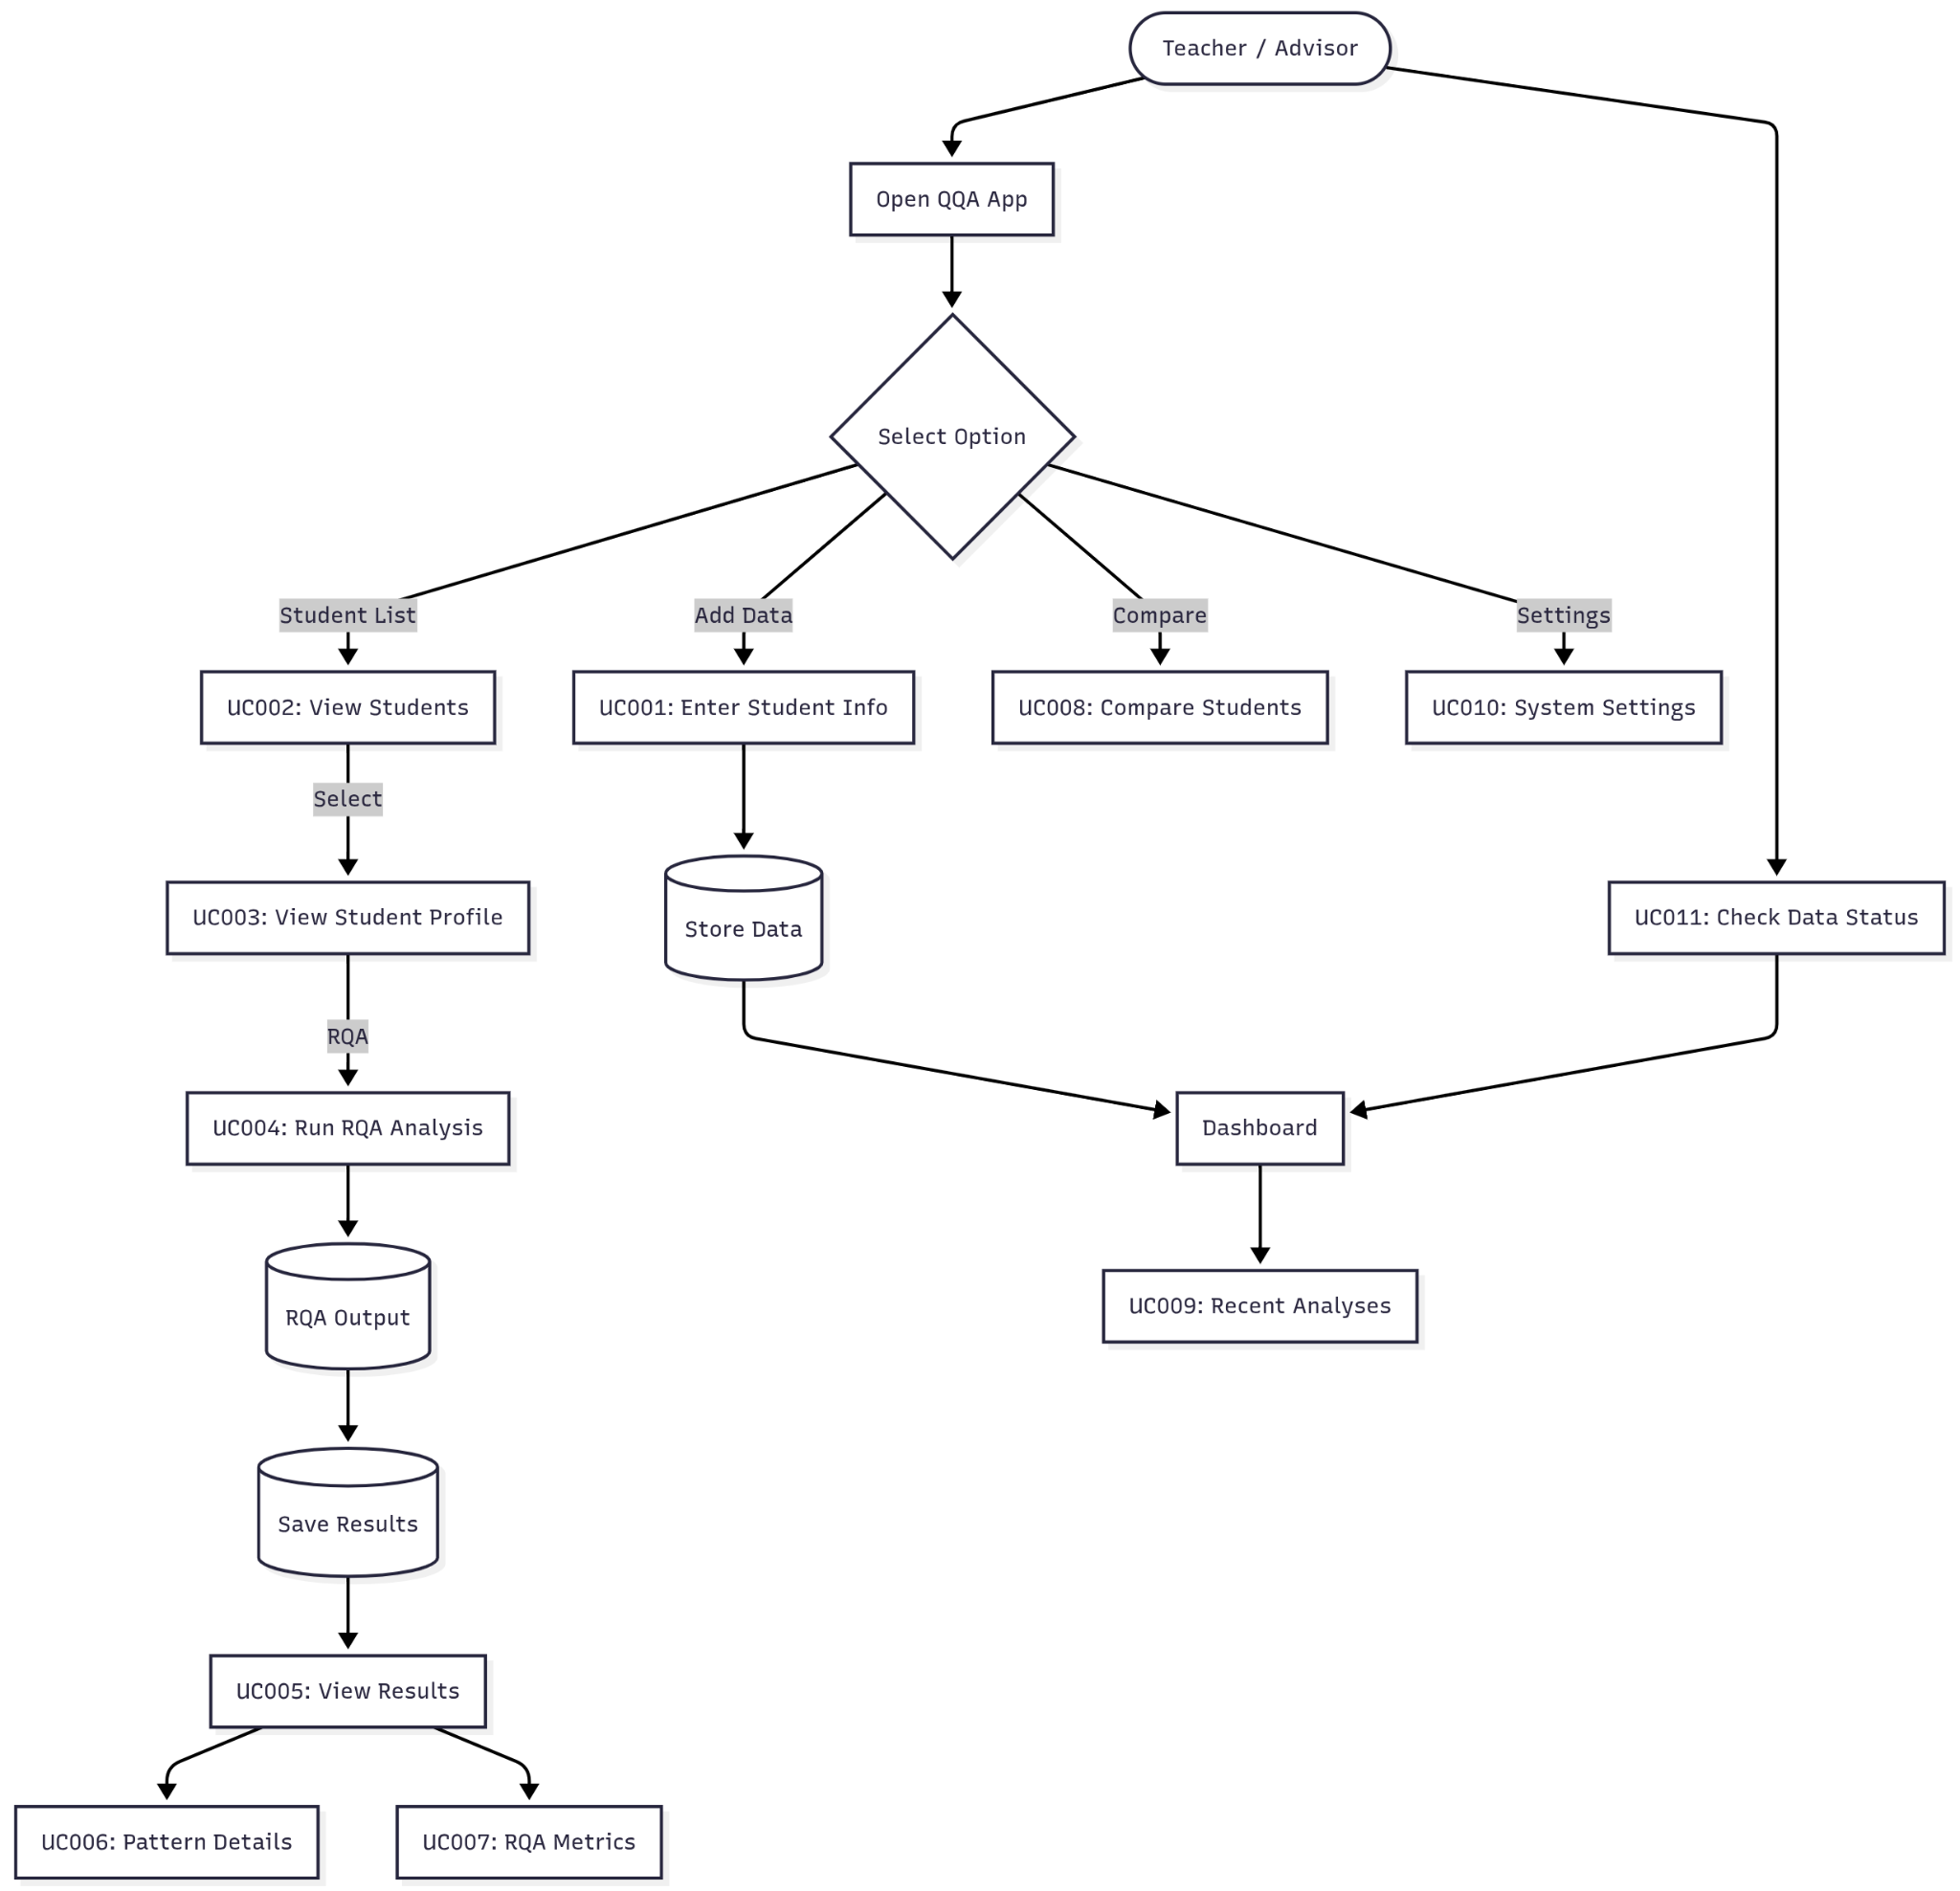
4. References
- “PyRQA,” PyPI package page. Available: https://pypi.org/project/PyRQA/ PyPI
- “FastAPI — high performance, easy to learn, fast to code, ready for production,” FastAPI documentation. Available: https://fastapi.tiangolo.com/ FastAPI+1
- FastAPI — Reference,” FastAPI docs (API reference and deployment guidance). Available: https://fastapi.tiangolo.com/reference/ FastAPI
- “Flutter — Build apps for any screen,” Flutter documentation. Available: https://docs.flutter.dev/ Flutter Docs+1
- T. Rawald, M. Sips, and N. Marwan, “PyRQA — Conducting recurrence quantification analysis on very long time series efficiently,” Computers & Geosciences, vol. 104, pp. 101–108, 2017. DOI: 10.1016/j.cageo.2016.11.016. (PyRQA software & implementation).

