**Network Connectivity In-site & multi-site**

**Network Course**

Prepared by:

Maha Mohammed Hamdy Ibrahim

Section:

Group:

Year:

Supervision of:

**Eng.**

Presented to:

**Dr.**

1. Introduction

1.1 Overview

Computer networks are vital for facilitating communication and data exchange among various devices and locations. Site-to-site connectivity is a fundamental aspect of networking infrastructure, particularly in scenarios where multiple geographically dispersed sites or branches need seamless communication.

focusing on two main aspects:

* **Inside networking aspect** (department to department connectivity)
* **Outside networking aspect** (Site-to-site connectivity)

**1.1.1 Inside computer networking** (department to department connectivity)

The localized network infrastructure and components within a particular physical location, such as an office building, data center, or campus such as inside “**Cairo Site”,** or “**Giza site”** which provide internal network communication, data exchange, and resource sharing within that specific site.

1.1.1.1 The importance of site connectivity lies in its ability to:

* **Efficient Communication:**
* **Establishment for Data Exchange:** Enable seamless and rapid transfer of data and information between different locations or branches of an organization.
* **Real-Time Collaboration:** Support real-time communication and collaboration among employees, teams, and departments across multiple geographical sites.
* **Enhance Operational Continuity:**
* **Business Continuity:** Ensure un-interrupted operations by maintaining connectivity between offices, allowing for continued access to critical resources and services.
* **Redundancy:** Offer redundancy options, reducing the impact of network outages or disruptions by providing alternative connectivity options.
* **Improve Resource Sharing:**
* **Shared Resources:** Enable sharing of resources, applications, and databases among different sites, enhancing efficiency and reducing duplication of efforts.
* **Support Scalability and Growth:**
* **Scalable Infrastructure:** Provide a scalable network infrastructure capable of accommodating the expansion and growth of an organization across different sites.
* **Flexible Operations:** Support flexible operations, allowing for the addition of new sites or the adjustment of network configurations to meet evolving business needs.

1.1.2 **Outside computer networking** (Site-to-site connectivity)

The connections between different network sites or locations, enabling continuous data transmission and communication across these sites from Cairo site to Giza Site as a first step. It ensures that various sites within an organization or network can interact as if they were part of a single network.

1.1.2.1 The importance of site-to-site connectivity lies in its ability to:

* Facilitate Inter-Site Communication: Enable seamless data sharing, resource access, and collaboration across multiple locations or branches.
* Enhance Business Operations: Support real-time information exchange and application access, optimizing business processes.
* Ensure Redundancy and Reliability: Provide backup connectivity options, ensuring network resilience in case of failures at one location.

Role in Modern Network Infrastructures

In modern network infrastructures, site-to-site connectivity is often established using various technologies, such as VPNs (Virtual Private Networks), MPLS (Multiprotocol Label Switching), or dedicated leased lines as in our case. These technologies enable secure and efficient communication between sites while accommodating different bandwidth and security requirements

**2. Literature Review**

Here separating the Insite into three room each room contain three department this type of separation ensures that even the same room users will only communicate through the router which is the centralized device for communication introducing the virtual separation for user into different local area networks (VLANS)

**2.1 Network Segmentation by VLAN (Virtual Local Area Network)**

is a crucial networking technology that allows the segmentation of a single physical network into multiple logical networks, offering several benefits:

Network Segmentation:

* Logical Isolation: Divides a single broadcast domain into multiple virtual segments, isolating traffic between different VLANs.
* Improved Performance: Reduces network congestion and broadcast traffic by separating devices logically.

Enhanced Security:

* Traffic Isolation: Prevents unauthorized access by restricting communication between devices in different VLANs, adding an extra layer of security.

Optimized Network Management:

* Simplified Administration: Eases network management by allowing administrators to group devices logically, making configuration and maintenance more efficient.
* Flexibility in Configuration: Enables changes to network configurations without physically restructuring the network.

VLANs provide a powerful means of logically segmenting and organizing network traffic, enabling better security, improved performance, simplified management, and enhanced flexibility within a network infrastructure. Their ability to isolate traffic, enhance security, and optimize network performance makes them a fundamental component in modern networking architectures.

From Vlan View Segmentation:

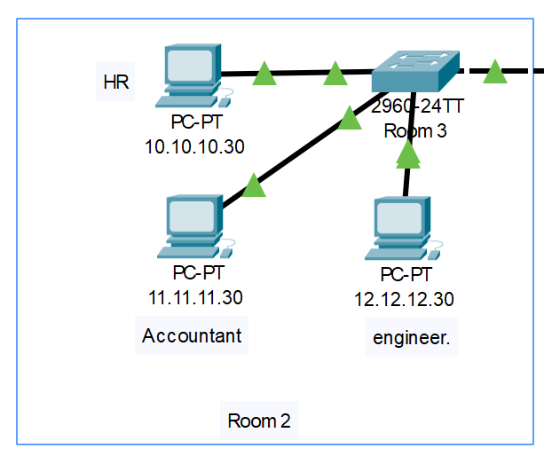

**2.2 Inter-VLAN routing**

is the process of allowing communication and data exchange between different VLANs within a network infrastructure.

VLAN Isolation:

* By default, devices within the same VLAN can communicate, while those in different VLANs are separated and unable to exchange data directly.

Inter-VLAN Communication:

* Inter-VLAN routing enables devices in separate VLANs to communicate by routing traffic through a router or Layer 3 switch.

Routing Mechanism:

* Router or Layer 3 Switch: Acts as the gateway between VLANs, having interfaces configured for each VLAN or using sub interfaces (Our Case) to connect to multiple VLANs.

Process of Inter-VLAN Routing:

* Routing Between Subnets: Each VLAN is typically associated with its subnet, and the router facilitates communication between these subnets.

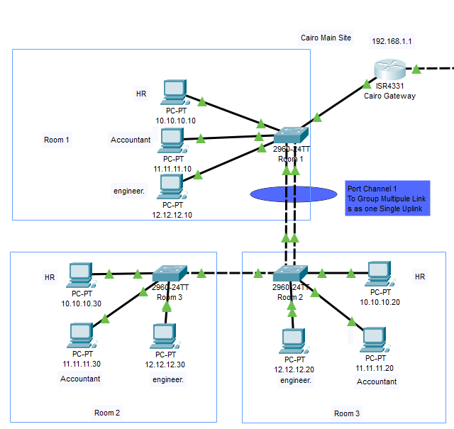

Inter-VLAN routing is a critical mechanism for enabling communication between separated VLANs within a network, allowing controlled and secure data exchange between different network segments. It plays a main role in facilitating efficient collaboration while maintaining network segmentation and security

**2.3 Static routing**

is a method used in network configurations where routing tables are manually configured by a network administrator or IT professional.

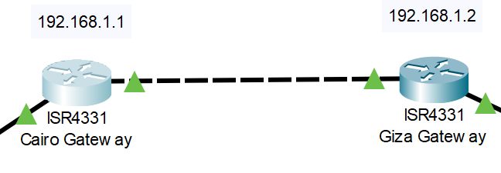

Routing Table Configuration:

* Manual Entry: Routes are added to the routing table manually, specifying the destination network or host and the next hop or outgoing interface.

Simplicity

* Easy to configure and understand, making it suitable for smaller networks with straightforward routing requirements and as in our case few sites are required.

Control

* Provides precise control over routing paths, allowing administrators to dictate the traffic flow according to specific preferences.

I.E

ip route <destination_network> <subnet_mask> <next_hop_ip_address>

ip route <destination_network> <subnet_mask> <Interface on L3 Device>

Static routing provides a straightforward and manually configured method for routing traffic between networks. While suitable for smaller, less complex networks. Administrators must carefully manage and update static routes to ensure network efficiency and adaptability to changes.

**2.4 Dedicated Communication Channel:**

**leased line** is a dedicated communication line that is rented by an enterprise from a telecommunications provider.

Point-to-Point Connection:

* Offers a direct and dedicated link between two locations, ensuring exclusive connectivity without sharing bandwidth with other users.

Reliability

* Ensures consistent and reliable performance as the bandwidth is dedicated solely to the subscriber.

Low Latency

* Offers low latency, making it suitable for real-time applications and critical data transfer.

**2.5 A port channel (Link Aggregation Group (LAG) or EtherChannel)**

* combine multiple physical Ethernet links into a single logical link.

Combining Links:

* Aggregates multiple parallel physical links between devices into a single logical link to increase bandwidth and redundancy.

Grouping Ports:

* Port channels group multiple physical ports together, treating them as a single higher-bandwidth connection.

Benefits of Port Channels:

Increased Bandwidth:

* Offers aggregated bandwidth equal to the combined bandwidth of individual member links (e.g., combining four 1 Gbps links results in a 4 Gbps logical link).

Load Balancing:

* Distributes traffic across member links, preventing congestion and optimizing bandwidth utilization.

Redundancy:

* Provides failover capabilities; if one link fails, traffic is automatically rerouted through the remaining active links.

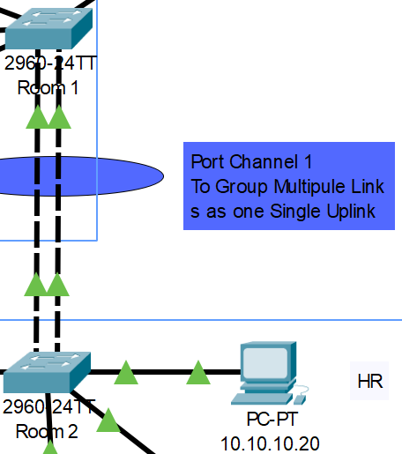

**3.Experiment Design and Simulation**

**3.1 Goals and Methodology**

Work with the main five network component and implementing them in one project:

* Network Segmentation by VLAN (Virtual Local Area Network
* port channel (Link Aggregation Group (LAG) or EtherChannel)
* Dedicated Communication Channel (Point to Point)
* Static routing
* Inter-VLAN routing

In order reach:

* In-site connectivity across communication on multiple VLANs representing various user types.
* site-to-site connectivity
* site-to-site connectivity across different VLANs representing various user types.

**3.2 Simulation Setup**

Using Cisco Packet Tracer to provide simulation for network:

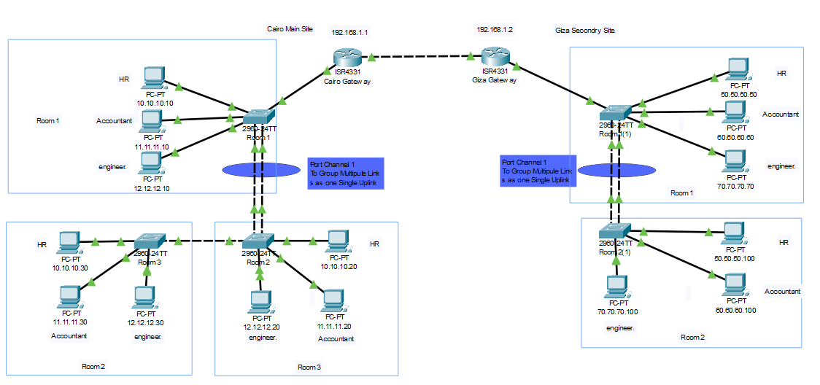

**3.3 Experiment Design and Simulation**

**Router Configuration:**

* Creating sub interface on the Cairo Router for each Vlan to reach the inter-Vlan routing
* Set Ip address to be the user gate way to communicate to
* Specify the encapsulation type inside the interface to only encapsulate the required Vlan

**Cairo Site**

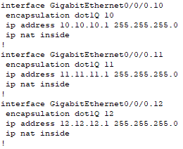

**Giza Site**

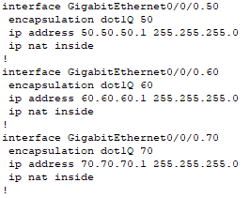

* Configuring the interface to outside communication on the Leased Line (point to point)

**Cairo Site**

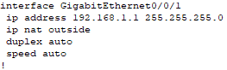

**Giza Site**

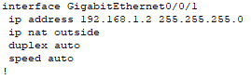

* Configuring the Static Routes to route this subnet to the point-to-point communication

**Cairo Site**

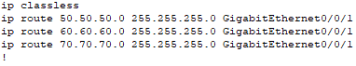

**Giza Site**

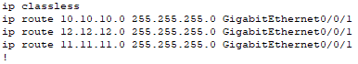

**Room 1 - Switch Configuration:**

* Assign interfaces of the user to the specified Vlan related to him/her

**Cairo Site**

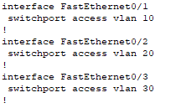

**Giza Site**

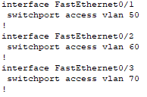

* Creating the port channel which provide redundant reliable connectivity between the switch of the room and the router

**Cairo Site**



**Giza Site**



* Configuration for the switch to other switches to be trunk which allow all the Vlans to pass

**Cairo Site**

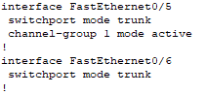

**Giza Site**

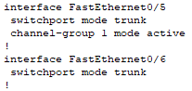

**4. Results and Analysis**

Data Collection: simulation execution process and the data gathered during the experiments.

|  |  |  |
| --- | --- | --- |
| (Cairo)  (Room 1)  (HR Pc)  IP Address: 10.10.10.10 | To | Interface Vlan 10  IP Address: 10.10.10.1 |

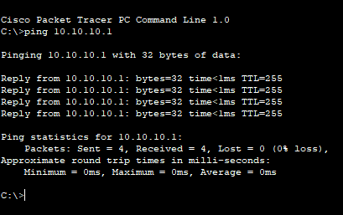

Sending 4 Ping Packet of 32 Byte length took (1 ms) journey time which is quite good, all 4 were sent successfully with Zero loss.

|  |  |  |
| --- | --- | --- |
| (Cairo)  (Room 1)  (HR Pc)  IP Address: 10.10.10.10 | To | Cairo  Outside point-to-point interface  IP Address: 192.168.1.1 |

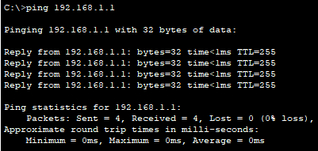

Sending 4 Ping Packet of 32 Byte length took (1 ms) journey time which is quite good, all 4 were sent successfully with Zero loss.

|  |  |  |
| --- | --- | --- |
| (Cairo)  (Room 1)  (HR Pc)  IP Address: 10.10.10.10 | To | Giza  Outside point-to-point interface  IP Address: 192.168.1.2 |

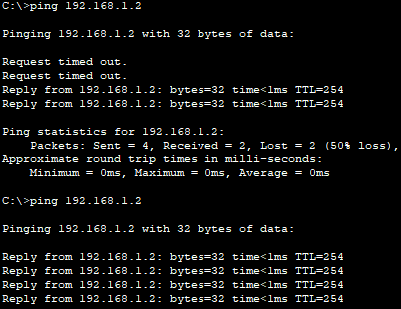

Sending 4 Ping Packet of 32 Byte length took (1 ms) journey time which is quite good, all 2 were sent successfully with 2 packet loss that just for the first discovery ping for network, repeating the ping 100% successfully with Zero loss

|  |  |  |
| --- | --- | --- |
| Cairo  Room 1  HR Pc  IP Address: 10.10.10.10 | To | Giza  Room 1  HR Pc  IP Address: 50.50.50.50 |

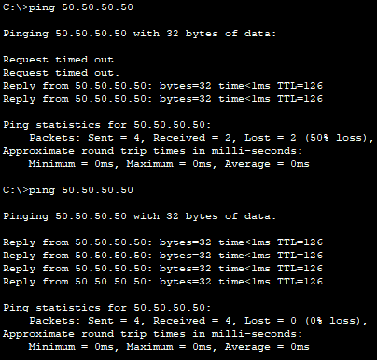

Sending 4 Ping Packet of 32 Byte length took (1 ms) journey time which is quite good, all 2 were sent successfully with 2 packet loss that just for the first discovery ping for network, repeating the ping 100% successfully with Zero loss

**5. Discussion**

Results: From the experimental design and simulation, we found that the reachability found from anywhere to everywhere either inside or outside the site.

Security and Reliability Considerations: reliability perspective was found, but our concern here is a security limitation no type of defense is implemented

**Future Research Directions:**

Recommendation: introduce FortiGate parameter Firewall, implement Site to Site VPN

**6.Conclusion:**

Setting up site-to-site static routing while managing access for different user groups involves careful planning, segmentation, and access control measures. By establishing static routes between sites and implementing secure access policies for different user groups, organizations can ensure efficient communication, controlled access, and enhanced security across their network infrastructure. Regular monitoring and updates are crucial to maintain optimal network performance and adapt to changing requirements.

Recommendation: introduce FortiGate parameter Firewall, implement Site to Site VPN to achieve a layer of security to the users.

**7.References:**

* Chapter: Configuring Static Routing

<https://www.cisco.com/c/en/us/td/docs/switches/datacenter/nexus3000/sw/unicast/503_u1_2/nexus3000_unicast_config_gd_503_u1_2/l3_route.html>

* Configuring Port Channels

<https://www.cisco.com/c/en/us/td/docs/switches/datacenter/nexus3400s/sw/93x/interfaces/configuration/guide/cisco-nexus-3400s-nx-os-interfaces-configuration-guide-93x/m_3400s_configuring_port_channels.pdf>

* Configuring VLANs

<https://www.cisco.com/c/en/us/td/docs/switches/datacenter/sw/5_x/nx-os/layer2/configuration/guide/Cisco_Nexus_7000_Series_NX-OS_Layer_2_Switching_Configuration_Guide_Release_5-x_chapter4.html>

* Configure InterVLAN Routing on Layer 3 Switches

<https://www.cisco.com/c/en/us/support/docs/lan-switching/inter-vlan-routing/41860-howto-L3-intervlanrouting.html>

Thanks, and best regards