M.TECH THESIS
RESEARCH DRAFT

AI-Driven RTL Test Generation, Coverage Analysis and Verification
  - A Simulation-Only UART TX/RX Study with PyVerilog, Hermes, Icarus, Coverage Feedback and Mutation Testing
DOCUMENT STATUS | WORKFLOW
Review-ready technical draft — not an approved university submission template | Phase 1 RTL → Phase 2 Parsing → Phase 3 AI Verification → Phase 4 Evaluation

Evidence status: historical 18/18 audit PASS; phase-based 12/12 audit PASS; Phase 4E read-only evidence audit PASS. All numerical results are taken from the user-verified WSL experiment outputs and Phase 4E report.
To be completed before submission: student / guide / university information, certification pages, institute formatting, official figure numbering, and a clean-checkout reproducibility record.
Prepared: 10 October 2026

Abstract
RTL verification remains a major engineering challenge because manually designed stimuli may miss protocol corner cases, while unconstrained random testing often spends simulation effort on redundant or low-value transactions. This work implements a simulation-only, phase-integrated verification workflow for a parameterized 8N1 UART transmitter and receiver. PyVerilog extracts RTL structural knowledge, which is converted into constrained verification objectives and prompts for the Hermes language-model interface. The generated JSON scenarios are deterministically validated, translated to self-checking Verilog testbenches and executed using Icarus Verilog at four clock-per-bit settings (8, 16, 32 and 64). Functional coverage is measured using ten explicitly defined UART scenario bins. A separate pre-layout architecture comparison assesses baseline, optimized and hybrid UART implementations.
Five fresh Hermes generations all produced valid scenarios and passing simulations, with 98% mean defined-bin coverage; four of five achieved complete coverage. Ten-seed protocol-aware random testing averaged 69% and a balanced-directed suite achieved 100%, matching the strongest AI outcomes. Across 14 selected fault operators and four clock configurations, the corrected reset-aware checker enabled both Hermes and balanced-directed suites to detect all mutants, while protocol-aware random testing averaged 81.43% mutant detection. A measured AI feedback request closed the final missing Trial 5 bin (edge_81) from 90% to 100% using one additional scenario; the matched directed feedback closed the same gap. The work demonstrates an executable, auditable coverage-guided workflow but does not establish superiority over expert-directed verification or generalize beyond this UART case study.

Keywords
RTL verification; UART; PyVerilog; large language model; Hermes; Icarus Verilog; coverage closure; mutation testing; testbench automation; simulation-only VLSI.

Document status and traceability
This is a technical thesis draft. It is not a completed academic certification or proof of publication-level novelty. The direct evidence consists of exported experiment logs and generated JSON/Markdown reports from the project phase_workflow/ folder. References [R1]–[R7] follow the verified Phase 4E literature report.

1. Introduction and Problem Definition

1.1 Engineering motivation
UART is a useful digital-protocol benchmark because correct behavior depends on byte serialization, start/stop framing, reset timing, busy/valid handshaking, and configurable clock division. A test suite that exercises only successful loopback transactions may miss framing failures or reset-cycle observability issues. Existing verification approaches include hand-written directed tests, randomized stimuli, coverage-guided selection and self-checking testbench methodologies.

1.2 Problem statement
The central problem is to translate structural RTL knowledge into valid, purposeful test scenarios, execute these scenarios using an independent checking oracle, expose untested behavior through explicit coverage measurement, and produce reviewable evidence without manual testbench construction for every model proposal.

1.3 Objectives
- Create a non-hardware UART benchmark using baseline and optimized RTL snapshots.
- Extract machine-readable knowledge from four UART RTL modules via a real PyVerilog AST.
- Integrate Hermes scenario generation with a deterministic schema validator and self-checking simulator.
- Measure functional-bin coverage and compare equal initial scenario budgets against fair baseline strategies.
- Demonstrate feedback-driven closure on an actually missing coverage bin.
- Evaluate fault sensitivity with immutable original RTL, controlled mutants and a corrected reset-cycle oracle.
- Distinguish pre-layout mapped architecture gains from gains attributable to AI-based verification.

1.4 Research questions
RQ | Question / acceptance evidence
RQ1 | Can the live model generate ten valid UART scenarios and pass Icarus simulations?
RQ2 | Does generated testing achieve useful defined-bin coverage versus random and balanced-directed controls?
RQ3 | Can the tests expose chosen RTL mutations using an effective checking oracle?
RQ4 | Does one targeted feedback call close an observed uncovered bin?
RQ5 | Are architecture/PPA observations independently reproducible and accurately bounded?

1.5 Scope
This work is simulation-only; it includes RTL development, parsing, simulation, technology mapping, timing and estimated power comparisons. There is no hardware prototype, FPGA deployment, place-and-route signoff or silicon measurement. The new end-to-end LLM study is evaluated on UART; earlier ALU/FIFO/FSM work remains historical project evidence, not an independent demonstration of this final Hermes-UART research procedure.

2. Related Work and Base-Paper Comparison
The closest publications show that LLM-generated testbenches, coverage-driven hardware stimulus and model-guided assertion extraction are established areas. The contribution here is not a first-ever LLM feedback mechanism; it is a constrained, executable UART implementation with repeatability, mutation evaluation and a reported reference suite.
Study | Established approach | Relationship to this work
AutoBench [R1] | Automated HDL testbench generation and evaluation | Broader HDL testbench focus; this study generates whitelisted UART scenarios.
CorrectBench [R2] | Testbench functional self-correction | Related simulation validation, but generated artifacts differ.
LLM4DV [R3] | Hardware test stimuli and functional coverage | Direct methodological overlap for bin-targeted stimuli.
ChatTest [R4] | Coverage-aware LLM test augmentation | Direct overlap for feedback-driven RTL verification.
AssertMiner-pro [R5] | RTL structure and hierarchical LLM-guided assertion mining | Selected conceptual base: AST guidance; assertions vs. executable UART scenarios.
SearchSYS [R6] | LLM support for system-simulator bug search | Methodological analogue, not a direct UART baseline.
ETS perspective [R7] | Broader LLMs in hardware testing/design | Background prior-art context.

2.1 Relation to the supplied AssertMiner-pro base paper
AssertMiner-pro concerns AST-informed, hierarchical specification and assertion mining. The present work likewise uses extracted RTL structure to guide a model but differs fundamentally in output and evaluation: the model emits controlled scenario JSON, followed by deterministic validation, executable Icarus testbenches, explicit functional bins and mutation testing. No claim is made that this project reproduces AssertMiner-pro or improves its original published numerical results.

2.2 Research gap supported by the experimental scope
A useful scoped contribution is an end-to-end, reproducible UART case study that integrates scenario-whitelisting, four clock-division settings, multiple fresh model generations, stronger random and balanced-directed baselines, oracle correction and a separately budgeted feedback closure example. It remains necessary to benchmark additional RTL families and compare against implementation-level alternatives before claiming broader method novelty.

3. Proposed System Architecture
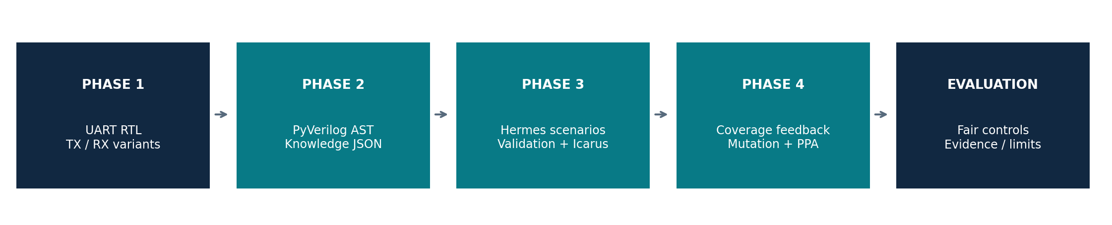
Figure 1. Phase-based architecture and evidence progression.

3.1 Phase 1 — UART RTL implementation
Four source snapshots cover baseline TX and RX plus optimized TX and RX variants. The UART configuration is 8N1. The design variants are evaluated at CLKS_PER_BIT of 8, 16, 32 and 64. Original file hashes are frozen and checked before subsequent experiments; new mutation experiments operate on copied RTL files only.

3.2 Phase 2 — AST-guided knowledge extraction
PyVerilog 1.3.0 parses four UART RTL modules. Extracted AST-based structural knowledge is written to uart_knowledge.json, with source fingerprints, and used to formulate ten coverage objectives. AST extraction is distinguishable from simulation: parsing success is evidence that the modules were processed, not behavioral correctness by itself.

3.3 Phase 3 — Hermes and deterministic simulation
The Hermes interface reads a generated prompt, requests constrained JSON scenarios and records the live model response. Python validators enforce a permitted schema and test actions before constructing a self-checking Verilog testbench. Icarus compilation and vvp execution are the behavioral authority; LLM output is never treated as proof of correctness. The evaluator stores per-CPB coverage, check counts and pass/fail results.

3.4 Phase 4 — Feedback, fault injection and PPA
The coverage-gap analyzer identifies absent UART bins, the feedback prompt requests a targeted scenario, and the generator reruns testbenches with the original and added cases. A separate mutation study checks detection of deliberately faulty RTL copies. The architecture experiment uses technology-mapped UART variants and estimated timing/power reports; this is independent of stimulus-generation performance.

4. Experimental Design and Reproducibility

4.1 Verification cohorts
Cohort | Number of suites | Scenario budget | Scope
Payload-only random | 10 seeded suites | 10 each | Weak payload/loopback random control
Protocol-aware random | 10 seeded suites | 10 each | Includes protocol-aware scenario types
Balanced directed | 1 curated suite | 10 | Strong expert-designed positive control
Fresh Hermes AI | 5 live model calls | 10 each | Five distinct validated sequences
Archived Hermes AI | 1 earlier model call | 10 | Historical reference experiment

4.2 Coverage definition
Coverage measures ten user-defined functional scenario bins, not full code/branch/toggle/transition coverage and not formal proof. A successful test must pass checking criteria before contributing to the relevant coverage bin. A minimum across CPB 8/16/32/64 is reported to avoid obscuring the weakest tested parameter setting.

4.3 Controlled fault model
Fourteen unique chosen UART mutation operators were injected into copies of the optimized TX/RX source. Each of 27 scenario suites was evaluated with a clean reference and each mutant across four CPB values: 108 clean controls plus 1,512 mutant simulations (1,620 total). Compile failures/invalid simulations are tracked separately rather than counted as detected faults. The original mutation study uncovered that the checker ignored a transient reset-cycle TX discrepancy; an independent probe proved this condition observable at all CPBs and a corrected checker was evaluated in a separate run.

4.4 Runtime and fair-comparison caveats
An equal number of initial scenarios does not imply equal simulator cycles or equal engineer/model effort. The initial ten-scenario AI suite consumed 18,144 total simulation cycles compared with 14,984 in the original directed/random baselines; AI model-generation time and provider charges must be disclosed separately. The feedback experiment uses 11 scenarios and one extra model request, so it is not silently included in the equal-budget ten-scenario comparison.

4.5 Evidence audit design
The phase-based acceptance audit checks 12 workflow gates; the separate Phase 4E script verifies important result JSON artifacts and the immutable UART fingerprints. The original historical 18-requirement audit is preserved. These are internal project acceptance audits; neither substitutes for peer review, independent replication, or a university certification.

5. Results

5.1 Coverage and repeatability
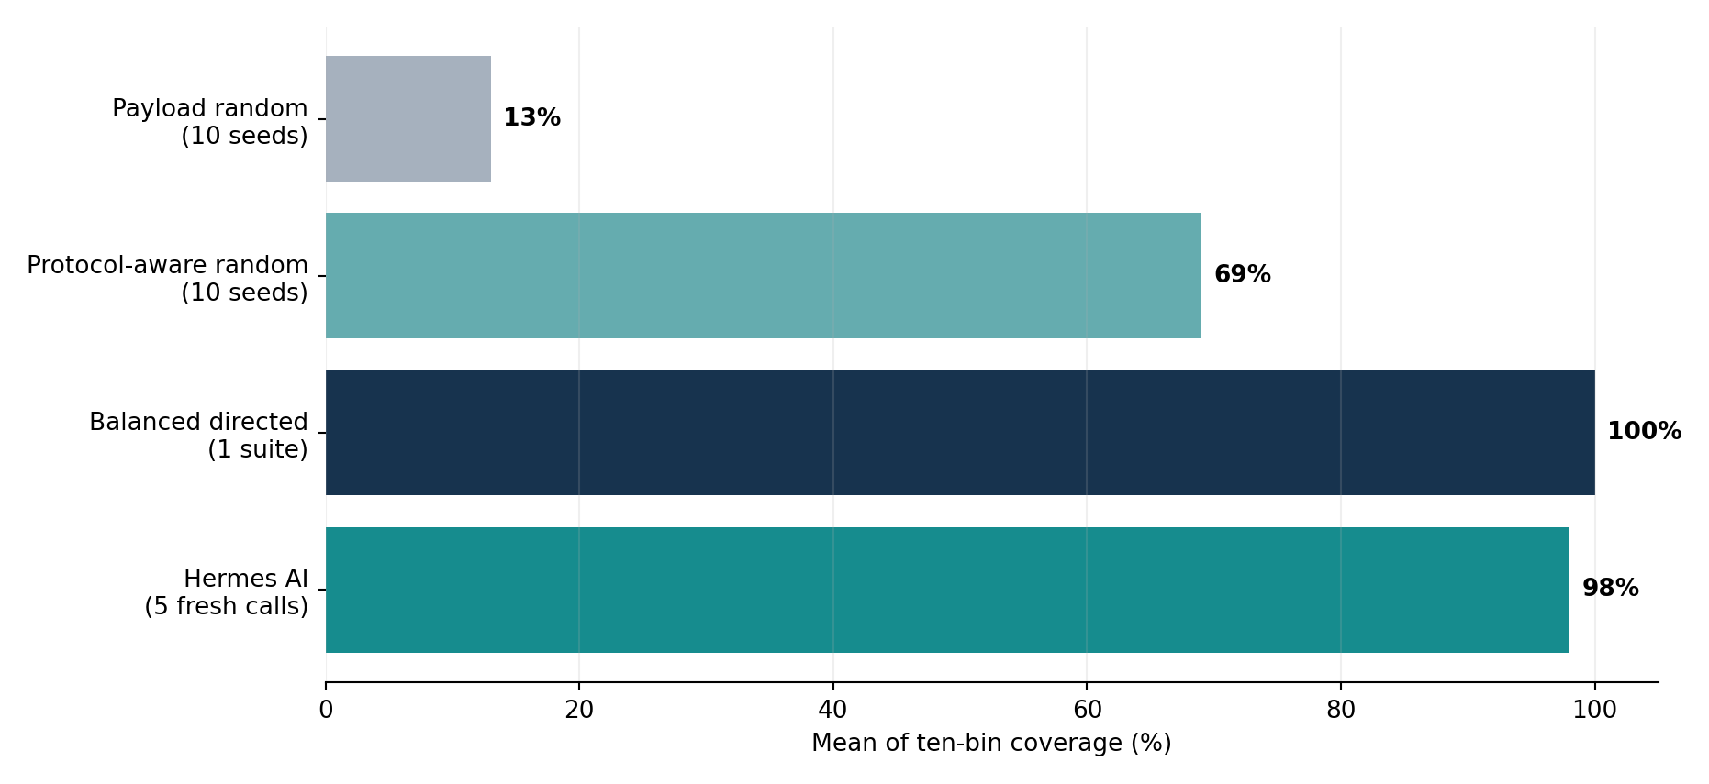
Figure 2. Mean defined-bin coverage; numbers of trials differ across methods.
Method | Trials | Mean coverage | Range / full coverage
Payload random | 10 | 13% | 10–30%; 0/10 full
Protocol-aware random | 10 | 69% | 50–80%; 0/10 full
Balanced directed | 1 | 100% | 1/1 full
Fresh Hermes | 5 | 98% | 90–100%; 4/5 full
Archived Hermes | 1 | 100% | 1/1 full

All five fresh Hermes trials generated valid scenario sets; each trial passed simulations at all four CPBs. They collectively yielded 182,040 simulator checks and zero failures. Trial 5 covered nine of ten functional bins, revealing edge_81 as an actual feedback target. Distinct generated sequences establish response variation but do not alone guarantee statistical independence from model sampling configuration.

5.2 Corrected mutation-score findings
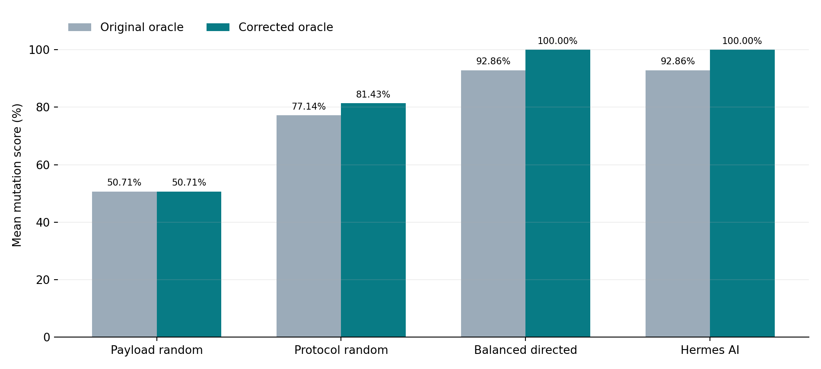
Figure 3. Selected 14-mutant scores before and after the corrected reset-cycle oracle.
The corrected-oracle study recorded 108 passing clean controls, 1,512 mutant simulations and zero invalid runs. The five fresh Hermes suites, one archived Hermes suite and balanced-directed suite detected all 14 chosen mutants at all four CPBs. Ten protocol-aware random suites averaged 81.43% mutation score; payload-only random suites averaged 50.71%. The improvement from 92.86% to 100% for Hermes and balanced-directed suites was due to correcting observability in the checking oracle; it was not due to changes in AI-generated scenarios.

5.3 Coverage-feedback experiment
Case | Scenario budget | Bin coverage | Interpretation
Trial 5 baseline | 10 | 90% | edge_81 not hit at any CPB
Hermes targeted feedback | 11 | 100% | One extra live model call, valid loopback 0x81 scenario
Matched directed feedback | 11 | 100% | Same closure with a manually selected case

The missing edge_81 bin required successful 0x81 loopback, not simply mentioning the byte in an unrelated scenario. The 11-scenario AI and directed replay suites passed 39,324 simulation checks each across the four CPBs. The evidence demonstrates successful automated translation of a known coverage gap into an executable case; it does not demonstrate a better outcome than explicit directed test design.

5.4 Architecture / PPA observation
UART configuration | Mapped area (µm²) | Estimated power (µW)
Baseline TX + baseline RX | 450.604 | 370.282
Optimized TX + optimized RX | 440.230 | 392.761
Baseline TX + optimized RX (hybrid) | 425.600 | 366.547

The hybrid arrangement produced approximately 5.55% lower mapped cell area and 1.01% lower estimated power than baseline, on the archived library/flow assumptions. Fully optimized TX/RX showed a power increase versus baseline. These figures are pre-layout estimates, not silicon measurements, and were produced by RTL architecture mapping rather than Hermes.

6. Discussion, Novelty and Limitations

6.1 What the experiments support
- A functioning UART case-study pipeline from AST knowledge to constrained Hermes scenarios and self-checking simulation.
- Consistent high defined-bin coverage across five fresh Hermes trials, with transparent repeatability limitations.
- Comparable 14-mutant fault sensitivity between Hermes-generated and balanced-directed tests after correction of the checking oracle.
- A fully executed one-call feedback example that closed an observed coverage gap and stated its incremental scenario/model budget.
- Separate mapped-UART architecture evidence with quantitatively bounded PPA claims.

6.2 What the experiments do not support
- The first ever LLM-guided RTL test generation or coverage-feedback loop; related methods exist in [R1]–[R4].
- Higher coverage or mutation score than carefully constructed balanced-directed testing; the strong directed suite matched both.
- Universal verification correctness, 100% code coverage, elimination of all UART bugs, or generalization to unseen RTL modules.
- Hardware/FPGA/silicon power benefits caused by LLM verification, or physical-design signoff.
- A formal statistically powered comparison of model providers or large hardware benchmark sets.

6.3 Key scientific threats
Single-DUT generalization, handcrafted ten-bin metrics, choice of 14 mutation operators, dependence on a differential reference oracle, provider/model revision variability, prompt-specified edge-case semantics, and nonequal simulation cycles all limit external validity. To strengthen publication claims, future evaluation should include independent UART implementations and other DUT families, stronger automatically generated SVA/protocol assertions, line/branch/transition coverage, calibrated model costs, failure-rate reporting, and consistent test-effort budgets.

7. Conclusions and Future Work
This project delivers a simulation-only, phase-integrated AI-assisted UART verification case study and supporting original evidence. Four modules were parsed using PyVerilog; real Hermes generations produced constrained, validated scenarios; Icarus simulation confirmed passing behavior at CPB 8/16/32/64; repeatability studies reached 98% mean defined-bin coverage; mutation testing revealed and helped correct a reset observability gap; and a targeted Hermes follow-up closed the one outstanding Trial 5 coverage bin. The strongest conclusion is the practicality and traceability of this automated pipeline, with fault sensitivity comparable to expert-directed testing under the reported evaluation settings.
Next steps are clean-checkout WSL reproduction, institute-specific thesis formatting, additional benchmark RTL evaluation if aiming for publication, documented tool/model versions and costs, compliance checks for technology libraries, and a final phase-based GitHub release package.

References
[R1] Qiu, R., Zhang, G. L., Drechsler, R., Schlichtmann, U., Li, B. (2024). AutoBench: Automatic Testbench Generation and Evaluation Using LLMs for HDL Design. ACM/IEEE MLCAD. https://doi.org/10.1145/3670474.3685956
[R2] Qiu, R., Zhang, G. L., Drechsler, R., Schlichtmann, U., Li, B. (2025). CorrectBench: Automatic Testbench Generation with Functional Self-Correction using LLMs for HDL Design. IEEE DATE. https://doi.org/10.23919/DATE64628.2025.10992873
[R3] Zhang, Z., Szekely, B., Gimenes, P., Chadwick, G., et al. (2025). LLM4DV: Using Large Language Models for Hardware Test Stimuli Generation. IEEE FCCM. https://doi.org/10.1109/FCCM62733.2025.00048
[R4] Wan, G.-W., Su, S., Zhang, J., Wong, S.-Z., Xing, M., et al. (2026). ChatTest: Coverage-Enhanced Testbench Generation for Agile Hardware Verification with LLMs. IEEE DATE. https://doi.org/10.23919/DATE69613.2026.11539733
[R5] Wang, Y., Zhou, J., Lyu, H., Chen, B., et al. (2026). AssertMiner-pro: Enhanced module-level spec generation and assertion mining with LLM guided by top-down hierarchical strategies. Integration (Elsevier), 110, 102797. https://doi.org/10.1016/j.vlsi.2026.102797
[R6] Dakhama, A., Even-Mendoza, K., Langdon, W. B., Menéndez, H. D., Petke, J. (2025). Enhancing search-based testing with LLMs for finding bugs in system simulators. Automated Software Engineering, 32, 63. https://doi.org/10.1007/s10515-025-00531-7
[R7] Jha, C. K., Hassan, M., Qayyum, K., et al. (2025). Large Language Models (LLMs) for Verification, Testing, and Design. IEEE European Test Symposium. https://doi.org/10.1109/ETS63895.2025.11049311

Appendix A — Phase-Based WSL Evidence Map
Evidence item | Path relative to phase_workflow/
Workflow 12/12 | evaluation/workflow_status.json
Initial AI and controls | phase_03_ai_verification/results/evaluation_summary.json
Random ten-seed study | evaluation/repeatability/phase4c_*/phase4c_summary.json
Five Hermes generations | evaluation/repeatability/hermes_trials/phase4c2_*/phase4c2_summary.json
Corrected 14-mutant study | evaluation/fault_injection/phase4d5_reset_checker_*/corrected_checker_summary.json
Feedback closure | evaluation/feedback_closure/phase4d7_*/PHASE4D7_RESEARCH_REPORT.md
Phase 4E evidence audit | phase_04_uart_novelty/research/PHASE4E_EVIDENCE_AUDIT.json
Historical UART PPA | phase_04_uart_novelty/UART_ARCHITECTURE_RESULTS.md

Appendix B — Reviewer Demonstration Checklist
- Present project title and simulation-only problem statement.
- Explain the AST → JSON → Hermes → validated scenarios → Icarus → coverage loop.
- Show baseline control coverage, stronger directed comparator and five fresh model trials.
- Explain the reset mutant observation gap and corrected checker without conflating with a new AI model.
- Show real feedback example edge_81: 90% at 10 scenarios → 100% at 11.
- Show mapped UART hybrid result separately from AI-driven test generation.
- State limitations and prior-art overlap before the novelty claim.
- Show phase-based evidence filenames and final workflow audit.

