Predicting Music Sybmol with Neural Network

Abstract—The Music symbols dataset contains 2128 clefs and 1970 accidentals. They were extracted from the modern and old music scores from the 19th century. The main goal of this assignment is to create a neural network that trains on the training data created from this dataset and then test the evaluation on the testing data. The goal is to predict whether a symbol is accidental or clef. For the second part, taking DoubleSharp as the class variable, the tests were conducted to classify them.

Introduction
All the music symbols are initially a BMP file where the task is to convert each BMP file into an array of pixels. They are first resized and converted into greyscale images which makes it easier to process. They are then converted into the array where the converted array of pixels is later passed on to the neural network for the training dataset and once the model gets trained, it is tested on the testing dataset. The dataset is taken and aggregated with accidental and clefs type of files altogether in a single directory. It is then divided into testing and training datasets with a 70-30 split using the package split_folders in python. For the second problem, the dataset is divided into accidental double sharp and not accidental double sharp. The aggregated dataset is divided into training and testing dataset with a 70-30 split using the same split_folders package. Later, the Keras package in Python is used where Sequential Keras model is used as a neural network to train our model and predict the results. The Stochastic gradient descent is used as an optimizer. Tuning different parameters like activation function, epochs, etc. gives different prediction accuracies. To best fit the model, grid search was used to find the best fitting parameters of the model.

DESCRIPTION OF data gOES HERE
The dataset is initially aggregated with accidental and clefs and divided into training and testing data with a 70-30 split using the split_folders packagde. This dataset is used to conduct the experiments of the problem 1. Also, the dataset is divided into accidental double sharp and not accidental double sharp. It is divided into training and testing data with 70-30 split using the split_folders package. For the first problem, the training data contains 3428 images while the testing data contains 666 images. For the second problem, the training data contains 3714 images and the testing data contains 400 images.

experiments
The Sequential Keras model is used as the neural network to train the model and predict the results. The Stochastic Gradient Descent is used as an optimizer. The parameters used for the experiment is: learning rate = 0.01, decay = 1e-5, momentum = 0.7. The model was iterated with 100 epochs which gave close to 85% accuracy. The implementation of this neural network was created in Jupyter Notebook that comes along with the Anaconda environment. The model is used from the Keras package that comes with Python dependencies. The second problem was experimented using the same parameters as the model tends to fit the best with these parameters. In the experiments, different parameter settings were tested where the learning rate was changed to 0.05, decay = 1e-5, momentum = 0.6 and the number of epochs 150. Another set of experiments included the following parameter settings as learning rate = 0.1, decay = 1e-5, momentum = 0.5 and number of epochs = 200. After trying different parameter settings, the optimal setting which better fits the model giving best accuracy of 85% found to be with learning rate = 0.01, decay = 1e-5, momentum = 0.7 and epochs = 100. With the same parameter settings, the experiment was conducted on the problem 2 which gave the accuracy of 91.5%.

results
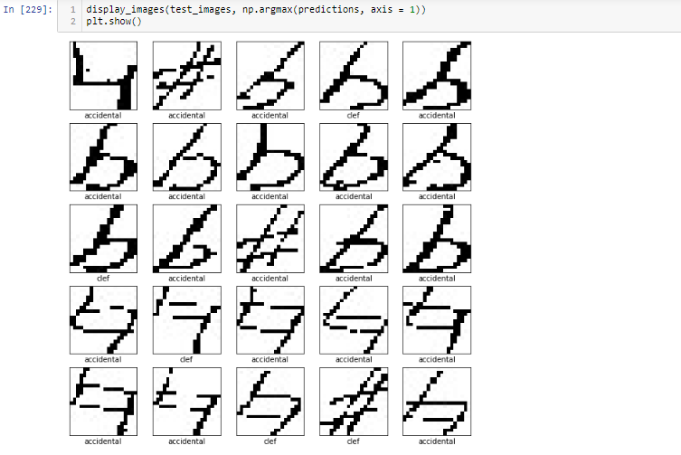
Fig. 1 Results of the Problem 1
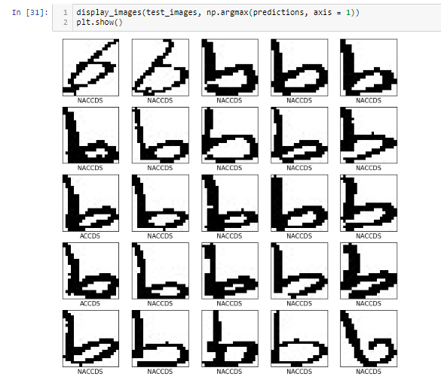
Fig. 2 Results of the Problem 2

For the Problem 1, it is seen that it accurately identifies the image as accidental quite reasonably but for the Problem 2, as the training set increased with increased different types of accidental and clef images, it was easier to accurately identify the accidental double sharp image from the non-accidental double sharp images.

Conclusion

From the above experiments, it can be concluded that when the training set increases with increased subgroup image types of accidental and clef images, the accuracy increased from 85% to 91.5%. This happened because for the Problem 1, the model was classifying the images based on accidental or clef while as for Problem 2, it had already classified the accidental images and it was further classifying whether if the image is double sharp or not. This increases the learning methods and decreases the anomalies found in the dataset due to increased training dataset.

references

- Dozat, T. (2016). Incorporating nesterov momentum into adam.
- Sutskever, I., Martens, J., Dahl, G., & Hinton, G. (2013, February). On the importance of initialization and momentum in deep learning. In International conference on machine learning (pp. 1139-1147).
- https://www.pyimagesearch.com/2014/01/20/basic-image-manipulations-in-python-and-opencv-resizing-scaling-rotating-and-cropping/
- https://pypi.org/project/split-folders/

