**Assignment-1**

(Microsoft Word Assignment)

**Office Automation Tools - (2302DU004)**

Department of Computer Engineering

4th Semester

(Darshan Institute of Engineering & Technology

for Diploma studies)

**SUBMITTED BY**

|  |  |
| --- | --- |
| **Student Name** | **Roll Number** |
| Mahammadnazil | 154 |



Contents

1. Introduction to Data Science 1

2. The Data Science Process 2

2.1 Problem Definition 2

2.2 Data Collection 2

2.3 Data Cleaning 2

3. Exploratory Data Analysis (EDA) 3

3.1 Modeling 3

3.2 Deployment 3

4. Tools and Technologies Used in Data Science 3

5. Data Visualization Techniques 5

6. Machine Learning and Its Applications 7

7. Future Trends in Data Science 8

8. Data analysts and data scientists: What do they do? 9

Figure 1 Data Science 2

Figure 2 How Data Science Works 5

Figure 3 Growth Ratio in IT 9

Figure 4 Difference between Data Analysts and Data Scientists 10

**Exploring Data Science**

## **Introduction to Data Science**

* Data science is an interdisciplinary field that focuses on extracting knowledge and insights from structured and unstructured data. It combines principles from various domains, including statistics, computer science, mathematics, and domain-specific expertise, to analyze and interpret complex data sets. In today's data-driven world, where vast amounts of data are generated every second, the role of data science has become increasingly vital.
* The importance of data science lies in its ability to turn raw data into actionable insights that can drive decision-making across different sectors. Organizations leverage data science to understand customer behavior, optimize operations, enhance product offerings, and predict future trends. For instance, businesses utilize predictive analytics to forecast sales, while healthcare providers analyze patient data to improve treatment outcomes.
* Data science employs a range of techniques, including data mining, machine learning, and statistical analysis. Data scientists utilize programming languages like Python and R to manipulate data and build models that reveal patterns and correlations. Furthermore, the integration of domain knowledge allows data scientists to contextualize their findings, making the insights more relevant and valuable.
* In addition to traditional analytical skills, data science emphasizes the importance of visualization and storytelling.

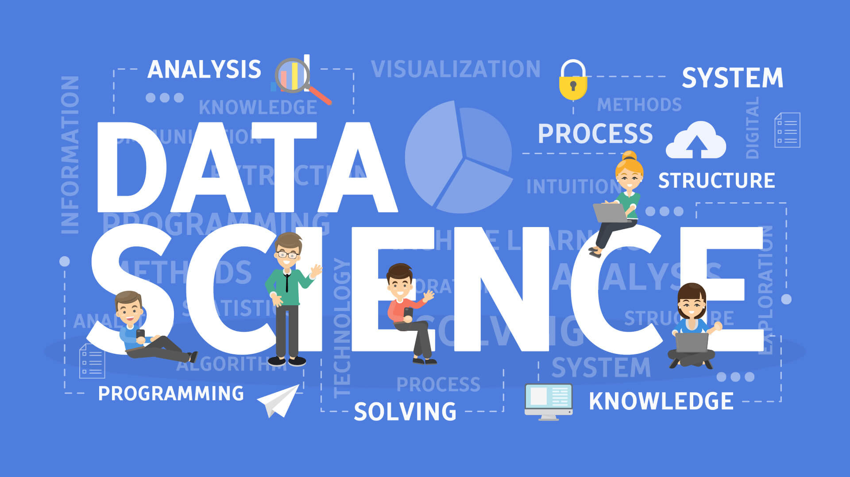

Figure 1 Data Science

## **The Data Science Process**

### The data science process is a structured workflow that guides data scientists through the various stages of a project, ensuring that analyses are thorough and insights are actionable. This process typically encompasses several key stages: problem definition, data collection, data cleaning, exploratory data analysis (EDA), modeling, and deployment.

### **2.1 Problem Definition**

* The first step in any data science project is to clearly define the problem at hand. This involves understanding the business objectives and determining how data can provide solutions. For example, a retail company may want to reduce customer churn. The data scientist will work with stakeholders to specify the metrics of churn and what success looks like.

### **2.2 Data Collection**

* Once the problem is defined, the next stage is data collection. This involves gathering relevant data from various sources, which may include internal databases, APIs, or public datasets. For instance, a company looking to understand customer behavior might collect data from transaction logs, customer surveys, and social media interactions.

### **2.3 Data Cleaning**

* Data cleaning is crucial to ensure the quality and reliability of the data. This stage involves identifying and correcting errors, handling missing values, and removing duplicates. An example would be a dataset where customer ages are recorded as text rather than numbers; the data scientist will need to convert these into a uniform numerical format.

### **Exploratory Data Analysis (EDA)**

* EDA is a critical phase where data scientists analyze the data to uncover patterns, anomalies, and insights. By using visualization tools like histograms or scatter plots, they can gain an understanding of the data's distribution and relationships. For example, EDA might reveal that certain demographics are more likely to churn, guiding further analysis.

### **3.1 Modeling**

* In the modeling stage, data scientists apply statistical and machine learning algorithms to build predictive models. For example, a logistic regression model could be used to predict the likelihood of customer churn based on various features such as age, purchase history, and engagement levels.

### **3.2 Deployment**

* The final stage is deployment, where the model is put into production to make real-time predictions. This may involve integrating the model into the company's current systems and monitoring its performance. For instance, the retail company may use the churn prediction model to target at-risk customers with personalized marketing campaigns.
* Through this systematic approach, the data science process enables professionals to tackle complex problems effectively and derive valuable insights that drive strategic decisions.

## **Tools and Technologies Used in Data Science**

* Data science relies heavily on a variety of programming languages and tools that facilitate data manipulation, analysis, and visualization. Among these, Python and R have emerged as the most popular programming languages in the field. Their widespread use can be attributed to their versatility, ease of learning, and strong community support.
* Python is often the go-to language for data scientists due to its simplicity and readability. It boasts an extensive ecosystem of libraries such as Pandas for data manipulation, NumPy for numerical computations, and Scikit-learn for machine learning. These libraries provide powerful tools that enable users to perform complex analyses with minimal code. For example, Pandas allows for efficient handling of data structures like Data Frames, making it easier to clean and analyze data.
* R, on the other hand, is particularly favored in academic and research settings because of its statistical capabilities and rich visualization libraries like ggplot2. It is designed specifically for statistical analysis, making it an excellent choice for data scientists dealing with intricate statistical models.
* SQL (Structured Query Language) is another critical tool in data science. It is used for managing and querying relational databases. Data scientists often need to extract data from databases for analysis, and SQL provides a powerful way to perform these tasks efficiently. Its ability to handle large datasets and perform complex queries makes it indispensable in the data science toolkit.

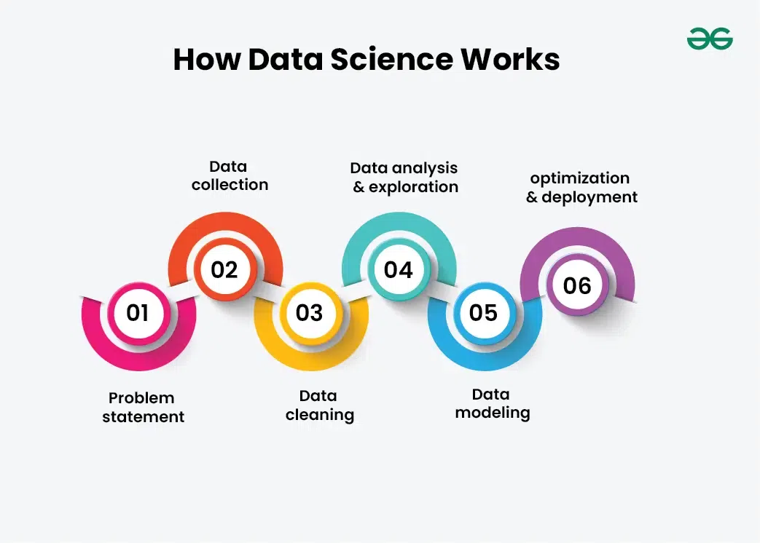

Figure 2 How Data Science Works

## **Data Visualization Techniques**

* Data visualization is a crucial aspect of data science, as it transforms complex datasets into visual representations that are easier to understand and interpret. The significance of data visualization lies in its ability to communicate findings clearly and effectively, allowing stakeholders to grasp insights quickly and make informed decisions. In a world where data is abundant, being able to present data visually can differentiate between actionable insights and overwhelming numbers.

Various visualization techniques serve specific purposes, depending on the nature of the data and the insights to be conveyed. Common techniques include bar charts, line graphs, scatter plots, heatmaps, and pie charts. Bar charts are ideal for comparing categorical data, while line graphs effectively show trends over time. Scatter plots can illustrate relationships between two variables, and heatmaps provide a visual summary of data through variations in color. Choosing the right visualization technique is essential for accurately conveying the intended message.

* Numerous tools are available to facilitate data visualization. Matplotlib and Seaborn are two popular Python libraries that allow data scientists to create a wide range of static, animated, and interactive plots. Matplotlib provides flexibility and control over the visual elements, while Seaborn simplifies the process of creating aesthetically pleasing statistical graphics. Tableau, on the other hand, is a powerful business intelligence tool that enables users to create interactive dashboards and share insights across organizations. Its user-friendly interface allows non-technical users to manipulate data visually without extensive programming knowledge.
* When selecting the appropriate visualization for different types of data, consider the audience and the story you want to tell. It is important to keep visualizations clear and uncluttered, avoiding excessive detail that may confuse the viewer. Color choices and labeling play a vital role in enhancing readability and comprehension. Ultimately, effective data visualization not only aids in the analysis but also fosters a culture of data-driven decision-making within organizations.

## **Machine Learning and Its Applications**

* Machine learning (ML) is a prominent subset of data science that focuses on the development of algorithms that enable computers to learn from and make predictions based on data. Unlike traditional programming, where specific instructions are coded, machine learning models improve their performance as they are exposed to more data. This iterative learning process allows machines to identify patterns and make decisions with minimal human intervention.
* There are three primary types of machine learning: supervised learning, unsupervised learning, and reinforcement learning.
* In supervised learning, algorithms are trained on labeled datasets, which means that the input data is paired with the correct output. This approach is widely used in applications such as recommendation systems. For example, platforms like Netflix and Amazon utilize supervised learning to analyze user preferences and suggest movies or products based on past behavior.
* Unsupervised learning, on the other hand, deals with unlabelled data. The algorithms attempt to identify inherent structures within the data. A common application of unsupervised learning is in clustering, where businesses segment customers into distinct groups based on purchasing behavior. This segmentation aids in targeted marketing and personalized customer experiences.
* Reinforcement learning is a different paradigm where an agent learns to make decisions by taking actions in an environment to maximize cumulative reward. This approach has gained traction in areas such as robotics and game playing. A notable example is AlphaGo, the AI developed by DeepMind, which learned to play the complex board game Go at a superhuman level through reinforcement learning techniques.
* Machine learning's real-world applications extend beyond these examples. In finance, it is utilized for fraud detection, where algorithms analyze transaction patterns to flag suspicious activities. In healthcare, predictive analytics driven by machine learning can forecast patient outcomes and optimize treatment plans. As machine learning continues to evolve, its potential to drive innovation across various industries is vast, making it an essential component of modern data science.

## **Future Trends in Data Science**

* As we look toward the future of data science, several key trends are poised to shape the landscape and revolutionize industries. Among these, advancements in artificial intelligence (AI), the rise of automated machine learning (AutoML), and the continued significance of big data stand out as pivotal factors influencing decision-making processes across various sectors.
* Artificial intelligence is rapidly evolving, with developments in deep learning and natural language processing (NLP) leading the charge. These advancements enable machines to understand and process human language more effectively, opening doors for applications such as sentiment analysis, chatbots, and personalized recommendations. AI's ability to analyze vast data sets quickly and accurately will empower organizations to make data-driven decisions at unprecedented speeds, enhancing operational efficiency and customer satisfaction.
* Automated machine learning (AutoML) is another trend that is democratizing access to machine learning for non-experts. By automating the model selection, tuning, and evaluation processes, AutoML tools enable users to apply machine learning without extensive programming knowledge. This shift could lead to a surge in data-driven initiatives across industries, as businesses can leverage AutoML to harness insights from their data more readily. As a result, organizations will be able to innovate faster, iterate on models quickly, and deploy solutions that respond to market demands in real time.
* Big data continues to play a crucial role in shaping data science practices. The exponential growth of data from various sources, including IoT devices, social media, and enterprise systems, presents both challenges and opportunities. Organizations that effectively harness big data will be equipped to derive actionable insights and maintain a competitive edge. Moreover, the integration of real-time data analytics will allow for more dynamic decision-making processes, enabling businesses to adapt swiftly to changing conditions in their respective markets.
* In summary, the future of data science will be characterized by increased capabilities in AI, the accessibility of machine learning through AutoML, and the strategic exploitation of big data. These trends will not only transform industries but also redefine how organizations approach decision-making, ultimately driving innovation and growth in the data-driven era.

Figure 3 Growth Ratio in IT

## **8. Data analysts and data scientists: What do they do?**

* One of the biggest differences between data analysts and scientists is what they do with data.
* Data analysts typically work with structured data to solve tangible business problems using tools like SQL, R or Python programming languages, data visualisation software, and statistical analysis. Common tasks for a data analyst might include:
* Collaborating with organisational leaders to identify informational needs
* Acquiring data from primary and secondary sources
* Cleaning and reorganising data for analysis
* Analysing data sets to spot trends and patterns that can be translated into actionable insights
* Presenting findings in an easy-to-understand way to inform data-driven decisions

|  |  |
| --- | --- |
| Data Analysts | Data Scientists |
| A data Analysts role is related to data cleaning, transforming and generating inferences from data. | A data Scientists deals with various data operation. |
| Involment is limited to small data and static inferences. | Involved with several underlying procedure. |
| Deals with structured data only. | Handles structured and unstructured data. |
| Has problem solving skill, knowledge of basic statistics. | Possesses knowledge of mathematics, statistics & machine learning algorithm. |
| Knows Excels, SQL,R(in some cases),Tableau. | Proficient in SAS,Python,R,Tensorflow,Hadoop,Spark. |

Figure 4 Difference between Data Analysts and Data Scientists