**Machine learning**

1. ***How does machine learning work?***

* A Decision Process: In general, machine learning algorithms are used to make a prediction or classification. Based on some input data, which can be labeled or unlabeled, your algorithm will produce an estimate about a pattern in the data.
* An Error Function: An error function evaluates the prediction of the model. If there are known examples, an error function can make a comparison to assess the accuracy of the model.
* A Model Optimization Process: If the model can fit better to the data points in the training set, then weights are adjusted to reduce the discrepancy between the known example and the model estimate. The algorithm will repeat this iterative “evaluate and optimize” process, updating weights autonomously until a threshold of accuracy has been met.

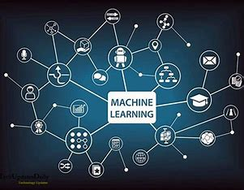

* ***Machine learning versus deep learning versus neural networks ?***
* Since deep learning and machine learning tend to be used interchangeably, it’s worth noting the nuances between the two. Machine learning, deep learning, and neural networks are all sub-fields of artificial intelligence. However, neural networks is actually a sub-field of machine learning, and deep learning is a sub-field of neural networks.

1. ***Machine learning methods***
   1. ***Supervised machine learning***

Supervised learning, also known as supervised machine learning, is defined by its use of labeled datasets to train algorithms to classify data or predict outcomes accurately. As input data is fed into the model, the model adjusts its weights until it has been fitted appropriately.

* 1. ***Unsupervised machine learning***
  + Unsupervised learning, also known as unsupervised machine learning, uses machine learning algorithms to analyze and cluster unlabeled datasets (subsets called clusters). These algorithms discover hidden patterns or data groupings without the need for human intervention.
  1. ***Semi-supervised learning***
* Semi-supervised learning offers a happy medium between supervised and unsupervised learning. During training, it uses a smaller labeled data set to guide classification and feature extraction from a larger, unlabeled data set.

1. ***Reinforcement machine learning***

* Reinforcement machine learning is a machine learning model that is similar to supervised learning, but the algorithm isn’t trained using sample data. This model learns as it goes by using trial and error.
* The IBM Watson® system that won the Jeopardy! challenge in 2011 is a good example. The system used reinforcement learning to learn when to attempt an answer (or question, as it were), which square to select on the board, and how much to wager—especially on daily doubles.
* 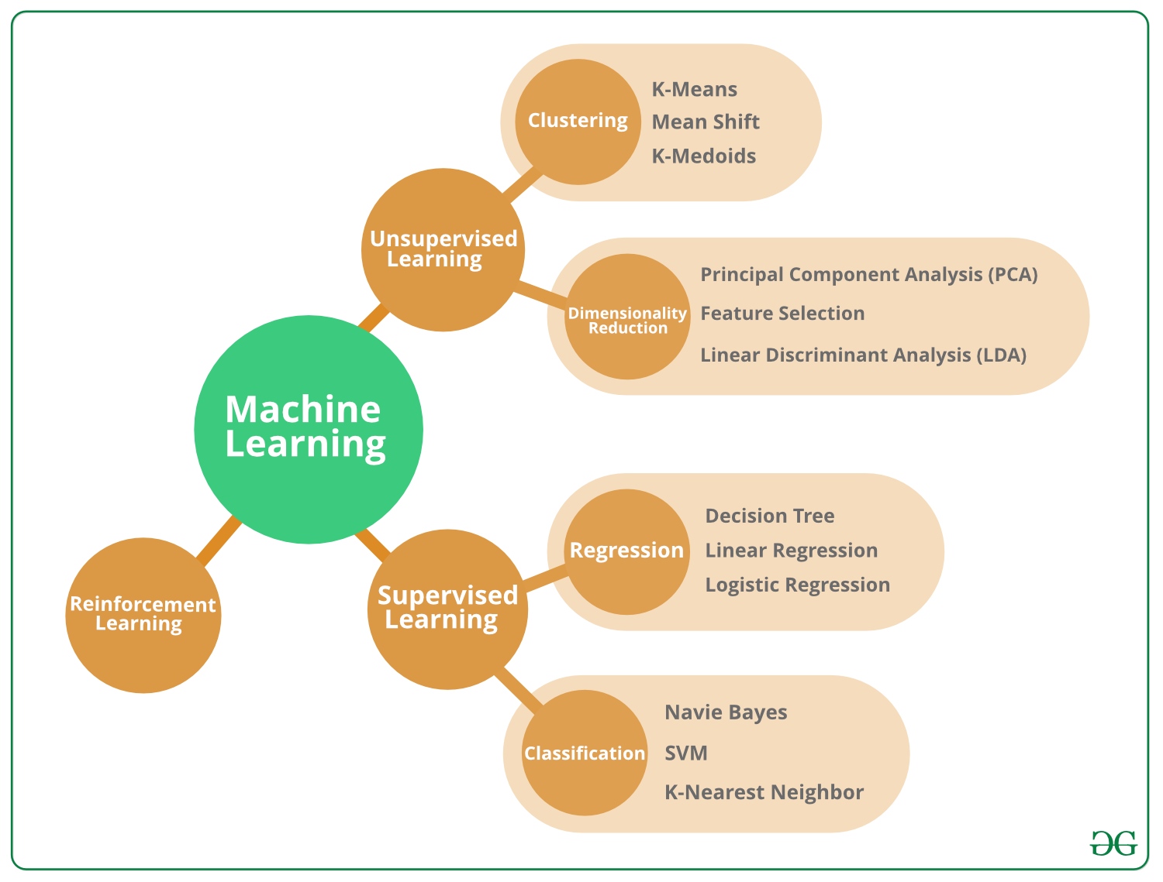

1. ***Common machine learning algorithms***

* A number of machine learning algorithms are commonly used. These include:
* Neural networks
* Linear regression
* Logistic regression
* Clustering
* Decision trees
* Random forests