**Practical-1:** Introduction of Figma and basic tools.

**Definition:** Create the design using the Figma Design Tools, Position, Size, Rotation, & Corner Radius properties.

**Solution:**

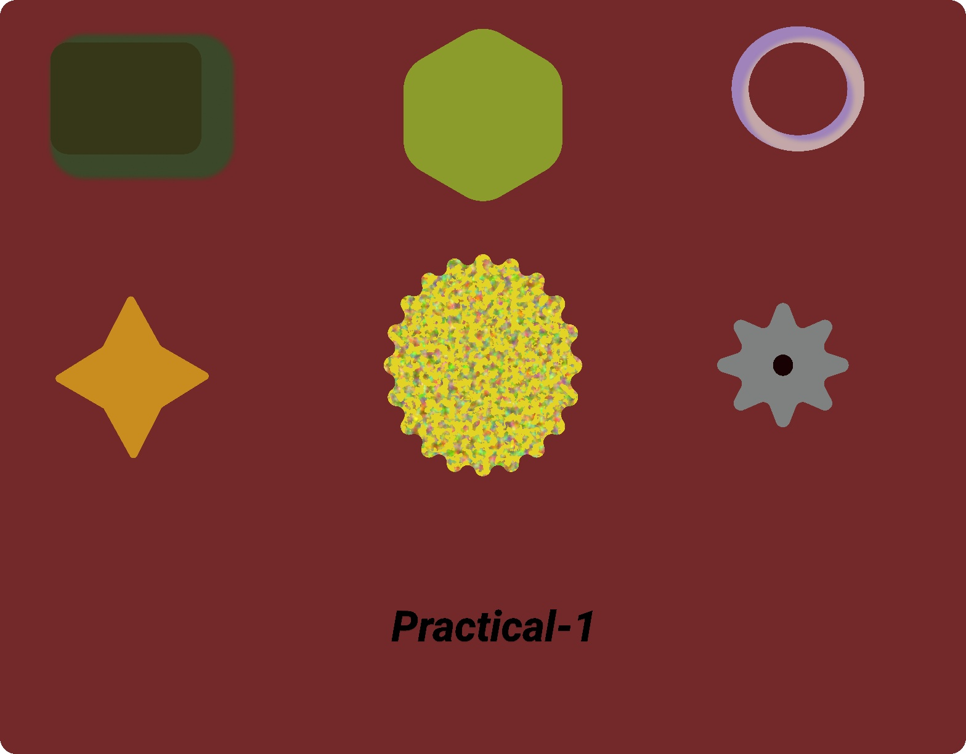

**Working:**

* First, open Figma. Add a new Figma design file.
* Rename a file as 210_Practical-1_shape.
* In this design, the following tools are used for a particular operation:

|  |  |  |
| --- | --- | --- |
| **Tools Name** | **Use** | **Properties** |
| Android Medium-1 | The Android Medium-1 is used as a container for this design | Width: 5949.76px  Height: 4650.31px  Color fill: #3E472B,100%  Corner radius: 100PX  Effects: Layer blur 4  Layout guide: Grid 10px  Blend mode: pass through |
| Rectangle | Use a rectangle for the search box design. Rename the layer as “Search box Rectangle”. Use opacity to make it hazy. Use layer blur for effect to blur a particular rectangle. | Width: 930px  Height: 690px  Corner radius: 111px  Color fill: #13400E  Opacity: 100%  Drop Shadow: Spread 100, Blur 30, Color 175D2A 60% |
| Polygon | Polygon is used to design the Frame. | Width:1130px  Heighth: 1130px  Opacity: 100%  Corner Radius: 217  Count: 6  Color: #8B9C2C 100% |
| Ellipse | Ellipse is used to draw a Tire like structure. | Width: 580.48px  Heigth: 612.7px  Opacity:100%  Corner Radius: 50  Color: #C3A9A9 100%  Effects: Inner Shadow: Blur-30, Color-3412F3, Spread-20 |
| Star | It’s like Twinkling Cartoon Star. | Width: 990px  Heigth: 1055px  Opacity: 100%  Corner Radius: 25  Count: 4  Ratio: 51%  Color: #C88D1F 100% |
| Star | This looks like a animated Jelly-Fish. | Width: 1403px  Heigth: 1591px  Opacity: 100%  Corner Radius: 78  Count: 20  Ratio: 71%  Color: #E3D324  Effects: Noise- Size 43.2, Opacity 50% |
| Star & Ellipse | They both made a Symbol of our mobile’s Setting. | Star =>  Width: 1011px  Heigth: 924px  Opacity: 100%  Corner Radius: 45  Count: 8  Ratio: 50%  Color: #7E817F 100%  Ellipse=>  Width: 144px  Heigth: 157px  Opacity: 100%  Corner Radius: 0  Color: #433C3C |
| Text | There is a Text-Box in this Frame.And in that Text-Box “Practical-1” is written. | Width: 1662px  Heigth: 90px  Opacity: 100%  Corner Radius: 0  Line Height: 64  Letter Spacing: -0.25  Color: #000000 100% |

* Export your design as a JPEG file.