**Practical-2:** Figma design tools and applying properties

**Definition:** Develop 1 screen using the tools listed below: Blending Modes, Alignment, & Distribution, Shadow, Blur Effects, Fill, & Stroke, Text Properties & Styles.

**Solution:**

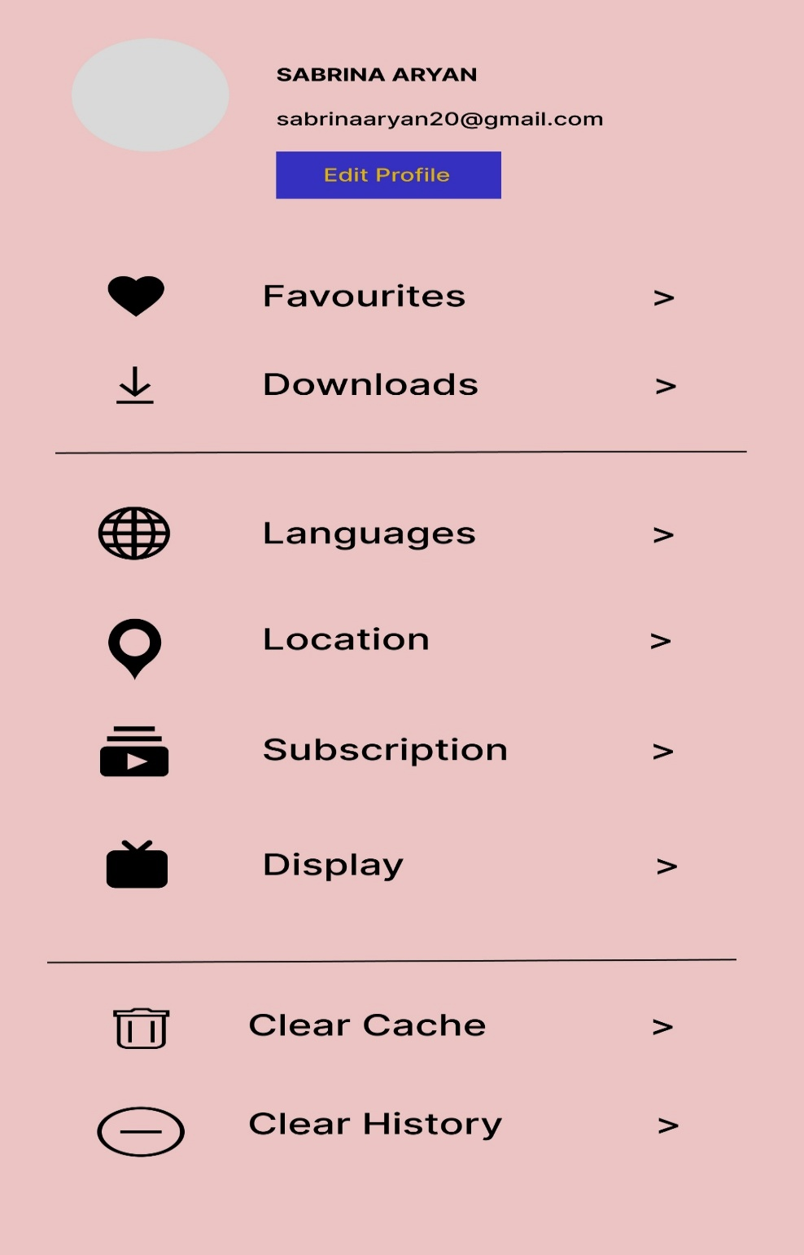

**Working:**

* In this design, the following tools are used for a particular operation:

|  |  |  |
| --- | --- | --- |
| **Tools Name** | **Use** | **Properties** |
| Iphone 16 | The Iphone 16 is used as a container for this design | Width: 393px  Height: 852px  Color fill: # EBC4C4,100%  Corner radius: 0PX |
| Text-Boxes | Use to write name, email, etc. | Width1: 172px  Height1: 65px  Width2: 245px  Height2: 26px  Width3: 63px  Height3: 15px  Corner radius: 0px  Color fill: # 000000  Opacity: 100% |
| Rectangle | Rectangle is used to design the Frame. | Width:110px  Heighth: 32px  Opacity: 100%  Corner Radius: 0  Color: # 3530BF 100% |
| Icons | Used icons to show symbols. | Width:33px  Heighth: 36px  Opacity: 100%  Corner Radius: 0 |
| Line | Use line to part. | Width:337.01px  Heighth: 0px  Opacity: 100%  Corner Radius: 0  Color: #FFFFFF  Weight: 1  Position: center |

* Export your design as a JPEG file.