**Practical-3:** Color styling effects and blending modes with Dark and Light Theme

**Definition:** Create a background for the Registration Form and Login Form using Blending Modes, color style, and color gradients for light and dark mode backgrounds.

**Solution:**

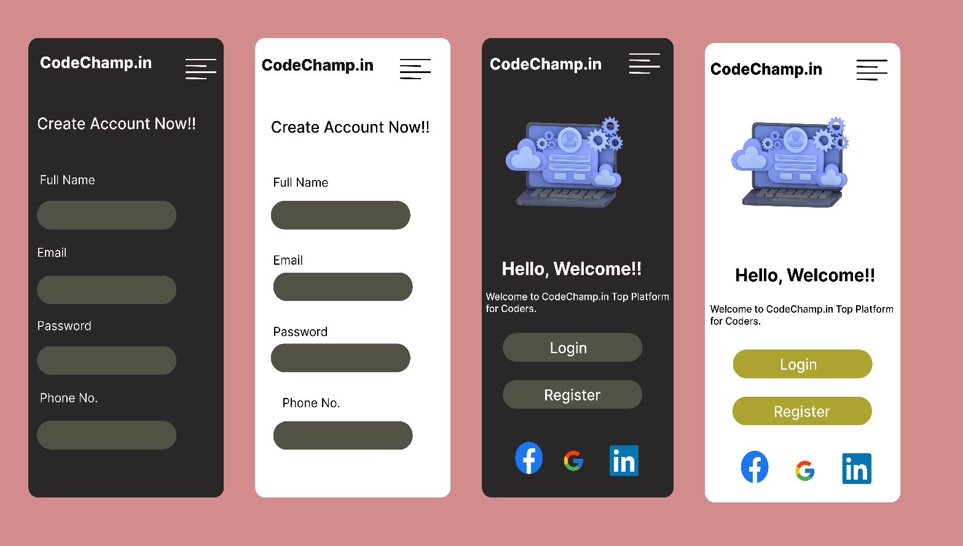

**Working:**

* First, open Figma. Add a new Figma design file.
* Rename a file as RollNumber_Practical-3_ShortFileName.
* In this design, the following tools are used for a particular operation:

|  |  |  |
| --- | --- | --- |
| **Tools Name** | **Use** | **Properties** |
| **Macbook Air 1** | The frame is used as a container for this design. | Width: 2030px  Height: 1079px  Color fill: # D28C8C,100%  Corner radius: 0px  Blend mode: pass through |
| **Android Compact-1** | This is the Screen one for the create account in Dark theme. | Width: 412px  Height: 917px  Color fill: # 292727  Corner radius: 20px |
| **Android Compact-2** | This is the Screen two for the create account in Light theme. | Width: 412px  Height: 917px  Color fill: # FFFFFF  Corner radius: 20px |
| **Android Compact-3** | This is the Screen three for the Login & Register in Dark theme. | Width: 412px  Height: 917px  Color fill: # 292727  Corner radius: 20px |
| **Android Compact-4** | This is the Screen three for the Login & Register in Light theme. | Width: 412px  Height: 917px  Color fill: #FFFFFF  Corner radius: 20px |
| **In Android Compact-1&2: -** | **Create Account** |  |
| **Text-Boxes** | It’s used to write User Full Name, Email, Password & Phone No. | Width: 294px  Height: 57px  Color fill: # 525146  Corner radius: 50px  Opacity: 100% |
| **In Android Compact-3&4: -** | **Login & Register** |  |
| **Text-Boxes** | It’s used for Login & Register for User. | Width: 294px  Height: 57px  Color fill: # 525146  Corner radius: 50px  Opacity: 100% |
| **Icons** | For Continue as Google, Facebook & LinkedIn . | Width: 58px  Height: 64px  Color fill: #1877F2, #FFFFFF  Corner radius: 0px  Opacity: 100% |

* Export your design as a JPEG file.