**Practical-4:** Boolean operations and Image Masking properties.

**Definition:** Create the pattern design using Boolean operations in Figma and use images and masking in Figma.

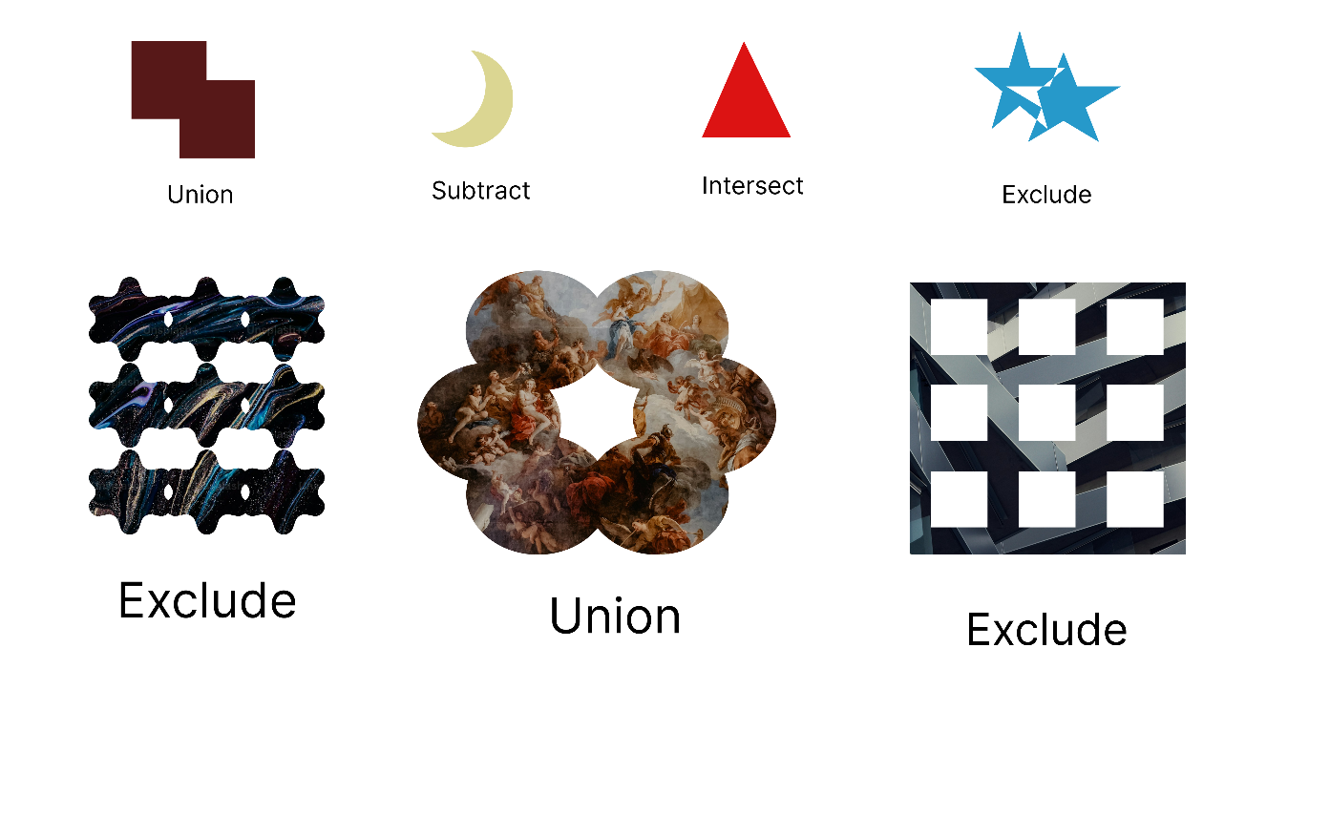**Solution:**

**Working:**

* In this design, the following tools are used for a particular operation:

|  |  |  |
| --- | --- | --- |
| **Tools Name** | **Use** | **Properties** |
| Macbook Air-1 | The Macbook Air-1  is used as a container for this design. | Width: 1357px  Height: 853px  Color fill: # FFFFFF,100%  Corner radius: 0PX |
| Text Boxes | Used to write Boolean Operations Name. | Width: 105px  Heighth: 29px  Opacity: 100%  Typography:  Inter, Regular, 26 |
| Union | It is made up of 2 squares. | Width: 125.83px  Heigth: 119.33px  Spacing: -28  Opacity:100%  Corner Radius: 0  Color: # 571818, 100% |
| Substract | Two circles made a substract. | Width: 83.71px  Heigth: 99.09px  Opacity: 100%  Corner Radius: 0  Color: #6EAA75 100% |
| Intersect | Two triangles made an intersect. | Width: 69.72px  Heigth: 60.45px  Opacity: 100%  Corner Radius: 0  Count: 3  Color: # DBD692, 100% |
| Exclude | Two stars make an Exclude. | Width: 149.9px  Heigth: 114px  Opacity: 100%  Corner Radius: 0  Count: 5  Ratio: 38.2%  Color: #26CA72 100% |
| Group-1 | Made an Exclude. | Width: 312px  Heigth: 304px  Opacity: 100%  Corner Radius: 10  Count: 6  Ratio: 38.2%  Color: #D9D9D9 100% |
| Group-2 | Makes an Union. | Width: 460px  Heigth: 384px  Opacity: 100%  Corner Radius: 0  Color: #000000 100% |
| Group-3 | Made a Exclude. | Width: 280px  Heigth: 234px  Opacity: 100%  Corner Radius: 0  Count: 5  Color: # 005D3B 100% |
| Masking an Image | Includes an image and a union. | Width: 460px  Heigth: 384px  Opacity: 100%  Corner Radius: 0  Fill: Image 100% |

* Export your design as a JPEG file.