**Practical-5:** Shadow and Blur effect with text tool and alignment properties.

**Definition:** Create a blog card design and pricing card design using Alignment, & Distribution, Google & Custom Fonts, Corner Radius, Shadow, Blur Effects, Fill, & Stroke, Text Properties & Styles.

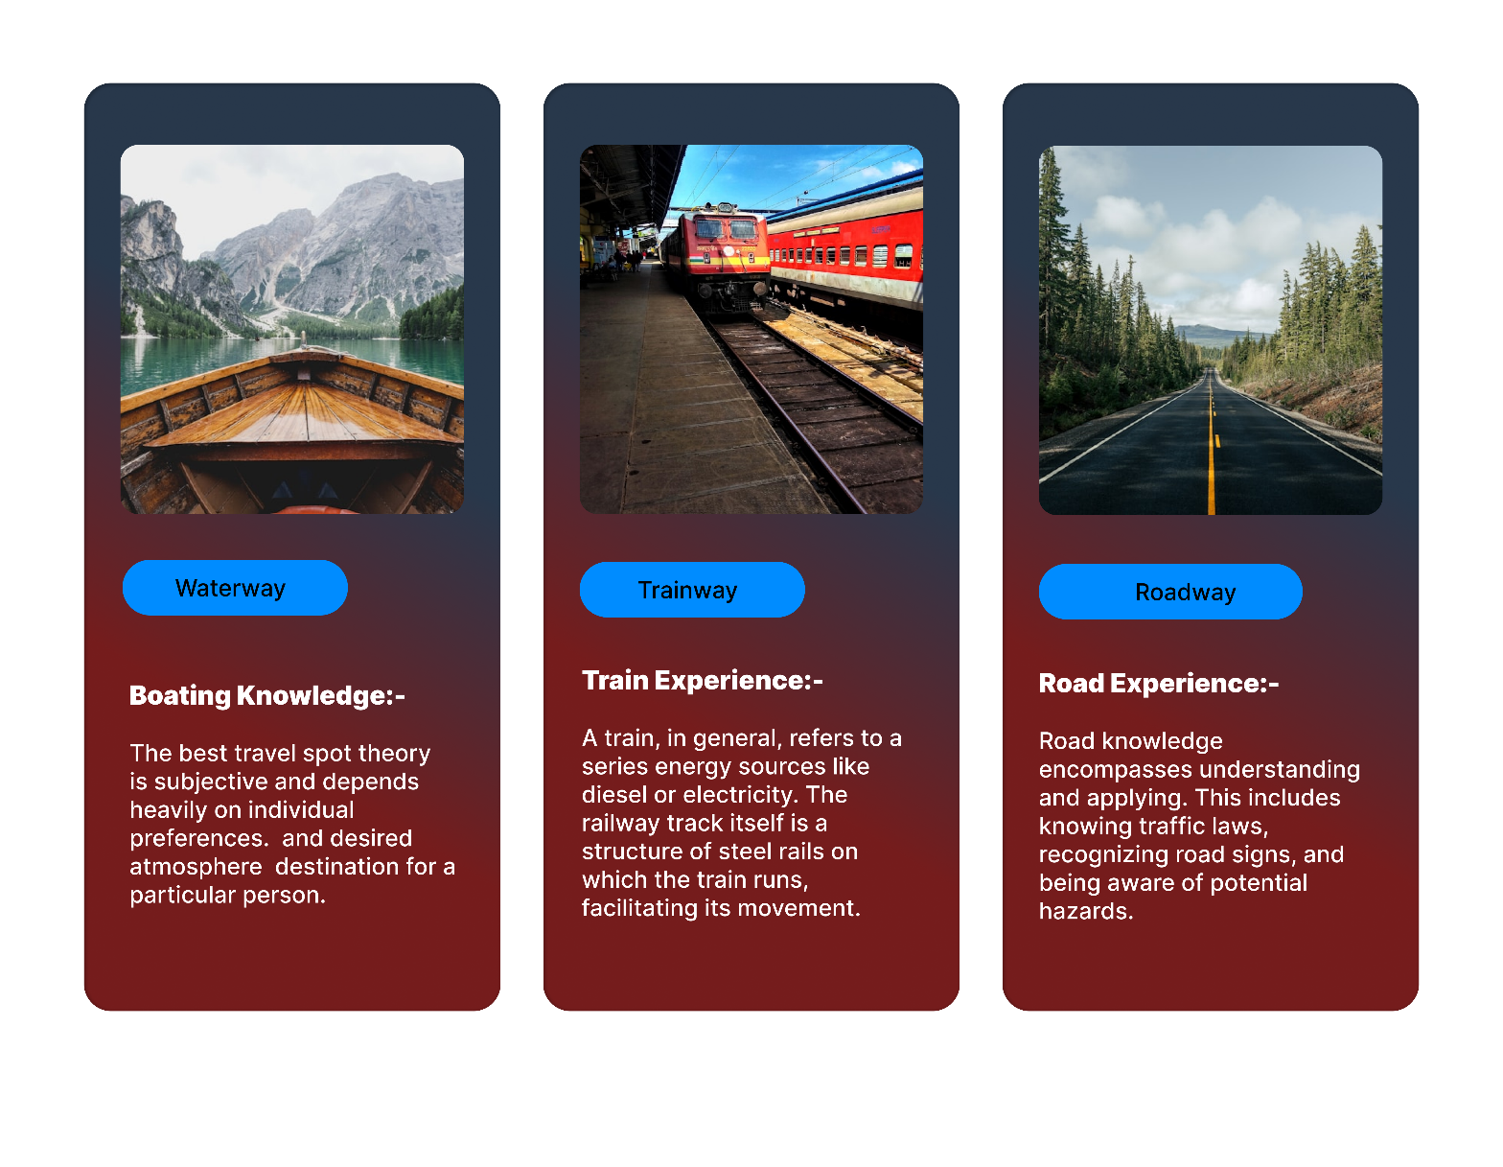**Solution:**

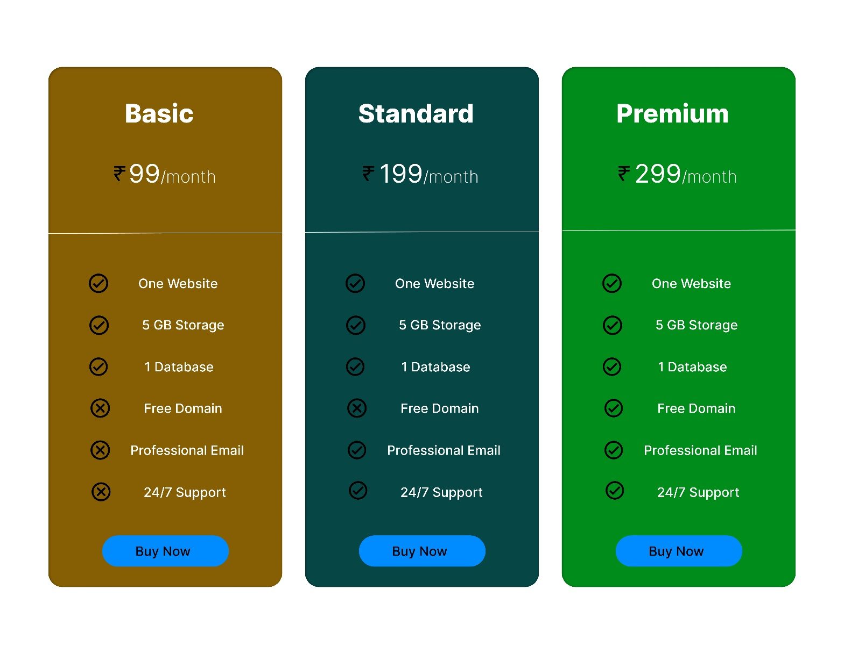

**Working:**

* First, open Figma. Add a new Figma design file.
* Rename a file as RollNumber_Practical-1_ShortFileName.
* In this design, the following tools are used for a particular operation:

|  |  |  |
| --- | --- | --- |
| **Tools Name** | **Use** | **Properties** |
| Macbook Air 1: | Blog Cards. | Width: 1486px  Height: 1153px  Color fill: #FFFFFF  Corner radius: 0px |
| Text-Box | Writted on Blog Card. | Width: 743px  Height: 73px  Corner radius: 0px  Typography:  Inter, Extra Bold, 45. |
| Android-Compact: 1, 2 & 3 | Used as Blog Cards. | Width: 412px  Height: 917px  Opacity: 100%  Color fill: Linear (#751C1C, #28384B)  Corner radius: 25px |
| Text-Boxes | Used write on it. | Width1: 211px  Height1: 69px  Width2: 212px  Height2: 54px  Width3: 229px  Height3: 74px  Width4: 98px  Height4: 28px  Opacity: 100%  Corner radius: 0px |
| Rectangle | Used to design. | Width: 223px  Height: 55px  Opacity: 100%  Color fill: # 008CFF  Corner radius: 50px |
| Line | Used to Separate. | Width: 412px  Height: 0px  Opacity: 100%  Corner radius: 0px  Stroke:  Center, 1, None, None, 100% |
| Icons | Used to show Rupee, Tick & Wrong Symbols. | Width1: 54px  Height1: 54px  Width2: 41px  Height2: 41px  Opacity: 100%  Corner radius: 0px |
| Macbook Air 2: | Price Cards. | Width: 1486px  Height: 1153px  Color fill: # FFFFFF  Corner radius: 0px |
| Text-Box | Used to write on it. | Width: 743px  Height: 73px  Corner radius: 0px  Typography:  Inter, Extra Bold, 45. |
| Android-Compact: 4, 5 & 6 | Used as Price Cards. | Width: 412px  Height: 917px  Opacity: 100%  Color fill: #865F04, 064645, 008C1A  Corner radius: 25px |
| Images | Used to put images on it. | Width: 340px  Height: 365px  Opacity: 100%  Corner radius: 18px |
| Rectangle | Used to design. | Width: 223px  Height: 55px  Opacity: 100%  Color fill: # 008CFF  Corner radius: 50px |
| Text-Boxes | Used to write. | Width1: 110px  Height1: 28px  Width2: 333px  Height2: 268px  Opacity: 100%  Corner Radius: 0px  Typography:  Inter, Mixed, Mixed, Auto, 0%, Right & Top. |

* Export your design as a JPEG file.