**Practical-6:** Variants with reusable components.

**Definition:** Use vector mode to edit and customize vector shapes and design different icons, and make reusable components of its vector using variants.

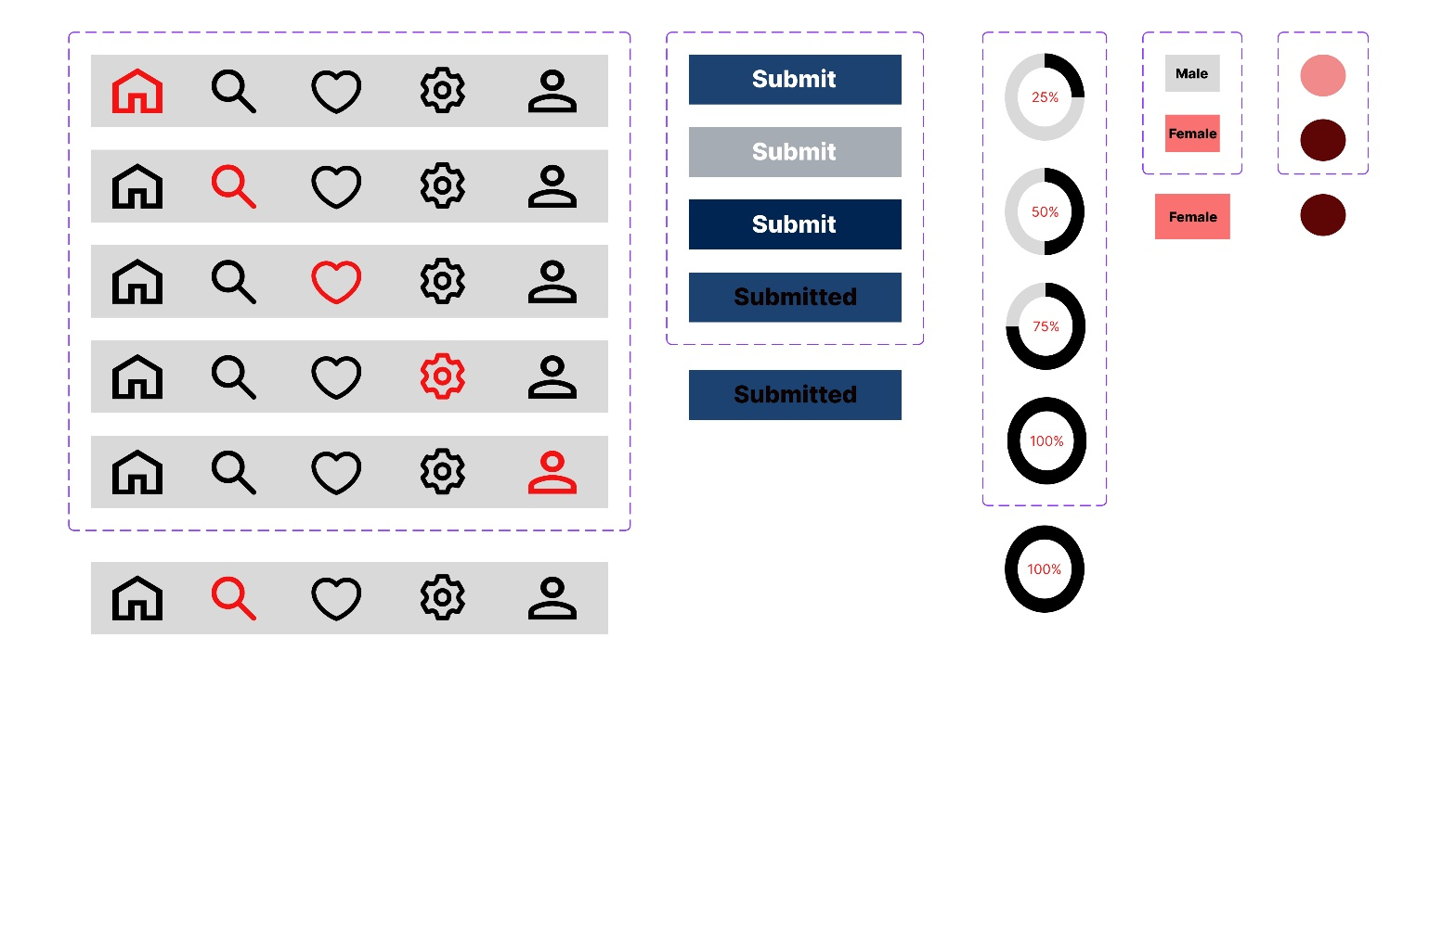**Solution:**

**Working:**

* First, open Figma. Add a new Figma design file.
* Rename a file as 210_Practical-6_Components&Variants.
* In this design, the following tools are used for a particular operation:

|  |  |  |
| --- | --- | --- |
| **Tools Name** | **Use** | **Properties** |
| Macbook Air-1 | The Macbook Air-1  is used as a Frame for this design | Width: 1280 px  Height: 832 px  Color fill: #FFFFFF, 100%  Corner radius: 0PX |
| Group-1 | Used to create Navigation-Bar. | Width: 495 px  Height: 440 px  Corner radius: 0 px  Color fill: # 8A38F5  Opacity: 100% |
| Navigation-Bar Implementation | Used to check the buttons. | Width:455 px  Height: 64 px  Opacity: 100%  Corner Radius: 0  Color: #D9D9D9, #000000, #F41313 Opacity: 100 px |
| Group-2 | Used to design Submit Button. | Width: 227 px  Height: 276 px  Opacity:100%  Corner Radius: 50  Color: # 8A38F5, 100%  Effects: Inner Shadow, Blur-30, Color-3412F3, Spread-20 |
| Submit Button Implementation | Used to check the Submit buttons. | Width: 187 px  Height: 44 px  Opacity: 100%  Corner Radius: 0  Color: # 0C0000, # 1C4271, 100% |
| Group-3 | Used to design Loading Button. | Width: 112px  Height: 420px  Opacity: 100%  Corner Radius: 5  Color: # 8A38F5 |
| Loading Button Implementation | Used to check the Loading button. | Width: 70 px  Height: 77 px  Opacity: 100%  Corner Radius: 0  Color: # 1C4271 100% |
| Rectangle-4 | Used to design Check Boxes. | Width: 88px  Height: 126px  Opacity: 100%  Corner radius: 5  Color1: # D9D9D9  Color2: # 580C0C |
| Check Box Implementation | Used to check check boxes. | Width: 66 px  Height: 40 px  Opacity: 100%  Corner Radius: 0  Color1: #FFFFFF 100% |
| Ellipse 4 | Used to design Radio Button. | Width: 80 px  Height: 126 px  Opacity: 100%  Corner Radius: 5  Color1: # 8A38F5  Color2: # D9D9D9 |
| Radio Button Implementation | Used to check radio button. | Width: 40px  Height: 37px  Opacity: 100%  Color: 5E0606 100% |
| Text-Boxes | Used to write on it. | Width1: 114.96 px  Height1: 21 px  Width2: 31.93 px  Height2: 31.07 px  Width3: 53 px  Height3: 19 px  Opacity: 100% px |
| Icons | Used to show symbols. | Home icon Height: 44 px  Home icon Width: 39 px  Search icon Height: 39 px  Search icon Width: 38 px  Like icon Height: 40 px  Like icon Width: 34 px  Setting icon Height: 48 px  Setting icon Width: 49 px  Profile icon Height: 63 px  Profile icon Width: 57 px  Opacity: 100%  Corner Radius: 0 |

* Export your design as a JPEG file.