**QUESTION NO: 01**

1. Implement Following Operations:

**BSTree()**

Requirements: None Results:

Constructor. Creates an empty binary search tree.

**BSTree ()**

Requirements: None Results:

Destructor. Deallocates (frees) the memory used to store a binary search tree. **void insert (const DT &newDataItem)**

Requirements: Binary search tree is not full.

Results: Inserts newDataItem into a binary search tree. If a data item with the same key as newDataItem already exists in the tree, then updates that data item’s non key fields with newDataItem’s non key fields. **bool retrieve (KF searchKey, DT &searchDataItem)**

Requirements: None

Results: Searches a binary search tree for the data item with key searchKey. If this data item is found, then copies the data item to searchDataItem and returns true. Otherwise, returns false with searchDataItem undefined. **boolisEmpty()**

Requirements: None

Results: Returns true if a binary search tree is empty. Otherwise, returns false. **intgetHeight()**

Requirements: Not Empty

Results: If BST is not empty returns height of a binary search tree, otherwise return -1.

**CODE:**

#include <iostream>

using namespace std;

class BSTree

{ int data;

BSTree *left, *right;

public:

BSTree();

BSTree(int);

BSTree* Insert(BST*, int);

void Inorder(BSTree*);

int getHeight(BSTree *);

bool isEmpty(BSTree*);

};

BSTree ::BSTree() : data(0) , left(NULL) , right(NULL)

{ }

BSTree ::BSTree(int value)

{ data = value;

left = right = NULL;

}

bool BSTree :: isEmpty(BSTree *root)

{ if(root == NULL)

return true;

return false;

}

int BSTree :: getHeight(BSTree *node)

{

if (node == NULL)

return 0;

else

{

int lDepth = getHeight(node->left);

int rDepth = getHeight(node->right);

if (lDepth > rDepth)

return(lDepth + 1);

else return(rDepth + 1);

}

}

BSTree* BSTree ::Insert(BSTree* root, int value)

{ if (!root)

{

return new BSTree(value);

}

if (value > root->data)

{

root->right = Insert(root->right, value);

}

else

{

root->left = Insert(root->left, value);

}

return root;

}

void BSTree ::Inorder(BSTree* root)

{

if (!root)

{

return;

}

Inorder(root->left);

cout << root->data << endl;

Inorder(root->right);

}

int main()

{

BSTree b, *root = NULL;

root = b.Insert(root, 50);

b.Insert(root, 30);

b.Insert(root, 20);

b.Insert(root, 40);

b.Insert(root, 70);

b.Insert(root, 60);

b.Insert(root, 80);

b.Inorder(root);

return 0;

}

1. A database is a collection of related pieces of information that is organized for easy retrieval. The following set of accounts records, for instance, form an accounts database. Construct BST for accounts database.

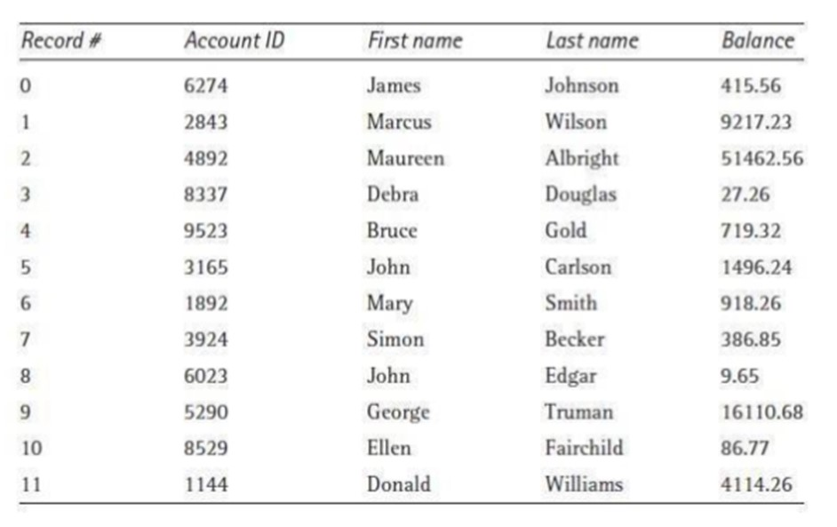

**CODE:**

#include <iostream>

#include <fstream>

using namespace std;

struct PersonAccount

{

int RecNum;

int AccountID;

string FirstName;

string LastName;

double Balance;

}

personAccount[15];

struct IndexEntry

{

int acctID;

long recNum;

};

struct node

{

struct IndexEntry *index;

struct node *left;

struct node *right;

}*root;

class BST

{

public:

BST()

{

root = NULL;

}

void insert(node*,node*);

void search(node*,int);

};

int main()

{

BST bst;

ifstream infile("accounts.dat");

if(!infile)

{

cout<<endl<<"Create the input file accounts.dat";

exit(0);

}

int n=0;

while(!infile.eof())

{

infile>>personAccount[n].RecNum>>personAccount[n].AccountID>>personAccount[n].FirstName>>personAccount[n].LastName>>personAccount[n].Balance;

struct IndexEntry *index=new IndexEntry;

index->acctID=personAccount[n].AccountID;

index->recNum=personAccount[n].RecNum;

node* temp=new node;

temp->index=index;

temp->left=NULL;

temp->right=NULL;

if(root==NULL)

root=temp;

else

bst.insert(root,temp);

n++;

}

int accountID;

cout<<endl<<"Enter account ID: ";

cin>>accountID;

bst.search(root,accountID);

}

void BST::insert(node *r, node *temp)

{

if (r == NULL)

{

r = new node;

r->index=temp->index;

r->left = NULL;

r->right = NULL;

}

if (temp->index->acctID < r->index->acctID )

{

if (r->left != NULL)

insert(r->left, temp);

else

{

r->left = new node;

r->left->index=temp->index;

(r->left)->left = NULL;

(r->left)->right = NULL;

return;

}

}

else

{

if (r->right != NULL)

{

insert(r->right, temp);

}

else

{

r->right = temp;

(r->right)->left = NULL;

(r->right)->right = NULL;

return;

}

}

}

void BST::search(node *root, int accountID )

{

if(root==NULL) return;

if (root->index->acctID > accountID)

{

if(root->left!=NULL)

search(root->left, accountID);

}

else if( root->index->acctID < accountID)

{

if(root->right!=NULL)

search(root->right, accountID);

}

else if( root->index->acctID == accountID)

{

cout<<endl<<"matched record number is "<<root->index->recNum;

cout<<endl<<"Corresponding account record from the database file: ";

cout<<endl<<"Record # Account ID First Name Last Name Balance";

cout<<endl<<personAccount[root->index->recNum].RecNum<<"\t "<<personAccount[root->index->recNum].AccountID<<"\t "<<personAccount[root->index->recNum].FirstName<<"\t"<<personAccount[root->index->recNum].LastName<<"\t"<<personAccount[root->index->recNum].Balance;

return;

}

}

**OUTPUT:**

1. Implement binary search tree. Then create a function which receive a node and should return its level. e.g. Node 14 is at level 1.

**CODE:**

#include <iostream>

using namespace std;

struct Node

{

int data;

struct Node* lchild;

struct Node* rchild;

};

bool find(int data, struct Node* root)

{

if (root_ == NULL)

{

return false;

}

else if (root_->data == data)

{

return true;

}

else if (data > root_->data)

{

return find(data, root_->rchild);

}

else

{

return find(data, root_->lchild);

}

}

bool insert(int data, struct Node** root)

{

if (*root_ == NULL)

{

*root_ = (struct Node*)malloc(sizeof(struct Node));

(*root_)->data = data;

(*root_)->lchild = NULL;

(*root_)->rchild = NULL;

return true;

}

else if (data > (*root_)->data)

{

return insert(data, &(*root_)->rchild);

}

else if (data < (*root_)->data)

{

return insert(data, &(*root_)->data);

return insert(data, &(*root_)->lchild);

}

else

{

return false;

}

}

void postorder(struct Node* root_)

{

if (root_ != NULL)

{

postorder(root_->lchild);

postorder(root_->rchild);

std::cout << root_->data << " ";

}

}