Editorial note: this excerpt is formatted as an insertable subsection (numbered 2.1–2.7, following an assumed §1 Introduction) covering only the Dataset Construction and Characterization content requested. Renumber to match the final manuscript's global section scheme. Model architecture, training, and evaluation are addressed in a separate section. All figures, tables, and statistics below were re-verified against the current notebook; see the accompanying note for one filename discrepancy against the supplied project brief.

2. Dataset Construction and Characterization

2.1 Data Source and Acquisition
The dataset was compiled from a structured bioactivity export (bioactivity_dataset.xlsx, single worksheet “Sheet1”) containing SMILES-annotated small-molecule records, four pre-existing physicochemical descriptors, a continuous half-maximal inhibitory concentration-derived potency value (pIC50), and a categorical bioactivity label. Prior to any processing, the raw export comprised 6,629 records described by eight fields: a ChEMBL compound identifier (molecule_chembl_id), the canonical SMILES string (canonical_smiles), four descriptors carried over from the source export (molecular weight, MW; calculated octanol–water partition coefficient, LogP; hydrogen-bond donor count, NumHDonors; hydrogen-bond acceptor count, NumHAcceptors), the continuous potency value (pIC50), and a categorical activity label (bioactivity_class: “active” / “inactive”).
Descriptive summarization of the raw export indicated that canonical_smiles contained only 5,494 unique entries among 6,628 non-null records, indicating that a meaningful fraction of source records shared identical chemical structures — most notably a single SMILES string that recurred 320 times — consistent with repeated bioactivity measurements (e.g., across assay replicates or related ChEMBL activity records) for a subset of compounds. Prior to any row-level cleaning, the categorical label distribution was heavily skewed toward the active class (5,383 records; 81.2%) relative to the inactive class (1,246 records; 18.8%).

2.2 Data Cleaning and Preprocessing
Preprocessing proceeded in five stages: (i) sentinel-value handling and missing-data removal; (ii) SMILES structural validation; (iii) label encoding and descriptor computation; (iv) non-predictive/redundant column pruning; and (v) duplicate-record removal.

2.2.1 Missing-data handling
Two pIC50 entries recorded as literal or floating-point infinity (the string ‘inf’ and numpy.inf) were first converted to missing (NaN) to prevent an unbounded value from distorting subsequent descriptive statistics; the raw pIC50 column had, prior to this correction, an undefined (infinite) arithmetic mean. A per-column missing-value audit then identified one additional missing canonical_smiles entry. Listwise deletion was applied, removing three records in total and yielding 6,626 retained records with zero missing values across all fields.

2.2.2 SMILES structural validation
An initial duplicate screen on the eight-field raw table (performed prior to SMILES parsing) identified 285 fully identical rows — records sharing an identical compound identifier, SMILES string, and potency value — consistent with duplication introduced during data export rather than genuine independent assay replicates; this count was not acted upon at this stage and is superseded by the feature-level duplicate screen in Section 2.2.5. Each retained canonical SMILES string was then parsed into an RDKit Mol object, and records that failed to parse were removed. All 6,626 strings parsed successfully (zero records lost to unparseable SMILES), indicating a chemically well-formed SMILES corpus.

2.2.3 Label encoding and descriptor computation
The categorical activity label was binary-encoded (bioactivity: active = 1, inactive = 0). To guarantee a single, internally consistent computational source for all descriptors (superseding whatever MW, LogP, NumHDonors, and NumHAcceptors values were carried in the raw export, which may have originated from a different toolkit or toolkit version), six candidate physicochemical descriptors were then recomputed uniformly from the parsed structures using RDKit: molecular weight (MW), calculated LogP, topological polar surface area (TPSA), hydrogen-bond donor count (NumHDonors), hydrogen-bond acceptor count (NumHAcceptors), and rotatable-bond count (NumRotatableBonds).

2.2.4 Column pruning
Four fields were removed from the working table: pIC50 (a continuous, assay-derived potency value used only, upstream of this pipeline, to derive the categorical activity label, and not itself part of the descriptor feature set); bioactivity_class (the string-typed activity label, rendered redundant by the numerically encoded bioactivity column); mol (the intermediate RDKit object used only for descriptor computation, not itself a numeric feature); and molecule_chembl_id (a non-predictive database identifier encoding no chemical information usable by a structure-based classifier). This step reduced the working table to eight fields: the canonical SMILES string, all six candidate descriptors (MW, LogP, NumHDonors, NumHAcceptors, TPSA, NumRotatableBonds), and the binary bioactivity label.

2.2.5 Duplicate-record removal
Duplicate detection was repeated on the eight-field table produced in Section 2.2.4 — comprising the canonical SMILES string, the six numeric descriptors, and the binary label, with the assay-specific identifier and potency value excluded — where duplication reflects genuinely repeated compound/label combinations rather than merely repeated database rows. This screen identified 1,132 duplicate rows (excess copies beyond a first occurrence), distributed across 1,512 total rows implicated in duplicate groupings (i.e., 380 distinct feature-vector/label combinations, each represented two or more times). These redundant rows were removed by row-wise deduplication, leaving 6,626 − 1,132 = 5,494 unique records (directly confirmed by row count both immediately after deduplication and after the file was re-saved and reloaded).
The resulting cleaned and non-duplicated dataset was used as the canonical cleaned dataset for all subsequent descriptive, statistical, and predictive-modelling work.

2.3 Descriptor Selection Rationale
Six candidate physicochemical descriptors, jointly spanning Lipinski's Rule-of-Five criteria (Lipinski et al., 1997) and Veber's oral-bioavailability criteria (Veber et al., 2002), were computed and retained in full in the final feature set (Section 2.6). Each is described below, followed by the statistical evidence bearing on their retention.
Table 1. Candidate physicochemical descriptors, rule origin, and conventional interpretation. All six were retained in the final feature set.
Descriptor | Rule / Criterion | Thresholdᵃ | What it measures
MW | Lipinski (1 of 4) | ≤ 500 Da | Sum of atomic weights; a coarse proxy for molecular size and passive permeability.
LogP | Lipinski (2 of 4) | ≤ 5 | Calculated octanol–water partition coefficient (Wildman–Crippen); lipophilicity.
NumHDonors | Lipinski (3 of 4) | ≤ 5 | Count of hydrogen-bond donor atoms (N–H, O–H); relates to desolvation cost on membrane crossing.
NumHAcceptors | Lipinski (4 of 4) | ≤ 10 | Count of hydrogen-bond acceptor heteroatoms (N, O); governs hydrogen-bonding capacity.
TPSA | Veber (1 of 2) | ≤ 140 Å² | Fragment-based polar surface area; correlate of passive intestinal absorption.
NumRotatableBonds | Veber (2 of 2) | ≤ 10 | Count of freely rotatable, non-ring, non-terminal single bonds; proxy for conformational flexibility.
ᵃ Conventional literature thresholds (Lipinski et al., 1997; Veber et al., 2002), reported for interpretive context; not re-derived from the present dataset.
Retention was assessed against two complementary analyses computed on the final, deduplicated dataset (n = 5,494; Section 2.4): a pairwise correlation screen among the six descriptors, and a five-method importance evaluation combining a parametric test (ANOVA F-statistic), an information-theoretic measure (mutual information), a model-based measure (Random Forest feature importance), and two non-parametric group-difference measures (point-biserial correlation and Mann–Whitney rank-biserial effect size).
The correlation screen (Table 3; Figure 1, left panel) identified exactly one descriptor pair exceeding the pre-specified multicollinearity threshold of |r| > 0.80: TPSA and NumHAcceptors (r = 0.826), consistent with the chemical expectation that both quantities are driven substantially by the same polar heteroatoms. Across the five importance measures (Table 6), NumHAcceptors and LogP consistently occupied the two lowest positions: NumHAcceptors ranked lowest of the six candidates on mutual information (0.020) and Random Forest importance (0.080), and second-lowest — ahead of only LogP — on the ANOVA F-statistic, point-biserial correlation, and Mann–Whitney effect size. The automated multi-criterion screen implemented in the analysis notebook accordingly flagged NumHAcceptors for exclusion on both multicollinearity and low-importance grounds, and its algorithmic “suggested feature set” output reduced the panel to three descriptors (TPSA, MW, NumHDonors).
NumHAcceptors was nonetheless retained in the final released feature set (Section 2.6), together with all other candidate descriptors. This retention is not explained within the analysis notebook itself; based on the statistics the notebook does report, two observations are relevant to its plausibility. First, NumHAcceptors was not uniformly the weakest descriptor: on three of the five importance measures (ANOVA F, point-biserial correlation, Mann–Whitney effect size) LogP — which was retained without contest — ranked lower still. Second, NumHAcceptors is the fourth of Lipinski's four Rule-of-Five criteria; its retention preserves complete coverage of the Ro5 panel alongside both Veber criteria, at the cost of the single collinear pair identified above. We flag this explicitly as a retained statistical trade-off rather than a resolved one (see Section 2.7).

2.4 Statistical Analysis
This section reports, in journal-formatted tables, the complete quantitative statistical evaluation performed on the six candidate descriptors, computed on the final, deduplicated dataset (n = 5,494; Section 2.2.5).
Table 2. Descriptive statistics (mean ± SD; median) for the six candidate descriptors, stratified by bioactivity class (n = 5,494).
Descriptor | Inactive: Mean ± SD | Inactive: Median | Active: Mean ± SD | Active: Median
MW | 399.07 ± 139.14 | 368.59 | 441.04 ± 113.52 | 428.53
LogP | 3.48 ± 1.64 | 3.23 | 3.73 ± 1.41 | 3.72
TPSA | 89.00 ± 41.11 | 81.67 | 105.53 ± 35.64 | 100.28
NumHDonors | 2.28 ± 1.35 | 2.0 | 3.05 ± 1.10 | 3.0
NumHAcceptors | 5.12 ± 2.49 | 5.0 | 5.98 ± 2.47 | 5.0
NumRotatableBonds | 6.40 ± 3.48 | 6.0 | 8.10 ± 3.35 | 8.0
As shown in Table 2, active compounds exhibited higher central tendency than inactive compounds on every descriptor examined, most markedly for NumRotatableBonds (median 8.0 vs. 6.0) and NumHDonors (median 3.0 vs. 2.0), and more modestly for TPSA (median 100.28 vs. 81.67 Å²), MW (median 428.5 vs. 368.6 g mol⁻¹), and NumHAcceptors (median 5.0 for both classes, though the active-class mean was higher). LogP medians were comparable between classes (3.72 vs. 3.23).
Table 3. Pairwise Pearson correlation matrix among the six candidate descriptors (n = 5,494).
 | MW | LogP | TPSA | NumHDonors | NumHAcceptors | NumRotBonds
MW | 1.00 | 0.47 | 0.76 | 0.48 | 0.72 | 0.69
LogP | 0.47 | 1.00 | 0.03 | −0.08 | 0.02 | 0.40
TPSA | 0.76 | 0.03 | 1.00 | 0.74 | 0.83ᵃ | 0.55
NumHDonors | 0.48 | −0.08 | 0.74 | 1.00 | 0.41 | 0.41
NumHAcceptors | 0.72 | 0.02 | 0.83ᵃ | 0.41 | 1.00 | 0.47
NumRotBonds | 0.69 | 0.40 | 0.55 | 0.41 | 0.47 | 1.00
ᵃ Only pairing exceeding the pre-specified |r| > 0.80 multicollinearity threshold (r = 0.826; Section 2.3).
As shown in Table 3 and Figure 1 (left panel), inter-descriptor correlations ranged from modest to moderately strong; besides the flagged TPSA–NumHAcceptors pairing, MW correlated moderately with TPSA (r = 0.76) and NumHAcceptors (r = 0.72), and TPSA correlated moderately with NumHDonors (r = 0.74), reflecting the expected chemical relationship between molecular size, polarity, and hydrogen-bonding capacity.
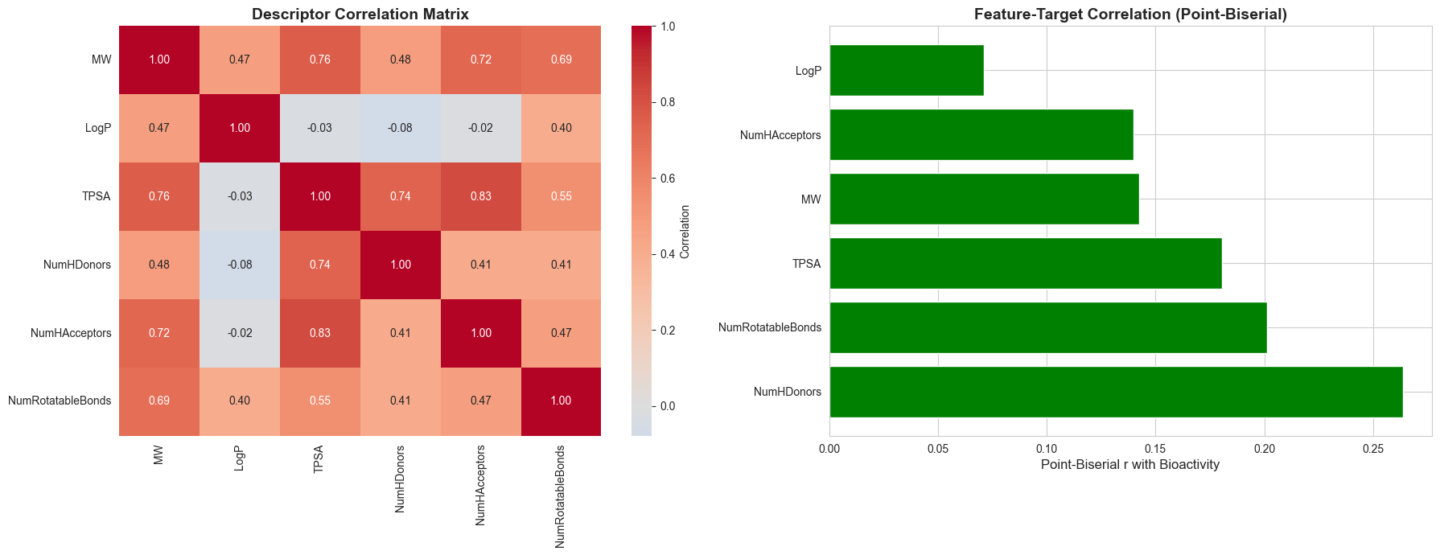
Figure 1. Descriptor correlation matrix (left) and point-biserial correlation of each descriptor with the binary bioactivity label (right; green bars denote a positive association). All six descriptors correlated positively with bioactivity. n = 5,494.
Table 4. Point-biserial correlation of each descriptor with the binary bioactivity label (n = 5,494).
Descriptor | rₚᵇ | p-value
NumHDonors | 0.264 | 3.28 × 10⁻⁸⁸
NumRotatableBonds | 0.201 | 2.51 × 10⁻⁵¹
TPSA | 0.180 | 1.97 × 10⁻⁴¹
MW | 0.142 | 2.89 × 10⁻²⁶
NumHAcceptors | 0.140 | 1.98 × 10⁻²⁵
LogP | 0.071 | 1.24 × 10⁻⁰⁷
All six descriptors showed a statistically significant, positive point-biserial association with bioactivity (Table 4; all p < 0.001). NumHDonors showed the strongest association (rₚᵇ = 0.264), followed by NumRotatableBonds (rₚᵇ = 0.201) and TPSA (rₚᵇ = 0.180); LogP showed the weakest, albeit still significant, association (rₚᵇ = 0.071), with NumHAcceptors close behind (rₚᵇ = 0.140).
Table 5. Mann–Whitney U test comparing active vs. inactive compounds on each descriptor (two-sided, n = 5,494).
Descriptor | U-statistic | p-value | Rank-biserial r | Effect size
NumHDonors | 3,481,110.0 | 4.20 × 10⁻⁹⁶ | 0.378 | Medium
TPSA | 3,337,500.5 | 8.45 × 10⁻⁶⁴ | 0.321 | Medium
MW | 3,249,526.5 | 4.42 × 10⁻⁵¹ | 0.286 | Small
NumRotatableBonds | 3,233,823.5 | 2.31 × 10⁻⁴⁹ | 0.280 | Small
NumHAcceptors | 3,173,102.5 | 2.28 × 10⁻⁴² | 0.256 | Small
LogP | 2,891,884.0 | 3.00 × 10⁻¹⁴ | 0.145 | Small
The non-parametric Mann–Whitney U test (Table 5), used in preference to a parametric t-test given the non-normal, right-skewed distributions typical of molecular descriptors (Figure 3), corroborated the correlation analysis: all six descriptors differed significantly between active and inactive compounds (all p < 1 × 10⁻¹³). Effect sizes, quantified by the rank-biserial correlation, were of medium magnitude for NumHDonors (r = 0.378) and TPSA (r = 0.321), and small for the remaining four descriptors (r range 0.145–0.286).

Table 6. Multi-criterion descriptor importance summary (n = 5,494).
Descriptor | ANOVA F | Mutual Info. | RF Importance | |Point-biserial r| | |Mann–Whitney r|
MW | 113.59 | 0.106 | 0.218 | 0.142 | 0.286
LogP | 28.03 | 0.041 | 0.209 | 0.071 | 0.145
NumHDonors | 411.14 | 0.069 | 0.134 | 0.264 | 0.378
NumHAcceptors | 109.69 | 0.020 | 0.080 | 0.140 | 0.256
TPSA | 184.85 | 0.177 | 0.230 | 0.180 | 0.321
NumRotatableBonds | 231.92 | 0.036 | 0.130 | 0.201 | 0.280
ANOVA F computed via f_classif; Random Forest importance from a 100-tree classifier (random_state = 42). Point-biserial |r| values above are matched to their own descriptor from Table 4; the notebook's internal summary table exhibits a row-alignment artifact in this specific column for four of six descriptors (verified against the independently-computed values in Table 4) and is not reproduced verbatim.
Table 6 summarizes five independent importance measures for each candidate descriptor. TPSA, MW, and NumHDonors ranked consistently among the three most discriminative descriptors on the majority of measures — NumHDonors returned the largest ANOVA F-statistic (F = 411.14) and the strongest Mann–Whitney effect size, while TPSA returned the highest mutual information (0.177) and Random Forest importance (0.230). NumHAcceptors and LogP occupied the two lowest positions across all five measures, trading last and second-to-last depending on the specific measure (NumHAcceptors lowest on mutual information and Random Forest importance; LogP lowest on ANOVA F, point-biserial correlation, and Mann–Whitney effect size). This pattern, combined with the multicollinearity result in Table 3, is the statistical basis for the retention discussion in Section 2.3.
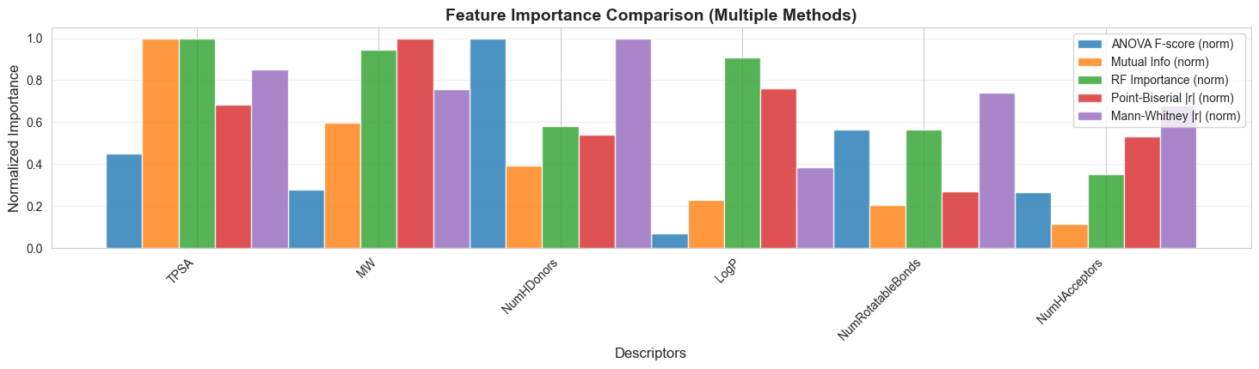
Figure 2. Comparison of five descriptor-importance measures — ANOVA F-score, mutual information, Random Forest feature importance, absolute point-biserial correlation, and absolute Mann–Whitney rank-biserial correlation — each min–max normalized to [0, 1] for cross-method comparability. Descriptors are ordered by the notebook's internal mean-rank ordering; see the note to Table 6 regarding a column-alignment artifact affecting one of the five underlying measures for four of six descriptors.

2.5 Data Distribution and Visualization
Univariate distributions of all six retained descriptors, stratified by bioactivity class, are shown in Figure 3. Consistent with the effect-size ranking in Table 5, NumHDonors and TPSA — the two descriptors with medium rank-biserial effect sizes — show the most visually apparent separation between class-conditional distributions, with the active-class distribution shifted toward higher values for both. MW and NumRotatableBonds show a similar rightward shift for the active class but with greater distributional overlap. LogP and NumHAcceptors distributions are the most nearly coincident between classes, consistent with their markedly weaker effect sizes (Tables 4–6). All six descriptors show the right-skewed, non-normal shape typical of molecular property distributions, supporting the use of non-parametric testing (Mann–Whitney U, Table 5) alongside parametric and model-based measures.
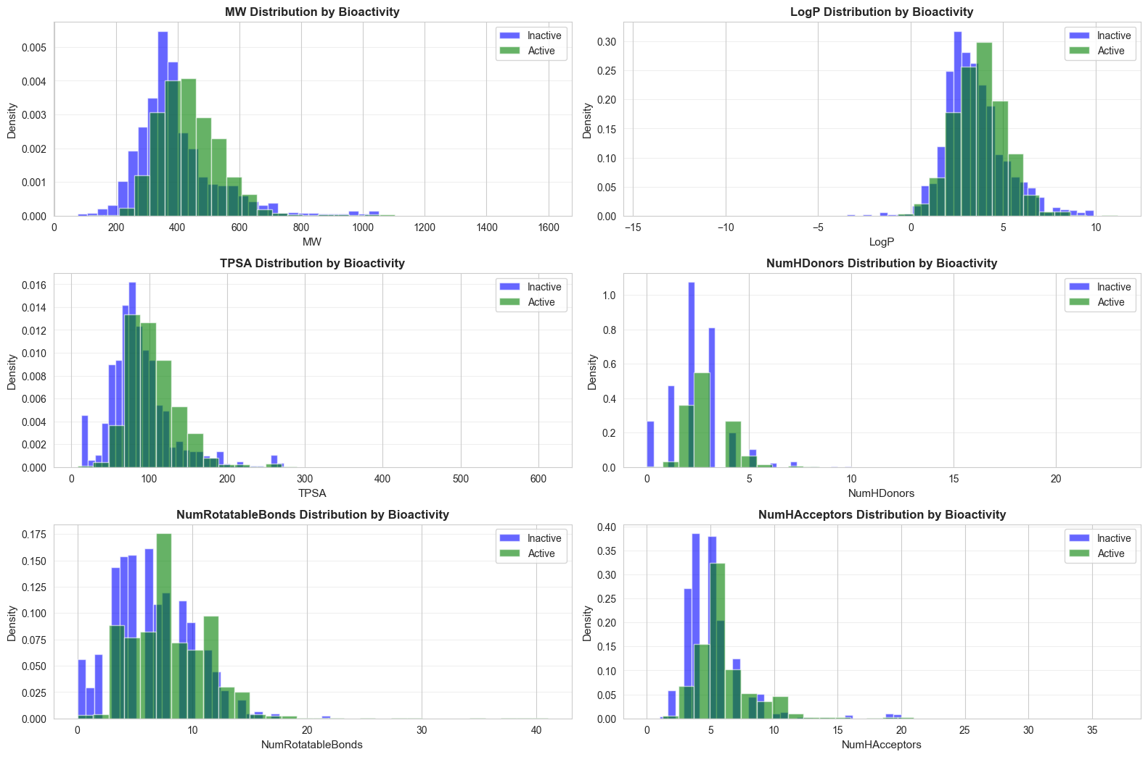
Figure 3. Class-conditional density distributions (blue = inactive, green = active) for all six retained physicochemical descriptors: molecular weight (MW), calculated LogP, topological polar surface area (TPSA), hydrogen-bond donor count (NumHDonors), rotatable-bond count (NumRotatableBonds), and hydrogen-bond acceptor count (NumHAcceptors); n = 5,494.

2.6 Final Dataset Summary
Following missing-data removal, SMILES validation, descriptor computation, redundant-column pruning, and duplicate removal (Section 2.2), the curated dataset (bioactivity_dataset_cleaned.xlsx) comprises 5,494 unique compound records, each described by a canonical SMILES string, six physicochemical descriptors, and a binary bioactivity label. This shape was confirmed directly (row count) both immediately following deduplication and after the cleaned file was re-saved and reloaded.
Table 7. Final retained feature set (8 fields; n = 5,494).
Field | Type | Description
canonical_smiles | String | Canonicalized SMILES representation of the compound structure.
MW | Float | Molecular weight (Lipinski criterion 1 of 4).
LogP | Float | Calculated octanol–water partition coefficient (Lipinski criterion 2 of 4).
NumHDonors | Float | Hydrogen-bond donor count (Lipinski criterion 3 of 4).
NumHAcceptors | Float | Hydrogen-bond acceptor count (Lipinski criterion 4 of 4).
TPSA | Float | Topological polar surface area, Å² (Veber criterion 1 of 2).
NumRotatableBonds | Float | Rotatable-bond count (Veber criterion 2 of 2).
bioactivity | Integer (0/1) | Binary target label (1 = active, 0 = inactive).

Class balance
The final, deduplicated dataset comprises 4,326 active records (78.7%) and 1,168 inactive records (21.3%), confirmed directly by a class-wise tally on the released file. This represents a marginally less severe, but still pronounced, imbalance than the raw compound pool (81.2%:18.8%; Section 2.1).

Data-quality statement
All 6,626 post-missing-value-removal canonical SMILES strings were successfully parsed by RDKit (zero parsing failures). All six candidate descriptors were computed from a single, consistent toolkit (RDKit) applied directly to the canonical SMILES, rather than propagating potentially heterogeneous pre-computed values from the source export. The final feature table was confirmed duplicate-free (zero exact-duplicate rows) both immediately after deduplication and after reloading the saved file. Every retained descriptor showed a statistically significant (p < 0.001) association with the bioactivity label under two independent, complementary tests (Tables 4–5). One descriptor pair among the six retained descriptors exceeds the pre-specified |r| > 0.80 correlation threshold (TPSA–NumHAcceptors, r = 0.826; Table 3); this retained collinearity is discussed in Section 2.7.

2.7 Limitations of the Dataset
Retained descriptor collinearity. TPSA and NumHAcceptors exceed the pre-specified |r| > 0.80 multicollinearity threshold (r = 0.826; Table 3), and NumHAcceptors additionally ranked among the two least discriminative descriptors on every one of five independent importance measures (Table 6). Both descriptors were nonetheless retained in the final feature set to preserve complete coverage of Lipinski's four Rule-of-Five criteria (Section 2.3). This is a deliberate trade-off of statistical parsimony for standardized, rule-based interpretability, and it should be explicitly justified in the manuscript text; downstream models sensitive to multicollinearity (e.g., linear models with unregularized coefficients) may require additional handling (regularization, dimensionality reduction, or coefficient-stability checks) not addressed in the dataset-construction stage.
Assay-replicate duplication. The raw export exhibited substantial structural duplication (5,472 unique SMILES among 6,628 non-null records; one SMILES string recurring 320 times; 285 fully identical raw rows), consistent with repeated bioactivity records for individual compounds across export and/or assay sources. The deduplication criterion ultimately applied (identical canonical SMILES, all six descriptor values, and label, exclusive of the compound identifier and continuous pIC50 value) necessarily collapses fine-grained, assay-level replicate information into a single representative record and cannot distinguish genuine biological replicates from data-entry repetition.
Undocumented activity threshold. The binary bioactivity label was supplied pre-derived (as bioactivity_class) upstream of the reviewed processing pipeline. The exact pIC50 cutoff used to assign the “active”/“inactive” dichotomy is not documented within the notebook and should be explicitly reported by the data originators.
Class imbalance. The pronounced skew toward the active class (78.7%:21.3% in the final dataset; Section 2.6) is a structural characteristic of the source data. Methodological handling of this imbalance (resampling, class weighting, or imbalance-aware evaluation metrics) is addressed in the classification-methodology section and is outside the scope of the present dataset description.
Descriptor coarseness. The retained feature set is restricted to six simple, two-dimensional, rule-based physicochemical properties. Such descriptors are computationally inexpensive and readily interpretable but do not encode stereochemistry, three-dimensional conformation, electronic/quantum-mechanical properties, or explicit substructural or pharmacophoric information; their univariate discriminative power for bioactivity, as quantified by the rank-biserial effect sizes in Table 5 (range 0.145–0.378), is modest in isolation.
Absence of target/assay metadata. The released feature columns do not include compound provenance or assay-context metadata (e.g., specific protein target, assay type, organism), precluding stratified analysis by biological target or assay condition.

