**1BM19CS219 MAHANTES GATTINA**

CONSTRAINT: rand() doesn’t generate unique numbers, repetition is possible

**QUICK SORT**

AVERAGE CASE: random input is considered here

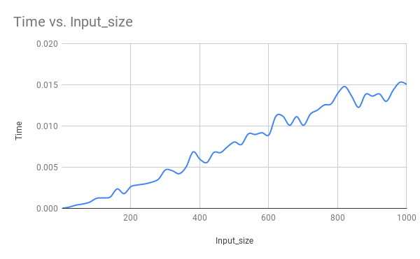

AVERAGE CASE VS WORST CASE:

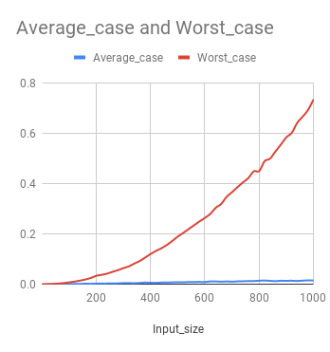

**MERGE SORT:**

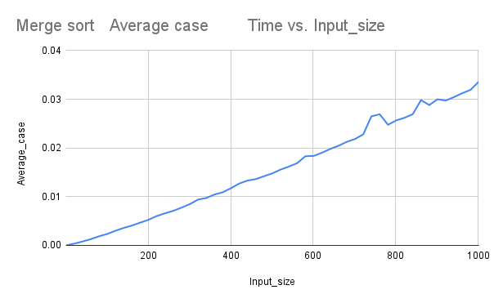

**INSERTION SORT:**

**BEST CASE:**

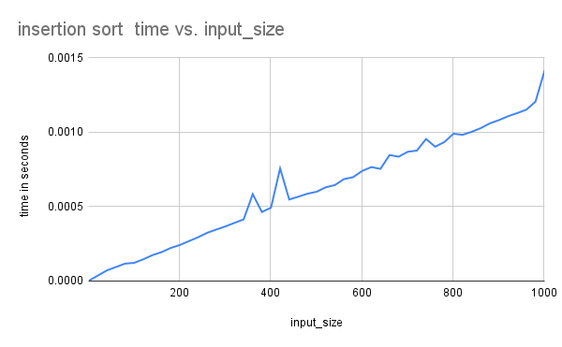

**WORST CASE:**

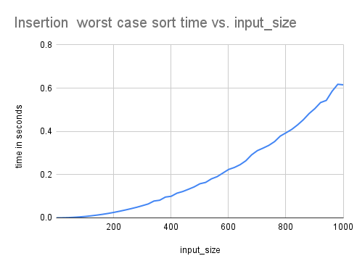

**COMPARISION:**

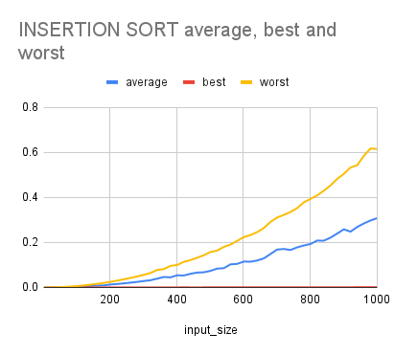

**BUBBLE SORT:**

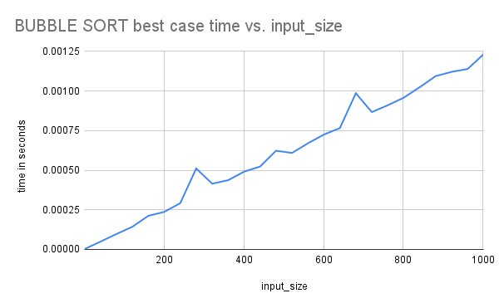

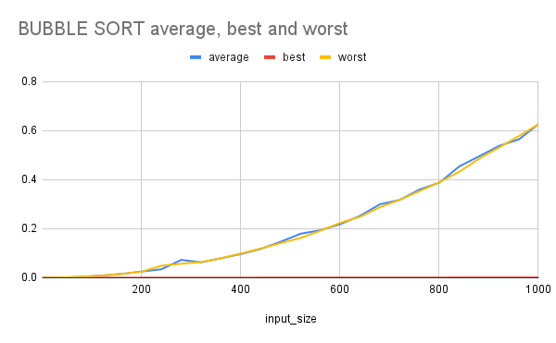

**SELECTION SORT:**

