**Hands on – DDL and DML Statements**

**Hands on Name: Book The Show**

**Description:**

BookTheShow Corporation tells you to build an automated movie booking system so that they can track the movie details, the customer details and the movie tickets booked by the customers on respective movie complex. Using the schema given below write necessary queries to create the tables and their constraints need by BookTheShow for automated movie management.

**Schema Name:dbBookTheShow**

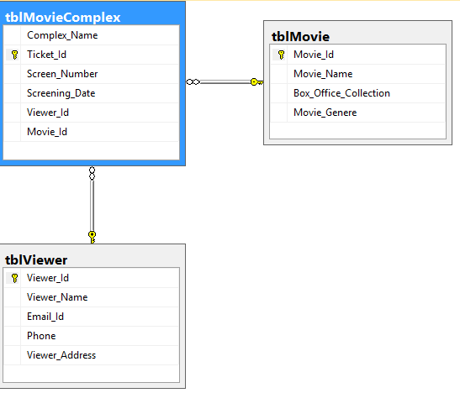

**Now based on the above schema perform the necessary DDL and DML operations:**

1. Create a table called tblMovie with given attributes [but without any constraint].
2. Create a primary constraint with name pk_MovieId on Movie_Id column of tblMovie using Alter Statement.
3. Create a unique constraint with name un_MovieName on Movie_Name column of tblMovie using Alter Statement.
4. Create a check constraint with name chk_MovieGenere on Movie_Genere column of tblMovie to allow only 3 valid values to enter: 'Action','Fantasy','Romantic' using Alter Statement.
5. Add 6 records for tblMovie.
6. Create a table called tblViewer with the attributes shown in schema [but without any constraint].
7. Create a primary constraint with name pk_ViewerId on Viewer_Id column of tblViewer using Alter Statement.
8. Create a unique constraint with name un_EmailId on Email_Id column of tblViewer using Alter Statement.
9. Create a unique constraint with name un_Phone on Phone column of tblViewer using Alter Statement.

10. Create a table called tblMovieComplex with the attributes shown in schema [but without any constraint].

11. Create a primary constraint with name pk_TicketId on Ticket_Id column of tblMovieComplex using Alter Statement.

12. Create a foreign key with name fk_ViewerId on Viewer_Id column of tblMovieComplex using Alter Statement.

13. Create a foreign key with name fk_MovieId on Movie_Id column of tblMovieComplex using Alter Statement.

14. Create a check constraint with name chk_ScreenNumber on Screen_Number column of tblMovieComplex using Alter Statement. It should check and allow value entry only between 1 and 5 range.

15. Add 5 records to tblViewer.

16. Add 6 records to tblMovieComplex.

17. Select Movie_Id,Movie_Name,Box_Office_Collection and Movie_Genere from tblMovie **[Note: The order of columns for display should be same as mentioned in question].**

18. Display Viewer_Id,Viewer_Name,Email_Id,Phone_Number and Viewer_Address from tblViewer **[Note: The order of columns for display should be same as mentioned in question].**

19. Display Complex_Name, Ticket_Id, Screen_Number, Screening_Date, Viewer_Id and Movie_Id from tblMovieComplex **[Note: The order of columns for display should be same as mentioned in question].**