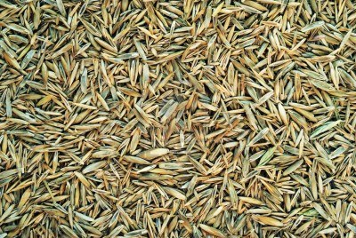
Him Agri Tech
(Unit of Rivoli Capital Holdings Pvt. Ltd)
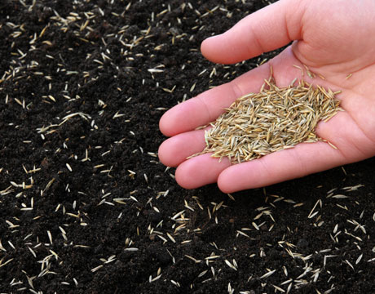
We are suppling the French Turf Grass Seeds all over INDIA. Please check the below mentioned Details of the Seeds.
RUFF TRACK / RUFFLAND  Quick installation, easy maintenance and all type of land use. low-maintenance | 5KG - 175 M2  Composition :  30% Fétuque rouge Traçante Salsa + 60% Fétuque élevée Susana + 10% Ray Grass Anglais Palmer.  1KG – Rs. 4500/-
SPORTS FIELDS (Recommended for the production of games and leisure areas, if you want to make a green fun place, a playground where everything is allowed! Very resistant to trampling. Long-lasting in time) | 5KG - 200 M2  Composition :  40% Fétuque Elevée Olimpic Gold or Izella + 20% Fétuque rouge 1/2 traçante Reggae + 40% Ray Grass Anglais Fandango.  1KG – Rs. 4500/-
RECREATION (Ideal to repair a damaged lawn. Quick installation on all types of terrain. Ideal for facelifts, youth of the implanted grass shots. Consisting of fast-growing varieties) | 5KG – 200 M2  Composition :  50% Ray Grass Anglais Ritmo + 50% Ray Grass Anglais Palmer.  1KG – Rs. 5300/-
SUN LAND (Recommended for the coastline; the drought and heat resistant. Suitable for dry land. Excellent ability to installation. Robust, resistant to trampling and grubbing-up. Very dense carpet. Ideal for non-irrigated land) | 5KG – 200 M2  Composition :  80% Fétuque Elevée Olimpic Gold ou Izella + 20% Ray Grass Anglais Fandango.  1KG – Rs. 4500/-
NOTE :
1. Minimum Order for the seeds is 100KG.
2. Technical Support will provides. Payment will pay by Cheque Only.
On the name of «Rivoli Capital Holdings Pvt. Ltd « Paid at Chandigarh
4. Delivery of the seeds. After incash the payment on the company Account.
5. Any Kind of Legal Issue will resolve in Chandigarh Court only.
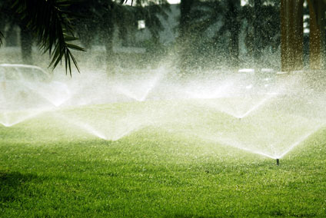
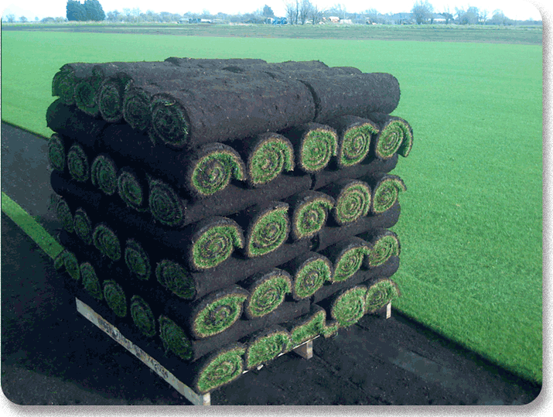
South India Distributer :
V.S. Shiva kumar Reddy
Landscape Designer
Hasirumane Exotic Plants Media.
Phone no : +91 8277219666

India Office :- Him Agri Tech India (Rivoli Capital Holdings Pvt. Ltd). Office No-7 First Floor Raghuwanshi Complex Sector 45A Chandigarh India 160045. Phone +91-172-500 -1634. Mobile +91- 99884-20634
www.himagritech.com , Email agroindia@himagritech.com

France Office :- 68 Rue d’Estienne d’orves 51100 Reims France.

