Jenkins-Setup

Jenkins-CI/CD Setup:

Prequestities:

1.AWS Ec2-server

2.Java

3.Jenkins Use t2.medium

1.Launch New EC2 server in the AWS Cloud

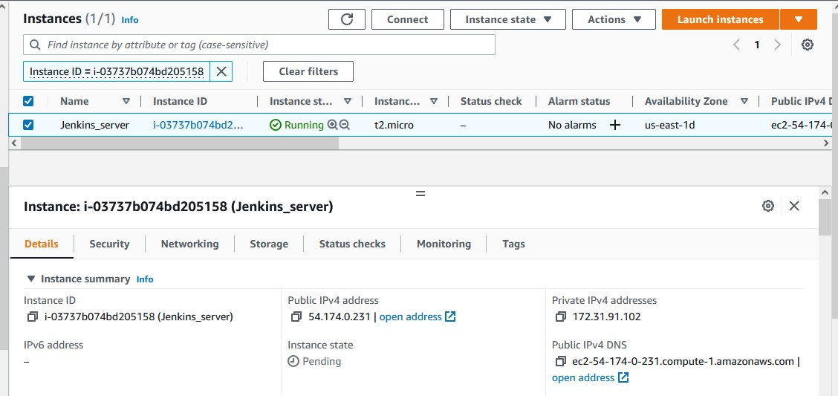



2.Once EC2 Created, Goto Security Group section:

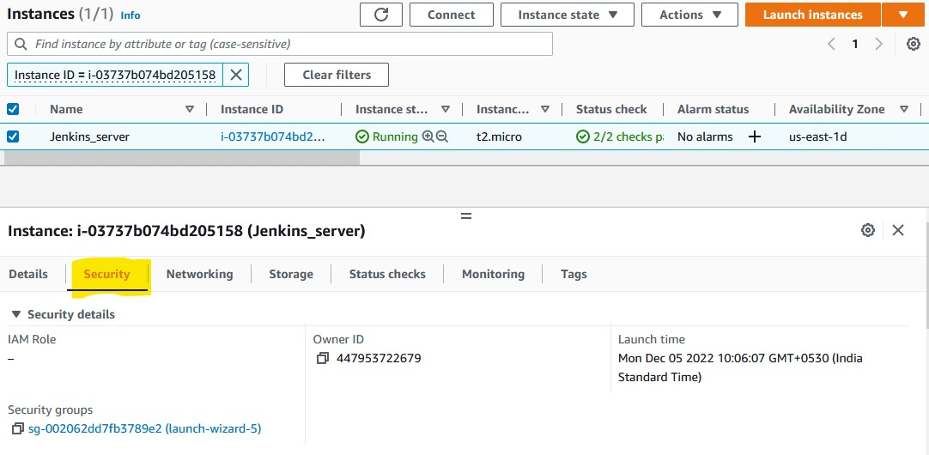

3.Select Security Group, Open in new Tab:

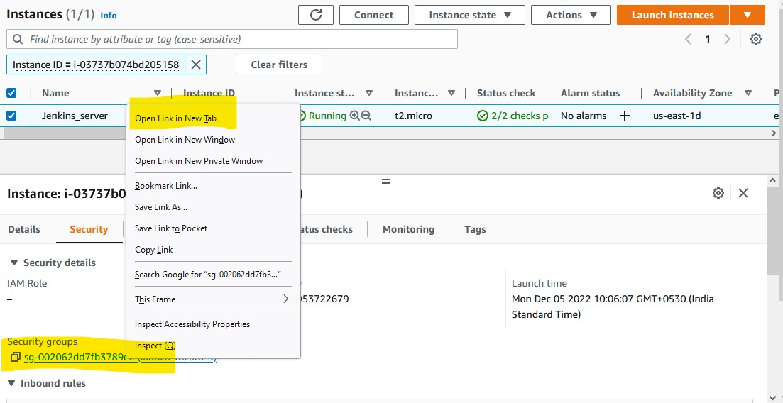



4.Then select Edit Inbound Rules:

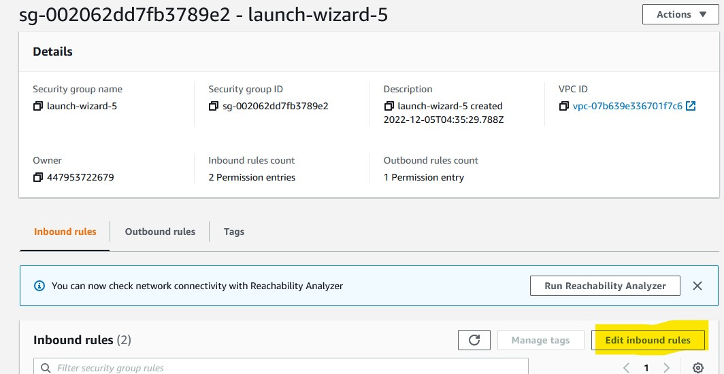

4.Click on Add rule

under Port Type select All Traffic and source as Anywhere-IPv4

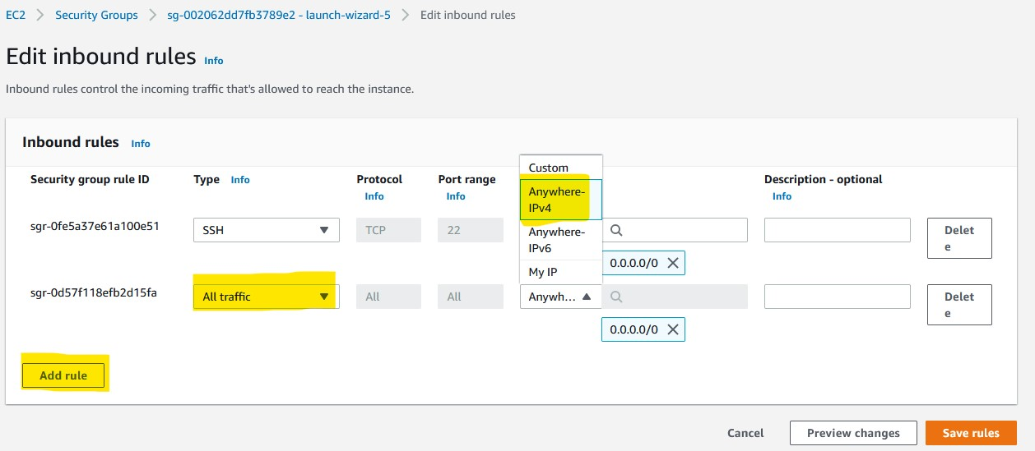

and click on Save rules

After adding All traffic, The console will be visible as below.

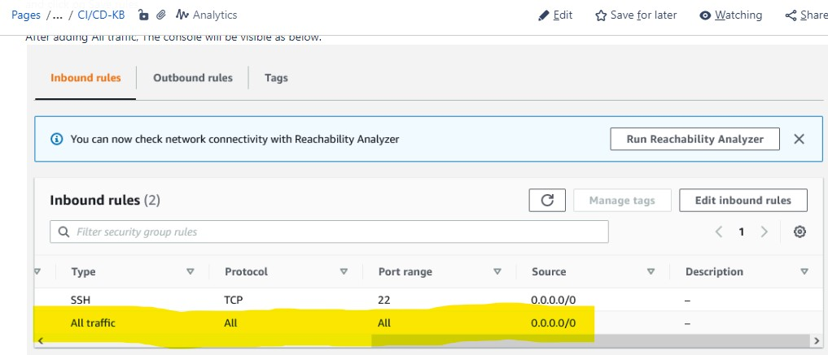

**Step 1: SSH Into Your Instance**

First things first, let’s SSH into the Amazon Linux instance where we’re setting up Jenkins. Open up your terminal and run:

ssh -i <your_key>.pem ec2-user@<your_amazon_linux_instance_ip>

This command lets you log in to your instance. Just replace <your_amazon_linux_instance_ip> with your instance's IP address and <your_key> with the actual key name.  
Example: **ssh -i jenkins-server-key.pem ec2-user@44.204.82.51**

All logged in? Perfect! Now, let’s get down to business and start the Jenkins setup.

**Step 2: Update the System**

It’s always a good practice to ensure that your system is up to date. Open a terminal window and enter the following command:

sudo dnf update

**Step 3: Install Java**

Jenkins is a Java application, so Java is a prerequisite. Install Java with the following command:

sudo dnf install java-17-amazon-corretto -y

Verify the installation with:

java -version

**Step 4: Add the Jenkins Repository**

Next, add the Jenkins repository to your system with the following commands:

sudo wget -O /etc/yum.repos.d/jenkins.repo \  
 https://pkg.jenkins.io/redhat-stable/jenkins.repo

Import a key file from Jenkins-CI to enable installation from the package:

sudo rpm --import https://pkg.jenkins.io/redhat-stable/jenkins.io-2023.key

**Step 5: Install Jenkins**

Now, install Jenkins by running:

sudo dnf install jenkins -y

**Step 6: Start and Enable Jenkins**

Enable and start the Jenkins service using:

sudo systemctl enable jenkins  
sudo systemctl start jenkins

**Step 7: Access Jenkins**

Now, open your web browser and access Jenkins by navigating to:

http://your_amazon_linux_instance_ip:8080

You will see a setup wizard and be prompted to enter the administrator password.

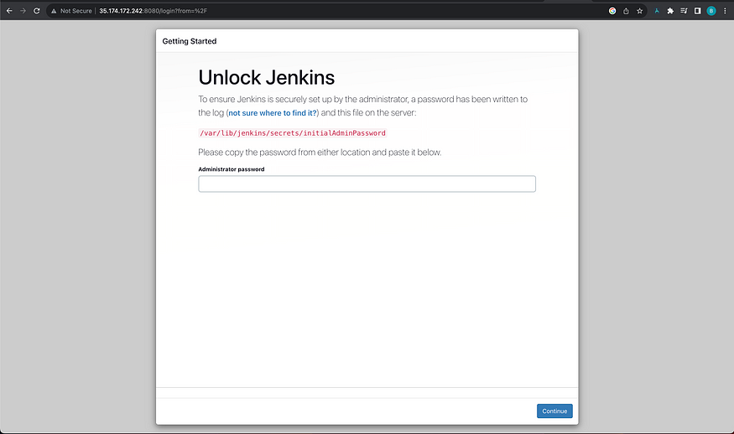

##To get initial Admin password

sudo cat /var/lib/jenkins/secrets/initialAdminPassword

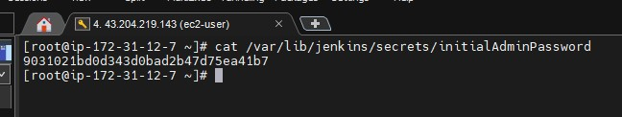

Signup with the username and passwd

username:admin password:admin email:admin@[gmail.com](http://gmail.com/)

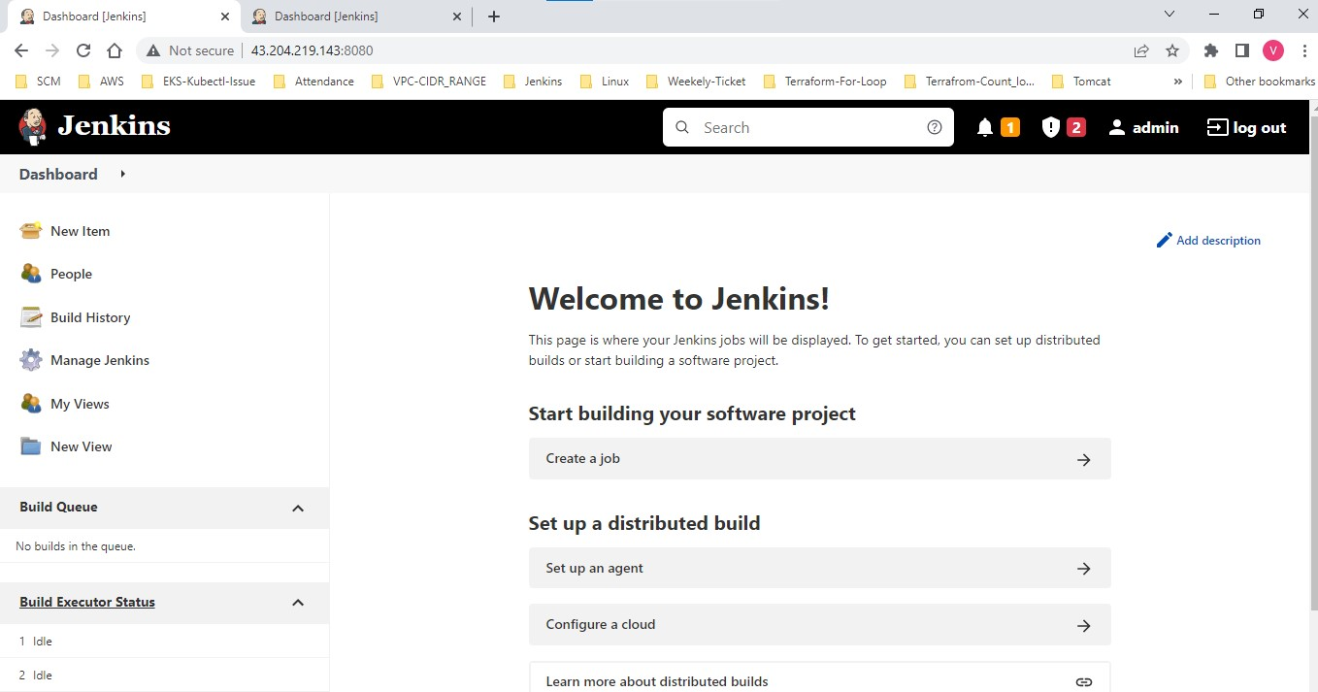

Jdk configuration

*****************

Install Amazon Corretto JDK

If Amazon Corretto JDK is not installed or installed incorrectly, follow these steps to install it:

Install Amazon Corretto JDK:

****************************

sudo yum install -y java-17-amazon-corretto-devel

Verify Installation:

java -version

Add Amazon Corretto Repository:

*******************************

sudo rpm --import https://yum.corretto.aws/corretto.key

sudo curl -Lo /etc/yum.repos.d/corretto.repo https://yum.corretto.aws/corretto.repo