**1.Git-HOL**

**git --version**

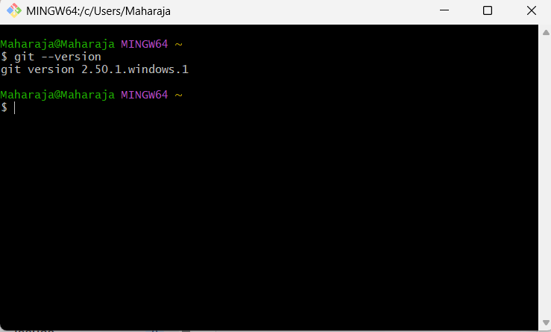

**git config --global user.name “Maharaja”**

**git config --global user.email “**[**cse123raja@gmail.com**](mailto:cse123raja@gmail.com)**”**

**notepad++**

**git config --global core.editor "notepad++ -multiInst -nosession"**

**git config --global -e**

**echo "Welcome to Git Hands-On" > welcome.txt**

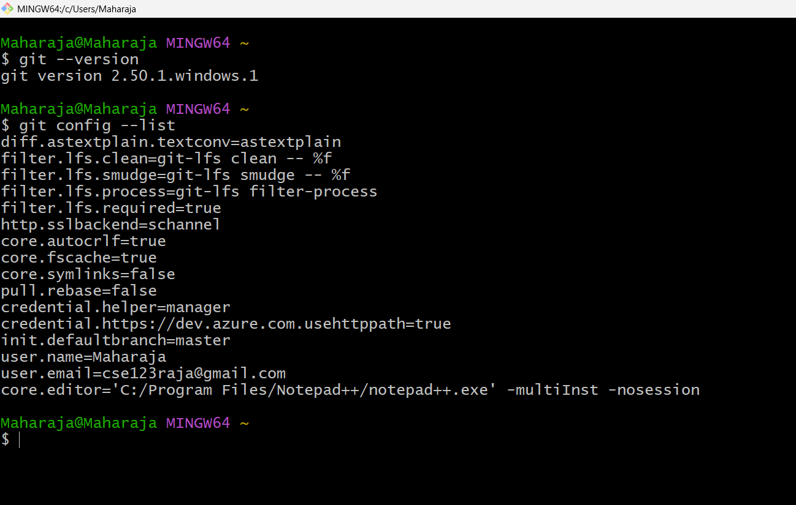

**ls**

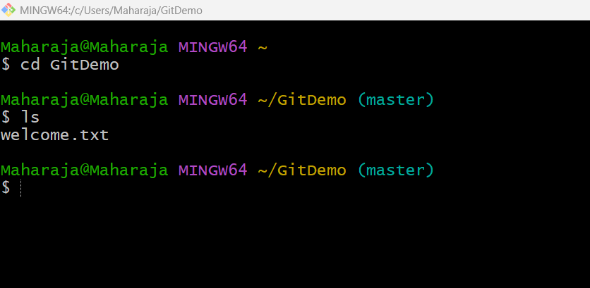

**cat welcome.txt**

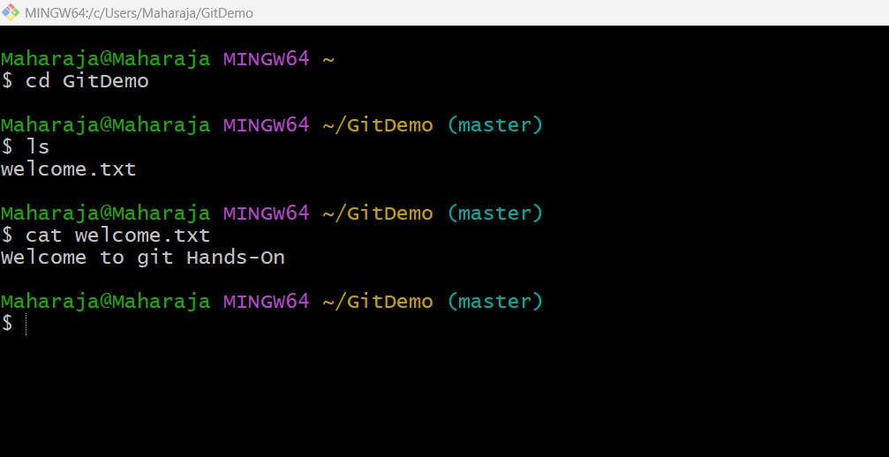

**git add welcome.txt**

**git commit**

**git log**

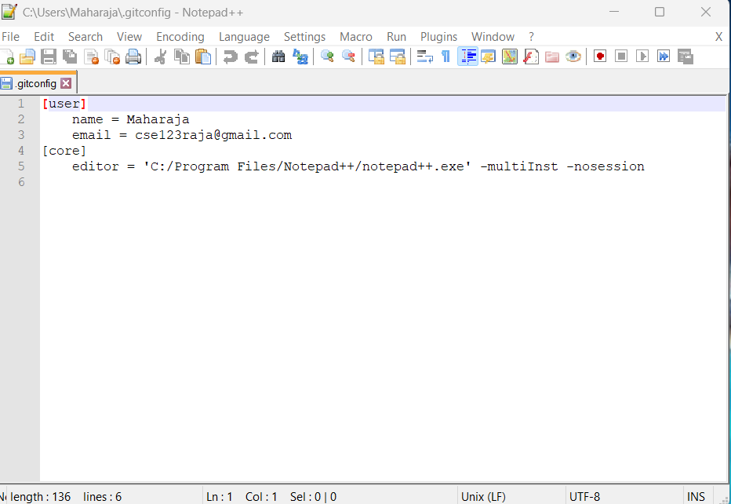

**git remote add origin https://gitlab.com/your-username/GitDemo.git**

**git branch -M master**

**git push -u origin master**

