**2.Git-HOL**

**cd /c/Users/Maharaja/GitDemo**

**echo "This is a log file" > debug.log**

**mkdir log**

**echo "This is inside log folder" > log/sample.txt**

**ls**

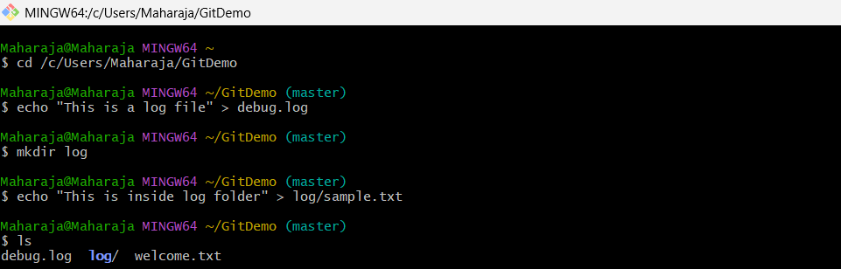

**notepad .gitignore**

**git status**

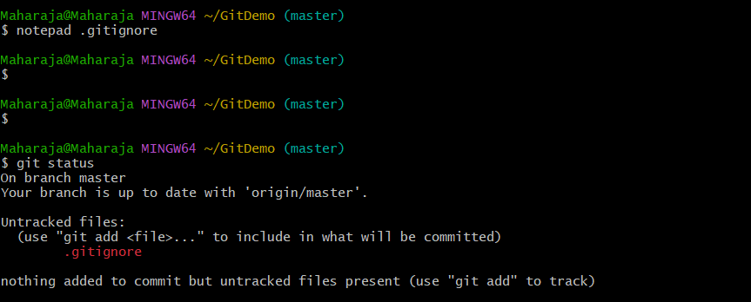

**git add .gitignore**

**git commit -m "Added .gitignore to ignore .log files and log folder"**

**git push**

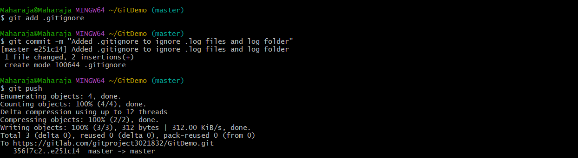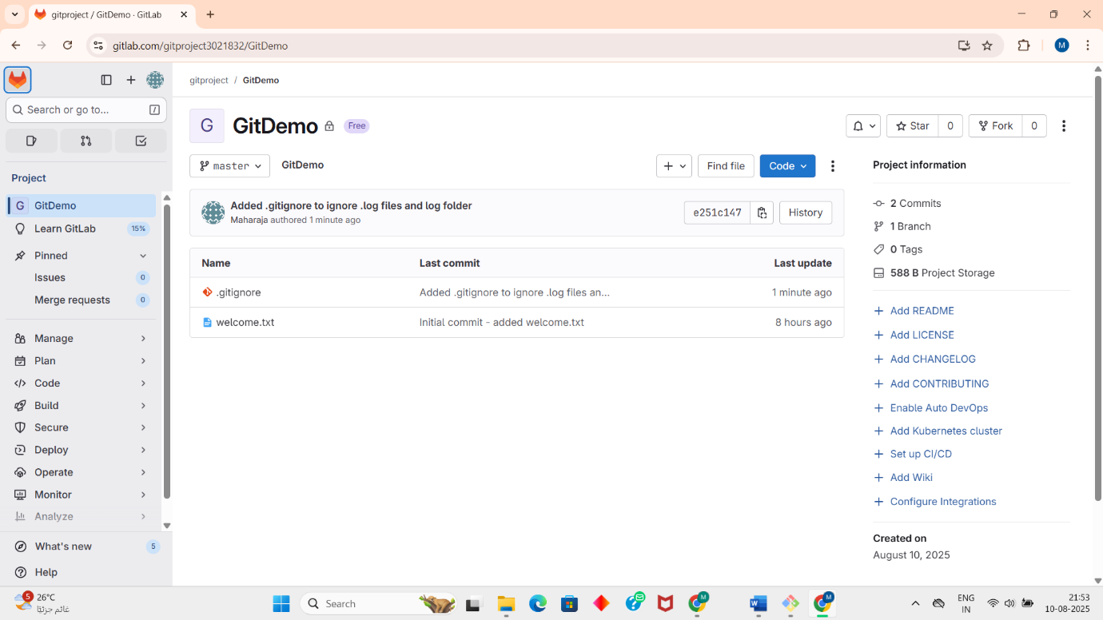

**OUTPUT:**