**3.Git-HOL**

**git branch GitNewBranch**

**git branch -a**

**git checkout GitNewBranch**

**echo "This is my first change in GitNewBranch" > file1.txt**

**git add file1.txt**

**git commit -m "Added file1.txt in GitNewBranch"**

**git status**

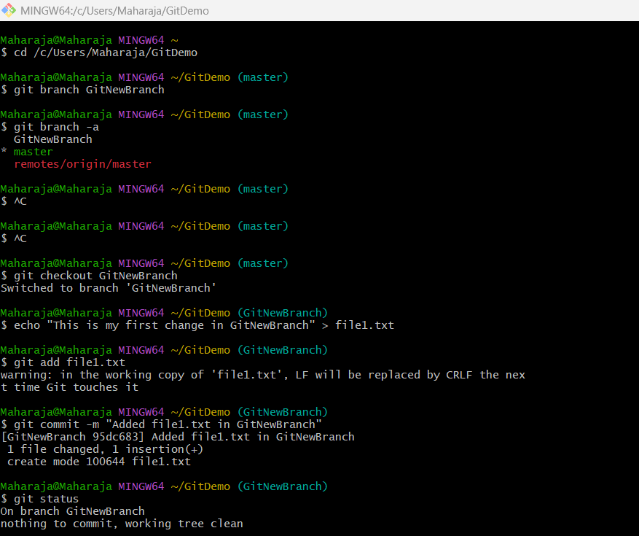

**git checkout master**

**git diff master GitNewBranch**

**git mergetool**

**git merge GitNewBranch**

**git log --oneline --graph –decorate**

**git branch -d GitNewBranch**

**git status**

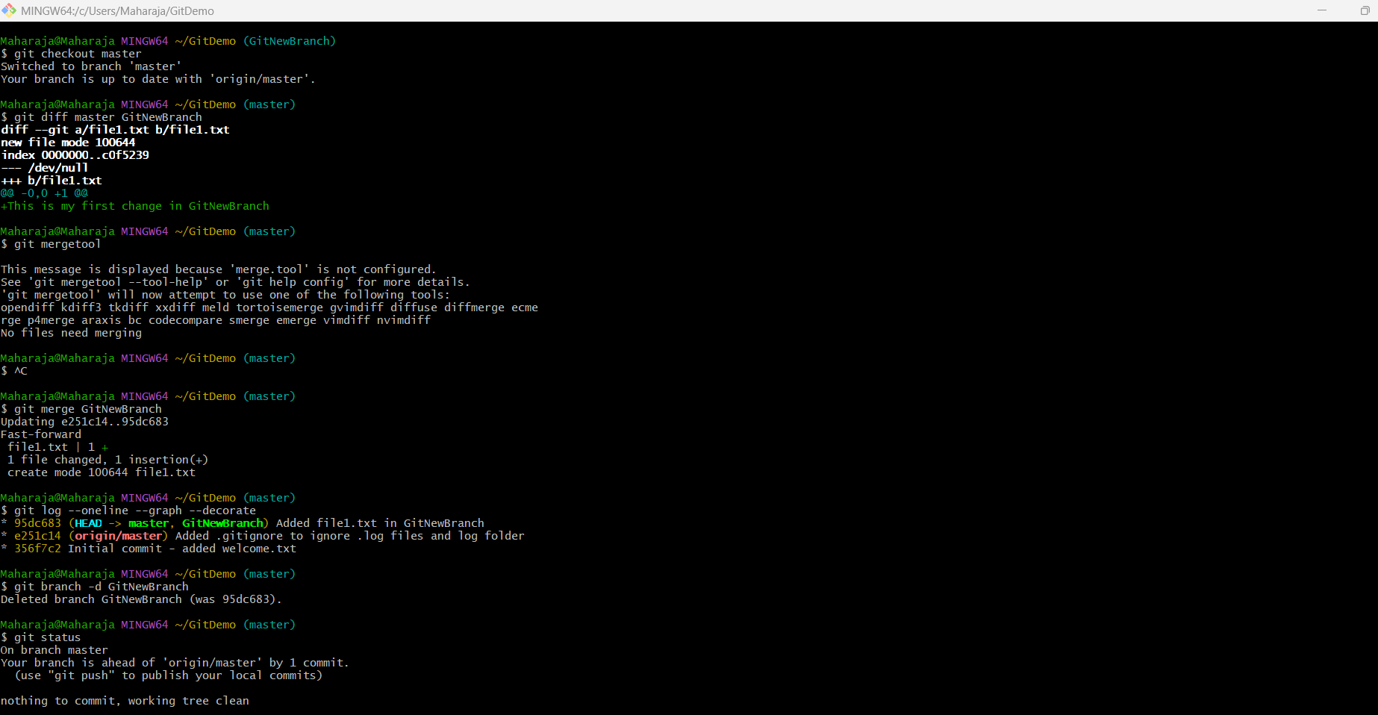

**git push origin master**

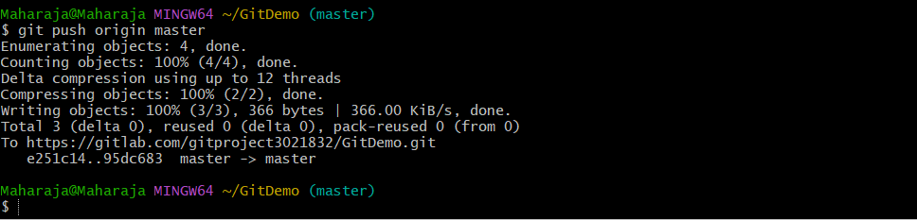

**Output:**

