| **EXP:1**  **23/01/2025** | **DATA PRE-PROCESSING TECHNIQUES** |
| --- | --- |

**AIM:**

To implement a program for time series data cleaning,loading and handling time series data & preprocessing techniques.

**PROCEDURE:**

**1)Install necessary libraries**

pip install seaborn

**2)Import the libraries**

import pandas as pd

import numpy as np

import seaborn as sns

import matplotlib.pyplot as plt

**3)Load the dataset**

**df = pd.read_csv("E:/221501073/Car_sales.csv")**

**4)Data preprocessing**

**df.dropna(inplace=True)**

**5)Plot the datapoints**

**plt.figure(figsize=(25, 6))**

**sns.barplot(data=df, x='Manufacturer', y='Sales_in_thousands')**

**plt.xlabel('Manufacturer')**

**plt.ylabel('Sales_in_thousands')**

**plt.title('Maximum Sales of Each Company')**

**plt.legend(title='Company')**

**plt.show()**

**OUTPUT:**

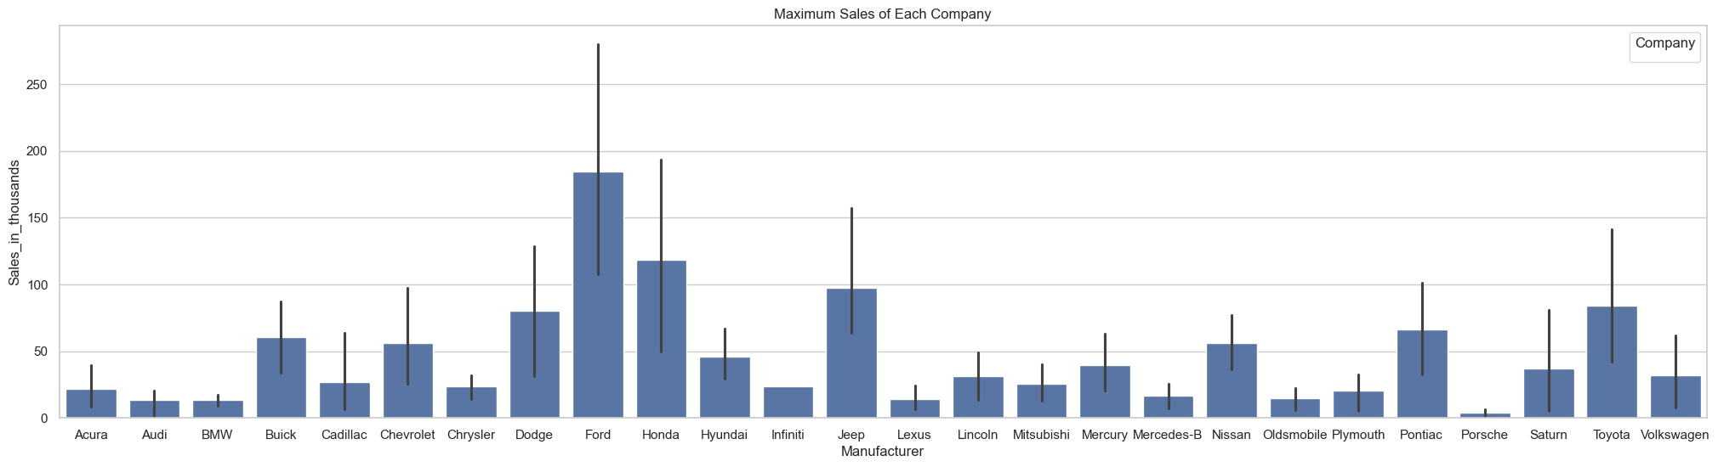

**RESULT:**

Thus the program has been executed successfully