| **EXP:2**  **30/01/2025** | **DATA VISUALIZATION TECHNIQUES** |
| --- | --- |

**AIM:**

To implement a program for time series data cleaning,loading and handling time series data & preprocessing techniques and visualization using different techniques

**PROCEDURE:**

**1)Install necessary libraries**

pip install seaborn

**2)Import the libraries**

import pandas as pd

import numpy as np

import seaborn as sns

import matplotlib.pyplot as plt

**3)Load the dataset**

**df = pd.read_csv("E:/221501073/Car_sales.csv")**

**4)Data preprocessing**

**df.dropna(inplace=True)**

**5)Plot the datapoints**

**A.Bar Plot**

**plt.figure(figsize=(25, 6))**

**sns.barplot(data=df, x='Manufacturer', y='Sales_in_thousands')**

**plt.xlabel('Manufacturer')**

**plt.ylabel('Sales_in_thousands')**

**plt.title('Bar Plot: Maximum Sales of Each Company')**

**plt.show()**

**B.Line Plot**

**plt.figure(figsize=(25, 6))**

**sns.lineplot(data=df, x='Manufacturer', y='Sales_in_thousands')**

**plt.xlabel('Manufacturer')**

**plt.ylabel('Sales_in_thousands')**

**plt.title('Line Plot: Sales Trend of Each Company')**

**plt.show()**

**C.Box Plot**

**plt.figure(figsize=(25, 6))**

**sns.boxplot(data=df, x='Manufacturer', y='Sales_in_thousands')**

**plt.xlabel('Manufacturer')**

**plt.ylabel('Sales_in_thousands')**

**plt.title('Box Plot: Distribution of Sales by Company')**

**plt.show()**

**D.Scatter Plot**

**plt.figure(figsize=(25, 6))**

**sns.scatterplot(data=df, x='Manufacturer', y='Sales_in_thousands')**

**plt.xlabel('Manufacturer')**

**plt.ylabel('Sales_in_thousands')**

**plt.title('Scatter Plot: Sales Distribution by Company')**

**plt.show()**

**E.Histogram**

**plt.figure(figsize=(25, 6))**

**sns.histplot(df['Sales_in_thousands'], kde=True)**

**plt.xlabel('Sales_in_thousands')**

**plt.ylabel('Frequency')**

**plt.title('Histogram: Distribution of Sales')**

**plt.show()**

**OUTPUT:**

**A.Bar Plot**

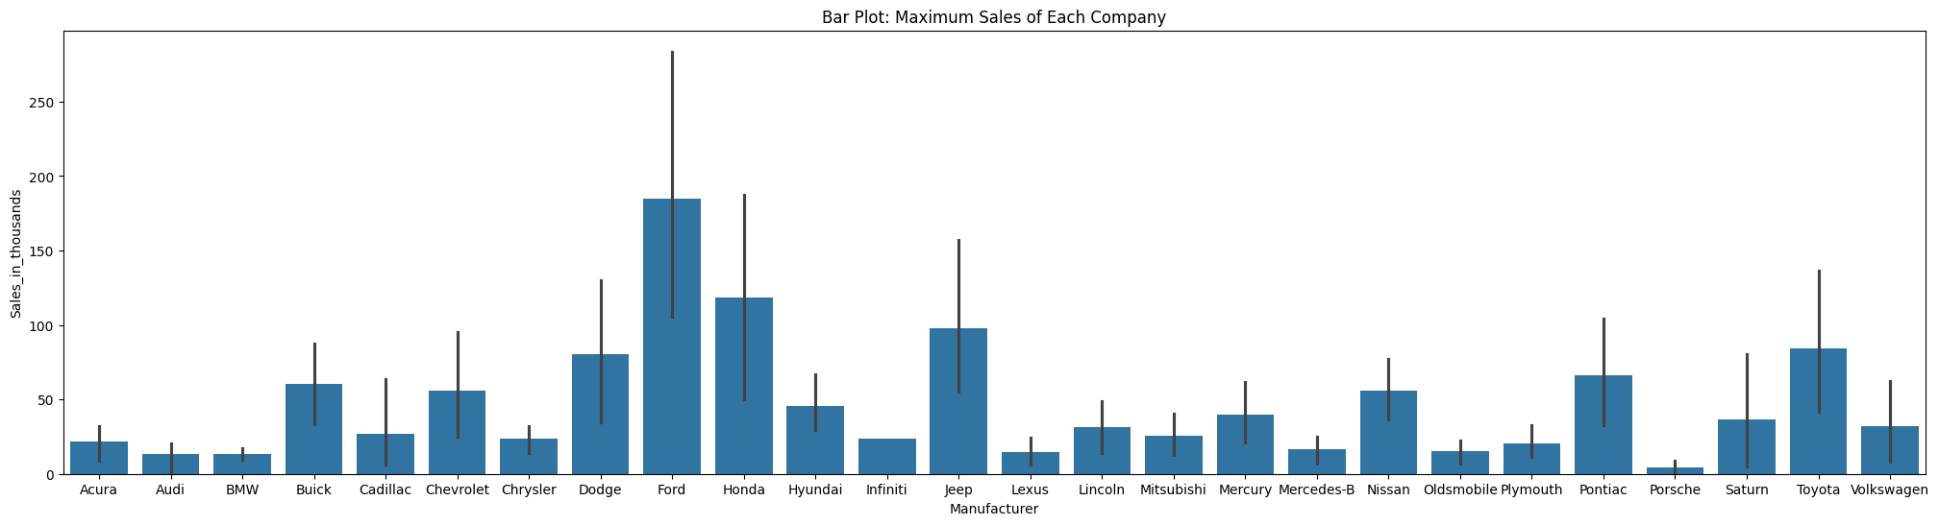

**B.Line Plot**

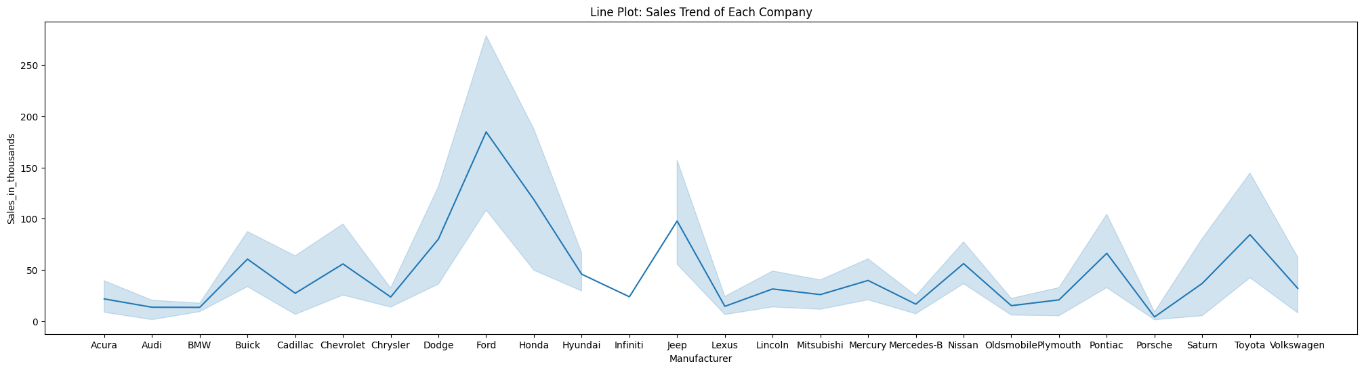

**C.Box Plot**

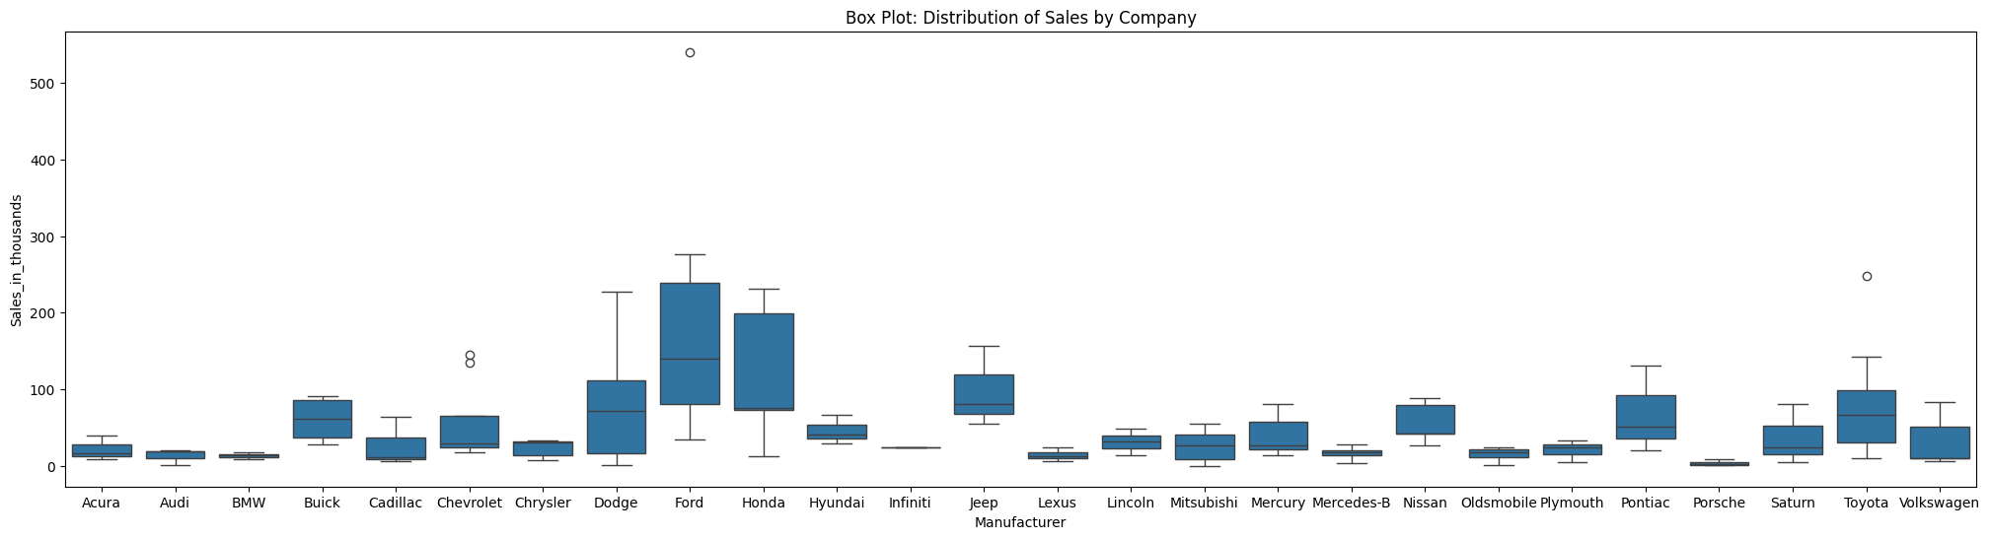

**D.Scatter Plot**

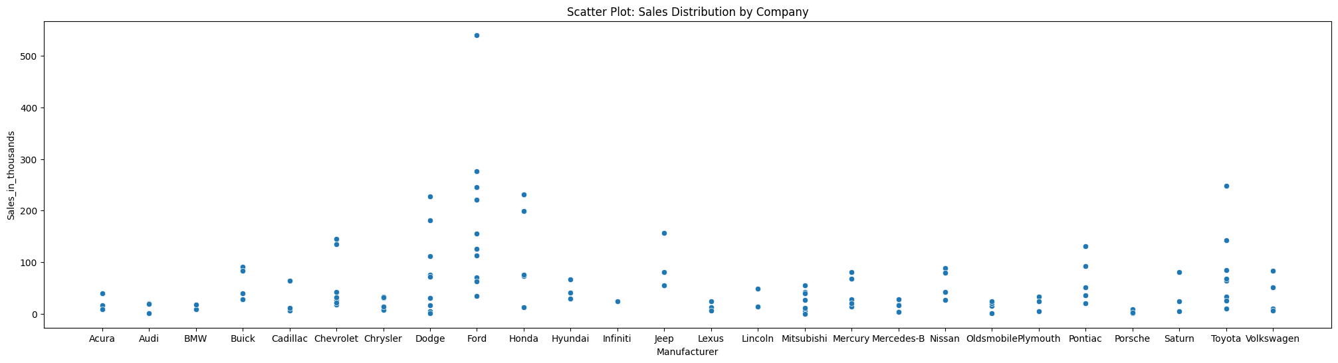

**E.Histogram**

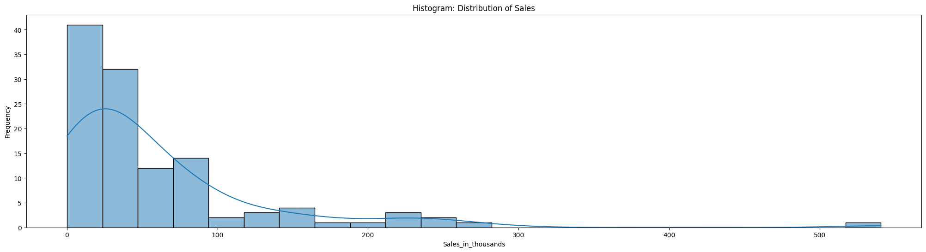

**RESULT:**

Thus the program has been executed successfully