| **EXP:3**  **06/02/2025** | **LINEAR REGRESSION** |
| --- | --- |

**AIM:**

To implement a program for time series data cleaning,loading and handling time series data & preprocessing techniques and perform linear regression

**PROCEDURE:**

**1)Import the libraries**

import pandas as pd

` import numpy as np

import seaborn as sns

import matplotlib.pyplot as plt

from sklearn.linear_model import LinearRegression

from sklearn.model_selection import train_test_split

from sklearn.metrics import mean_squared_error, r2_score

**2)Load & Clear the dataset**

**df = pd.read_csv("/content/sample_data/Car_sales.csv")**

**df.dropna(inplace=True)**

**3)Prepare features and target**

X = pd.get_dummies(df[['Manufacturer']], drop_first=True)

y = df['Sales_in_thousands']

**4)Split the dataset**

X_train, X_test, y_train, y_test = train_test_split(X, y, test_size=0.2, random_state=42)

**5)Train the model**

model = LinearRegression()

model.fit(X_train, y_train)

**6)Make Predictions**

y_pred = model.predict(X_test)

**7)Evaluate the model**

mse = mean_squared_error(y_test, y_pred)

r2 = r2_score(y_test, y_pred)

print(f"Mean Squared Error: {mse}")

print(f"R-squared: {r2}")

**OUTPUT:**



**8)Plot scatter plot**

plt.figure(figsize=(25, 6))

sns.scatterplot(data=df, x='Manufacturer', y='Sales_in_thousands')

plt.xlabel('Manufacturer')

plt.ylabel('Sales_in_thousands')

plt.title('Line Plot: Sales Trend of Each Company with Regression Line')

plt.legend()

plt.show()

**OUTPUT:**

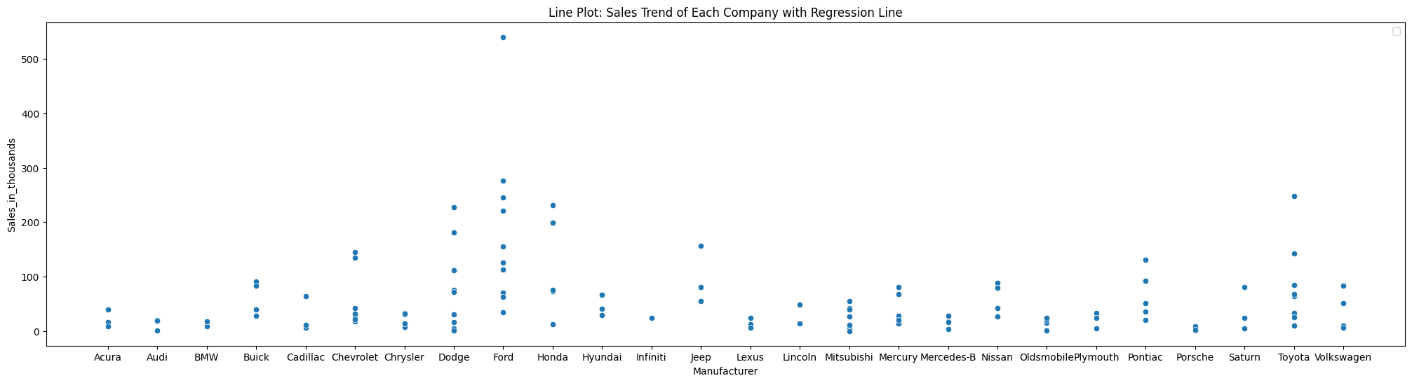

**9)Plot regression line**

plt.figure(figsize=(25, 6))

sns.lineplot(data=df, x='Manufacturer',y='__year_resale_value', color='red', label='Regression Line')

plt.xlabel('Manufacturer')

plt.ylabel('Resale Value')

plt.title('Line Plot: Sales Trend of Each Company with Regression Line')

plt.legend()

plt.show()

**OUTPUT:**

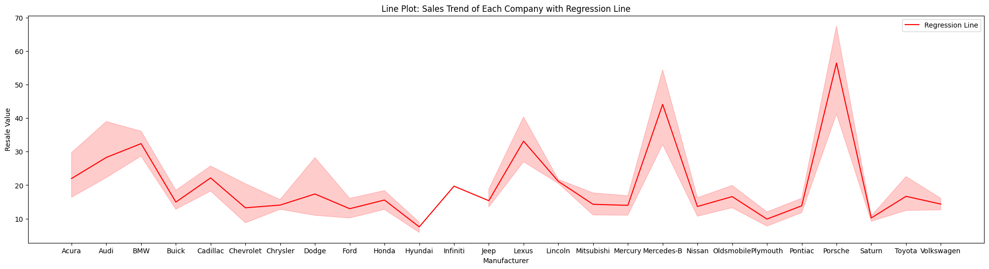

**RESULT:**

Thus the program has been executed successfully