| **EXP:4**  **20/02/2025** | **Checking Time Series Stationarity using Statistical Tests** |
| --- | --- |

**AIM:**

To determine whether a time series dataset is stationary using the Augmented Dickey-Fuller (ADF) Test and Kwiatkowski-Phillips-Schmidt-Shin (KPSS) Test in Python.

**PROCEDURE:**

**1) Load Data & Preprocess**

import pandas as pd

import numpy as np

import matplotlib.pyplot as plt

from statsmodels.tsa.stattools import adfuller, kpss

data = pd.read_csv("/content/sample_data/Car_sales.csv", header=0, index_col=0)

data = data.dropna()

sales_data = data['Sales_in_thousands']

data.head()

**OUTPUT**

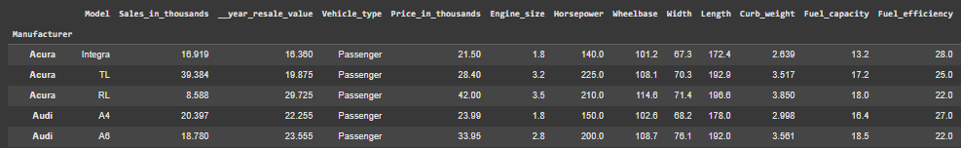

**2)Visual Inspection - Rolling Mean & Standard Deviation**

**` plt.figure(figsize=(12, 6))**

**rolling_mean = sales_data.rolling(window=12).mean()**

**rolling_std = sales_data.rolling(window=12).std()**

**plt.plot(sales_data, label='Original Data')**

**plt.plot(rolling_mean, label='Rolling Mean', color='red')**

**plt.plot(rolling_std, label='Rolling Std Dev', color='black')**

**plt.legend()**

**plt.title('Rolling Mean & Standard Deviation')**

**plt.show()**

**OUTPUT**

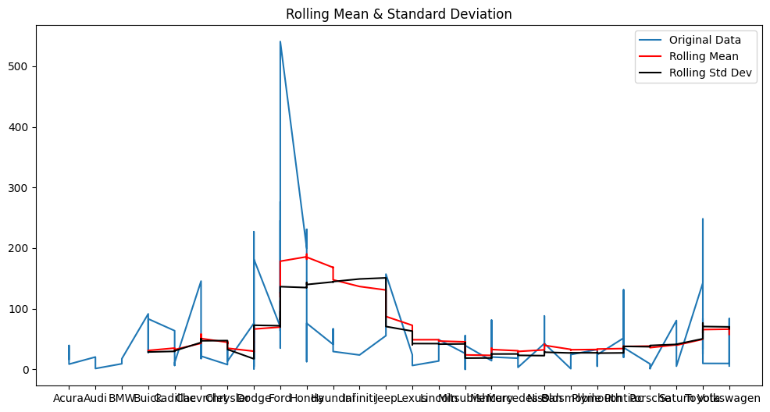

**3) Augmented Dickey-Fuller (ADF) Test**

print("\n### Augmented Dickey-Fuller (ADF) Test ###")

adf_test = adfuller(sales_data)

print(f"ADF Statistic: {adf_test[0]}")

print(f"p-value: {adf_test[1]}")

print("Critical Values:")

for key, value in adf_test[4].items():

print(f"{key}: {value}")

if adf_test[1] <= 0.05:

print("The data is stationary (reject H0)")

else:

print("The data is non-stationary (fail to reject H0)")

**OUTPUT**

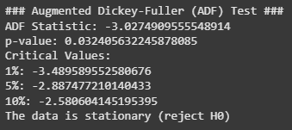

**4)KPSS Test**

X_train, X_test, y_train, y_test = train_test_split(X, y, test_size=0.2, random_state=42)

**5)KPSS Test (Checks if Data is Stationary)**

from statsmodels.tsa.stattools import kpss

print("\n### KPSS Test ###")

kpss_test = kpss(sales_data, regression='c', nlags='auto')

print(f"KPSS Statistic: {kpss_test[0]}")

print(f"p-value: {kpss_test[1]}")

print("Critical Values:")

for key, value in kpss_test[3].items():

print(f"{key}: {value}")

if kpss_test[1] > 0.05:

print("The data is stationary (fail to reject H0)")

else:

print("The data is non-stationary (reject H0)")

**OUTPUT**

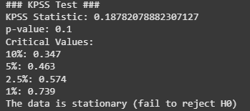

**RESULT:**

Thus the program has been executed successfully