EXP:9  17/04/2025 | Develop neural network-based time series forecasting model

AIM:
To develop a neural network-based model for forecasting car sales using historical time series data and evaluate its performance using prediction accuracy metrics.

PROCEDURE:
1) Import Necessary Libraries
import pandas as pd
import numpy as np
import matplotlib.pyplot as plt
from sklearn.preprocessing import MinMaxScaler
from tensorflow.keras.models import Sequential
from tensorflow.keras.layers import Dense
from sklearn.metrics import mean_squared_error

2) Load and Prepare Time Series
df = pd.read_csv("Car_sales.csv")
df['Latest_Launch'] = pd.to_datetime(df['Latest_Launch'], errors='coerce')
df = df.dropna(subset=['Latest_Launch', 'Sales_in_thousands'])
ts = df.groupby('Latest_Launch')['Sales_in_thousands'].sum().sort_index()
scaler = MinMaxScaler()
scaled_ts = scaler.fit_transform(ts.values.reshape(-1, 1))

3) Convert Time Series to Supervised Learning Format
def create_dataset(data, look_back=5):
X, y = [], []
for i in range(len(data) - look_back):
X.append(data[i:i + look_back, 0])
y.append(data[i + look_back, 0])
return np.array(X), np.array(y)

look_back = 5
X, y = create_dataset(scaled_ts, look_back)

4)Split Dataset into Train and Test Sets
train_size = int(len(X) * 0.8)
X_train, X_test = X[:train_size], X[train_size:]
y_train, y_test = y[:train_size], y[train_size:]

5)Build and Train the Neural Network
model = Sequential()
model.add(Dense(64, input_dim=look_back, activation='relu'))
model.add(Dense(32, activation='relu'))
model.add(Dense(1))
model.compile(optimizer='adam', loss='mean_squared_error')
model.fit(X_train, y_train, epochs=100, verbose=0)

6) Evaluate and Predict
train_pred = model.predict(X_train)
test_pred = model.predict(X_test)

train_pred_rescaled = scaler.inverse_transform(train_pred)
test_pred_rescaled = scaler.inverse_transform(test_pred)
y_train_rescaled = scaler.inverse_transform(y_train.reshape(-1, 1))
y_test_rescaled = scaler.inverse_transform(y_test.reshape(-1, 1))

train_rmse = np.sqrt(mean_squared_error(y_train_rescaled, train_pred_rescaled))
test_rmse = np.sqrt(mean_squared_error(y_test_rescaled, test_pred_rescaled))

print(f"Train RMSE: {train_rmse:.2f}")
print(f"Test RMSE: {test_rmse:.2f}")

7) Plot Predictions
plt.figure(figsize=(12, 5))
plt.plot(ts.index[look_back:train_size+look_back], y_train_rescaled, label='Train Actual')
plt.plot(ts.index[look_back:train_size+look_back], train_pred_rescaled, label='Train Predicted')
plt.plot(ts.index[train_size+look_back:], y_test_rescaled, label='Test Actual')
plt.plot(ts.index[train_size+look_back:], test_pred_rescaled, label='Test Predicted', linestyle='--')
plt.title('Neural Network Forecasting on Car Sales')
plt.xlabel('Date')
plt.ylabel('Sales in Thousands')
plt.legend()
plt.grid(True)
plt.tight_layout()
plt.show()

OUTPUT:
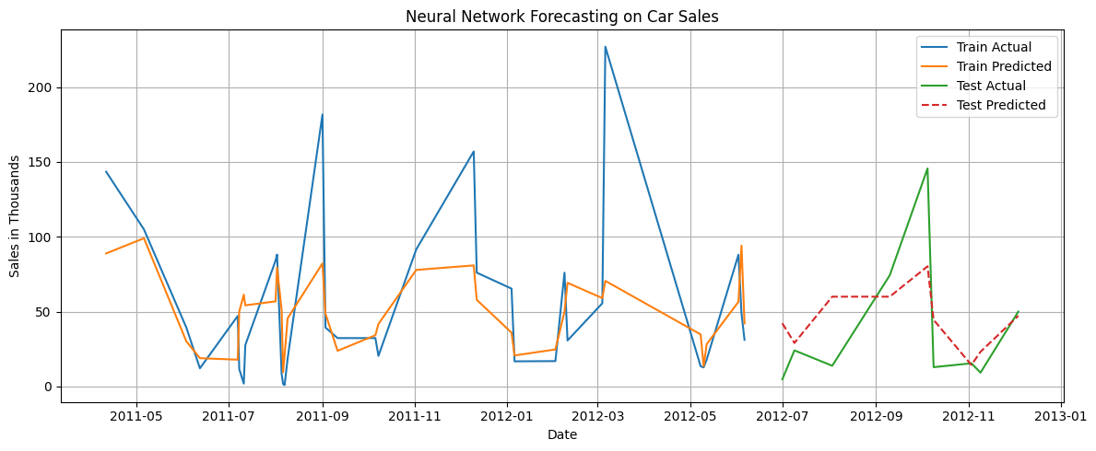

RESULT:
Thus the program has been executed successfully

