EXP:9  17/04/2025 | Develop vector auto regression model for multivariate time series data forecasting.

AIM:
To develop a Vector Auto Regression (VAR) model for forecasting multiple interdependent time series variables—such as car sales, price, engine size, and horsepower—using historical data.

PROCEDURE:
1) Import Necessary Libraries
import pandas as pd
import numpy as np
import matplotlib.pyplot as plt
from statsmodels.tsa.api import VAR
from statsmodels.tools.eval_measures import rmse

2) Load and Preprocess the Data
df = pd.read_csv("Car_sales.csv")
df['Latest_Launch'] = pd.to_datetime(df['Latest_Launch'], errors='coerce')
df = df.dropna(subset=['Latest_Launch'])

df = df[['Latest_Launch', 'Sales_in_thousands', 'Price_in_thousands', 'Engine_size', 'Horsepower']]
df = df.dropna()

df = df.groupby('Latest_Launch').mean().sort_index()

3)Check Stationarity and Difference the Data
df_diff = df.diff().dropna()

4)Split Dataset into Train and Test Sets
n_obs = 10
train = df_diff[:-n_obs]
test = df_diff[-n_obs:]

5)Fit the VAR Model
model = VAR(train)
results = model.fit(maxlags=15, ic='aic')

6) Inverse Differencing for Actual Values
last_values = df.iloc[-n_obs - 1:-1]
forecast_values = forecast_df.cumsum() + last_values.values

actual = df[-n_obs:]
predicted = pd.DataFrame(forecast_values, index=test.index, columns=test.columns)

7)Forecasting
forecast_input = train.values[-results.k_ar:]
forecast = results.forecast(y=forecast_input, steps=n_obs)
forecast_df = pd.DataFrame(forecast, index=test.index, columns=test.columns)

8)Visualize Results
plt.figure(figsize=(12, 6))
for col in df.columns:
plt.plot(actual.index, actual[col], label=f'Actual {col}')
plt.plot(predicted.index, predicted[col], linestyle='--', label=f'Forecast {col}')
plt.legend()
plt.title('VAR Forecast vs Actual')
plt.grid(True)
plt.tight_layout()
plt.show()

OUTPUT:
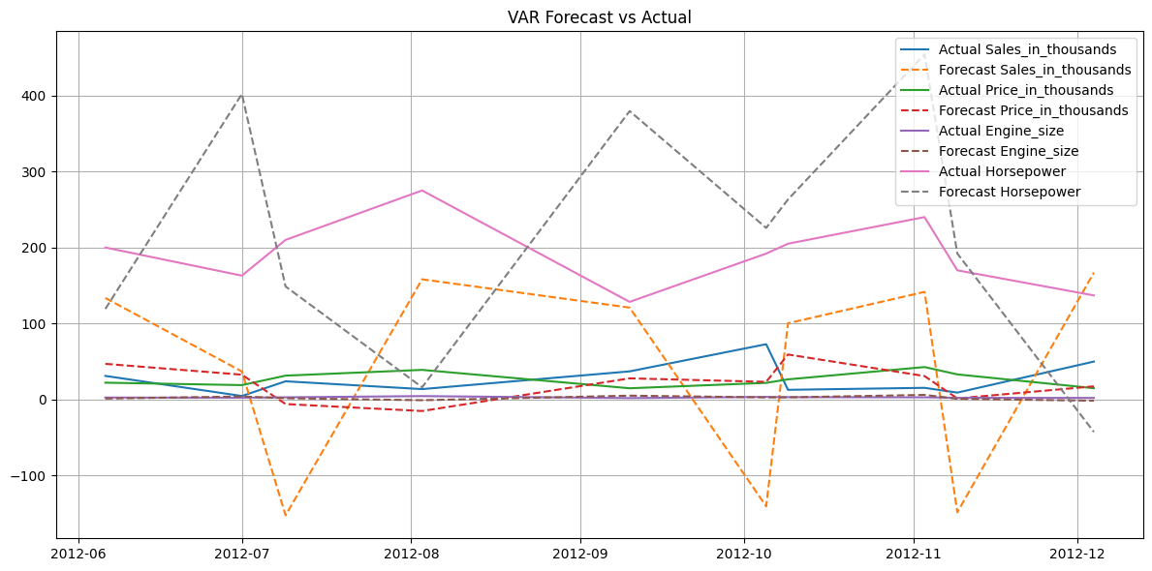

9)Calculate RMSE for Each Variable\
for col in df.columns:
print(f'{col} RMSE: {rmse(actual[col], predicted[col]):.2f}')

OUTPUT
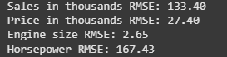

RESULT:
Thus the program has been executed successfully

