EXP:8  17/04/2025 | Create an ARIMA model for time series forecasting

AIM:
To analyze car sales data over time and develop an ARIMA time series forecasting model that predicts future sales based on historical trends.

PROCEDURE:
1) Import Necessary Libraries
import pandas as pd
import numpy as np
import matplotlib.pyplot as plt
from statsmodels.tsa.arima.model import ARIMA
from statsmodels.tsa.stattools import adfuller
from pandas.plotting import register_matplotlib_converters

register_matplotlib_converters()

2) Load and Inspect the Dataset
# Load the CSV file
df = pd.read_csv("Car_sales.csv")

# Display first few rows
df.head()

3) Preprocess the Data
df['Latest_Launch'] = pd.to_datetime(df['Latest_Launch'], errors='coerce')
df = df.dropna(subset=['Latest_Launch', 'Sales_in_thousands'])
ts = df.groupby('Latest_Launch')['Sales_in_thousands'].sum().sort_index()
ts.head()

OUTPUT:
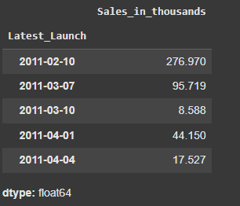

4) Visualize the Time Series
plt.figure(figsize=(12, 5))
plt.plot(ts, marker='o')
plt.title('Car Sales Over Time')
plt.xlabel('Launch Date')
plt.ylabel('Sales in Thousands')
plt.grid(True)
plt.tight_layout()
plt.show()
OUTPUT:
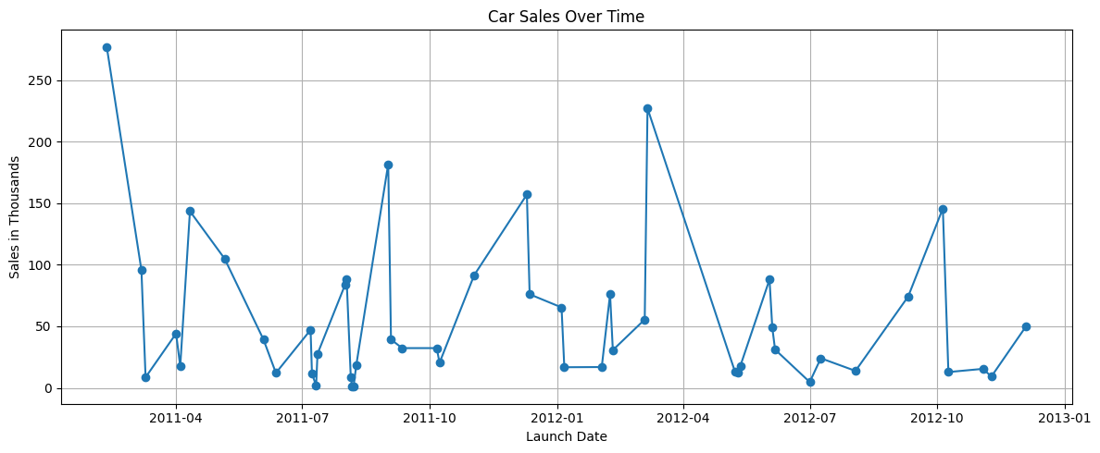

5) Check for Stationarity (ADF Test)
result = adfuller(ts)
print("ADF Statistic:", result[0])
print("p-value:", result[1])
print("Critical Values:")
for key, value in result[4].items():
print(f" {key}: {value}")

OUTPUT:
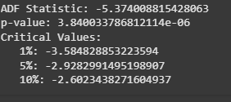

6) Fit ARIMA Model
model = ARIMA(ts, order=(1, 0, 1))
model_fit = model.fit()
print(model_fit.summary())

OUTPUT:
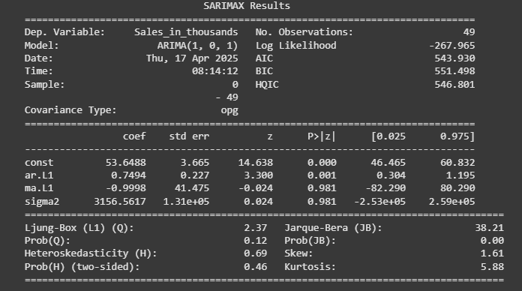

7) Forecast Future Sales
# Forecast next 10 time periods
forecast = model_fit.forecast(steps=10)

# Plot the forecast
plt.figure(figsize=(12, 5))
plt.plot(ts, label='Historical Sales')
plt.plot(forecast.index, forecast, label='Forecasted Sales', color='red', marker='o')
plt.title('ARIMA(1,0,1) Model Forecast')
plt.xlabel('Launch Date')
plt.ylabel('Sales in Thousands')
plt.legend()
plt.grid(True)
plt.tight_layout()
plt.show()

OUTPUT
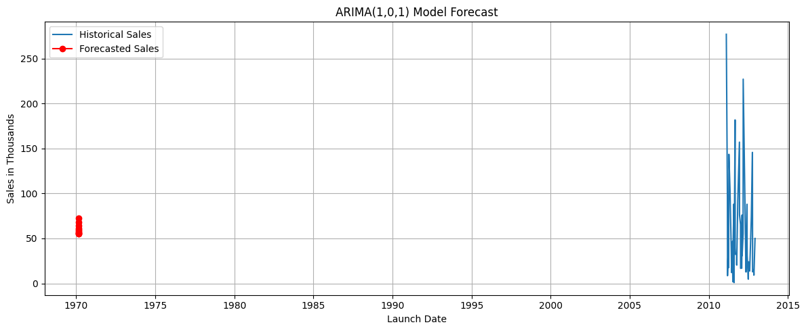

7)Show Forecasted Values
print("Forecasted Sales (next 10 periods):")
print(forecast)

OUTPUT:
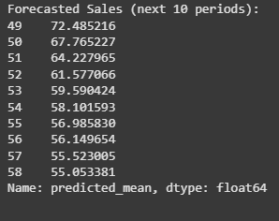

RESULT:
Thus the program has been executed successfully

