EXP:7  10/04/2025 | Implement program for decomposing time series data into trend and seasonality

AIM:
To analyze the car sales time series data using additive and multiplicative decomposition methods, in order to identify and visualize the underlying trend, seasonality, and residual components.

PROCEDURE:
1) Import Necessary Libraries
import pandas as pd
import matplotlib.pyplot as plt
from statsmodels.tsa.seasonal import seasonal_decompose

2) Load and Inspect the Dataset
df = pd.read_csv("/content/sample_data/Car_sales.csv")

3) Convert Date Column and Set Index
df['Latest_Launch'] = pd.to_datetime(df['Latest_Launch'], errors='coerce', infer_datetime_format=True)
df = df.dropna(subset=['Latest_Launch'])

4)Perform Additive Decomposition (6-Month Period)
sales_ts = df.groupby('Latest_Launch')['Sales_in_thousands'].sum().sort_index()

5)Resample to monthly data
sales_ts = sales_ts.resample('M').sum().fillna(0)

6) Decompose with a seasonal period
decomposition = seasonal_decompose(sales_ts, model='additive', period=6)

7) Shift series to make all values positive
shifted_ts = sales_ts + 1)

8)Multiplicative decomposition
multiplicative_decomp = seasonal_decompose(shifted_ts, model='multiplicative', period=6)
fig2 = multiplicative_decomp.plot()
fig2.set_size_inches(12, 10)
plt.suptitle("Multiplicative Decomposition (Shifted Series)", fontsize=18, y=1.02)
plt.tight_layout(rect=[0, 0.03, 1, 0.95])
plt.show()

OUTPUT:
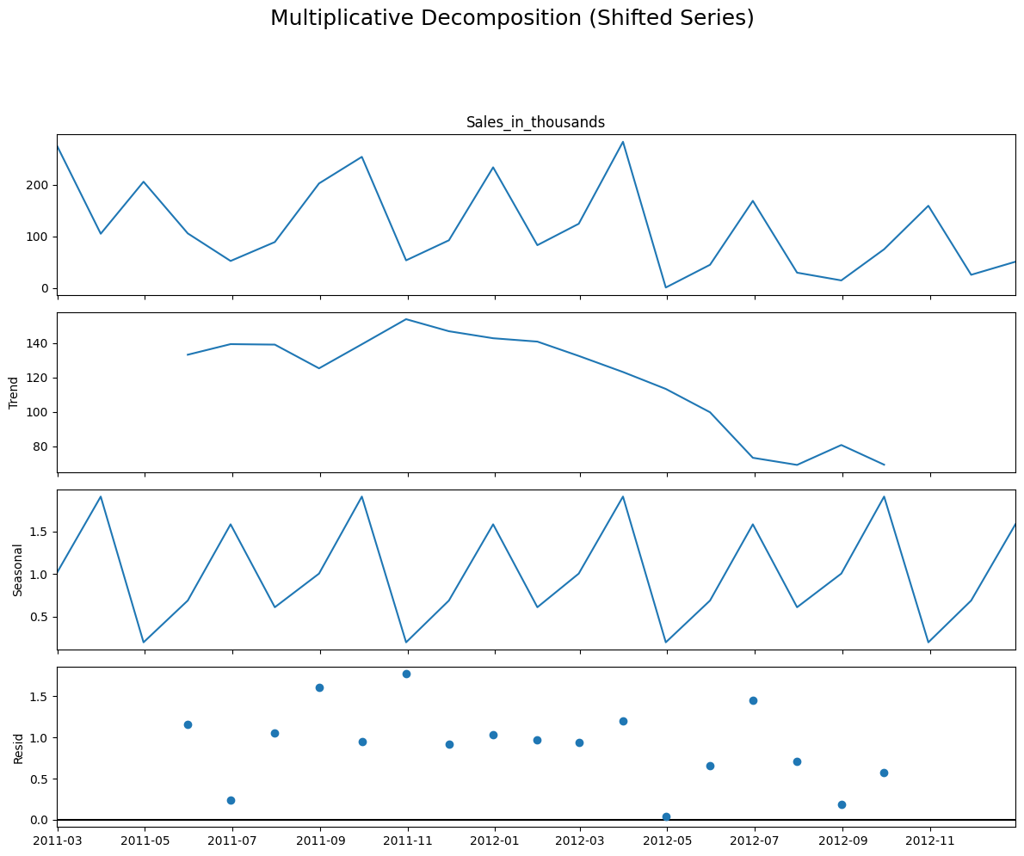

RESULT:
Thus the program has been executed successfully

