**Assignment/Report Cover Sheet**

|  |  |  |
| --- | --- | --- |
| Name | Matric Number | Signature |
| Muhammad Hafiz Bin Abu Bakar | 73615 | Hafiz |
| Jovian Jayome Anak Nyimbong | 70019 | Jov |
| Muhammad Faris bin Musa | 73609 | Faris |
| Mohd Farhan bin Mohd Sukri | 73580 | Farhan |
| Shawn Francis Patrick Octothus | 76749 | Shawn |
| Vadrianey Anak Asas | 72720 | Vad |
| Mohd Ibrahim bin Khushi Mohd | 70485 | Ahim |

|  |  |  |  |  |  |
| --- | --- | --- | --- | --- | --- |
| Subject Code: **TME3413** | | Subject Name: **Software Engineering Laboratory G02** | | | Group Name: **Membuaya with U** |
| Assignment Title: | **Project Proposal (10%)** | | Lecturer: | **Ts. Nurfauza binti Jali** | |
| Due Date: **21th November 2022** | | | Date Submitted: **18th November 2022** | | |
| Project Title: **Counselling Web Service With Unit Kaunseling Dan Psikologi Sibu** | | | | | |

This cover sheet must be completed, signed and firmly attached to the front of the submission. All work must be submitted by the due date. If an extension of work is granted, an assignment extension acknowledgement slip must be signed by the lecturer/tutor and attached to assignment. Please note that is your responsibility to retain copies of your assignment.

|  |
| --- |
| ***Plagiarism and Collusion are methods of cheating that falls under Peraturan Akademik Universiti Malaysia Sarawak para 11: Etika Akademik***  **Plagiarism**  Plagiarism is the presentation of work which has been copied in whole or in part from another person’s work, or from any other source such as the internet, published books or periodicals without due acknowledgement given in the text.  **Collusion**  Collusion is the presentation of work that is the result in whole or in part of unauthorized collaboration with another person or persons.  Where there are reasonable grounds for believing that cheating has occurred, the only action that may be taken when plagiarism or collusion is detected is for the staff member not to mark the item of work and to report or refer the matter to the Dean. This may result in work being disallowed and given a fail grade or if the circumstances warrant, the matter may be referred to a Committee of inquiry for investigation. Such investigation may result in the matter being referred to the University Discipline Committee, **which** has the power to exclude a student. |
| **Note:** Assignments are returned after being assessed by lecturer and to be collected from the lecturer’s office. Students should endeavour to collect their assignments prior to commencement of next semester. All unclaimed assignments become the property of the faculty and will become subject to destruction. |
| **Student’s Statement:**  I / We certify that I / We have not plagiarized the work of others or participated in unauthorized collusion when preparing this assignment. I / We also certify that I / We have taken proper case in safeguarding my / our work and have made all reasonable efforts to ensure that may work not be able to be copied. |

|  |
| --- |
| **MARK :** |

**The Proposal of**

**Counselling Web Service With Unit Kaunseling Dan Psikologi Sibu**

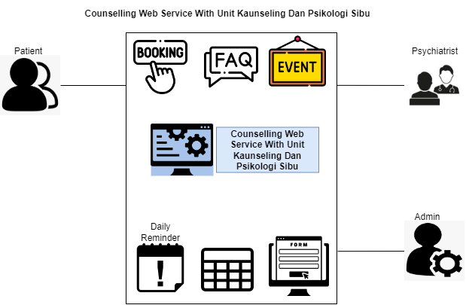





**Table of Content**

Abstract 4

1. Introduction 5

1.1. Company Background 6

1.2. Team Background 7

2. Problem statement 9

3. Project Objectives 10

4. Project Perspective 11

5. Project Scope 13

5.1. System Environment 14

5.2. System Functionality 16

6. Software Methodology 20

7. Task Allocation & contribution 24

8. Team Goals 27

9. Expected Result / Deliverables 28

9.1. Working System 28

9.2. System Artefacts/Documentation 29

10. Project planning 30

11. References 34

**List of Figures**

Figure 1 - Our Team with the representative of Unit Kaunseling Dan Psikologi Sibu, Puan Hamidah. 6

Figure 2: Unit Kaunseling dan Psikologi Sibu organization with the tagline 6

Figure 3: Group members of Membuaya with U 7

Figure 4: Membuaya with U Official Logo 8

Figure 5: Detailed System Architecture of the Counselling Web Service With Unit Kaunseling Dan Psikologi Sibu 11

Figure 6: System Modules for the Counselling Web Service With Unit Kaunseling Dan Psikologi Sibu 16

Figure 7: Agile Scrum Methodology – The Scrum process. *Note*. Source: (Krusche & Company, 2022) 21

Figure 8: Timeline for Planning and Proposal. 32

Figure 9: Timeline for Developing the System and Initial Report. 32

Figure 10: Timeline for Modification, Maintenance, Testing, and Completion of Project 33

**List of Table**

Table 1: System Environment for the Counselling Web Service With Unit Kaunseling Dan Psikologi Sibu 14

Table 2: Explanation of System Modules for the Counselling Web Service With Unit Kaunseling Dan Psikologi Sibu 19

Table 3: Task Allocation, Responsibilities and Contribution of Team Members 26

Table 4: Description of System Artefacts / Documentation Involved 29

Table 5: Project Schedule 31

# Abstract

Many people were affected when the Covid epidemic erupted in 2019. Not only are Covid cases on the rise, but so is mental health. Mental health is a major issue that should not be overlooked. That is why our client, the Unit Kaunseling Dan Psikologi Sibu, is considering various options to address this, one of which is a counselling appointment. The problem is that our client's current approach, manual booking, is very outdated and slow. When we discuss mental health, we know that the patient must be approached and treated because they do not know how to manage themselves in the first place. To solve this, a solution must be devised, which is what we, Membuaya, with U planned to achieve. The web application will be developed on us based on requirements which has been discussed and agree between the client and us, the developers. To better understand how Unit Kaunseling and Psikologi Sibu manage patients, we conducted an interview with one of the organizer's representatives, Puan Hamidah Binti Khushi Mohd. With the information, we were able to sort out potential results for developing our website such that it met the client's criteria. We also hope that when the project is completed our client's problems will be solved using the approach given by our team.

# Introduction

Most patients are ashamed to seek treatment from a psychiatrist because most hospitals only accept walk-ins. This type of patient is afraid that if they walk in need of assistance, the people around them would look at them differently. Our client, Unit Kaunseling Dan Psikologi Sibu, is still employing the old way of booking an appointment with a specialist by walking in. In order to overcome this, our group decides to help them by creating an appointment booking system via web application. This will be called as Counselling Web Service With Hospital Sibu. Our customer, based in Hospital Sibu, Sarawak, has been dealing with numerous clients for the past 20 years. Aside from face-to-face counseling, Unit Kaunseling Dan Psikologi Sibu promotes extra services such as physiotherapy and participatory activities such as family day. Our team will develop Counselling Web Service with Unit Kaunseling Dan Psikologi Sibu based on the client's requirements and specifications. A little bit about psychology disorder is persistently dysfunctional thinking, feeling, or behaviour pattern that significantly affects the person and is seen as abnormal in their culture or community (Stangor & Walinga, 2014). The bio-psycho-social model states that biological, psychological, and social factors all contribute to psychological diseases (Stangor & Walinga, 2014).

## Company Background

The name of organization would be Unit Kaunseling Dan Psikologi Sibu which is under Hospital Sibu. It was established after the opening of Hospital Sibu back August 1994. The name of our client would be Hamidah Binti Khushi Mohd, She has employed for 15 years and now currently as Ketua Unit Pegawai Psikologi. The goal is to assist as many patients as possible who have problems with mental awareness as well as other aspects such as providing physiotherapy treatment.

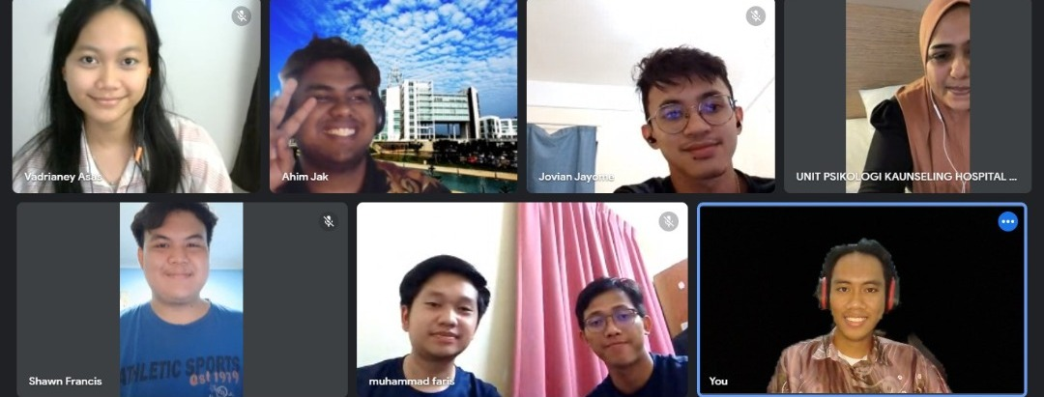

Figure 1 - Our Team with the representative of Unit Kaunseling Dan Psikologi Sibu, Puan Hamidah.



Figure 2: Unit Kaunseling dan Psikologi Sibu organization with the tagline

## Team Background

Our team consists of 7 members. The members are Muhammad Hafiz bin Abu Bakar, Jovian Jayome Anak Nyimbong, Muhammad Faris bin Musa, Mohd Farhan bin Mohd Sukri, Shawn Francis Patrick Octothus, Vadrianey Anak Asas and Mohd Ibrahim bin Khushi Mohd. Our group was named Membuaya with U to represent Sarawak's bujang senang and their fearlessness in facing various challenges to survive. This group was formed in October 2022. Muhammad Hafiz led the group, assigning work assignments to everyone based on their individual skills. Every member carries out their assigned roles and tasks as directed by the team leader. With the guidance of Madam Nurfauza Binti Jali, we formed a group to support Unit Kaunseling Dan Psikologi Sibu and for our project TME 3413 - Software Engineering Laboratory as well. Our motto is that we hope to do our best to aid our client as well as many other patients who require our assistance.

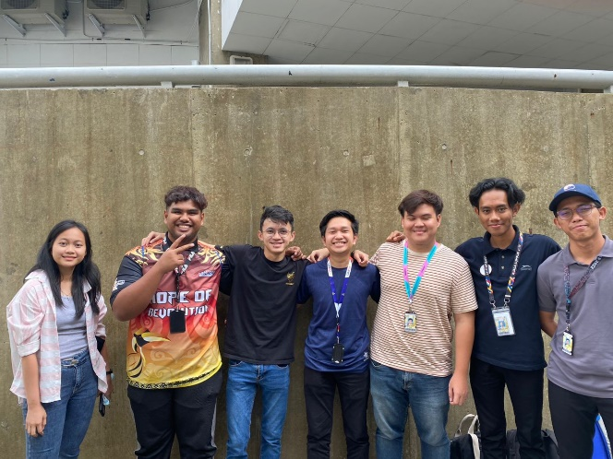

Figure 3: Group members of Membuaya with U



Figure 4: Membuaya with U Official Logo

# Problem statement

Hamidah Binti Khushi Mohd, one of the psychologist's reps, was interviewed to discover about the problems our client is having with the patients. According to the information we collected, Unit Kaunseling Dan Psikologi Sibu only accepts walk-in patients for medical attention. This is difficult for our clients because not every patient is courageous enough to seek medical assistance for mental health issues. Another issue is that patients do not have time to walk into the hospital due to other work; therefore, online appointment booking would be very useful for them because they could book anywhere and at any time. Finally, some patients have a difficult time contacting a specialist to ask some basic health issues, therefore a frequently asked questions (FAQ) section would help them quickly find some basic questions.

# Project Objectives

The objectives in this project are as the following:

1. **To study and analyse the existing system problem and find solution for Unit Kaunseling Dan Psikologi Sibu** - Our aim is to let both counsellor and patient be close to one another through a simple appointment system, whereas the old approach is slow and complex. We were able to learn the most common problems Puan Hamidah encountered while scheduling an appointment with a patient through our interview with her. This allows us to thoroughly analyse how the system should function and provide her with our best option.
2. **To design a system based on our client's requirements. -** During our interview with Puan Hamidah, she mentioned some additional requirements, such as a FAQ area or a bulletin board for patients. We collect these criteria as our fundamental design and develop our system so that we may follow her satisfaction to create a high-performance system later on.
3. **To test and assess the build system in accordance with the client's specifications in order to identify any errors and develop further based on the client's feedback -** Once the system is completed, we will test it to look for errors and then offer it to our clients as a beta program to determine if the created system is good or needs further work in terms of reliability and so on. This is done so that when it is released to patients and widely used by other counsellors, they will not encounter any issues when using our high-performance system.

# Project Perspective

Counselling Web Service With Unit Kaunseling Dan Psikologi Sibu is a web-based system. It helps the counsellor to keep track of their appointment with the patient. From the system patient can also know when their appointment for counselling session is. After booking, patients will be given a reference form to use when they visit to the counsellor. Any updates or counsellor working timetable will be updated in the system. This web application development will make the daily operations of Unit Kaunseling Dan Psikologi Sibu easier.

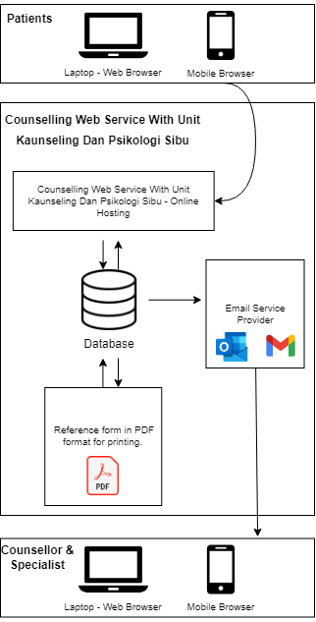

Figure 5: Detailed System Architecture of the Counselling Web Service With Unit Kaunseling Dan Psikologi Sibu

Referring to Figure 5, patients and clients can access the system from a variety of devices, including a smartphone. Counselling Web Service With Unit Kaunseling Dan Psikologi Sibu contains appointment menu options, FAQ sections, a person to contact option, an event menu, and a daily reminder menu for counsellors.

Counselling Web Service With Unit Kaunseling Dan Psikologi Sibu system provides the functionality for patients as below.

1. To schedule an appointment on the preferred date
2. To have a better understanding of mental health, psychology, or any other related field
3. To learn more about how the system works, read our basic FAQ.
4. To contact a counsellor or specialist via the contact menu
5. To stay up to date on any forthcoming Unit Kaunseling Dan Psikologi Sibu events

# Project Scope

This project requires developing of a web-based web application for Counselling Web Service With Unit Kaunseling Dan Psikologi Sibu. This web application will coordinate appointments and other services that Counselling Web Service provides with Unit Kaunseling Dan Psikologi Sibu. The web application will also be responsible for maintaining a relevant record of patients and their sessions with their psychiatrist for records purposes and allowing for the psychiatrist in charge to be able to track their patients’ well-being.

This web application will have two primary users that will be involved, mainly the patient and the counsellor. The web application will also provide relevant information regarding the hospital that could prove useful for potential patients and site-visitors. For site-visitors and patients, they will be able to view useful information regarding the hospital and can also schedule or book an appointment with a counsellor from a list of available slots for appointments. After the appointment is booked, the patient will receive reference form and reminders regarding the booking via e-mail after the booking is done. Suppose the patients is unable to make their scheduled appointment date. In that case, they will have to inform their counsellor by calling through provided contact number, and counsellor will cancel the appointment through the web application. If the patient is able to attend their scheduled appointment, the reference form will be used for follow-up during the next session.

## System Environment

Table 1 shows the possible system environment for the Counselling Web Service With Unit Kaunseling Dan Psikologi Sibu. Clients, patients, and the development team should be able to use the settings with ease in the future.

|  |  |  |  |
| --- | --- | --- | --- |
| Environment | Software | Hardware | System Requirements |
| Development | Operating System - macOS | Personal Computer -  PCs (Desktop / Laptop  / Notebook)  Mobile Devices  (Smartphones /  Tablets) | Stable Internet  Connection |
| Operating System - Windows 11 |
| Source Code Editor - Visual  Studio Code |
| Source Code Editor – Notepad ++ |
| Web Hosting - 000webhost.com |
| Local hosting - XAMPP Server |
| Graphics Editor – Adobe Illustrator 2019 |
| Delivered | Web Browser - Google Chrome |
| Web Browser - Safari |
| Email Application - Google Mail App, Outlook |

Table 1: System Environment for the Counselling Web Service With Unit Kaunseling Dan Psikologi Sibu

The Counselling Web Service with Unit Kaunseling Dan Psikologi Sibu will be developed using some common language in web development so that we can build a web that we can refer to from many sources during development, debugging, and testing later. The following are the components of the development language:

• HTML

• CSS

• JavaScript

• PHP

• MySQL.

## System Functionality

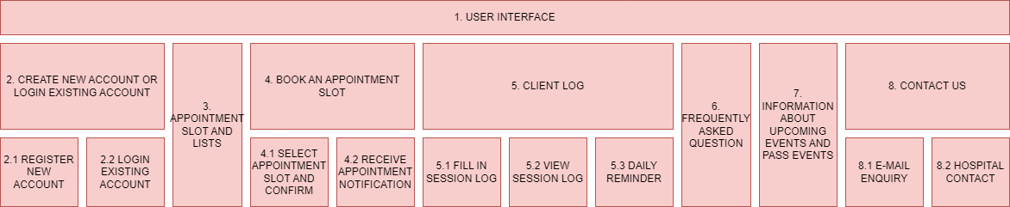

Figure 6: System Modules for the Counselling Web Service With Unit Kaunseling Dan Psikologi Sibu

The functionality and description of the System Modules for the Counselling Web Service With Unit Kaunseling Dan Psikologi Sibu are as per below:

|  |  |  |  |
| --- | --- | --- | --- |
| Module | | Functions | Description |
| 1. User interface | | User able to navigate through the website easily | All the button, link, photos, videos, and navigation tools are user-friendly and organized neatly. |
| 2. Create new account or login existing account | 2.1 - Register new account | User need to create a new account before making an appointment | A registered account by counsellor is required to save a patient's progress and maintain track of their appointment history. |
| 2.2 - Login existing account | User need to login existing account before making an appointment | Counsellor must log in to any existing account to continue their progress with patients. |
| 3. Appointment slots and lists | | When the user clicks on the navigation button for appointment they will lead to the other window where the information about the appointment slots and list will be display. | The user can view all available slot that are free to be book, so that they can tally with their free time. |
| 4. Book an appointment slot | 4.1 – Select appointment slot and confirm | User able to book the desired appointment date and time | There will be a multiple choice of date and time that they can choose based on the availability of the counsellor time. |
| 4.2 – Receive appointment notification | To notify that their booking is confirm and as the alert remainder. | When the user books an appointment, they will get a notification about the confirmation regarding their booking and they also will be notified when the date for the counselling is almost near. |
| 5. Client log | 5.1 – Fill in session log | User can fill the log session after the session | To keep update about the patient after the counselling session is over |
| 5.2 – View session logs | User able to view back all the previous session logs. | User can refer back to the old session logs of the patient. It also served as the reference logs of the patient. |
| 5.3 – Daily Reminder | The user will interact with reminders to take a little nap or to stay hydrated. | The user will be encouraged to stay healthy. |
| 6. Frequently asked question | | User (admin) able to add frequently asked question for patients about the system. | User (patient) able to search for their desired question. |
| 7. Information about the upcoming and pass events | | User (admin) able to update incoming or pass events. | User (patient) able to find the information about the clinic through this site. |
| 8. Contact us | 8.1 – E-mail enquiry | User can send an email to counsellor | The option of enquiry will help the user to communicate with the counsellor. |
| 8.2 – Clinic contact info | User can view the information regarding the clinic | All the information about how to contact the clinic can be add through this site. |

Table 2: Explanation of System Modules for the Counselling Web Service With Unit Kaunseling Dan Psikologi Sibu

# Software Methodology

It is hard to maintain track of the workflow and project documentation in the world of software development without an effective approach to manage them. It is crucial since it influences how well the project will be completed. Various software is planned, designed, developed, and released; each of these activities calls for intense concentration and teamwork. Software businesses consider software development approaches for this reason in order to assess client needs and construct a reliable business solution on time (Mehta, 2022). Understanding the methodology is essential for greater collaboration and high-quality results. The development method is a simple procedure that consists of a few processes, phases, and rules that the development team adheres to up until your software is not released. Any software project needs a solid methodology since it directs the team to address all of the clients' business requirements in detail and ensures that the final product will be a feature-rich programme. Additionally, it helps both parties interact and execute the software development efficiently and on time. Thus, our group have decided to use Agile Scrum Methodology throughout this project. Agile scrum methodology is a sprint-based project management approach with the objective of providing stakeholders with the greatest possible value (Peek, 2022). Going deeper into the definition of Agile Scrum Methodology, the agile scrum methodology combines the scrum framework and the agile philosophy. Agile refers to incremental development, enabling teams to create projects in manageable chunks. One of the numerous varieties of agile technique is scrum, which is recognised for segmenting projects into sizeable units called "sprints." Agile scrum methodology is advantageous for companies that must complete particular projects fast (Peek, 2022).

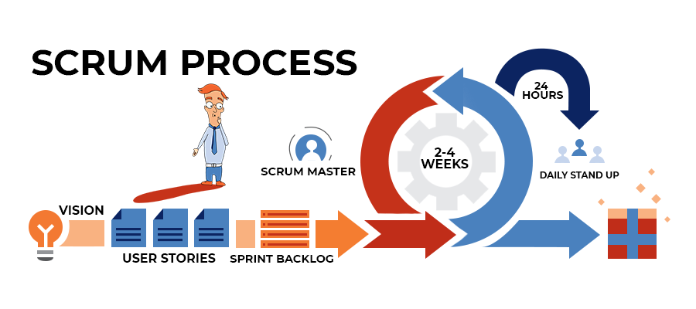

Figure 7: Agile Scrum Methodology – The Scrum process. *Note*. Source: (Krusche & Company, 2022)

Like all Agile methods for developing software, the Scrum frameworks process is iterative and incremental. This means that development tasks are divided into Scrum iterations called Sprints in order to produce a working initial version of the product (Adam, 2022). Sprints, which are typically 2-3-week work cycles, are a timeframe for the development of a set of features known as Epics and User Stories, or simply Stories. A Sprint becomes an incremental phase if it is not possible to complete enough features for a shippable MVP in a single Sprint. Subsequent Sprints then add up to an iteration, or release in Scrum terminology. The sequential development life cycle is divided into smaller cycles by scrum. Following each cycle, the development team, end users, and other stakeholders, including the software owner, evaluate the deployed software. This review guides the next cycle. Agility in the Scrum framework ensures that the final result best satisfies the needs of the client or user (Adam, 2022).

There are 3 important roles in Scrum, which are:

1. Product owner - They focuses on comprehending the demands of the business, the client, and the market before setting the engineering team's workload priorities accordingly (Atlassian, n.d.).
2. Scrum master - In order to improve their use of the scrum process, they coach teams, product owners, and the company (Atlassian, n.d.).
3. Development team - The plan for each sprint is developed by the scrum team. They use their past velocity as a reference to predict how much work they think they can finish over the iteration. The development team receives valuable feedback by maintaining a set iteration duration on its estimation and delivery procedures, which helps iteratively improve forecast accuracy (Atlassian, n.d.).

Our team concentrates on steadily enhancing the project's features or functioning while attempting to adjust to changes within the deadline or timeframe. Scrum includes events that are designed to control and reduce member meetings. When the event's objective is achieved, the remaining events may end, making sure that enough time is spent without wasting it.

Following is a list of Scrum Events:

1. Sprint Planning - An agreed-upon reasonable and reachable Sprint Goal and Sprint Backlog are the results of the Sprint Planning event (Kneafsey, 2022).
2. Daily Scrum - The Daily Scrum gives the Developers a chance to check in, evaluate their progress toward attaining the Sprint Goal, and review and plan their tasks for the following 24 hours (Kneafsey, 2022).
3. Sprint Review - Generally, a Sprint Review occurs on the final day of the Sprint, giving the Scrum Team the chance to show stakeholders the Done Increment (customers, management and anyone else considered relevant and interested) (Kneafsey, 2022).
4. Sprint Retrospective - The Sprint Retrospective is the last event of the Sprint. The Scrum Team evaluates what may be done better for upcoming sprints and how to proceed at this point (Kneafsey, 2022).
5. The Sprint – The Sprint is an event where all of the labour and other activities that take place during the time-boxed development period (Kneafsey, 2022).

Scrum's basic framework is straightforward. The roles, actions, and rules are all simple to comprehend. Its semi-prescriptive approach actually aids in clearing up any confusion in the development process while allowing businesses to inject their unique taste into it (Atlassian, n.d.). It is also the biggest reason why our team believes that by choosing Agile Scrum Methodology, we can ensure that the progress towards the Product Goal is reviewed and altered in accordance with the timeline. If a sprint lasts for too long, the goal may no longer be relevant, and the risks and complexity of the problems may increase. Our team can produce more learning cycles and reduce the risk of expense and effort in a shorter amount of time by having shorter sprints.

# Task Allocation & contribution

|  |  |
| --- | --- |
| **Team Members** | **Roles, Task and Responsibilities** |
| 1. **Muhammad Hafiz bin Abu Bakar** | 1. **Project Manager**  * Manage the project team * Alliance with planning manager to plan the project * Monitor the progress of the project * Managing the project risk * Report the progress of the project to the client * Accumulate the requirement of the system from the client      1. **Quality Manager**  * Evaluates the coding, interface and function of the system * Plan, carry out, and keep track of the tests and inspections of the system to verify their quality |
| 1. **Vadrianey Anak Asas**      1. **Jovian Jayome Anak Nyimbong** | 1. **Planning Manager**  * Plan the overall strategies and process of the project * Monitor all the process and ensuring it follow the plan schedule * Alliance with project manager regarding of the project plan.      1. **Process Manager**  * Designing and ensuring the efficiency of the project workflow * Overview all the project process |
| 1. **Mohd Farhan bin Mohd Sukri**      1. **Muhammad Faris Musa** | 1. **Customer Interface Manager**  * Designing the interface of the system based on the requirement and specification by the client * Take multiple consideration when designing the system according to the specific needs by the client.  1. **Support Manager**  * Provide support in the technical side and troubleshooting in software or hardware * Detecting any problem that occur in the system * Ensuring that all client issues have been successfully resolved |
| 1. **Shawn Francis Patrick Octothus**      1. **Mohd Ibrahim bin Khushi Mohd** | 1. **Implementation Manager**  * Implementing the system develop according to the business condition * Analyse the product demand from external clients * Ensure the implementation process able to finish on time  1. **Test Manager**  * Planning and managing the testing activities * Documentation of the preparation and testing result |

Table 3: Task Allocation, Responsibilities and Contribution of Team Members

# Team Goals

1. Develop a fully functional website application that satisfies the client’s needs at the end of our project.
2. Documentation of our project will be record and review for further inspection and improvement in the future.
3. Works as a team to simulate a real-life working experience as a software developer in a company to familiarize ourself with scrums and sprint method.
4. Punctuality and discipline are must, as we strictly follow the project planning to finish developing the web application on time as expected by the client.

# Expected Result / Deliverables

## Working System

Towards the end of our project, we will be expecting a fully functional website along the modification and maintenance are on tiptop condition. This web application features an appointment booking for user that needs a counsellor to talk about their problems. As the user book for an appointment, they will have to select which psychiatrist are available during that time for them to book the suitable date for their appointment with the psychiatrist. The user will get a ticket notification from the psychiatrist for the booking slot that are chosen by the user. The psychiatrist should update for their availability in the meantime to prevent from clashing occurs, there will be also a person to contact with whenever the user has an urgent matter to talk about. It will show that the user will feel connected within the web application while waiting for the booking. An extra FAQ’s will be provided on the page such as demographic contents or facts that creates awareness for the user to be shared on the other media platforms. Towards the end of the experience, easy to use and well-designed web application are also important factors for the user to navigate through the web application.

## System Artefacts/Documentation

|  |  |
| --- | --- |
| Documentation | Description |
| 1. Project Proposal | A brief overview documentation on our project to propose with the client and project supervisor during the presentation |
| 2. User Manual | Documentation of instruction on behalf of the web application for references by the quality manager and user interacting with the system |
| 1. System Requirements Specification | A more thorough project development prescription that includes all the requirements of the project |
| 1. System Design Specification | Documentation of the system's design structure |
| 1. TSPi Forms | Analysing the information gathered that can help to plan and estimate the process of a project as a guide for the software engineer |

Table 4: Description of System Artefacts / Documentation Involved

# Project planning

|  |  |  |  |  |
| --- | --- | --- | --- | --- |
| No. | Task | Duration | Start | End |
| **1.0** | **Planning and proposal** | **19 Days** | **17/10/2022** | **12/11/2022** |
| 1.1 | Information gathering from client | 2 Days | 17/10/2022 | 18/10/2022 |
| 1.2 | Review and analysis client requirements | 3 Days | 19/10/2022 | 21/10/2022 |
| 1.3 | Documentation of project proposal | 10 Days | 22/10/2022 | 31/10/2022 |
| 1.4 | Evaluation of project proposal | 2 Days | 1/11/2022 | 2/11/2022 |
| 1.5 | Submission of project proposal | 1 Day | 4/11/2022 | 4/11/2022 |
| 1.6 | Presentation of project proposal | 1 Day | 11/11/2022 | 11/11/2022 |
| 1.7 | Project Meeting | 1 Day | 12/11/2022 | 12/11/2022 |
|  |  |  |  |  |
| **2.0** | **Developing the System and Initial Report** | **26 Days** | **14/11/2022** | **9/12/2022** |
| 2.1 | Develop system prototype | 16 Days | 14/11/2022 | 30/11/2022 |
| 2.2 | Testing system prototype | 2 Days | 1/12/2022 | 2/12/2022 |
| 2.3 | Documentation of initial report | 5 Days | 3/12/2022 | 7/12/2022 |
| 2.4 | Submission of initial report | 1 Day | 8/12/2022 | 8/12/2022 |
| 2.5 | Project presentation and demonstration of the system | 1 Day | 8/12/2022 | 8/12/2022 |
| 2.6 | Project meeting | 1 Day | 9/12/2022 | 9/12/2022 |
|  |  |  |  |  |
| **3.0** | **Modification, Maintenance, Testing and Completion of Project** | **31 Days** | **10/12/2022** | **13/01/2023** |
| 3.1 | Modification of the system | 12 Days | 10/12/2022 | 21/12/2022 |
| 3.2 | Testing and maintenance of overall system | 7 Days | 22/12/2022 | 28/12/2022 |
| 3.3 | Project meeting | 1 Day | 29/12/2022 | 29/12/2022 |
| 3.4 | Completion of project | 1 Day | 30/12/2022 | 30/12/2022 |
| 3.5 | Documentation of project | 7 Days | 30/01/2022 | 5/01/2023 |
| 3.6 | Submission final report | 1 Day | 6/01/2023 | 6/01/2023 |
| 3.7 | Preparation for presentation | 2 Days | 10/01/2023 | 11/01/2023 |
| 3.8 | Project presentation and demonstration of the system | 1 Day | 12/01/2023 | 12/01/2023 |
| 3.9 | Project handover | 1 Day | 13/01/2023 | 13/01/2023 |

Table 5: Project Schedule

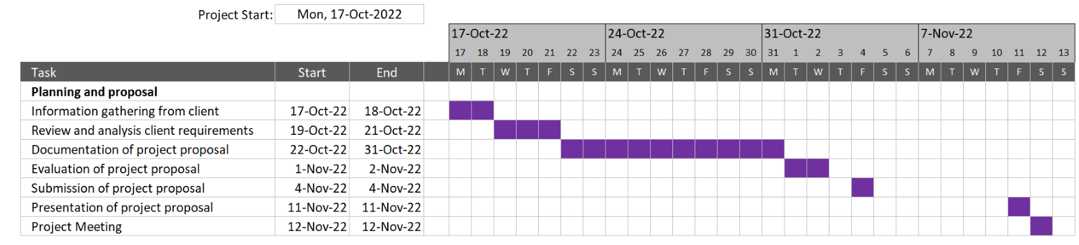

Figure 8: Timeline for Planning and Proposal.

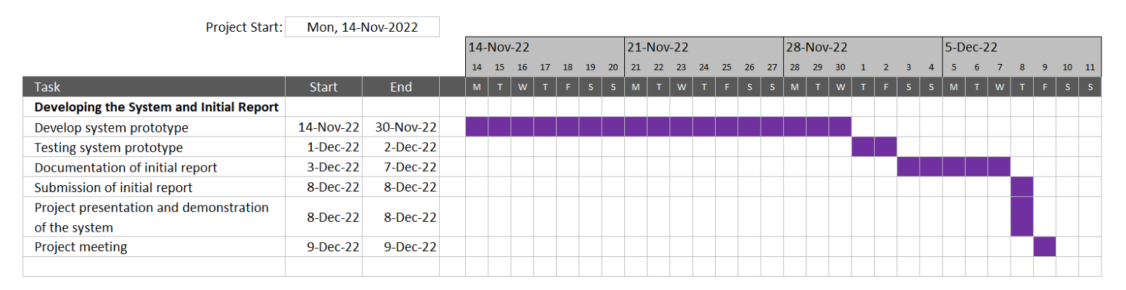

Figure 9: Timeline for Developing the System and Initial Report.

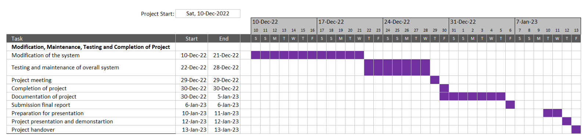

Figure 10: Timeline for Modification, Maintenance, Testing, and Completion of Project

# References

1. Adam, J. (2022, March 30). *Agile software development with Scrum*. K&C. <https://kruschecompany.com/agile-software-development-with-scrum-framework/>
2. Atlassian. (n.d.). *What is Scrum?* Retrieved November 2, 2022, from <https://www.atlassian.com/agile/scrum>
3. Kneafsey, S. (2022, January 26). *The Five Scrum Events*. TheScrumMaster.co.uk. <https://www.thescrummaster.co.uk/scrum/the-five-scrum-events/>
4. Mehta, P. (2022, July 13). *What is Software Development Methodology?* POSITIWISE. <https://positiwise.com/blog/what-is-software-development-methodology/>
5. Peek, S. (2022, June 29). *What Is Agile Scrum Methodology?* Business News Daily. <https://www.businessnewsdaily.com/4987-what-is-agile-scrum-methodology.html>
6. Stangor, C., & Walinga, J. (2014). *Introduction to Psychology – 1st Canadian Edition.* BCcampus.

TSP Student Information Sheet: Form Info

Name: Muhammad Hafiz bin Abu Bakar Instructor: Ts. Nurfauza binti Jali

Date: 4th November 2022____________ Number of College Credits:73______

Major: Software Engineer_____________________ Expected Graduation Date:_1/11/2024__

Briefly describe your relevant experience and interests:

Back during school days I’m learn about IT more to smartphones such as rooting, custom ROM and jailbreak. I received my first laptop during form 5, which I’m keener to learn about computer architecture such as RAM and so on. I start my first coding experiences when I try Linux which I do basic coding in there based on YouTube. Then I slowly learn other supercomputer language, even several software such as Adobe Illustrator 2019 and Adobe Premiere Pro 2022.

Briefly describe your work on other team projects:

Based on my experience, I usually the one who lead my team in any project. Because I can also learn based on another people opinion and grow my maturity and leadership skill. Almost every project work so well except of course need to co-operate with free riders and so on.

Briefly describe any leadership or management positions you have held (at work or in clubs/ organization):

I currently act as Vice President for PERTEKMA, student associations of FKTSM for almost 2 years. I acted as program manager for many events held on FSKTM, one of the latest events I handle is 60 Minutes Talk With SAINS which lasts for 6 months. Another event that lately I handle as project manager was Hi-Tea with 2019-2021 PERTEKMA held at Imperial Hotel during Jun 2022 which is personally one of the best yet I organize.

State your team preferences, if any:

I prefer teammates which capable of doing fast work like me. I don’t mind if they are cannot catchup with me but as long as they asking me to guide them then I don’t have any issues. Moreover, it would be very nice to see if each teammate and myself manage to work together as team without leaving one another behind.

|  |  |  |  |  |  |  |  |
| --- | --- | --- | --- | --- | --- | --- | --- |
| **List your class schedule and other times when you have scheduled activities such as work, clubs, sports teams, etc.** | | | | | | | |
| Time | Mon | Tues | Wed | Thurs | Fri | Sat | Sun |
| 800-900 |  | TMF3113 | SSU1023 | TMF3113 |  |  |  |
| 915-1015 | TME3423 |  | SSU1023 | TMF3113 |  |  |  |
| 1030-1130 | TME3423 |  | SSU1023 |  |  |  |  |
| 1145-1245 |  | TME3033 |  |  |  |  |  |
| 1300-1400 |  | TME3033 |  |  | FRIDAY PRAYER |  |  |
| 1415-1515 |  | TME3033 |  | TME3413 |  |  |  |
| 1530-1630 |  | TME3413 |  | TME3413 |  |  |  |
| 1645-1745 |  | TME3423 |  | TMF3012 |  |  |  |

|  |
| --- |
| Rank from 1 (least) to 5 (most) your preferences for serving in the following team roles: |
| Team Leader 1 2 3 4 5 |
| Development Manager 1 2 3 4 5 |
| Planning Manager 1 2 3 4 5 |
| Quality/Process Manager 1 2 3 4 5 |
| Support Manager 1 2 3 4 5 |

TSP Student Information Sheet: Form Info

Name: Shawn Francis Patrick Octothus Instructor: Ts. Nurfauza binti Jali

Date: 1st November 2022 Number of College Credits: 3

Major: Software Engineering Expected Graduation Date: 2024/2025

Briefly describe your relevant experience and interests:

5 years of experience learning in the field of computer science and information technology with a keen interest of using programming knowledge to create and explore interesting concepts in the digital field and computational science. Programming experience with various programming languages such as C++, Java, PHP, HTML, and basic machine language.

Briefly describe your work on other team projects:

Work on other team project mainly involves programming, with direct work responsibilities of implementing features or modules and testing the program. Bug fixing and solving problems related to the program is also usually the task that is delegated to me.

Briefly describe any leadership or management positions you have held (at work or in clubs/ organization):

Formerly president of Computer Science association from 2018-2019, Secretariate for Student Representative council from 2017-2019, Faculty representative for STEM fair on the years of 2018-2019, STEM Ranger for various programs under faculty from the years of 2017-2018.

State your team preferences, if any:

My preference for a team when it comes to working in one is to have a team that can prioritize communication when it comes to working together. I believe that having proper communication channels when working together can maximize the potential of teamwork and reduce disputes and issues that comes with working in a group of individuals.

|  |  |  |  |  |  |  |  |
| --- | --- | --- | --- | --- | --- | --- | --- |
| **List your class schedule and other times when you have scheduled activities such as work ,clubs, sports teams, etc.** | | | | | | | |
| Time | Mon | Tues | Wed | Thurs | Fri | Sat | Sun |
| 800-900 |  | Class |  | Class | Class |  |  |
| 900-1000 |  |  |  | Class | Class |  |  |
| 1000-1100 | Sports Activities |  | Sports Activities |  | Class |  |  |
| 1100-1200 | Sports Activities |  | Sports Activities |  |  |  |  |
| 1200-1300 | Sports Activities | Class | Sports Activities |  | Sports Activities |  |  |
| 1300-1400 | Sports Activities | Class | Sports Activities | Class | Sports Activities |  |  |
| 1400-1500 |  | Class |  | Class | Sports Activities |  |  |
| 1500-1600 |  | Class |  | Class | Sports Activities |  |  |
| 1600-1700 |  | Class |  |  |  |  |  |
| 1700-1800 |  |  |  | Class |  |  |  |
| 1800-1900 |  |  |  | Class |  |  |  |

|  |
| --- |
| Rank from 1 (least) to 5 (most) your preferences for serving in the following team roles: |
| Team Leader 1 2 3 4 5 |
| Development Manager 1 2 3 4 5 |
| Planning Manager 1 2 3 4 5 |
| Quality/Process Manager 1 2 3 4 5 |
| Support Manager 1 2 3 4 5 |

TSP Student Information Sheet: Form Info

Name: Vadrianey anak Asas Instructor: Ts. Nurfauza binti Jali

Date : 4th November 2022 Number of College Credits: 85

Major: Software Engineering Expected Graduation Date: 31st July 2023

**Briefly describe your relevant experience and interests:**

Software Engineering was not my first choice for my degree. However, when I was offered to continue my study in Software Engineering, I decided to accept what have been offered and determined to do well in these four years of studies. It was a big challenge for me as I was a Biology student with no IT background during my Pre-University studies. It was a blessing for me to have a lot of good friends and caring lecturers who were willing to help and introduced me to this IT world. For the past 3 years in degree, I learned some basic programming languages such as C, C++, Java, HTML, CSS, MySQL and PHP. I can say that my programming skill is still far from excellent thus, I always actively involved in the documentation part of any project to make it fair for my teammates who worked hard covering the coding part. I still have a lot to learn in computer science and I look forward for more exposure in the future.

**Briefly describe your work on other team projects:**

During my third-year of study, I have undergone Industrial Training for 6-months. Throughout the 6-months, I was exposed to the real-world working environment. It was very thrilling as I get to learn a lot from people outside the university. I was assigned to develop a loan management system for the company where I had my internship. I also did a bit programming in some projects during my previous semesters. However, due to my lack of programming skill, I contributed more on the documentation part.

**Briefly describe any leadership or management positions you have held (at work or in clubs/ organization):**

I was actively involved in college and faculty activities during my first year. I was the unit leader of Ethnic and Traditional Unit under Xpresso Club of Sakura College. Our unit participated in a few competitions under my leadership for 2-semesters. I was also one the students who lead and trained dancers for 2019 Citrawarna, representing Sakura College. Other than being active in college, I was assigned as a secretariat for the Student Interaction Room in FCSIT. I was also a crew member for IT Week 2020.

**State your team preferences, if any:**

I would love to work in a team with positive vibe as I believe that being positive allows us to do the work effectively. A positive working environment can help to minimise stress, thus, allowing us to complete our project accordingly.

|  |  |  |  |  |  |  |  |
| --- | --- | --- | --- | --- | --- | --- | --- |
| **List your class schedule and other times when you have scheduled activities such as work ,clubs, sports teams, etc.** | | | | | | | |
| Time | Mon | Tues | Wed | Thurs | Fri | Sat | Sun |
| 800-900 |  | CLASS | RESERVED FOR FYP MEETINGS/  SERVICE LEARNING | CLASS |  |  | CHURCH |
| 900-1000 |  | CLASS |  | CLASS |  | CHURCH |
| 1000-1100 |  | CLASS |  | CLASS |  |  |
| 1100-1200 | CLASS | CLASS |  |  |  |  |
| 1200-1300 |  |  |  |  |  |  |
| 1300-1400 | CLASS |  |  |  |  |  |
| 1400-1500 | CLASS |  | CLASS |  |  |  |
| 1500-1600 |  | CLASS | CLASS |  |  |  |
| 1600-1700 |  |  | CLASS |  |  |  |
| 1700-1800 | CLASS |  | CLASS |  | CHURCH |  |
| 1800-1900 | CLASS |  | LAB |  | CHURCH |  |
| 1900-2000 | CLASS |  | LAB |  | CHURCH |  |

|  |
| --- |
| Rank from 1 (least) to 5 (most) your preferences for serving in the following team roles: |
| Team Leader 1 2 3 4 5 |
| Development Manager 1 2 3 4 5 |
| Planning Manager 1 2 3 4 5 |
| Quality/Process Manager 1 2 3 4 5 |
| Support Manager 1 2 3 4 5 |

TSP Student Information Sheet: Form Info

Name: Muhammad Faris bin Musa Instructor: Ts. Nurfauza binti Jali

Date: 4/11/2022 Number of College Credits: 73

Major: Software Engineering Expected Graduation Date: 2024

Briefly describe your relevant experience and interests:

In terms of experience, I only have some basic beginner experience in the development project such as coding and database. Still need to reshape and learn from someone experience. In terms of interests, I like to develop easy to use, minimalist and helpful application or website for the user. If the application or website are able to be use and give helps to the user, is already a success project in my opinion.

Briefly describe your work on other team projects:

I have work in multiple role in other different project, so basically I’m quite flexible in terms of role in a team project. As long as other team members are able to commit into the project, I will also give my best to make the project successful.

Briefly describe any leadership or management positions you have held (at work or in clubs/ organization):

The latest position that I manage is as the head of nomination and registration unit in MEGAH event. The job basically involve in handling the process to find students who wanted to nominate themselves in this event and handling the registration process on the event day.

State your team preferences, if any:

The most important, someone that able to give cooperation while doing the project. Always asking when there is a problem that need to be solve together. Finally, able to communicate well and understanding his or her role well inside the team.

|  |  |  |  |  |  |  |  |
| --- | --- | --- | --- | --- | --- | --- | --- |
| **List your class schedule and other times when you have scheduled activities such as work ,clubs, sports teams, etc.** | | | | | | | |
| Time | Mon | Tues | Wed | Thurs | Fri | Sat | Sun |
| 800-900 | Class | Class | Class | Class | (Usually free all day) | (Usually free all day) | (Usually free all day) |
| 915-1015 | Class |  | Class | Class |  |  |  |
| 1030-1130 |  |  | Class |  |  |  |  |
| 1145-1245 |  | Class |  |  |  |  |  |
| 1300-1400 |  | Class |  |  |  |  |  |
| 1415-1515 |  | Class |  | Class |  |  |  |
| 1530-1630 | Class | Class | Sport Activity | Class |  |  |  |
| 1645-1745 | Class | Class |  | Class |  |  |  |
| 1800-1900 |  |  |  |  |  |  |  |
| 1915-2015 |  |  |  |  | Club Meeting |  |  |
| 2030-2130 |  |  |  |  | Club Meeting | Club Meeting |  |

|  |
| --- |
| Rank from 1 (least) to 5 (most) your preferences for serving in the following team roles: |
| Team Leader 1 2 3 4 5 |
| Development Manager 1 2 3 4 5 |
| Planning Manager 1 2 3 4 5 |
| Quality/Process Manager 1 2 3 4 5 |
| Support Manager 1 2 3 4 5 |

TSP Student Information Sheet: Form Info

Name: JOVIAN JAYOME Instructor: Dr Fauza

Date :4/11/2022 Number of College Credits:

Major: Software Engineering Expected Graduation Date: 2024

Briefly describe your relevant experience and interests:

I took computer science in my matriculation days so I have the basic of C++ and programming. I’ve learnt Java and C programming language but need more refinement on that.Back in secondary school I joined Solar Car competition and got into 2nd place and I joined robotics competition during my matriculation programme.

Briefly describe your work on other team projects:

My work on other team project was more on interface and a part of it is function.

Briefly describe any leadership or management positions you have held (at work or in clubs/ organization):

I’ve held a captain football club during secondary school and matriculation. I was a vice president for Christian Club in secondary school.

State your team preferences, if any:

My team preferences was more on outspoken people and teamwork. My team should be able to communicate with each other because communication is key

|  |  |  |  |  |  |  |  |
| --- | --- | --- | --- | --- | --- | --- | --- |
| **List your class schedule and other times when you have scheduled activities such as work ,clubs, sports teams, etc.** | | | | | | | |
| Time | Mon | Tues | Wed | Thurs | Fri | Sat | Sun |
| 800-900 | Class | Class | Class | Class |  |  |  |
| 915-1015 | Class |  | Class | Class |  |  |  |
| 1030-1130 |  |  | Class |  |  |  |  |
| 1145-1245 |  | Class |  |  |  |  |  |
| 1300-1400 |  | Class |  |  |  |  |  |
| 1415-1515 |  | Class |  | Class |  |  |  |
| 1530-1630 | Class | Class | Sport Activity | Class |  |  |  |
| 1645-1745 | Class | Class |  | Class |  |  |  |
| 1800-1900 |  |  |  |  |  |  |  |

|  |
| --- |
| Rank from 1 (least) to 5 (most) your preferences for serving in the following team roles: |
| Team Leader 1 2 3 4 5 |
| Development Manager 1 2 3 4 5 |
| Planning Manager 1 2 3 4 5 |
| Quality/Process Manager 1 2 3 4 5 |
| Support Manager 1 2 3 4 5 |

TSP Student Information Sheet: Form Info

Name: Mohd Farhan Bin Mohd Sukri Instructor: Ts. Nurfauza binti Jali

Date: 4th November 2022____________ Number of College Credits: 3______

Major: Software Engineer_____________________ Expected Graduation Date:_2024__

Briefly describe your relevant experience and interests:

I'm interested to design the pages for web application, I've also contributed front end work for previous assignment

Briefly describe your work on other team projects:

Mostly, I support them and asking them whether they need extra helps because we work as one team to accomplish our projects.

Briefly describe any leadership or management positions you have held (at work or in clubs/ organization):

I like to support my team members whenever they need an extra hand to finish the task given

State your team preferences, if any:

____________________________________________________________________________________________________________________________________________________________________________________________________________________________________________________________________________________________________________________________________________________

|  |  |  |  |  |  |  |  |
| --- | --- | --- | --- | --- | --- | --- | --- |
| **List your class schedule and other times when you have scheduled activities such as work ,clubs, sports teams, etc.** | | | | | | | |
| Time | Mon | Tues | Wed | Thurs | Fri | Sat | Sun |
| 800-900 | TME3423 | TMF3113 | EBU1023 | TMF3113 |  |  |  |
| 915-1015 | TME3423 |  | EBU1023 |  |  |  |  |
| 1030-1130 |  |  | EBU1023 |  |  |  |  |
| 1145-1245 |  | TME3033 |  |  |  |  |  |
| 1300-1400 |  | TME3033 |  |  |  |  |  |
| 1415-1515 |  | TME3033 |  | TME3413 | PBI1082 |  |  |
| 1530-1630 |  | TME3413 |  | TME3413 | PBI1082 |  |  |
| 1645-1745 |  | TME3423 |  | TMF3012 |  |  |  |

|  |
| --- |
| Rank from 1 (least) to 5 (most) your preferences for serving in the following team roles: |
| Team Leader 1 2 3 4 5 |
| Development Manager 1 2 3 4 5 |
| Planning Manager 1 2 3 4 5 |
| Quality/Process Manager 1 2 3 4 5 |
| Support Manager 1 2 3 4 5 |

TSP Student Information Sheet: Form Info

Name: Mohd Ibrahim bin Khushi Mohd Instructor: Ts. Nurfauza binti Jali

Date: 4th November 2022____________ Number of College Credits:73______

Major: Software Engineer_____________________ Expected Graduation Date:_1/11/2024__

Briefly describe your relevant experience and interests:

Based on my experience, I usually like to explore more on development of application process. It gives me a huge imagination what can world be in the future.

Briefly describe your work on other team projects:

Usually, I can commit my time in order to accomplish the project. I am very punctual with time management. So, mostly I am involve more on the planning and process of the project

Briefly describe any leadership or management positions you have held (at work or in clubs/ organization):

I am the leader of the previous group project last semester

State your team preferences, if any:

____________________________________________________________________________________________________________________________________________________________________________________________________________________________________________________________________________________________________________________________________________________

|  |  |  |  |  |  |  |  |
| --- | --- | --- | --- | --- | --- | --- | --- |
| **List your class schedule and other times when you have scheduled activities such as work ,clubs, sports teams, etc.** | | | | | | | |
| Time | Mon | Tues | Wed | Thurs | Fri | Sat | Sun |
| 800-900 |  | CLASS | RESERVED FOR FYP MEETINGS/  SERVICE LEARNING | CLASS |  |  |  |
| 900-1000 |  | CLASS |  | CLASS |  |  |
| 1000-1100 |  | CLASS |  | CLASS |  |  |
| 1100-1200 | CLASS | CLASS |  |  |  |  |
| 1200-1300 |  |  |  |  |  |  |
| 1300-1400 | CLASS |  |  |  |  |  |
| 1400-1500 | CLASS |  | CLASS |  |  |  |
| 1500-1600 |  | CLASS | CLASS |  |  |  |
| 1600-1700 |  |  | CLASS |  |  |  |
| 1700-1800 | CLASS |  | CLASS |  |  |  |
| 1800-1900 | CLASS | LAB |  |  |  |  |
| 1900-2000 | CLASS | LAB |  |  |  |  |

|  |
| --- |
| Rank from 1 (least) to 5 (most) your preferences for serving in the following team roles: |
| Team Leader 1 2 3 4 5 |
| Development Manager 1 2 3 4 5 |
| Planning Manager 1 2 3 4 5 |
| Quality/Process Manager 1 2 3 4 5 |
| Support Manager 1 2 3 4 5 |

TSP Student Information Sheet Instructions: Form Info

|  |  |
| --- | --- |
| Purpose | Use this form to describe your interests and experiences |
| General | * Complete this form and give to the instructor during the first laboratory period of the TSP course. * The instructor will use it to make team and role assignments. * The schedule information is needed so that teams can be formed that are able to meet during selected times of the week. * Use additional pages if necessary. |
| Header | Enter   * Your name, the instructor’s name and the date * The number of credits you expect from this course * Your major field of study * Your expected graduation date |
| Relevant Experience and Interests | * List any experience and interests you feel would be helpful to the instructor in making team and role assignments. * Examples would be language fluency, PSP experience, database design and development and so on. |
| Other Team Projects | * List any team experiences you feel would be helpful to the instructor in making team and role assignments. |
| Leadership or Management | * List any leadership or management experiences you feel would be helpful to the instructor in making team and role assignments. * Examples would include a club business manager, work as a teaching assistant, time spent in office work and so on. |
| Team Preferences | * If you have preferences regarding working with particular groups, state them. * You need not make any statement. |
| Schedule | * List the times you have commitments for classes or other activities. * If the times do not precisely line up with those given, mark the rough periods and note below the precise times. |
| Role preferences | * Rank your team role preferences from 1(least desired) to 5 (most desired). * Note that you can list several as 1s or 5s if you feel they are all equally desirable or undesirable. |