**Software Design Specification**

**for**

**Counselling Web Service** **With Unit Kaunseling Dan Psikologi Sibu**

**Version 1.0**

**Prepared by**

**Group Name: Membuaya With U**

|  |  |  |
| --- | --- | --- |
| **Muhammad Hafiz bin Abu Bakar** | **73615** | **73615@siswa.unimas.my** |
| **Jovian Jayome Anak Nyimbong** | **70019** | **70019@siswa.unimas.my** |
| **Muhammad Faris bin Musa** | **73609** | **73609@siswa.unimas.my** |
| **Mohd Farhan bin Mohd Sukri** | **73580** | **73580@siswa.unimas.my** |
| **Shawn Francis Patrick Octothus** | **76749** | **76749@siswa.unimas.my** |
| **Vadrianey Anak Asas** | **72720** | **72720@siswa.unimas.my** |
| **Mohd Ibrahim bin Khushi Mohd** | **70485** | **70485@siswa.unimas.my** |

|  |  |
| --- | --- |
| **Instructor:** | **Madam Nurfauza Binti Jali** |
| **Course:** | **TME3413 Software Engineering Laboratory** |
| **Lab Section:** | **Group 2** |
| **Teaching Assistant:** | **Madam Nurfauza Binti Jali** |
| **Date:** | **27th December 2022** |

Contents

Contents i

Revisions ii

1 Introduction 1

1.1 Purpose 1

1.2 System Overview 1

1.3 Definitions, Acronyms and Abbreviations 2

1.4 Supporting Materials 2

1.5 Document Overview 2

2 Architecture 4

2.1 Overview 4

2.2 System Component 6

3 High Level Design 7

3.1 View / Model Component 1..n 9

Appendix A – Group Log 13

Revisions

| Version | Primary Author(s) | Description of Version | Date Completed |
| --- | --- | --- | --- |
|  |  |  |  |

# Introduction

Membuaya With U will define the programme design specification for the Counseling Web Service With Unit Kaunseling Dan Psikologi Sibu in this section. This paper defines the architecture requirements based on the previously published Software Requirements Specification. The goal of this document, a description of the Counseling Web Service structure, and sources utilised in the creation of this document are all specified on the following section.

## Purpose

Our Counseling Web Service product strategy is reported in this Software Design Specification (SDS). The objective of this paper is to include a high-level design analysis as well as a low-level structure for the platform Counseling Web Service With Unit Kaunseling Dan Psikologi Sibu. The architecture is based on the system's characteristics, capabilities, specifications, and interfaces. Clients will use this web application to book their appointment and other relevant comments. This SDS will handle the reader in detail for our web application product strategy.

## System Overview

Figure 1: System Architecture of the Counselling Web Service With Unit Kaunseling Dan Psikologi Sibu

Our client, Unit Kaunseling Dan Psikologi Sibu requires a system in which they can manage and receive any appointment booking by patients, online. As per the requirement from Unit Kaunseling Dan Psikologi Sibu, our team decided to develop a system for our client to fulfill their request. We have come out with a web application system, called the Counselling Web Service With Unit Kaunseling Dan Psikologi Sibu. This system hopes to help Unit Kaunseling Dan Psikologi Sibu in terms of their daily operational and managerial tasks whereby patient’s appointment management will be improved much further than the current system our client is using. Also, this web application helps Unit Kaunseling Dan Psikologi Sibu and its customers to build a better relationship in terms of connectivity whereby Unit Kaunseling Dan Psikologi Sibu is following the trend to have an official website for their organization.

Patients and clients can access the system from a variety of devices, including a smartphone. Counselling Web Service With Unit Kaunseling Dan Psikologi Sibu contains appointment menu options, FAQ sections, a person to contact option, an event menu, and a daily reminder menu for counsellors.

## Definitions, Acronyms and Abbreviations

Acronyms and Abbreviations

* CSS – Cascading Style Sheet
* HTML – Hypertext Markup Language
* IEEE – Institute of Electrical and Electronic Engineers
* MySQL – Structured Query Language
* PC – Personal Computer
* PHP – Hypertext Preprocessor
* SRS – Software Requirement Specification
* UI – User Interface
* XAMPP – Cross-Platform (X), Apache (A), MariaDB (M), PHP (P), and Perl (P)

## Supporting Materials

For this document, the IEEE formatting requirements are used. Formatting requirements involves the document to be in Arial Font to be in size 11, singled spaced and 1” margins at all sides. Bold letters indicate the main topic and the subtopic for ease of readability of topics desired. All the diagrams and figures included in this document are numbered accordingly in order and a brief description is provided where necessary.

[1] M. Rouse, "3-tier application architecture," 3 April 2007. [Online]. Available: https://searchsoftwarequality.techtarget.com/definition/3-tier-application. [Accessed 27th December 2022].

[2] P. Mirenda, "Software Design Specification Document," 17 March 2006. [Online]. Available: https://lostclouds.com/2Communicate/project/SDS.pdf. [Accessed 27th December 2022].

## Document Overview

This SDS is a document that is specifically for the Counseling Web Service With Unit Kaunseling Dan Psikologi Sibu design process. The Introduction, Architecture, High Level Design, and Appendix are the four sections of this SDS. Regarding the first section, a brief description of this SDS can be found in the Introduction. The top-level design of the system is outlined in the second section, Architecture, which also serves as the foundation for more detailed design work. The elements covered in the Architecture part are further discussed in the High-Level Design section. This section will typically be divided into different documents for the various design areas. Minutes of group meetings, group activities, and other pertinent information are typically included in the Appendix section, where our instructor can evaluate the preparation efforts done for this report.

It is advised to read this Software Design Specification (SDS) from page one to the last for our instructor. We advised our client to only read the Introduction, Architecture, and High-Level Design sections.

# Architecture

The high-level design Component Diagram for the Counseling Web Service is defined in this section. High-Level Design (HLD) refers to the overall system design, which includes all of the specifications and the structure of the application. It comprises a system summary, a description of the database design, and the system architecture. The component diagram is chosen to illustrate the high-level design as it depicts the arrangement of the system components and their interdependencies. A system's components are shown from a high-level perspective in the component diagram. As a result, the Counseling Web Service's design should be split into the following three tiers:

* Interface Layer
* Application Layer
* Data Layer

A tier can also be referred to as a layer in the situation mentioned above. A web page is shown by an interface layer by sending HTML, JS, and CSS-formatted content to the browsers; in essence, it offers some fields or buttons for user interaction. This data is transmitted to the application layer once the user interacts with the interface layer, for as by clicking on a "Login" button. The application layer generates a query, and this information is subsequently sent to the data layer. The application layer then transforms the requested query into a user interface presentation in a particular website page when the data layer executes the given query and gives the result back to it. Counseling Web Service uses PHP because the application layer needs an application server to perform the application's business logic. The Counseling Web Service will use MySQL as the database management system since the data layer is a database management system that offers data access.

## Overview

The Counseling Web Service is divided in a distinct way due to the distinct roles that each component must serve. Figure 2 displays the Counseling Web Service system's component diagram at a high-level design.

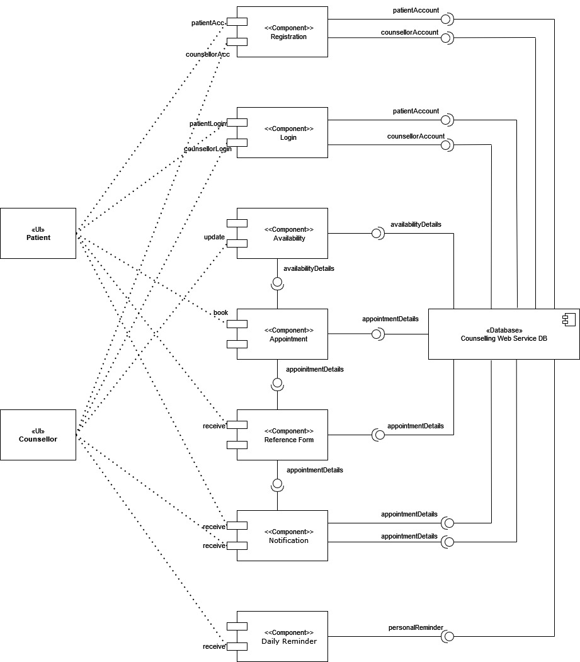

Figure 2: Component Diagram of Counselling Web Service

The component of the system consists of:

* Registration
* Login
* Availability
* Appointment
* Reference form
* Notification
* Daily reminder

## System Component

**2.2.1 Registration**

Registration allows user to insert their personal data information to the database to create an account for the system. This information includes full name, date of birth, email,password and other personal information.

**2.2.2 Login**

The login features allow the administrator and the patient to view the dashboard. Successful login allows them to use the available features. Admin can overview the bookings and patients can book their appointment.

**2.2.3 Availability**

This feature allows the admin and the patient to view the availability of the counsellors.

**2.2.4 Appointment**

The patients can book the appointment and browse the counsellor’s schedule to book for the suitable time for both counsellors and patients. Administration can update or delete the doctor’s and the patient’s information. First, the patient can choose the date and the preferred counsellor. Next the patient can view the availability of the counsellor and book their appointment.

**2.2.5 Reference form**

Reference form feature is a form that will be available if the booking has been made. The reference form will provide the booking details that has been made to the. patients

**2.2.6 Notification**

The notification features are to notify if any booking changes has been made or created. This also allow the counsellor to be notified if any patients made their booking with the chosen counsellor.

**2.2.6 Daily reminder**

The daily reminder features serve as a pop-up reminder where the system will remind the administration to take care of their well-being. For example, it will remind the administration to drink water or have a five-minute break.

# High Level Design

High-level design (HLD) explains the architecture that would be used for developing a software product. The architecture diagram provides an overview of an entire system, identifying the main components that would be developed for the product and their interfaces. To illustrate the dynamic behavior of Counseling Web Service. Patient and admin state charts are used. Both state charts outline behaviour within the perspective of customer and administrator entities. The figure below outlines the overall Counseling Web Service through the respective entity. The system is hosted on a live server on the Internet and can be accessed publicly using its web address.

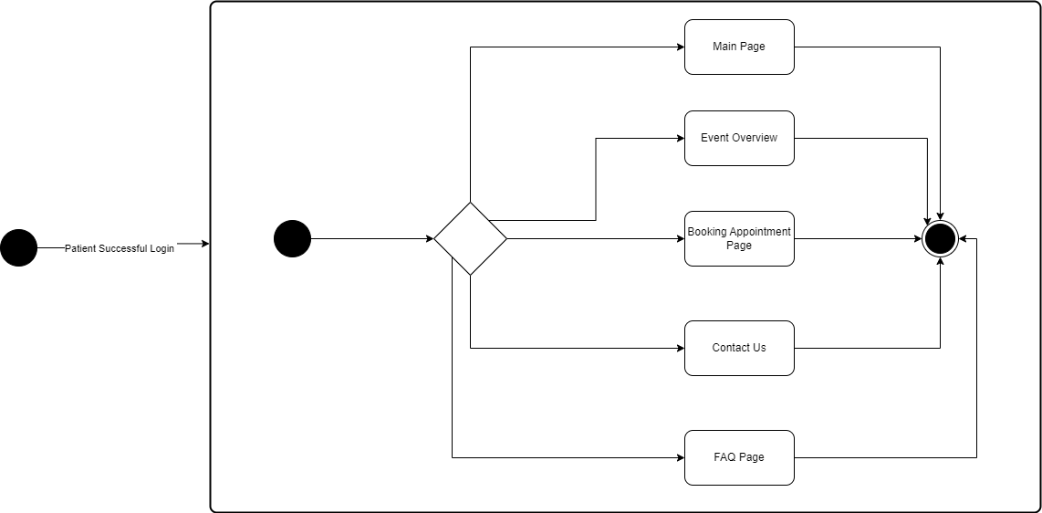

Figure 3: Patient Overview State Chart model component

On the event of a user successfully landed to the Unit Kaunseling dan Psikologi Sibu website, patient can browser the doctors’ schedule. That are few events can be triggered:

1. Patient can view main page of the website.
2. Patient can view event overview.
3. Patient can view booking appointment page.
4. Patient can view contact us page.
5. Patient can view frequently ask question (FAQ) page.

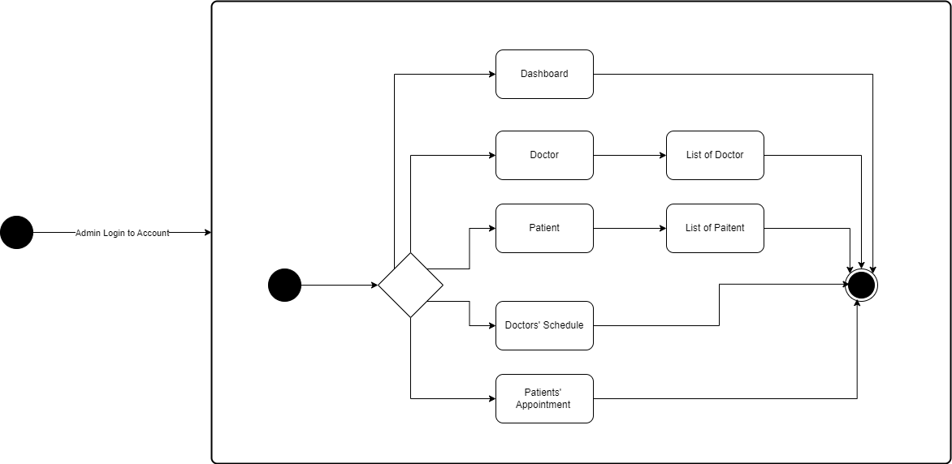

Figure 4: Admin Overview State Chart model component

On the event of a user successfully landed to the Unit Kaunseling dan Psikologi Sibu dashboard (Admin page), admin can manage the doctor details. That are few events can be triggered:

1. Administrator can view dashboard.
2. Administrator can view list of doctors.
3. Administrator can view list of patients.
4. Administrator can view doctor schedule.
5. Administrator can view patient appointment.

## View / Model Component 1..n

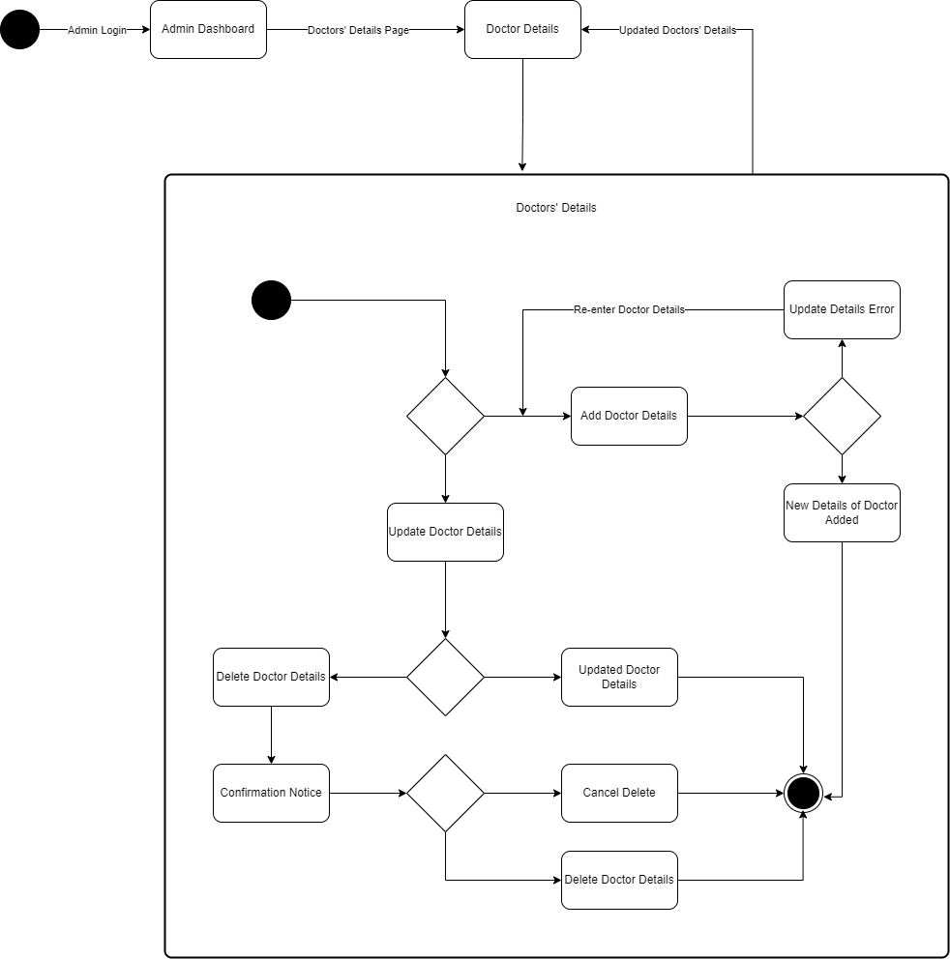

Figure 5: Doctor Details State Chart model component

On the event of a user successfully landed to the Unit Kaunseling dan Psikologi Sibu dashboard (Admin page), admin can manage the doctor details. That are few events can be triggered:

1. Administrator can add new doctor details.
2. Administrator can update doctor details.
3. Administrator can delete doctor details.

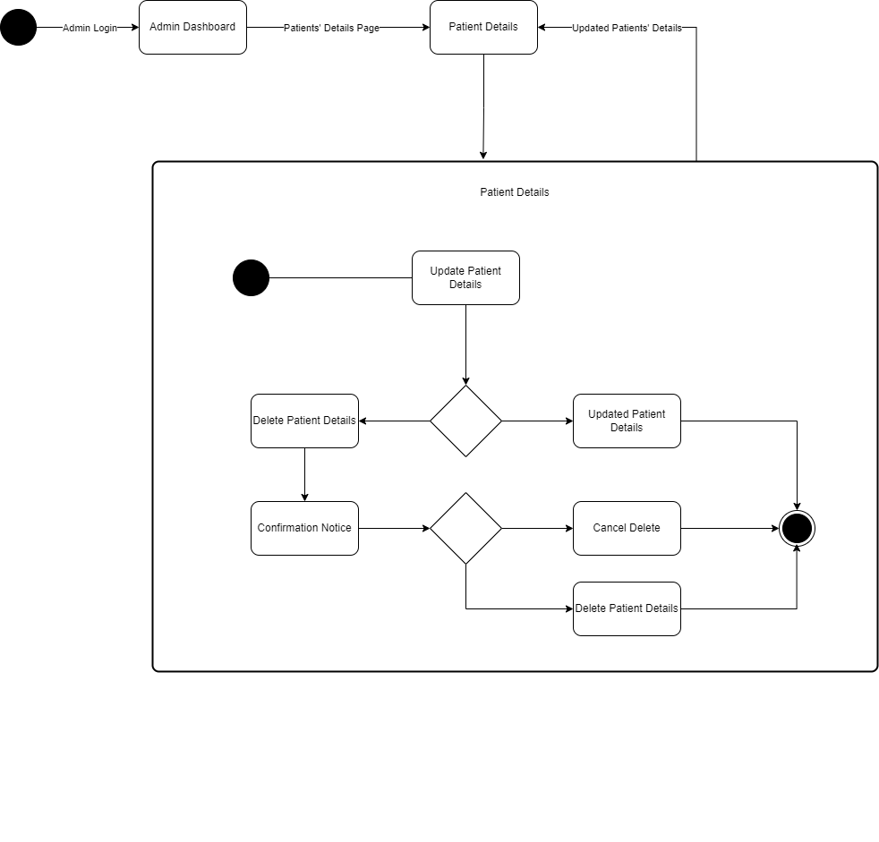

Figure 6: Patient Details State Chart model component

On the event of a user successfully landed to the Unit Kaunseling dan Psikologi Sibu dashboard (Admin page), admin can manage the doctor details. That are few events can be triggered:

1. Administrator can update patient details.
2. Administrator can delete patient details.

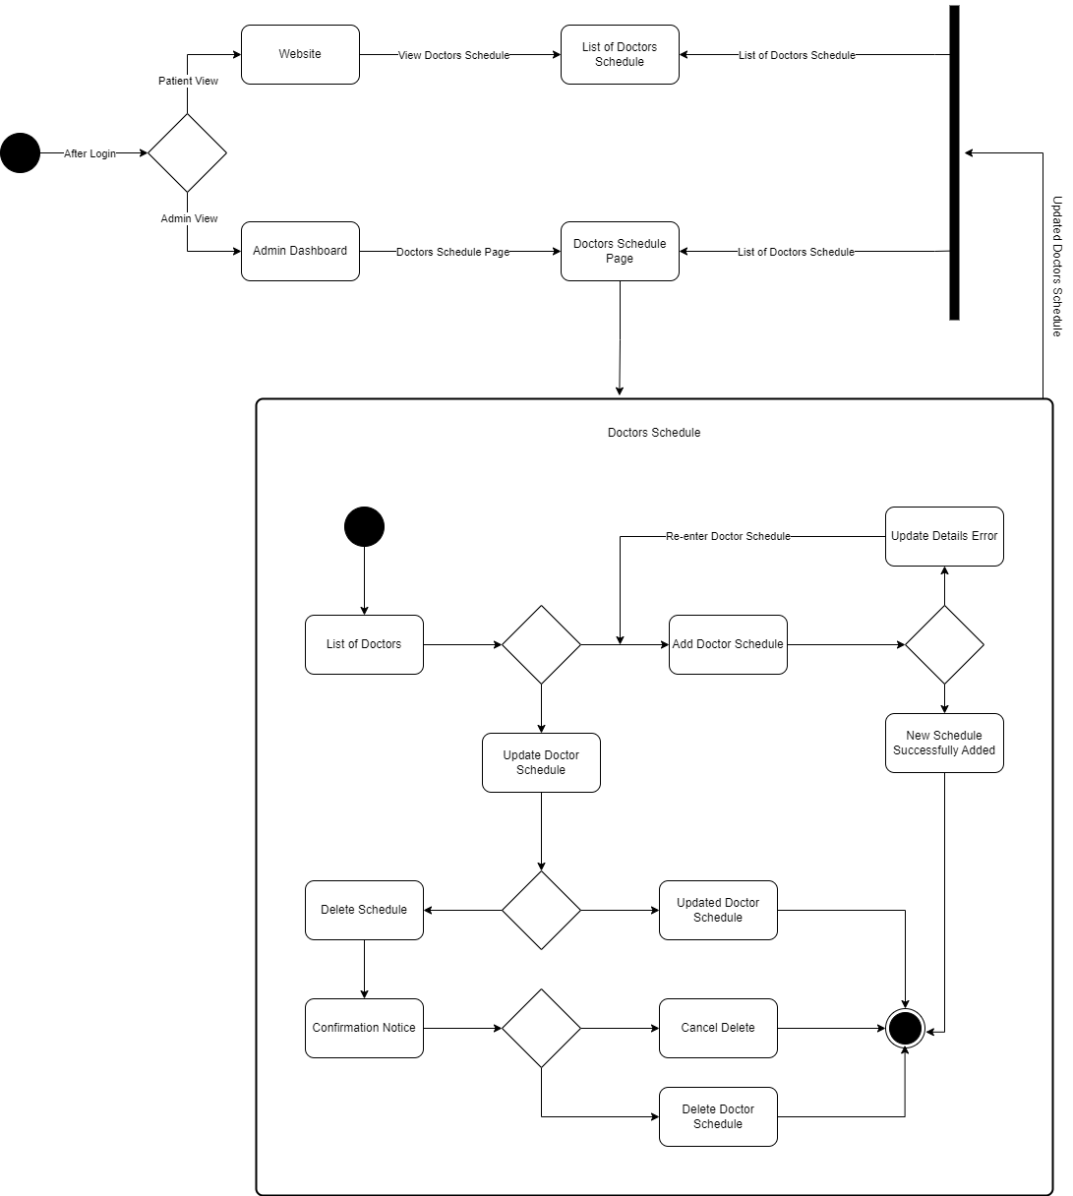

Figure 7: Doctor Schedule State Chart model component

On the event of a user successfully landed to the Unit Kaunseling dan Psikologi Sibu website, patient can browser the doctors’ schedule. That are few events can be triggered:

1. Patient can browser the schedule of the doctor

On the event of a user successfully landed to the Unit Kaunseling dan Psikologi Sibu dashboard (Admin page), admin can manage the doctor details. That are few events can be triggered:

1. Administrator can add new doctor schedule.
2. Administrator can update doctor schedule.
3. Administrator can delete doctor schedule.

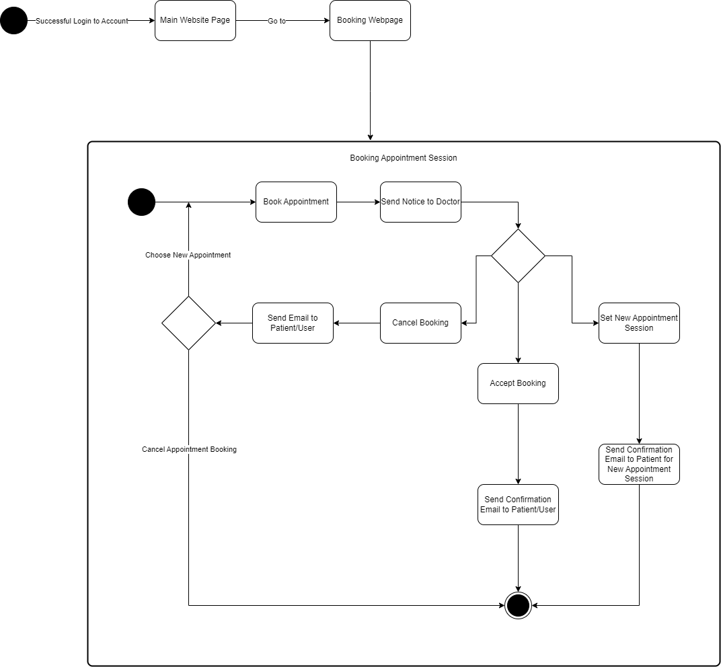

Figure 8: Booking Appointment Session State Chart model component

On the event of a user successfully landed to the Unit Kaunseling dan Psikologi Sibu website, patient can browser the doctors’ schedule. That are few events can be triggered:

1. Patient can book appointment for counselling session

On the event of a user successfully landed to the Unit Kaunseling dan Psikologi Sibu dashboard (Admin page), admin can manage the doctor details. That are few events can be triggered:

1. Administrator can accept patient booking.
2. Administrator can cancel patient booking.
3. Administrator can set new appointment for patient.

Appendix A – Group Log

**Membuaya With U Group**

Meeting Minutes

Location: SIR Room, FCSIT, UNIMAS.

Date: 21th October 2022.

Time: 2:00 PM

Attendees: Muhammad Hafiz bin Abu Bakar, Jovian Jayome Anak Nyimbong, Muhammad Faris bin Musa, Mohd Farhan bin Mohd Sukri, Shawn Francis Patrick Octothus, Vadrianey Anak Asas, Mohd Ibrahim bin Khushi Mohd

Absent: None.

Meeting Objective: To plan on the type of client to have a collaboration with.

|  |  |
| --- | --- |
| Agenda Item #1 | |
| Discussion: | Hafiz started the meeting by asking the team members what kind of client standard they preferred. |
| Hafiz and Shawn suggested finding a client based on student interactions with universities. |
| Ibrahim suggested finding a client with medical field management. |
| Faris and Farhan advised finding a client who owns a food business. |
| Vadrianey suggested finding a client that owns an ice cream shop. |
| Jovian suggested finding a client who manages motorcycle mechanics. |
| Everyone on the team agrees and begins emailing potential clients about project collaboration. |
| Decision: | Everyone on the team agreed on a client with medical field management in Sibu. |
| Meeting Adjournment: | Meeting adjourned at 3:00 PM |

**Membuaya With U Group**

Meeting Minutes

Location: SIR Room, FCSIT, UNIMAS.

Date: 24th October 2022.

Time: 8:00 AM

Attendees: Muhammad Hafiz bin Abu Bakar, Jovian Jayome Anak Nyimbong, Muhammad Faris bin Musa, Mohd Farhan bin Mohd Sukri, Shawn Francis Patrick Octothus, Vadrianey Anak Asas, Mohd Ibrahim bin Khushi Mohd

Absent: None.

Meeting Objective: To plan the date, time and venue of meeting the client.

|  |  |
| --- | --- |
| Agenda Item #1 | |
| Discussion: | Ibrahim informed the group about the possible client's interest to collaborate on the Software Engineering Laboratory Project. |
| Ibrahim provided a brief overview of the client's name, business background, and location of operation. |
| Hafiz suggested that they meet the client online instead. |
| All team members agreed on Hafiz's date selection. |
| Decision: | Membuaya With U and Unit Kaunseling Dan Psikologi have agreed that Unit Kaunseling Dan Psikologi will be Membuaya With U's client for the Software Engineering Laboratory Project. |
| Meeting Adjournment: | Meeting adjourned at 9:05 AM |

**Membuaya With U Group**

Meeting Minutes

Location: Online Meeting, Discord Application.

Date: 26th October 2022.

Time: 9:00 PM

Attendees: Muhammad Hafiz bin Abu Bakar, Jovian Jayome Anak Nyimbong, Muhammad Faris bin Musa, Mohd Farhan bin Mohd Sukri, Shawn Francis Patrick Octothus, Vadrianey Anak Asas, Mohd Ibrahim bin Khushi Mohd

Absent: None.

Meeting Objective: To discuss and assign tasks and roles throughout the project phase.

|  |  |
| --- | --- |
| Agenda Item #1 | |
| Discussion: | Hafiz started the meeting mentioning that all team members will be required to take roles for the purpose of the project. |
| Hafiz mentioned that he will be taking 2 roles for the project. He will be the Project Manager and Quality Manager. |
| Vadrianey will be the Planning Manager and Process Manager |
| Farhan mentioned that he will be taking Customer Interface Manager and Support Manager. |
| Faris mentioned he will be taking over Support Manager and Customer Interface Manager. |
| Shawn stated that he will be Implementation Manager and Test Manager. |
| Ibrahim will be the Implementation Manager and Test Manager. |
| Jovian is appointed to became the Planning Manager and Process Manager. |
| All decided to take on their duties  responsibly and do their job appropriate and effectively. |
| Decision: | Task and roles for the project has been  determined. |
| Meeting Adjournment: | Meeting adjourned at 10.15 PM |

**Membuaya With U Group**

Meeting Minutes

Location: Online Meeting, Google Meet Application.

Date: 27th October 2022.

Time: 8:00 PM

Attendees: Muhammad Hafiz bin Abu Bakar, Jovian Jayome Anak Nyimbong, Muhammad Faris bin Musa, Mohd Farhan bin Mohd Sukri, Shawn Francis Patrick Octothus, Vadrianey Anak Asas, Mohd Ibrahim bin Khushi Mohd

Absent: None.

Meeting Objective: Gathering requirements from client, Unit Kaunseling Dan Psikologi Sibu.

|  |  |
| --- | --- |
| Agenda Item #1 | |
| Discussion:  Greeting and introduction Membuaya With U team members to one of Unit Kaunseling Dan Psikologi Sibu representative, Hamidah Binti Khushi Mohd | Membuaya With U greeted the representive of Unit Kaunseling Dan Psikologi Sibu, Madam Hamidah Binti Khushi Mohd and gave thanks for her time in gathering the necessary requirements for the project. |
|  | The members of the team all introduced themselves to Madam Hamidah. Madam Hamidah introduced himself and gave us a brief introduction to his company, its potential clients, hours and place of operations. |
| Decision: | None |

|  |  |
| --- | --- |
| Agenda Item #2 | |
| Discussion:  Gathering necessary requirements for the  project from the client. | Hafiz and Ibrahim mentioned to the client about a possible project proposal for Madam Hamidah’s patient appointment bookings which is to build a web application for the company. Madam Hamidah was very keen with the idea and decided to give her support and help throughout the project development phase. |
|  | Madam Hamidah shared how does the services of her organizations. Madam Hamidah discussed how she would like to look like the web application. As soon as the necessary requirements were collected, the meeting ends with a photography session with Membuaya With U and Madam Hamidah. |
| Decision: | None |
| Meeting Adjournment: | Meeting adjourned at 9:30 PM |

**Membuaya With U Group**

Meeting Minutes

Location: Online Meeting, WhatsApp Application

Date: 30th October 2022.

Time: 9:00 PM

Attendees: Muhammad Hafiz bin Abu Bakar, Jovian Jayome Anak Nyimbong, Muhammad Faris bin Musa, Mohd Farhan bin Mohd Sukri, Shawn Francis Patrick Octothus, Vadrianey Anak Asas, Mohd Ibrahim bin Khushi Mohd

Absent: None.

Meeting Objective: To plan on task distribution for the project proposal.

|  |  |
| --- | --- |
| Agenda Item #1 | |
| Discussion: | Hafiz started the meeting by highlighting the  major topics that needs to be done for the  Unit Kaunseling Dan Psikologi’s Web Application Project Proposal. |
| Hafiz mentioned that he will be doing the Introduction and Problem Statement section |
| Vadrianey mentioned that she wil be doing the Software Methodology section |
| Faris mentioned that he will take over the Project Planning section |
| Farhan mentioned that he will be doing Team Goals and Expected Result / Deliverables sections |
| Jovian mentioned he will be doing Task Allocation & contribution section |
| Shawn mentioned he will take up Project Scope section |
| Ibrahim mentioned that he will do Project Objectives and Project Perspective section |
| Everyone agreed to do their part in the task allocation and to deliver the project proposal on time. |
| Decision | Task allocation has been agreed for the proposal for the project. |
| Meeting Adjournment: | Meeting adjourned at 10:30 PM |

**Membuaya With U Group**

Meeting Minutes

Location: Online Meeting, WhatsApp Application.

Date: 14th November 2022.

Time: 9:00 AM

Attendees: Muhammad Hafiz bin Abu Bakar, Jovian Jayome Anak Nyimbong, Muhammad Faris bin Musa, Mohd Farhan bin Mohd Sukri, Shawn Francis Patrick Octothus, Vadrianey Anak Asas, Mohd Ibrahim bin Khushi Mohd

Absent: None.

Meeting Objective: To plan on task distribution for the Software Requirement Specification (SRS) document.

|  |  |
| --- | --- |
| Agenda Item #1 | |
| Discussion: | Hafiz started the meeting by highlighting the  major topics that needs to be done for the  Software Requirements Specification  documentation. |
| Shawn and Jovian mentioned that they will do the backend of the web application. |
| Faris and Farhan mentioned that they will do the frontend of the web application. |
| Hafiz mentioned that he will doing the Introduction and Overall Description of the SRS |
| Vadrianey mentioned that she will doing the Specific Requirement and Appendixes of the SRS. |
| Ibrahim mentioned that he will doing the Other Non-Functional Requirement of the SRS |
| Everyone agreed to do their parts responsibly,  efficiently and to deliver the SRS on the given  time |
| Decision: | Task distribution for the SRS documentation  has been decided. |
| Meeting Adjournment: | Meeting adjourned at 9:55 AM |

**Membuaya With U Group**

Meeting Minutes

Location: Online Meeting, WhatsApp Application.

Date: 27th December 2022.

Time: 9:00 PM

Attendees: Muhammad Hafiz bin Abu Bakar, Jovian Jayome Anak Nyimbong, Muhammad Faris bin Musa, Mohd Farhan bin Mohd Sukri, Shawn Francis Patrick Octothus, Vadrianey Anak Asas, Mohd Ibrahim bin Khushi Mohd

Absent: None.

Meeting Objective: To plan on task distribution for the Software Document Specification (SDS) document.

|  |  |
| --- | --- |
| Agenda Item #1 | |
| Discussion: | Hafiz started the meeting by highlighting the major topics that needs to be done for the Software Design Specification documentation. |
| Hafiz stated that he will be doing Introduction and Purpose of the project sections in SDS. |
| Faris and Farhan said that they will do the System Overview, Definitions, Acronyms and Abbreviations, Supporting Materials and Document Overview sections in SDS. |
| Shawn And Ibrahim will be doing the Architecture and Architecture Overview section in SDS. |
| Vadrianey mentioned that they will do the system component section in SDS. |
| Jovian will be doing High Level Design and View/Model Component sections in SDS. |
| Everyone agreed to do their parts responsibly,  efficiently and to deliver the SDS on the given  time |
| Decision: | Task distribution for the SDS documentation  has been decided. |
| Meeting Adjournment: | Meeting adjourned at 9:55 PM |

**Membuaya With U Group**

Meeting Minutes

Location: Online Meeting, WhatsApp Application.

Date: 1th January 2023.

Time: 9:00 PM

Attendees: Muhammad Hafiz bin Abu Bakar, Jovian Jayome Anak Nyimbong, Muhammad Faris bin Musa, Mohd Farhan bin Mohd Sukri, Shawn Francis Patrick Octothus, Vadrianey Anak Asas, Mohd Ibrahim bin Khushi Mohd

Absent: None.

Meeting Objective: To plan on task distribution for the User Manual And Test Case document.

|  |  |
| --- | --- |
| Agenda Item #1 | |
| Discussion: | Hafiz started the meeting by highlighting the major documents that needs to be done which are the user manual for customer and admin and the test case documents. |
| Nurul mentioned that he will do the test case documents. |
| Shawn, Farhan and Faris will be the person in charge for the user manual for customer. |
| Ibrahim, Jovian, and Vad will be the person in charge for the user manual for administrator. |
| Everyone agreed to do their parts responsibly, effectively and deliver the required documents at the time provided. |
| Decision: | Task distribution for the User Manual and Test Case Documents is achieved. |
| Meeting Adjournment: | Meeting adjourned at 9:55 PM |

**Membuaya With U Group**

Meeting Minutes

Location: Online Meeting, WhatsApp Application.

Date: 8th January 2023.

Time: 9:00 AM

Attendees: Muhammad Hafiz bin Abu Bakar, Jovian Jayome Anak Nyimbong, Muhammad Faris bin Musa, Mohd Farhan bin Mohd Sukri, Shawn Francis Patrick Octothus, Vadrianey Anak Asas, Mohd Ibrahim bin Khushi Mohd

Absent: None.

Meeting Objective: To plan on document submission, discussing the presentation and overall review regarding the whole project.

|  |  |
| --- | --- |
| Agenda Item #1 | |
| Discussion: | Hafiz started the meeting by highlighting what need to be done for final preparation before project presentation, document sub-mission and overall review regarding the whole project. |
| Hafiz gives brief explanation on what need to be finish and distribute tasks to whole members of groups before the project presentation. |
| Hafiz mention that all documentation is already completed, and the system is working well according to Farhan, Shawn and Faris. |
| Hafiz also mentions that the Trello has been updated by him and the Trello team (Vad, Ibrahim, and Jovian). |
| Everyone agreed to do their parts responsibly, effectively and deliver the required documents at the time provided. |
| Decision: | Task distribution for the User Manual and Test Case Documents is achieved. |
| Meeting Adjournment: | Meeting adjourned at 11:00 AM |