1. Change the path here in the Emailforensics.bat file with your path

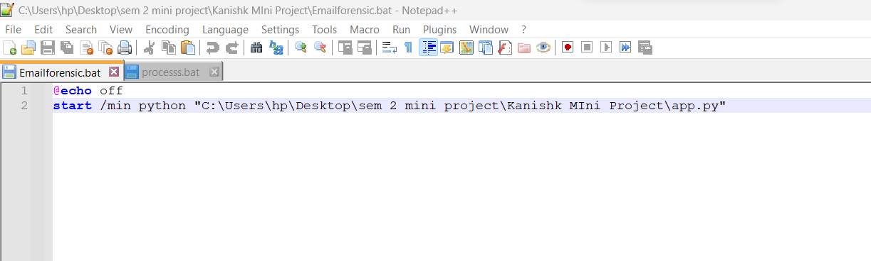

1. Now Change the path in the processs.bat file with your .py file path

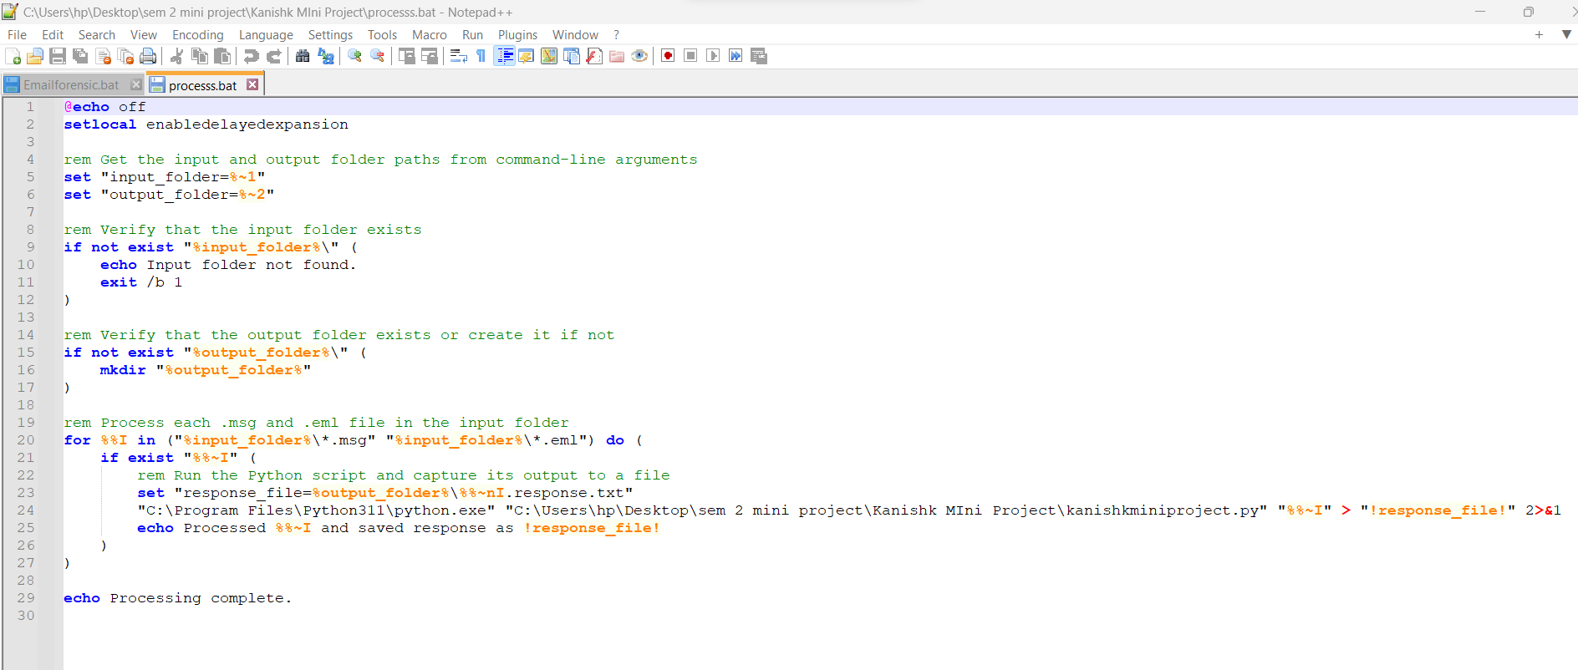

1. Now here you have to change bat file path and background file path also

