**Aim:**

# Task-1

Declare a variable using var, let, and const. Assign different data types to each variable and print their values.

**Theoretical Background: Source Code:**

**// Using var**

**var example = 'Hqwerqer'; console.log(example);**

**// Using let**

**let exapmle1 = 42132; console.log(exapmle1);**

**// Using const**

**const myConst = true; console.log(myConst);**

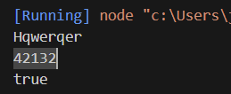**Output:**

# Task-2

**Aim:**

Write a function that takes two numbers as arguments and returns their sum, difference, product, and quotient using arithmetic operators.

**Source Code:**

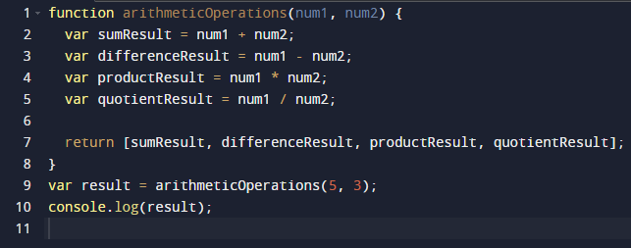

**Output:**

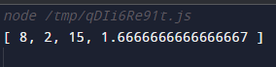

# Task-3

**Aim:** Write a program that prompts the user to enter their age. Based on their age, display

different messages:

○ If the age is less than 18, display "You are a minor."

○ If the age is between 18 and 65, display "You are an adult."

○ If the age is 65 or older, display "You are a senior citizen."

**Source Code:**

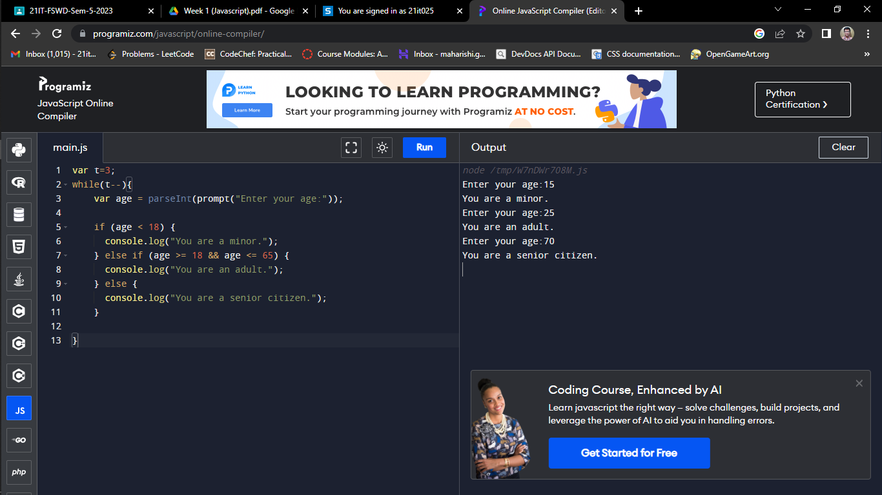

**Output:**



# Task-4

**Aim:**

Write a function that takes an array of salary as an argument and returns the min/max salary in the array.

**Source Code:**

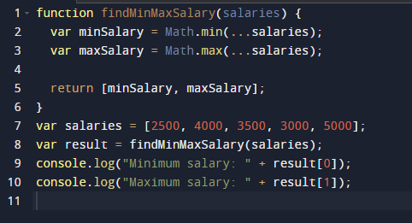

**Output:**

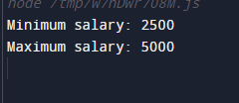

# Task-5

**Aim:** Create an array of your favorite books. Write a function that takes the array as an argument and displays each book title on a separate line.

**Source Code:**

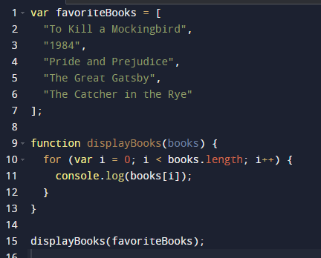

**Output:**

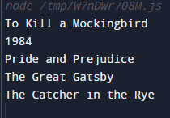

# Task-6

**Aim:** Declare a variable inside a function and try to access it outside the function. Observe the scope behavior and explain the results. [var vs let vs const]

**Source Code:**

// Using var

function varExample() {

var x = 10;

console.log("Inside varExample:", x); // Output: 10

}

varExample();

// Throws an error: "Uncaught ReferenceError: x is not defined"

console.log("Outside varExample:", x);

// Using let

function letExample() {

let y = 20;

console.log("Inside letExample:", y); // Output: 20

}

letExample();

// Throws an error: "Uncaught ReferenceError: y is not defined"

console.log("Outside letExample:", y);

// Using const

function constExample() {

const z = 30;

console.log("Inside constExample:", z); // Output: 30

}

constExample();

// Throws an error: "Uncaught ReferenceError: z is not defined"

console.log("Outside constExample:", z);

# Task-7

**Aim:** Create an HTML page with a button. Write JavaScript code that adds an event listener to the button and changes its text when clicked.

**Source Code:**

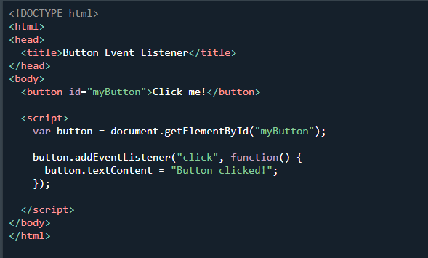

**Output:**

Before: After:

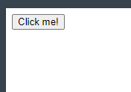 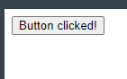

# Task-8

**Aim:**

Write a function that takes a number as an argument and throws an error if the number is negative. Handle the error and display a custom error message.

**Source Code:**

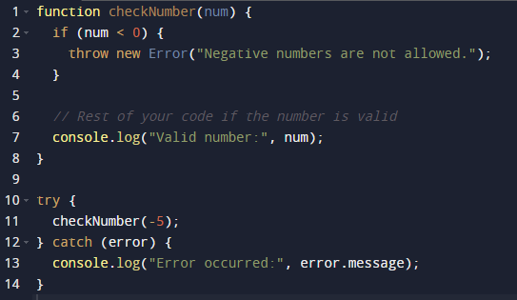

**Output:**

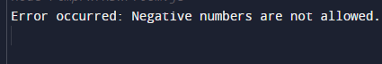

# Task-9

**Aim:** Write a function that uses setTimeout to simulate an asynchronous operation. Use a callback function to handle the result.

**Source Code:**

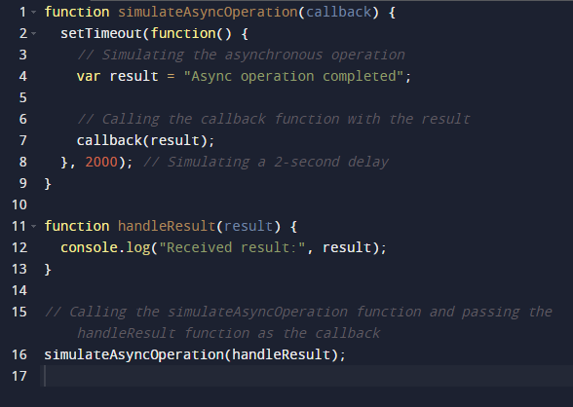

**Output:**

