Game Design Document

Fill up the following document

1. Write the title of your project.

Destroy tanks

1. What is the goal of the game?

The goal of the game is to destroy the enemies tanks by using different superpowers of tanks and destroying the enemie’s tank to win the game. This game is an online multiplayer game.

1. Write a brief story of your game.

Decades ago, the tanks were invented for peace and harmony of world and humanity. But due to this invention, many people started killing each other and to conquer lands and become the superior. They started to upgrade their tanks so that they can win over more people. You are a part of this world and you have to conquer over the people and to change the perspective of the world about the peace and harmony of world .

1. Which are the playing characters of this game?

* Playing characters are the ones who respond to the user based on the input from the user.
* Cars, monkeys, dinos, wizards, etc., are the playing characters in the game.

|  |  |  |
| --- | --- | --- |
| Number | Character Name | What can this character do? |
| 1 | Tank 1 | Shoot bullets from tanks and give damage |
| 2 | Tank 2(Controlled by online player) | Shoot bullets from tanks and give damage |
| 3 |  |  |
| 4 |  |  |
| 5 |  |  |
| 6 |  |  |
| 7 |  |  |
| 8 |  |  |

1. Which are the Non-Playing Characters of this game?

* Non-Playing characters are the ones that don't have an action or behavior when the user interacts with the game.
* Hurdles, stones, bananas, coins, etc., are non-playing characters in the game.

|  |  |  |
| --- | --- | --- |
| Number | Character Name | What can this character do? |
| 1 |  |  |
| 2 |  |  |
| 3 |  |  |
| 4 |  |  |
| 5 |  |  |
| 6 |  |  |
| 7 |  |  |
| 8 |  |  |

Draw your imagination of this game. What does this game look like?

* Draw the game either on your computer or on paper.
* Add images of the game scenes to show each of the playing and non-playing characters at least once.

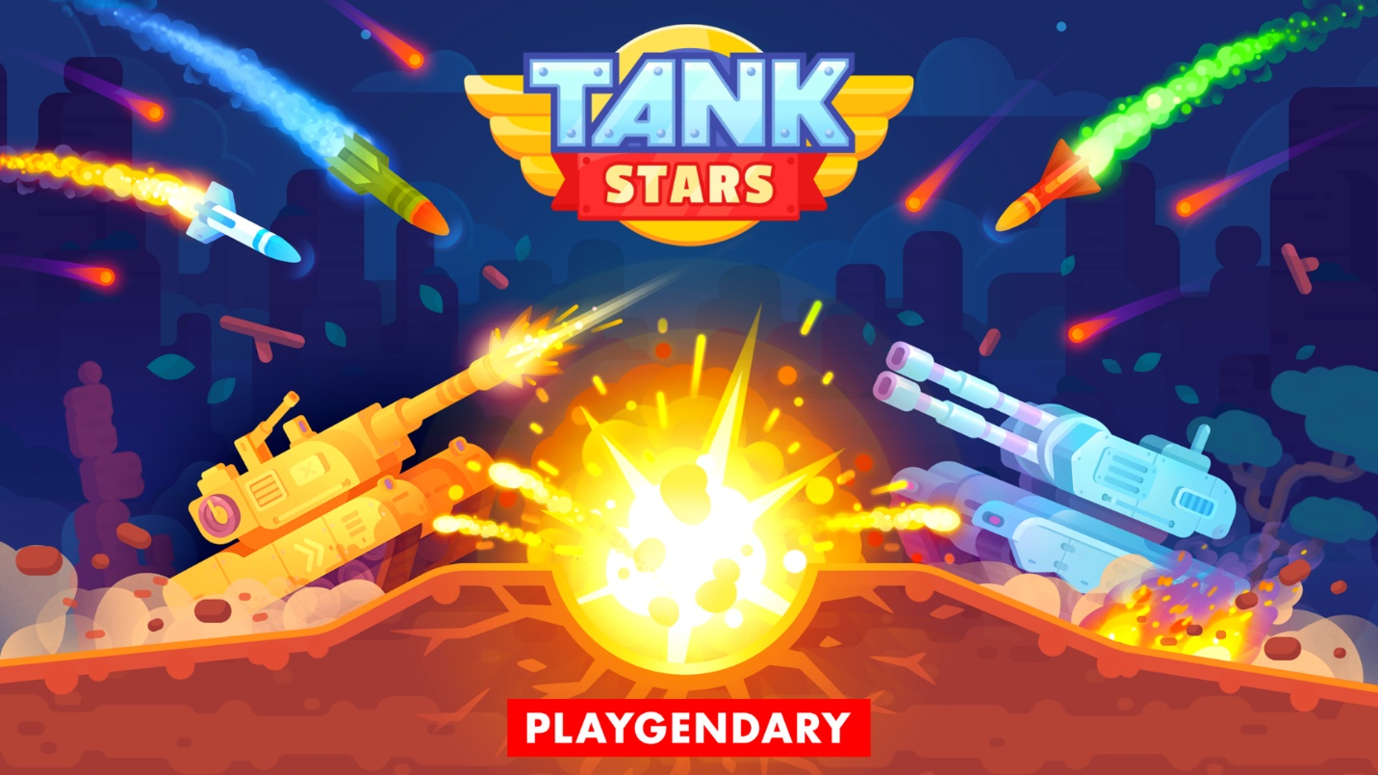

How do you plan to make your game engaging?

We will make the game engaging by giving score points, damage, rank, at the end of game so that player is more engaged in game. Also we will add sound effects when bombs or bullets blast .