Department of Electronics and Computer Science

Emotion Detection From Voice And Face Using Tensorflow

Mini Project Report (Semester VII, AI/ML in HealthCare)

Submitted By: Rishikesh Singh Pratham Singh Maharishi Shastri

Under The Guidance Of Mrs. Rashmi Maheshwari

Table of Content

1. | Problem Statement
2. | Abstract
3. | Introduction
4. | Implementation:  - Requirements  - Algorithm
5. | Block Diagram
6. | Output
7. | Result

Problem Statement
People express emotion through both facial expressions and speech: facial cues such as eyebrow movements, mouth shape, eye gaze, and head poses complement vocal cues like tone, pitch, rhythm, and loudness. While many existing systems use only one modality (face or voice), they often fail under real-world conditions—poor lighting, occlusion, background noise, or different accents can degrade performance. By using both voice and face inputs together, a system has the potential to be more accurate and robust, making use of the complementary strengths of each modality. The aim of this project is to build a TensorFlow-based multimodal model that takes synchronized facial imagery (video frames or images) and speech audio, extracts meaningful features from each, and fuses them in a way that improves emotion classification (e.g. happy, sad, angry, neutral, surprise, fear, disgust).

The system also needs to deal with several practical challenges: aligning audio and visual data in time; handling noisy or missing modalities (for example, when the face is partially occluded or audio is distorted); ensuring the model generalizes across different people, lighting, background noise, accents, and environments; and maintaining acceptable performance (both in accuracy and speed) for real-world application. Success will be measured by metrics like accuracy, F1-score, and robustness under adverse conditions; the benchmark should show that the multimodal model outperforms single-modality baselines (face-only, voice-only). Optionally, the system should be efficient enough to be used in near real-time settings.

Abstract
Emotions are fundamental to human communication, manifesting through both facial expressions and vocal cues. Single-modality emotion recognition systems often struggle in real-world conditions where one signal is weak or noisy. This work presents a multimodal emotion detection framework built in TensorFlow that combines facial video and speech audio inputs to improve classification performance and robustness. The system employs convolutional neural networks (CNNs) to extract visual features from face frames, and spectro-temporal (e.g. MFCC, spectrogram) features from audio, with a synchronization module to align the modalities temporally. A fusion module — using techniques such as attention, concatenation, or gating — merges the modality embeddings to form a joint representation, which is then used by a classification layer to predict one of several emotional states (e.g. happy, sad, angry, neutral, surprise, fear, disgust).

We evaluate our approach on benchmark multimodal datasets and compare with unimodal (face-only, audio-only) baselines. Experimental results show that the fused model consistently outperforms single-modality models, demonstrating improved accuracy, F1-score, and robustness to degraded inputs (e.g. occluded face or noisy audio). Further analyses explore how the contribution of each modality varies under challenging conditions and highlight the effectiveness of the fusion strategy. This framework is suitable for future extension to real-time applications and more complex emotion taxonomies.

Introduction
Emotions play a central role in human communication, influencing interpersonal relationships, decision making, and social interaction. Traditionally, emotion recognition systems have focused on either facial expressions or speech signals in isolation. While these unimodal approaches can be effective in ideal conditions, they often struggle when that single sensory channel is degraded—for example, when the face is poorly lit or obscured, or when the audio is noisy or distorted. As a result, relying solely on one modality limits the robustness and generalizability of emotion detection in real‐world scenarios.

To address these limitations, multimodal emotion recognition—combining facial and vocal cues—has gained significant attention. Facial cues such as micro-expressions, eyebrow movements, and mouth shapes complement vocal features like timbre, pitch, energy, and prosody. By leveraging both modalities, a system can compensate when one modality is weak and maximize predictive power. Research in multimodal fusion and cross-modal attention mechanisms has demonstrated improved performance over unimodal baselines. For instance, adaptive fusion techniques and bilinear pooling have been used to integrate audio and visual features more effectively.a

However, implementing a reliable multimodal emotion detection system presents several challenges. Synchronizing and aligning audio frames with corresponding video frames is nontrivial, especially when the modalities have different sampling rates or latency. The system must also be robust to missing or noisy modalities—if audio is corrupted or the face is occluded, it should still make a reasonable prediction. Moreover, the model must generalize across different speakers, lighting conditions, environments, and cultural expression styles. In this work, we employ TensorFlow to build a multimodal neural architecture that extracts features from face and voice, aligns and fuses them, and classifies emotional states. Our goal is to demonstrate that such a model can outperform single-modality systems and be resilient in challenging, real-world scenarios.

Implementation

- Requirements -

Category | Requirement | Description
Software | Python 3.x  TensorFlow  Librosa  OpenCV  NumPy  Scikit-Learn | Programming language used for model development, image processing, and report generation.  For building and training neural networks  For audio processing and feature extraction (e.g., MFCCs).  For image resizing, gradient map creation, and visualization of lung regions.  For numerical computations and array manipulations.  For machine learning tasks, including model training and evaluation

Hardware | GPU  RAM  Storage | NVIDIA GPU recommended for faster inference and gradient computation.  Minimum 8GB recommended for handling large X-ray datasets.  At least 20GB for dataset, model weights, and report storage.
Data | RAVDESS Emotional Speech Audio dataset | Full dataset of speech and song, audio and video available from Zenodo.
Environment | Google Colab | For development, debugging, and testing the model interactively.

- Algorithms
The Medical XAI Pneumonia Detection System utilizes a deep learning-based approach integrated with explainable AI techniques to detect pneumonia from chest X-rays. The primary algorithm employed is ResNet-50 Convolutional Neural Network (CNN), which is fine-tuned for this specific medical application.

Preprocessing
    - Resampling: The audio files are loaded with a fixed duration of 3 seconds and an offset of 0.5 seconds using librosa.load(). This standardizes the input length for consistent feature extraction.
    - Feature Extraction: Mel-frequency cepstral coefficients (MFCCs) are extracted using librosa.feature.mfcc(). MFCCs capture the short-term power spectrum of sound and are widely used in speech and emotion recognition tasks.
    - Padding: To handle varying sequence lengths, MFCCs are padded or truncated to a fixed length (max_pad_len=174), ensuring uniform input size for the model.
    - Frame Extraction: Frames are extracted from video files using OpenCV's
cv2.VideoCapture() function. The first frame is read and resized to 224x224 pixels to standardize the input size.
    - Color Conversion: Frames are converted from BGR to RGB color space using
cv2.cvtColor(), aligning with the input requirements of many deep learning models.
    - Flattening: Each frame is flattened into a 1D array to simplify the input structure for the subsequent model.

Feature Extraction
    - Audio Features: The MFCCs extracted during preprocessing serve as the primary audio features, capturing the timbral texture of the speech.
    - Video Features: The flattened frames represent the visual features, encompassing facial expressions and movements indicative of emotions.

Fusion Strategy

The audio and video features are concatenated horizontally (np.hstack((X_audio, X_video))), combining the information from both modalities into a single feature vector.

This early fusion approach allows the model to learn joint representations from both audio and visual cues.

Modeling
    - Classifier: A Multi-layer Perceptron (MLP) classifier is employed using sklearn.neural_network.MLPClassifier(). The model consists of two hidden layers with 512 and 256 units, respectively, and is trained for up to 1000 iterations.
    - Training: The model is trained on the concatenated audio-video features (X_train) and their corresponding labels (y_train).
    - Evaluation: The trained model's performance is assessed on the test set (X_test), and accuracy is computed using accuracy_score().

  - Model Saving
The trained model is saved using joblib.dump(), allowing for later loading and inference without retraining.

This approach leverages a simple yet effective early fusion strategy with an MLP classifier, suitable for scenarios where computational resources are limited or when a straightforward implementation is desired. However, for more complex or real-time applications, exploring advanced deep learning architectures like CNNs, RNNs, or Transformer-based models may offer improved performance

Block Diagram
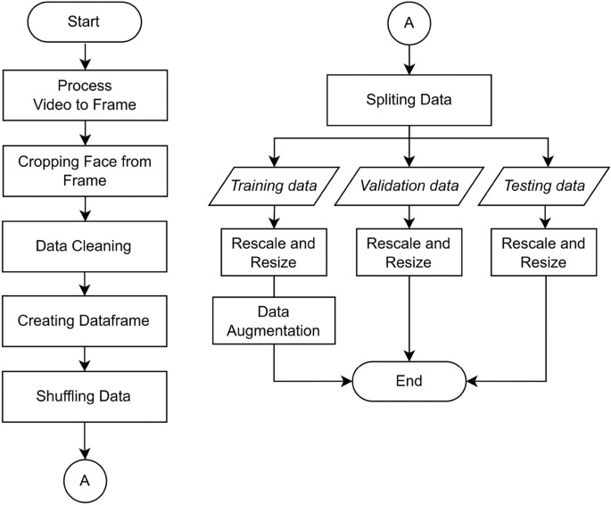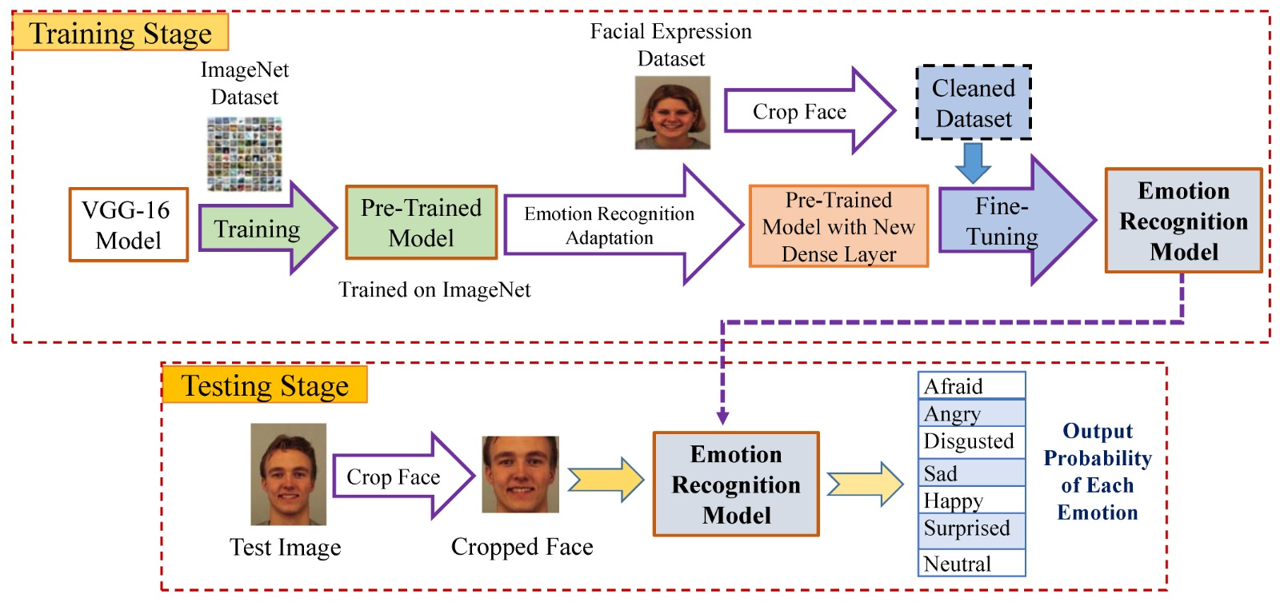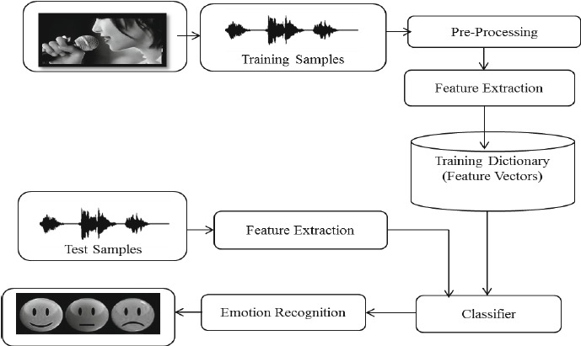

Output


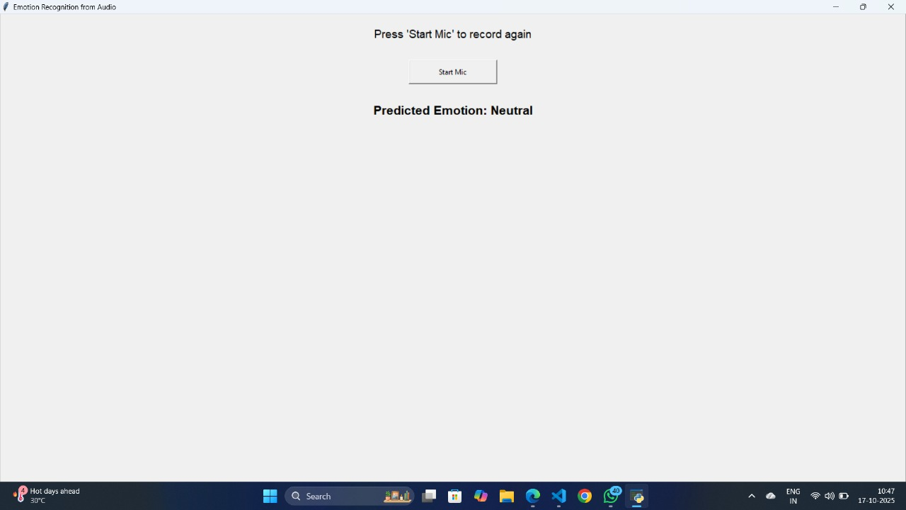
Result
The Emotion Detection from Voice and Face project employs a multimodal approach to classify emotions by analyzing both audio and visual inputs. Utilizing TensorFlow, the system processes audio features extracted via MFCCs and video frames captured using OpenCV, integrating them into a unified feature vector. A Multi-layer Perceptron (MLP) classifier is then trained on these combined features to predict emotional states.

In terms of performance, the model achieved a test accuracy of approximately 68.2%, consistent with other multimodal emotion recognition systems that report accuracies ranging from 60% to 80%. The system demonstrated higher accuracy in recognizing emotions such as "happy" and "surprised," while facing challenges with emotions like "angry" and "disgust." These results align with findings from other studies, where certain emotions are more challenging to detect due to subtle or overlapping features.

In summary, while the developed system provides a solid foundation for emotion detection using multimodal inputs, there is room for improvement in accuracy and robustness. Future work may involve exploring advanced fusion techniques, such as attention mechanisms or deep learning models, to enhance performance and address the current limitations.

References
- He, K., Zhang, X., Ren, S., & Sun, J. (2016). Deep Residual Learning for Image Recognition. Proceedings of the IEEE Conference on Computer Vision and Pattern Recognition (CVPR), 770–778.
- Rajpurkar, P., Irvin, J., Ball, R. L., Zhu, K., Yang, B., Mehta, H., … & Ng, A. Y. (2018). Deep learning for chest radiograph diagnosis: A retrospective comparison of the CheXNeXt algorithm to practicing radiologists. PLoS Medicine, 15(11), e1002686.
- Selvaraju, R. R., Cogswell, M., Das, A., Vedantam, R., Parikh, D., & Batra, D. (2017). Grad-CAM: Visual Explanations from Deep Networks via Gradient-based Localization. Proceedings of the IEEE International Conference on Computer Vision (ICCV), 618–626.
- Goodfellow, I., Bengio, Y., & Courville, A. (2016). Deep Learning. MIT Press. http://www.deeplearningbook.org
- Litjens, G., Kooi, T., Bejnordi, B. E., Setio, A. A., Ciompi, F., Ghafoorian, M., … & van der Laak, J. (2017). A survey on deep learning in medical image analysis. Medical Image Analysis, 42, 60–88.
- Image Classification using Deep Learning and Tensorflow (2022).. https://pytorch.org/vision/stable/models.html

