AI Based Diabetes Prediction System
Project Title:Diabetes Prediction System
Phase3:Development Part 1

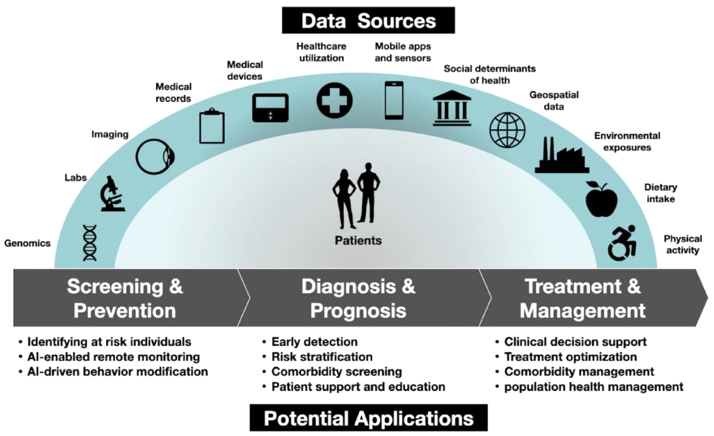
Diabetes prediction System
Introduction:
- An AI diabetics prediction system is a computer program that uses artificial intelligence (AI) to predict whether a person is likely to develop diabetes. AI diabetics prediction systems are trained on large datasets of patient data, including medical history, demographics, lifestyle factors, and blood test results. Once trained, the system can be used to predict the risk of diabetes for new patients.
- AI diabetics prediction systems have several potential benefits. First, they can help to identify people who are at high risk of developing diabetes so that they can take steps to prevent the disease. Second, they can help to improve the efficiency of diabetes screening and diagnosis. Third, they can help to personalize diabetes care by providing tailored recommendations for patients based on their individual risk factors.
- AI diabetics prediction systems are still under development, but they have the potential to revolutionize the way that diabetes is prevented and managed.
Dataset: https://www.kaggle.com/datasets/mathchi/diabetes-data-set
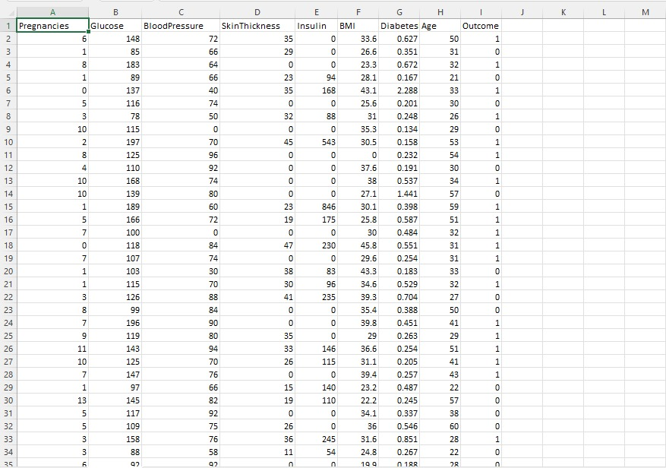

Necessary step to follow:
- Collect data:AI models are trained on data, so the first step is to collect a large and comprehensive dataset of diabetes patients. This data should include information such as blood sugar levels, insulin levels, diet, exercise, and other relevant factors.
- Prepare the data: Once the data has been collected, it needs to be prepared for training the AI model. This may involve cleaning the data, removing outliers, and transforming the data into a format that the model can understand.
- Choose an AI algorithm: There are many different AI algorithms that can be used for diabetes management. The choice of algorithm will depend on the specific task that the model is being trained to perform. For example, if the model is being trained to predict blood sugar levels, a different algorithm may be used than if the model is being trained to recommend insulin doses.
- Train the AI model: Once the data has been prepared and an algorithm has been chosen, the AI model can be trained. This involves feeding the data to the algorithm and allowing it to learn the patterns in the data.
- Evaluate the AI model: Once the model has been trained, it needs to be evaluated to see how well it performs on a held-out test set. This will help to ensure that the model is not overfitting the training data.
- Deploy the AI model. Once the model has been evaluated and deemed to be performing well, it can be deployed to production. This may involve integrating the model into a healthcare app or software system.
Importance to loading and processing dataset:
- To ensure that the model has enough data to learn from: AI models are trained on data, so it is important to have a dataset that is large enough and representative of the population that the model will be used on. A small or incomplete dataset will not allow the model to learn the patterns in the data accurately.
- To improve the accuracy of the model: The quality of the data also has a significant impact on the accuracy of the trained model. If the data is noisy or contains errors, the model will be more likely to make mistakes. Cleaning the data and removing errors can help to improve the accuracy of the model.
- To make the model more efficient: Processing the data can also help to make the model more efficient. For example, by transforming the data into a format that is more suitable for the chosen AI algorithm, the model can be trained faster and make predictions more quickly.
Challenges involved in loading and preprocessing ai based prediction system:
- Data quality: AI models are trained on data, so it is important to have high-quality data that is accurate, complete, and representative of the population that the model will be used on. However, in the real world, data is often noisy, incomplete, and inconsistent. This can create challenges for loading and preprocessing the data, as well as for training and evaluating the model.
- Data size: AI models can be trained on very large datasets. This can make it challenging to load and preprocess the data, especially if the data is stored in multiple locations or in different formats.
- Data complexity: AI models can be used to solve a wide range of problems, from simple classification tasks to complex regression tasks. The complexity of the problem will determine the complexity of the data that needs to be loaded and preprocessed. For example, a model that is used to predict the risk of developing diabetes will need to be trained on a dataset that includes a wide range of features, such as age, weight, family history, and lifestyle habits.
- Data privacy and security: AI models often contain sensitive data about people, such as their health information or financial data. It is important to ensure that the data is loaded and preprocessed in a secure manner to Here are some specific examples of challenges that can be encountered when protect the privacy of the individuals whose data is being used.
- Dealing with missing values: Missing values are data points that are not present in the dataset. This can happen for a variety of reasons, such as data collection errors or patient refusal to provide certain information. Missing values can be handled in a variety of ways, such as imputing the missing values with a default value or removing the rows with missing values. However, the best way to handle missing values will depend on the specific dataset and the problem that the model is being trained to solve.
- Handling outliers: Outliers are data points that are significantly different from the rest of the data. They can be caused by errors in data collection or entry, or they may be real data points that are simply different from the norm. Outliers can skew the results of the model and reduce its accuracy. It is important to identify and remove outliers before training the model. However, it is also important to be careful not to remove outliers that are simply different from the norm, as this can reduce the diversity of the dataset and make the model less generalizable.
- Feature engineering: Feature engineering is the process of creating new features from existing features. This can be done to make the data more informative or to make the data more suitable for the chosen AI algorithm. Feature engineering can be a complex and time-consuming process, and it is important to have a good understanding of the data and the problem that the model is being trained to solve before performing feature engineering.
How to overcome the challenges of loading and preprocessing a diabetes dataset:
1. Understand the dataset. Before you start loading and preprocessing the dataset, it is important to understand the structure and content of the data. This will help you to identify any potential challenges and to develop a plan for addressing them.
2. Use a data loading library. There are many data loading libraries available that can help you to load and parse data from a variety of sources, including CSV files, Excel files, and databases. Using a data loading library can help you to save time and to avoid errors.
3. Handle missing values. Missing values are a common challenge in diabetes datasets. There are a number of ways to handle missing values, such as imputing them with the mean or median value of the feature, or dropping the rows with missing values. The best approach to handling missing values will depend on the specific dataset and the task at hand.
4. Discretize continuous variables. Many machine learning algorithms cannot handle continuous variables directly. Therefore, it is often necessary to discretize continuous variables before training a machine learning model. There are a number of different ways to discretize continuous variables, such as binning and equal-width discretization.
5. Scale features. Different features in a diabetes dataset may have different scales. This can make it difficult for machine learning algorithms to learn from the data. Therefore, it is often necessary to scale features before training a machine learning model. There are a number of different ways to scale features, such as min-max scaling and standard scaling.
6. Remove outliers. Outliers are data points that are significantly different from the rest of the data. Outliers can have a negative impact on the performance of machine learning algorithms. Therefore, it is often necessary to remove outliers before training a machine learning model. There are a number of different ways to remove outliers, such as using IQR filtering or the DBSCAN clustering algorithm.
7. Split the data into train and test sets. Once the dataset has been cleaned and preprocessed, it is important to split it into train and test sets. The train set will be used to train the machine learning model, and the test set will be used to evaluate the performance of the trained model. It is important to split the data in a way that ensures that the train and test sets are representative of the overall dataset.
Program:
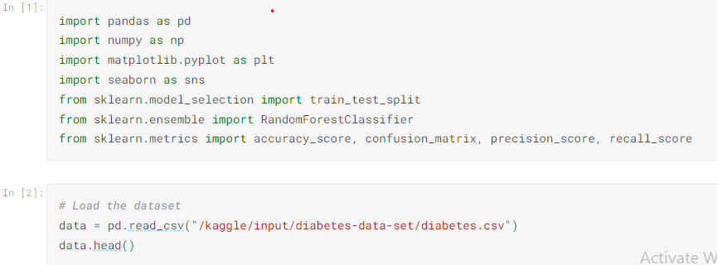
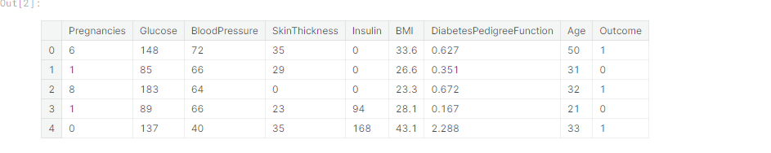
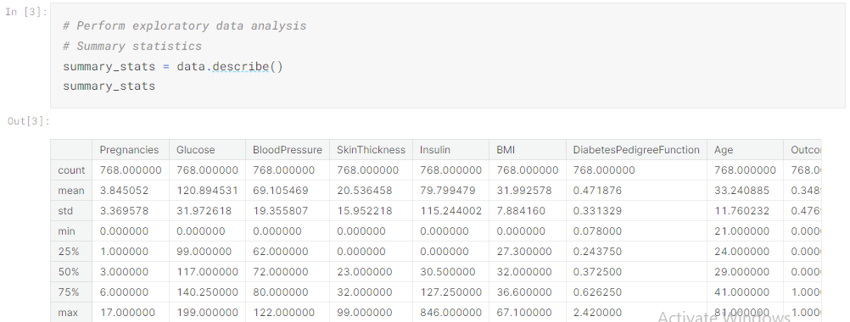

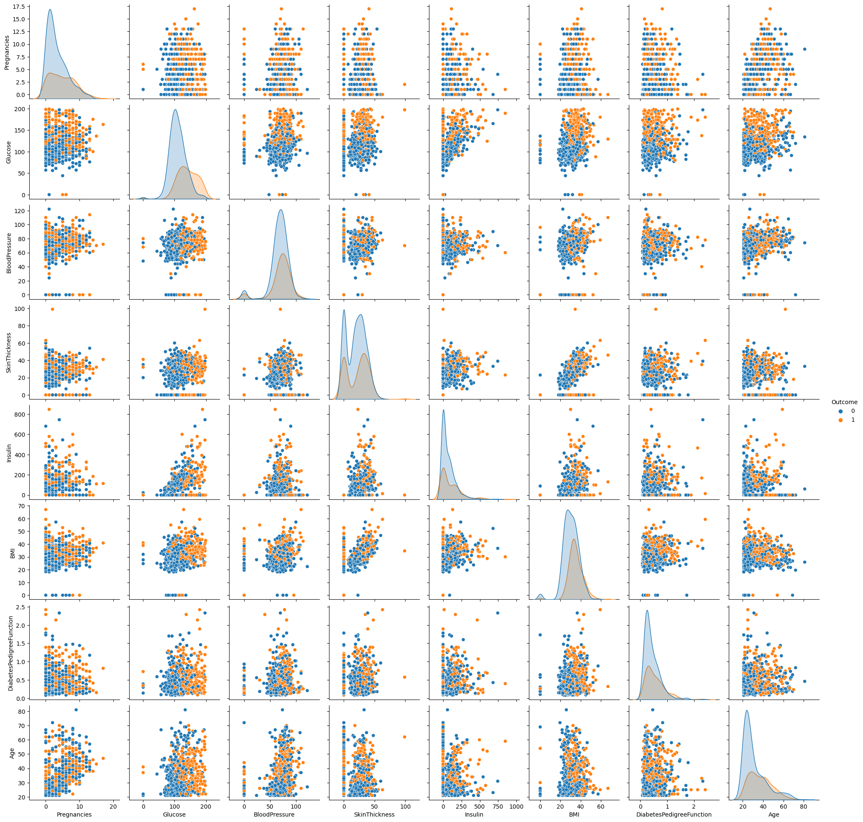
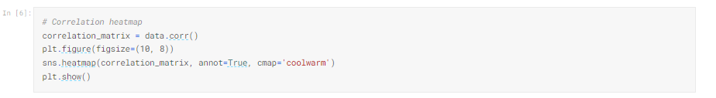

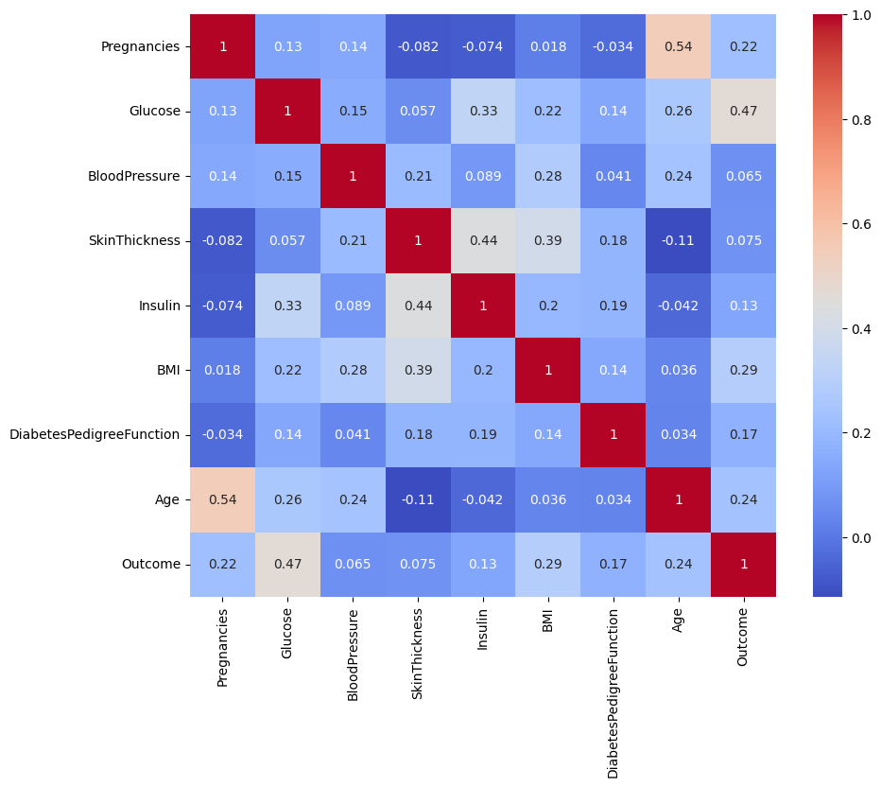
Conclusion:
The development of AI-based diabetes prediction systems is a promising area of research with the potential to improve the lives of millions of people. However, there are still some challenges that need to be addressed before these systems can be widely deployed in clinical practice.
One challenge is the need for more high-quality data to train and validate AI models. Another challenge is ensuring that AI models are fair and unbiased, and that they can be used in a way that is beneficial to all patients.
Despite these challenges, the progress that has been made in the development of AI-based diabetes prediction systems is encouraging. As these systems continue to develop and mature, they have the potential to make a significant impact on the prevention and management of diabetes.
Here are some specific conclusions that can be drawn from the development of AI-based diabetes prediction systems so far:
- AI-based diabetes prediction systems can achieve high levels of accuracy, comparable to or even better than traditional methods.
- AI-based diabetes prediction systems can be used to identify people at high risk of developing diabetes, even in the early stages of disease.
- AI-based diabetes prediction systems can be used to personalize diabetes management plans and improve patient outcomes.
- AI-based diabetes prediction systems have the potential to be used in a variety of settings, including primary care clinics, hospitals, and public health programs.

