Assignment-1

1.Create an AMI in Mumbai region andd find a way to use it across the region , say N.virginia.

Ans-Use copy AMI option

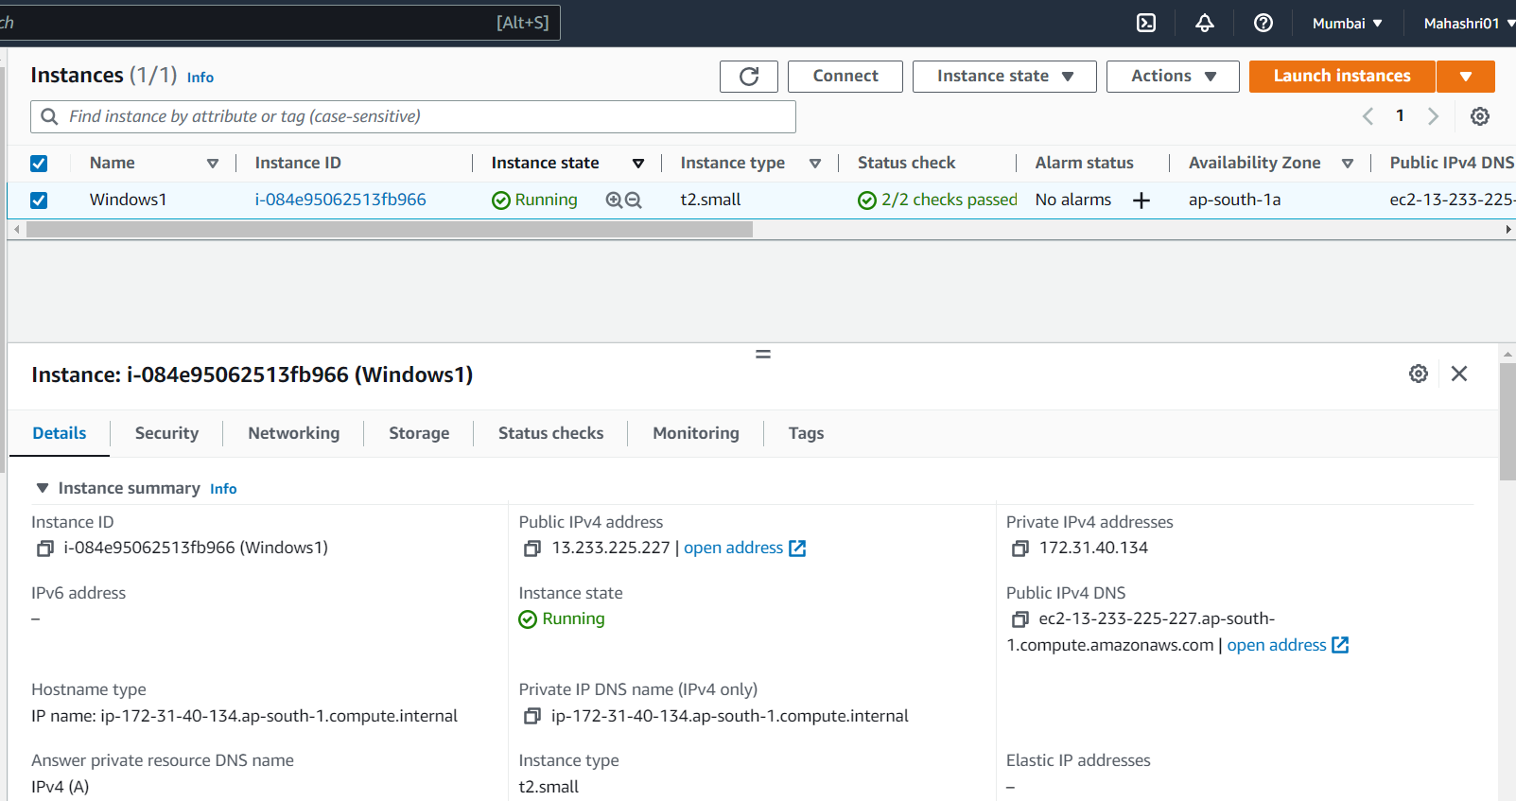

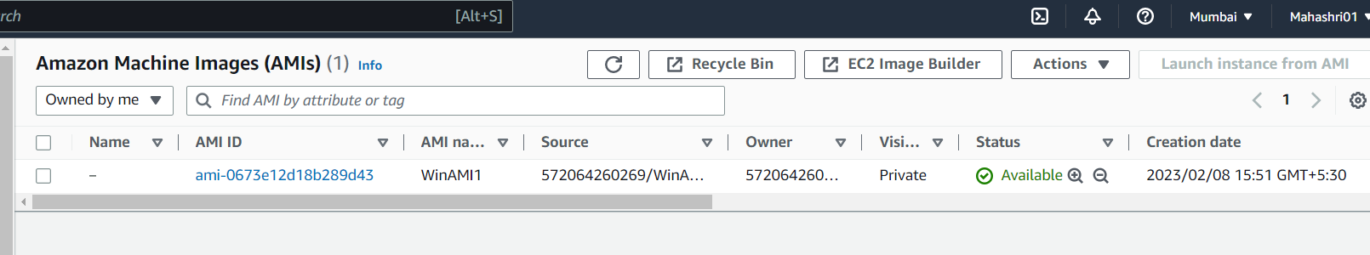

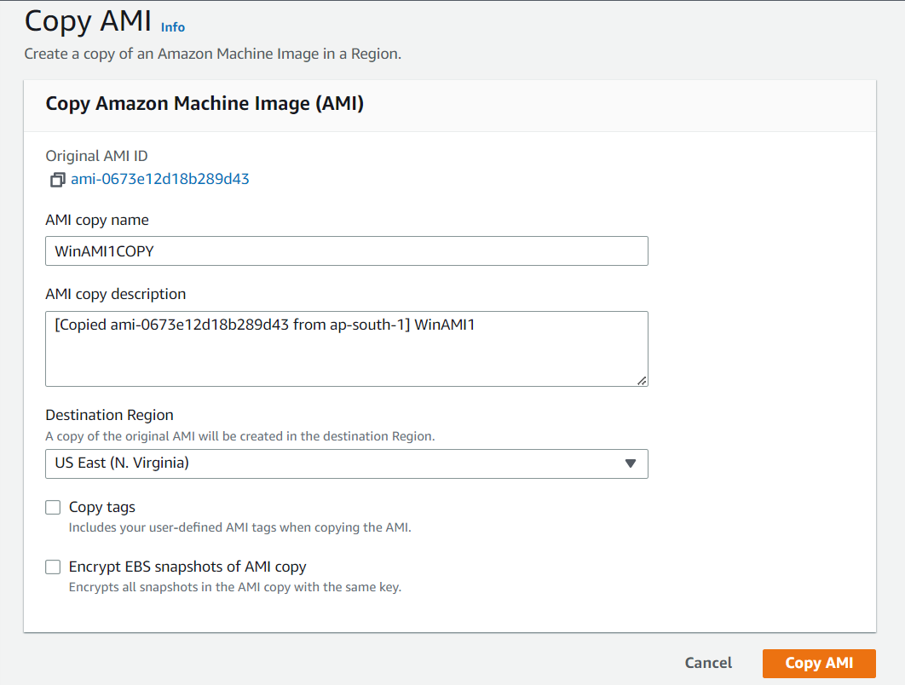

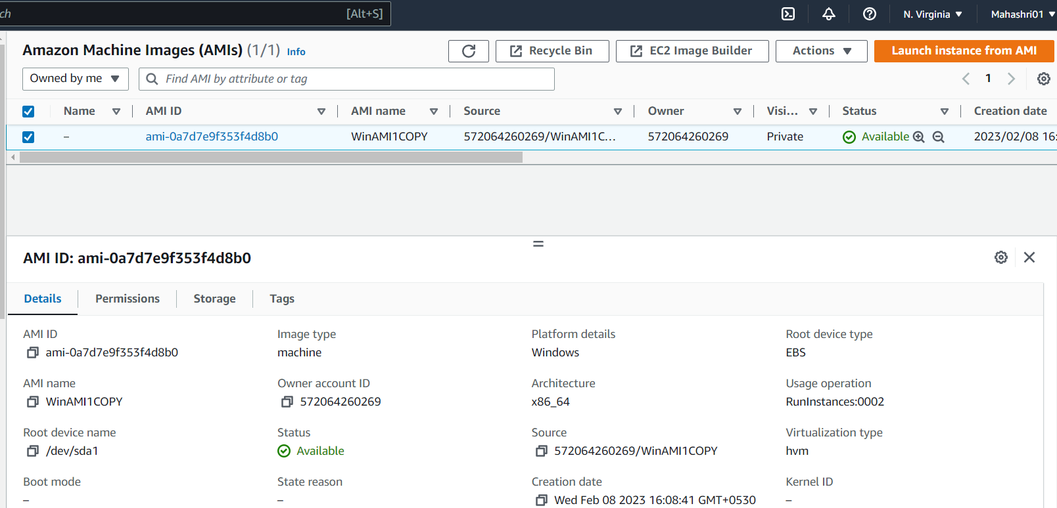

2. Try auto scaling group with load balancer count request.If request is crossing 10,then add one more EC2 instance.

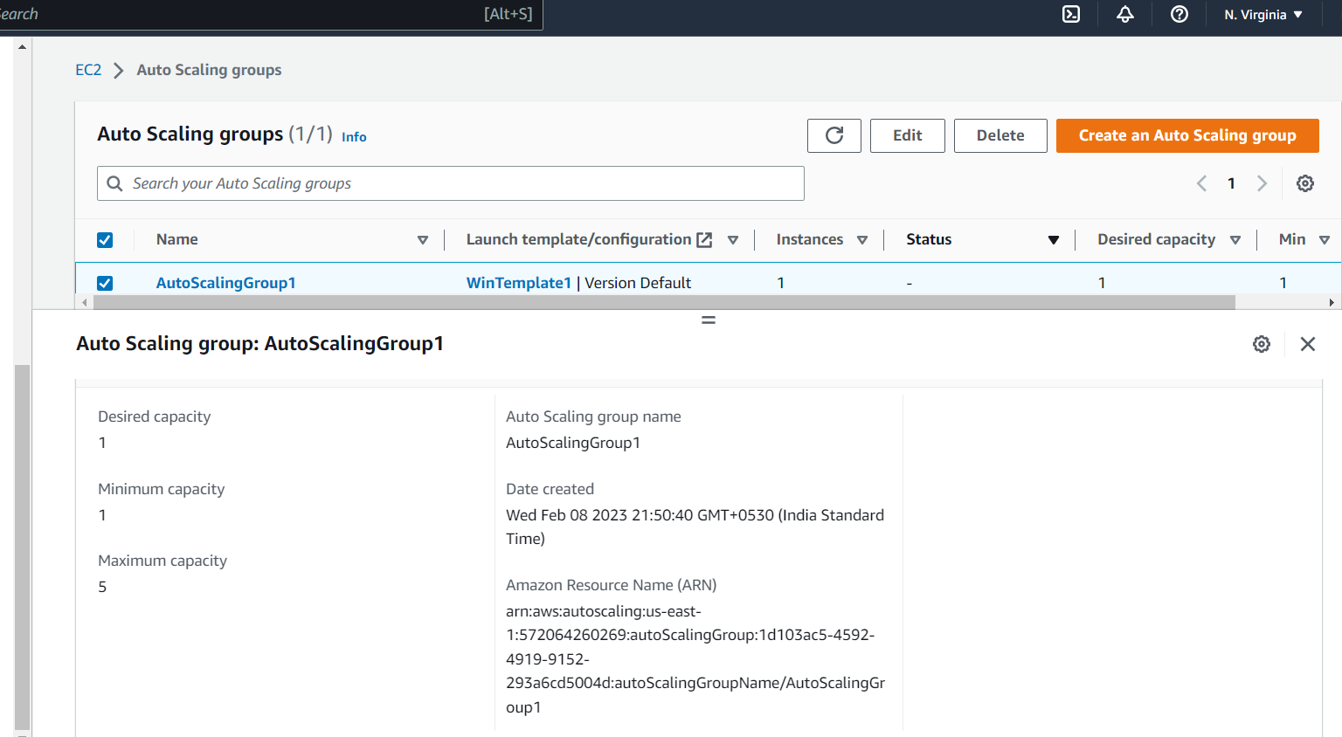

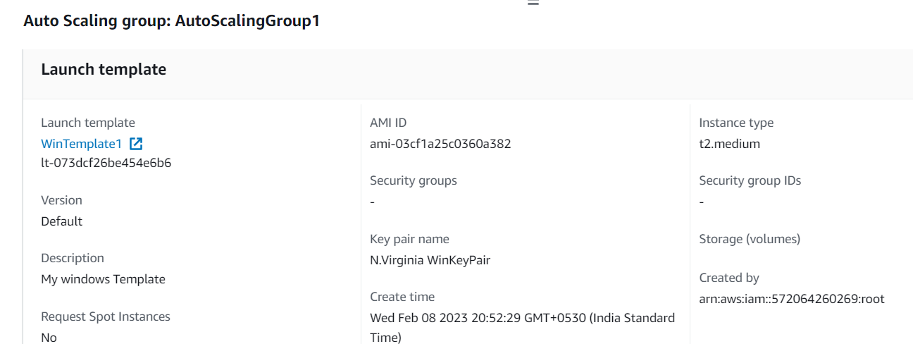

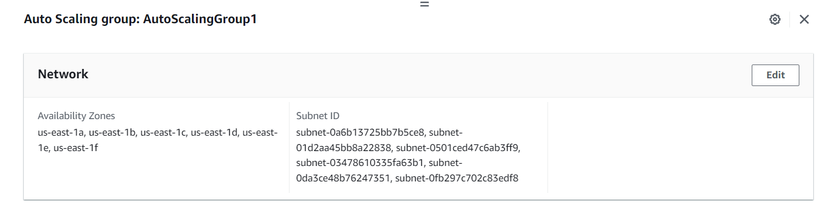

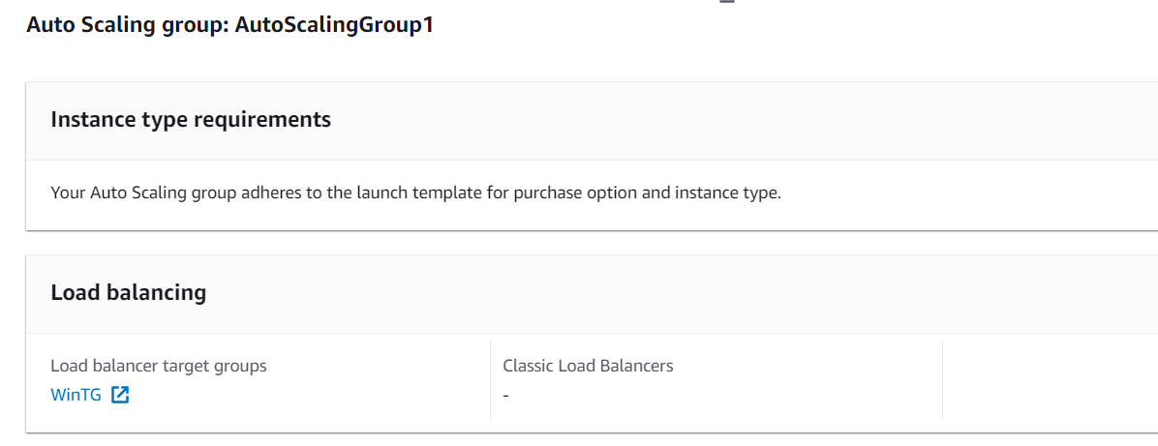

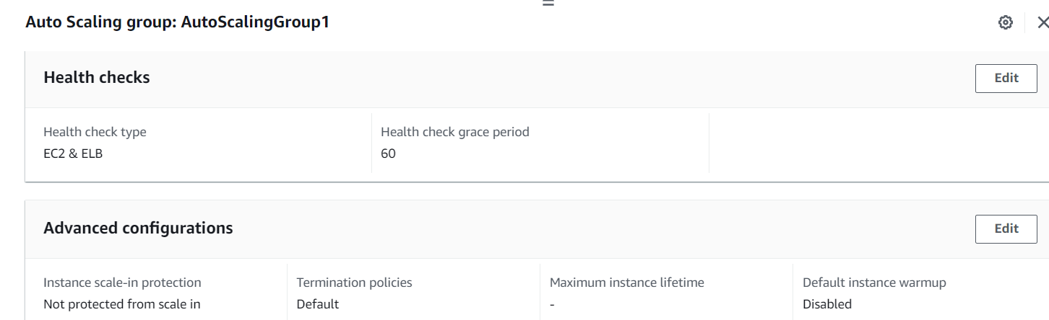

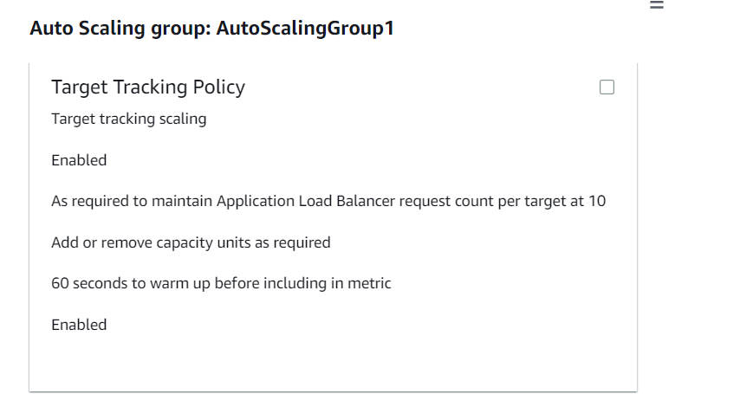

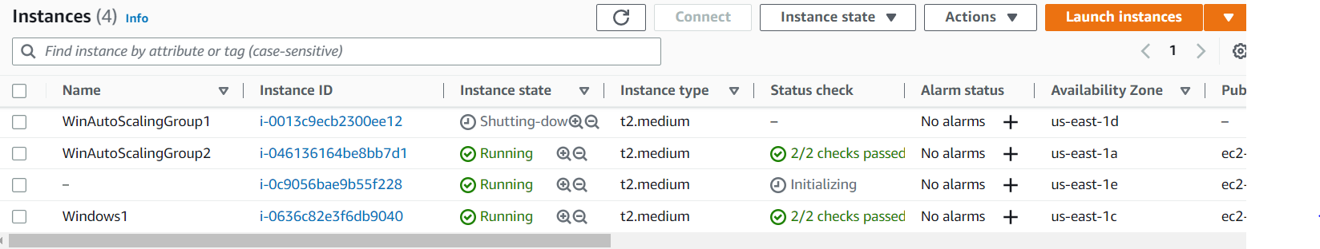

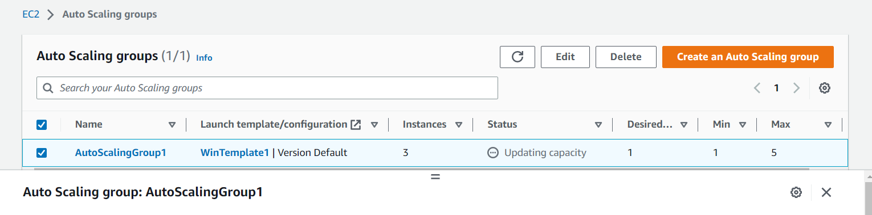

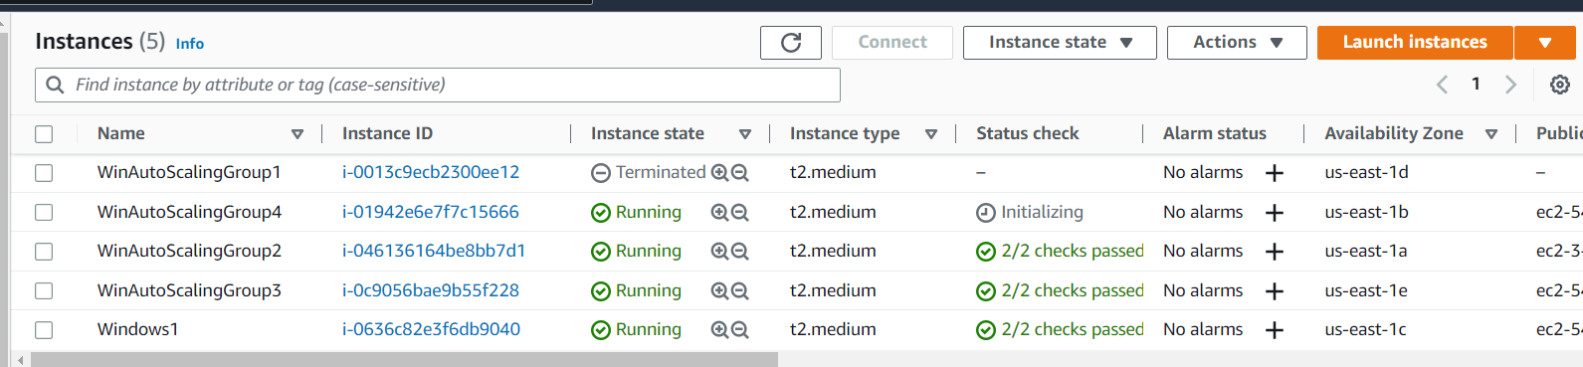

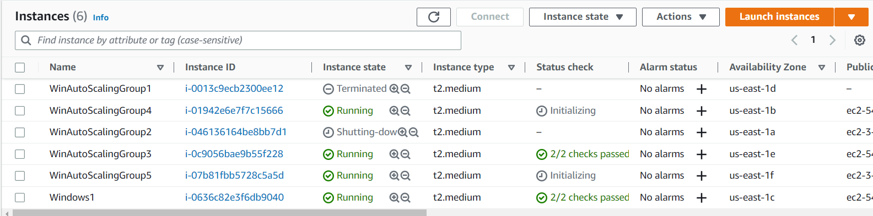

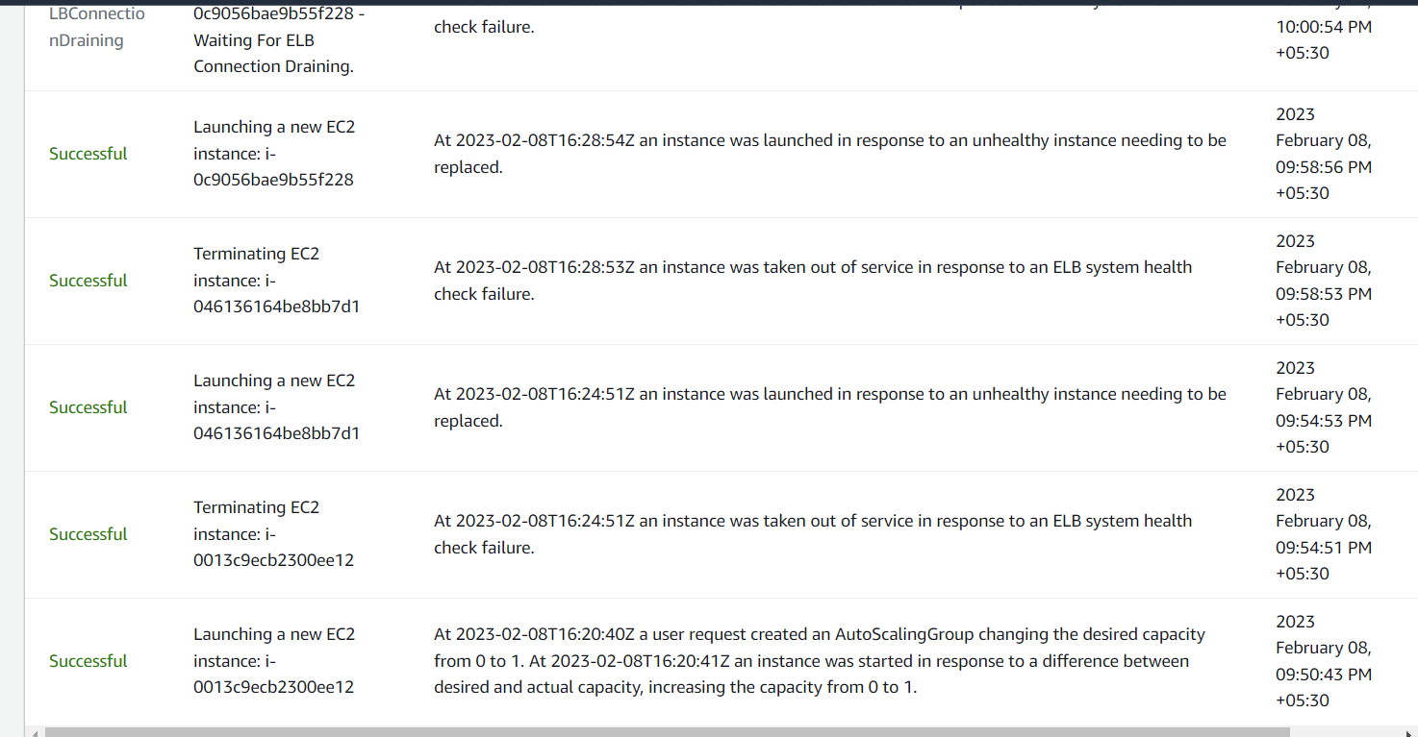

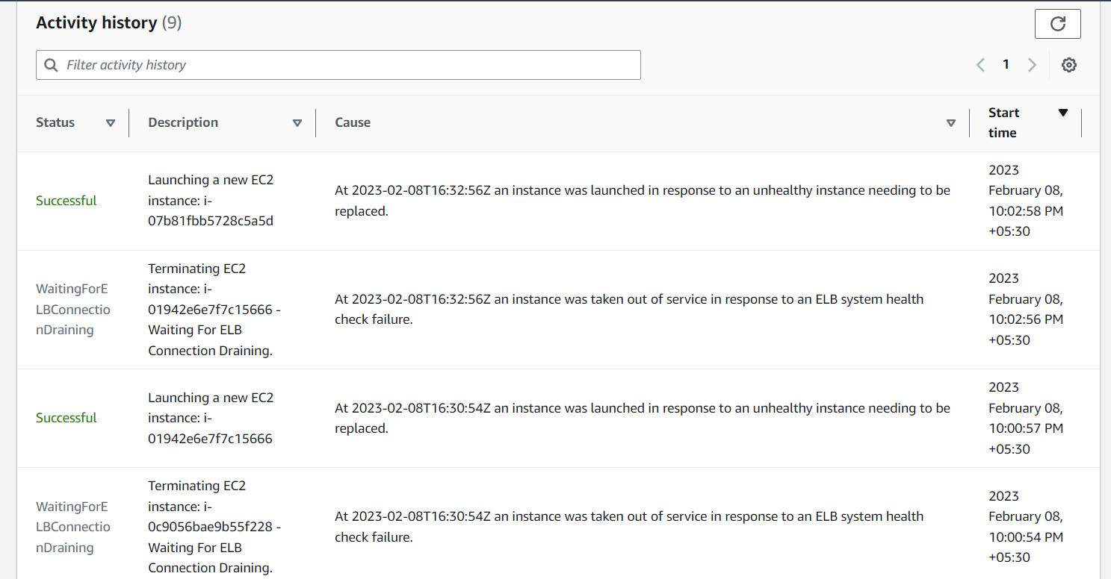

3.create a linux machine and write a script to list down S3 buckets in one document.



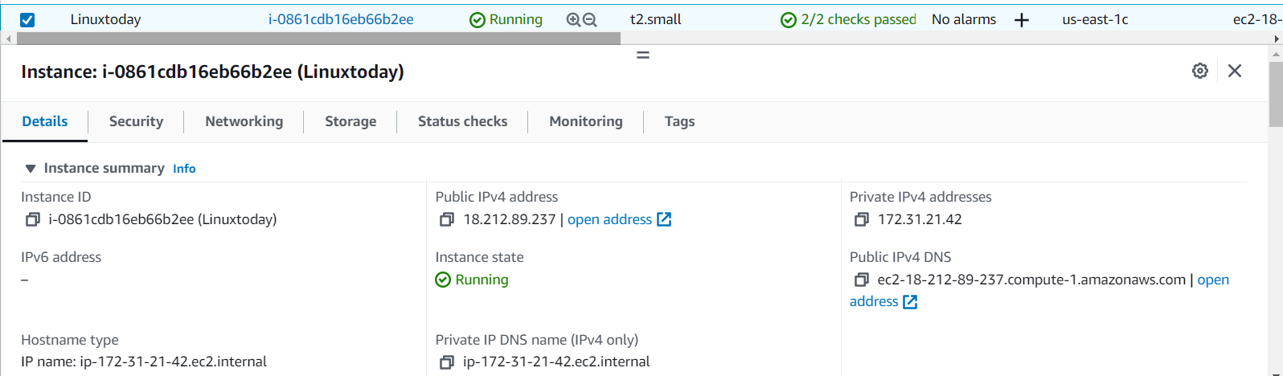

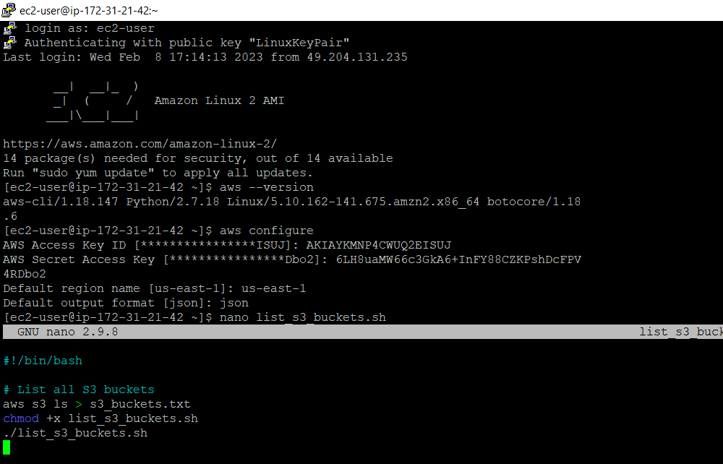

1.Nano Is a popular text editor of Linux OS. We are creating a file named lists3 buckets in shell.create a script file names “list_s3_buckets.sh” using a text editor like Nano.

Nano_list_s3_buckets.sh

2.Enter into Bash ,paste the following code into the script file.

#!/bin/bash

# List all S3 buckets

The command “ aws s3 ls > s3_buckets.txt” is a shell command that lists the Amazon S3 buckets for the current AWS CLI profile, and redirects the output to a file called s3_buckets.txt.

“aws s3 ls “ is the AWS CLI command to list the contents of an S3 bucket.

“>” is a shell operator that redirects the output of the command to the right of it, to a file.

“s3_buckets.txt” is the file to which the output will be written.

So this command lists all the S3 buckets for the current profile and saves the list to a text file named s3_buckets.txt.

4.To make the file executable: The “chmod +x list_s3_buckets.sh” command is used to change the file permissions of a file named list_s3_buckets.sh to make it executable. The +x option adds the executable permission to the file for the owner of the file. This allows the owner of the file to run the file as a shell script.

5.To list all the S3 buckets:” ./list_s3_buckets.sh”

The command ./list_s3_buckets.sh is a shell script that lists all Amazon S3 buckets associated with an AWS account. The "./" at the beginning of the command is used to run the script file in the current directory, whereas the "sh" extension at the end of the filename indicates that it is a shell script.

4.create autoscaling group with Linux machine

