ASSESSMENT – I

MCQ

1. What does WSL stand for?

Ans: c. Windows Subsystem for Linux

1. Which Linux command is used to navigate to the home directory of the current user?

Ans: b. cd ~

1. What is the default package manager for most Linux distributions?

Ans: b. Apt

1. Which OSI model layer is responsible for routing and forwarding data packets?

Ans: c. Network Layer

1. What is the purpose of a subnet mask in networking?

Ans: b. It defines the range of IP addresses in a network.

1. Which Linux command is used to create a new directory?

Ans: b. mkdir

1. What is the primary role of a shell in a Linux environment?

Ans: c. Providing a command-line interface

1. Which of the following is NOT a Linux distribution?

Ans: b. Apache

1. In networking, what does the acronym DNS stand for?

Ans: b. Domain Name System

1. Which Linux command is used to display the contents of a file?

Ans: a. cat

TASKS

1. Task: Use the **ls** command to list all files and directories in your home directory.

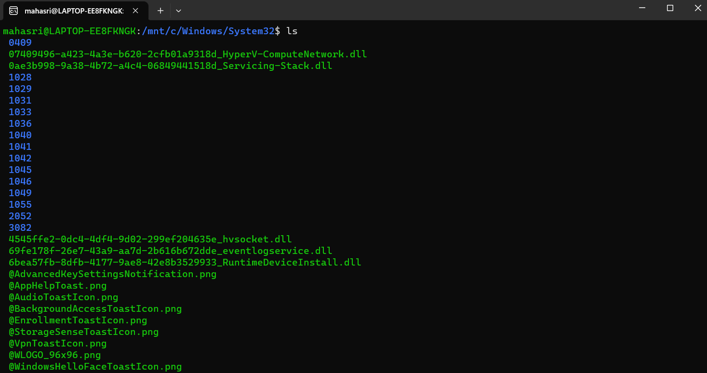

1. Task: Create a new directory called "Documents" within your home directory.



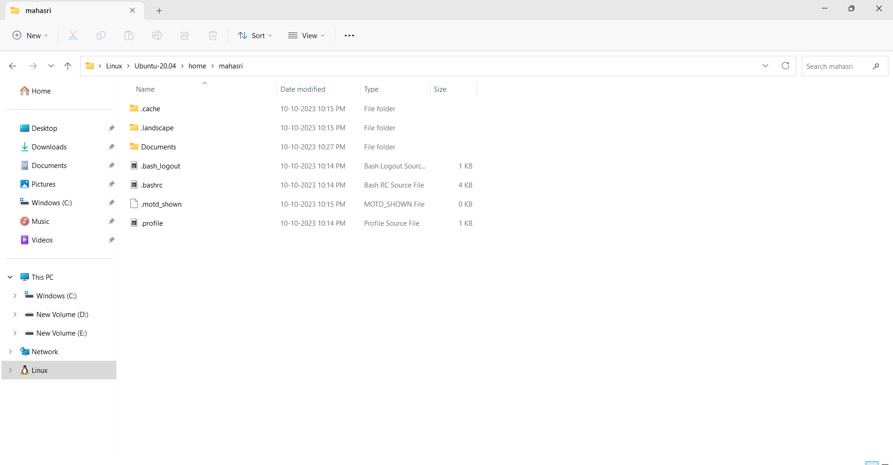

1. Task: Change the permissions of a file named "myFile.txt" to allow read and write access for the owner, and read-only access for others.

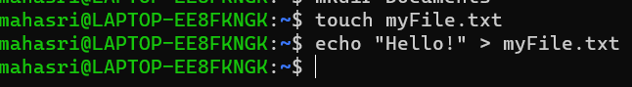

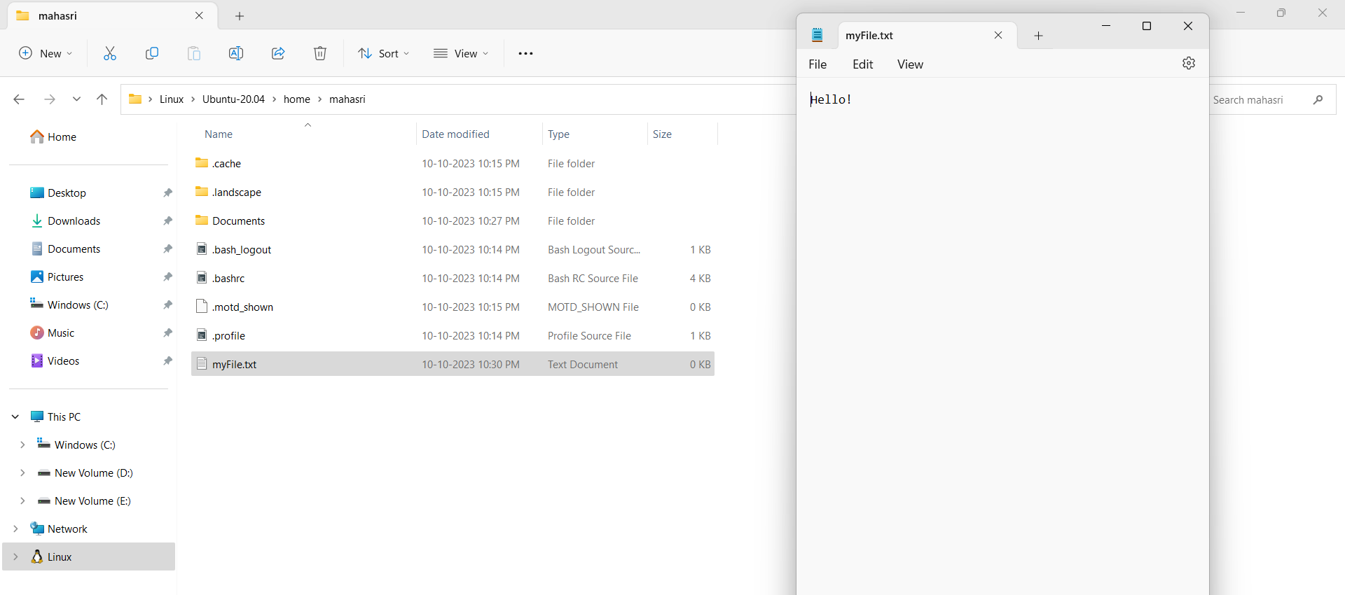



1. Task: Install a text editor of your choice on your Linux system using the appropriate package manager.

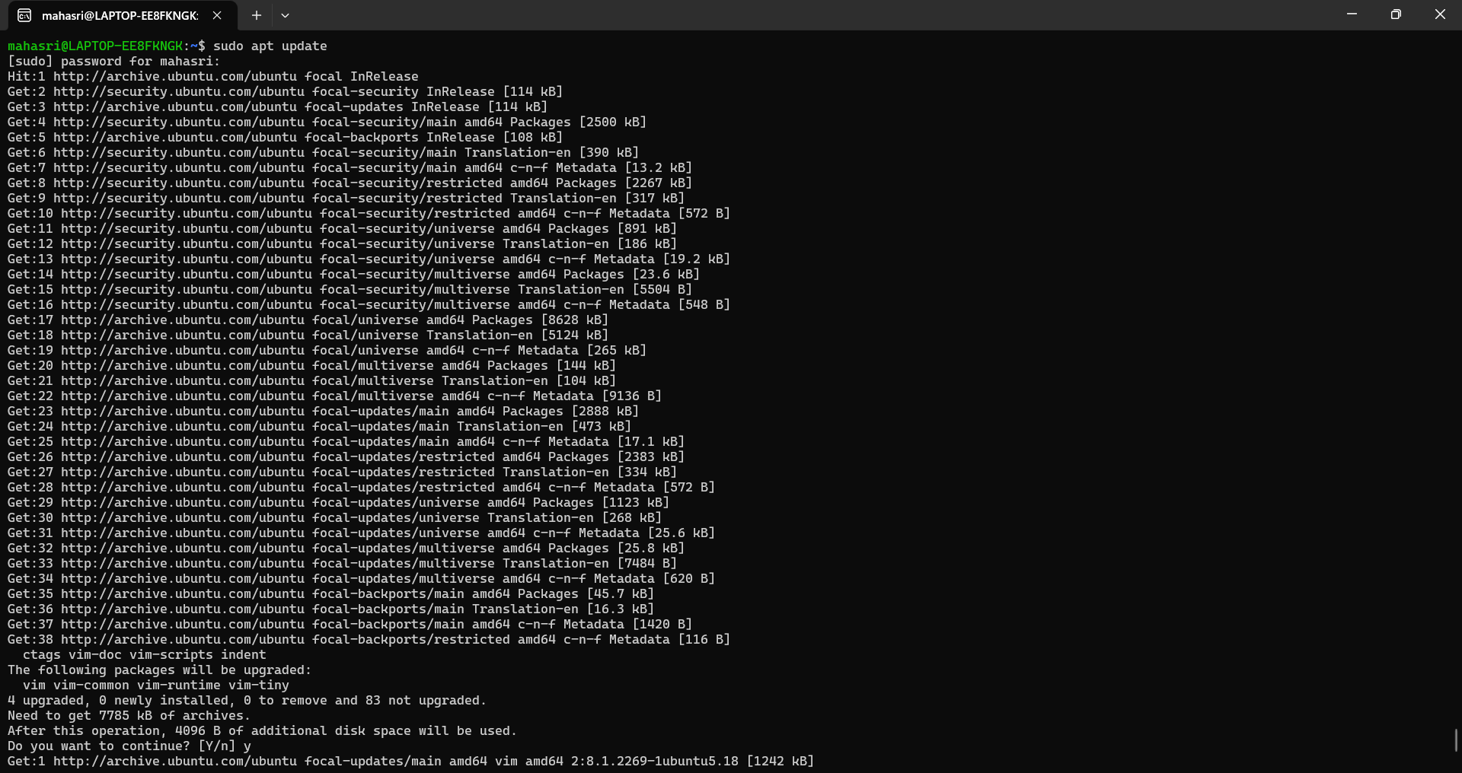

1. 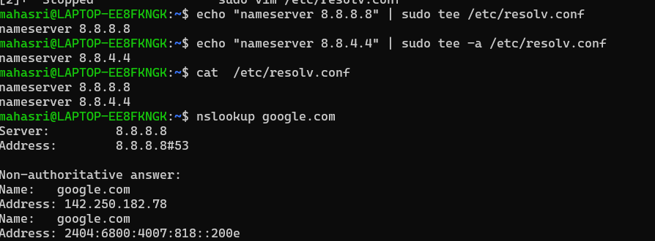Task: Configure your Linux system to use Google's DNS servers (8.8.8.8 and 8.8.4.4) for DNS resolution.
2. 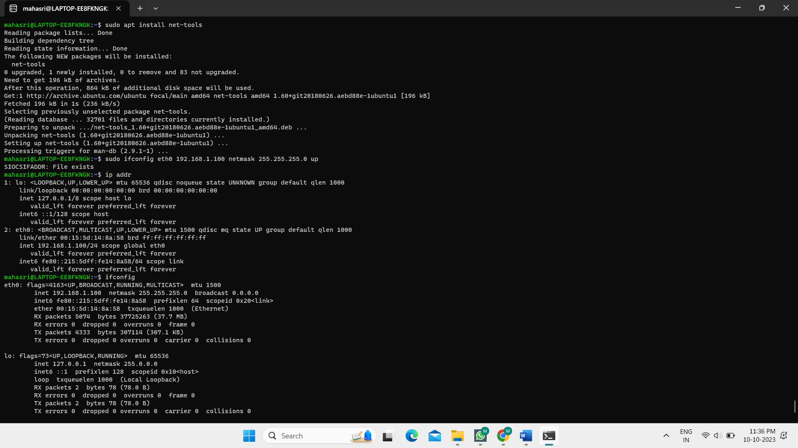Task: Set up a static IP address (e.g., 192.168.1.100) on your Linux machine using the command line.
3. Task: Create a simple bash script that prints "Hello, World!" when executed.

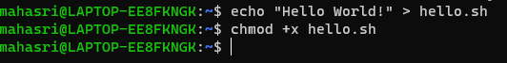

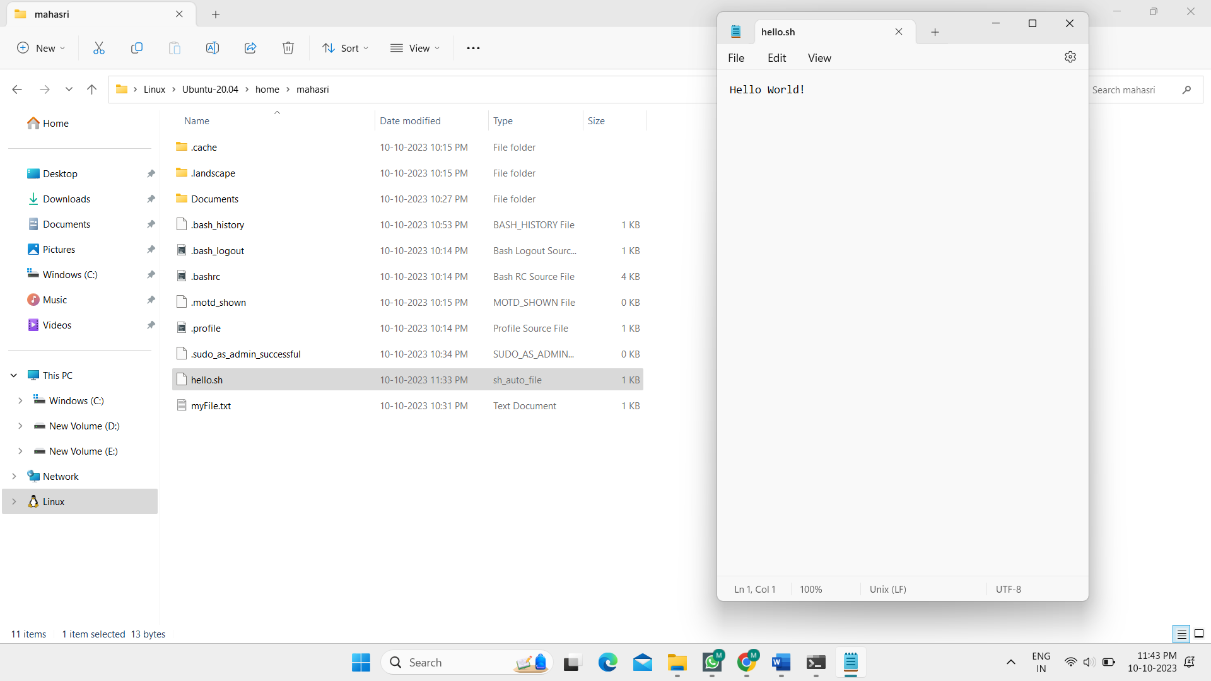

1. 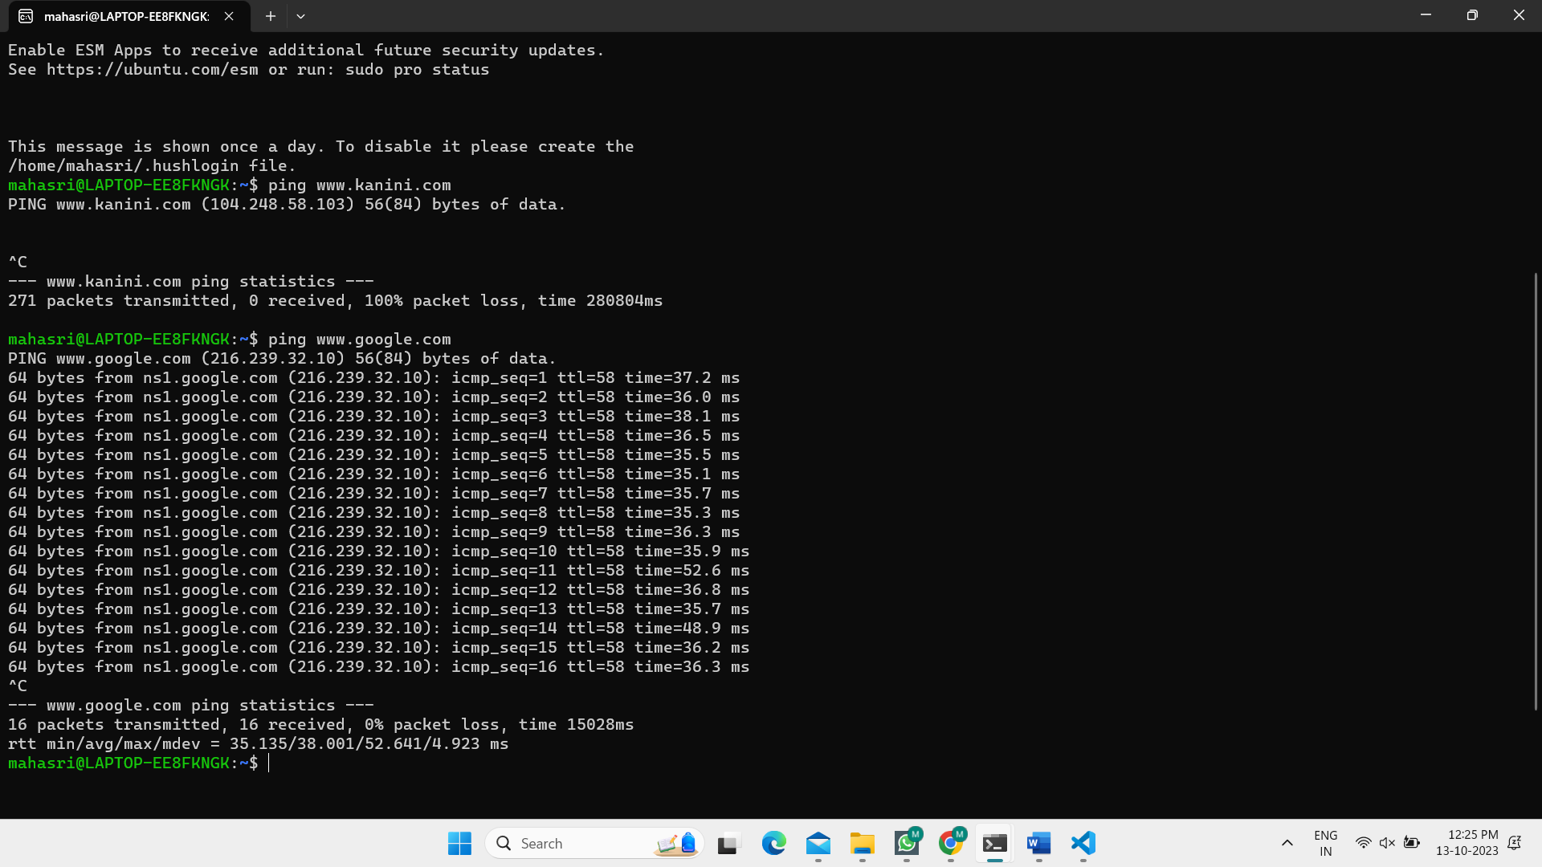Task: Use the **ping** command to check the connectivity to a remote server or website (e.g., "ping [www.example.com](http://www.example.com/)").
2. 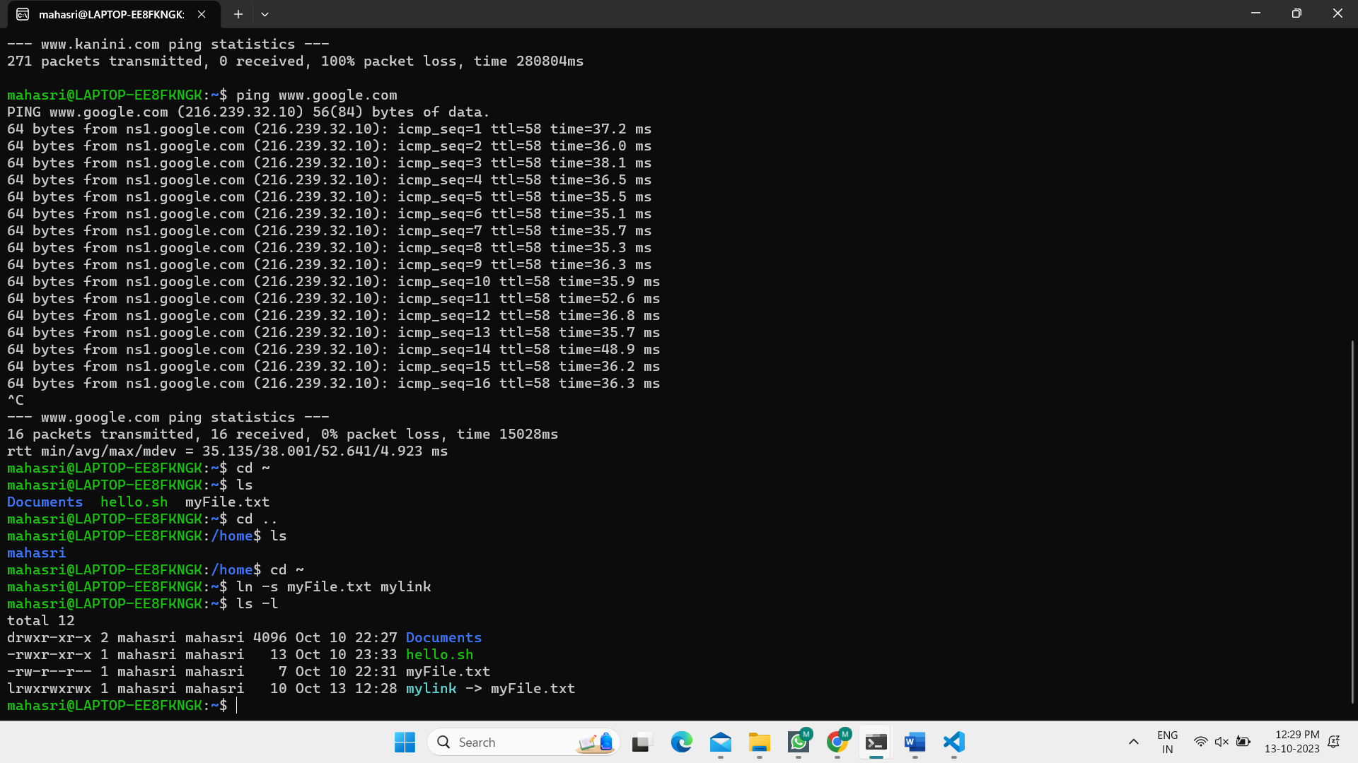Task: Create a symbolic link named "mylink" that points to a file named "targetfile.txt."
3. Task: Use the **netstat** command to display a list of open network connections on your Linux machine.

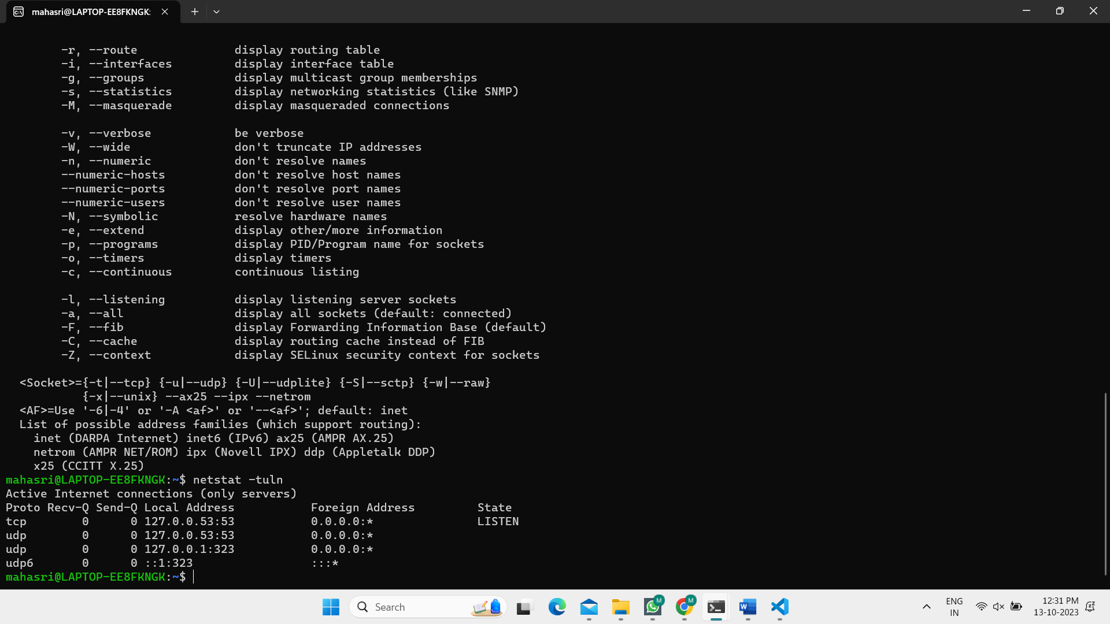

### Labs:

**Lab 1: WSL Installation**

* 1. Objective: Install Windows Subsystem for Linux (WSL) on your Windows machine.
  2. Steps: Document the installation process, and launch a Linux distribution through WSL.

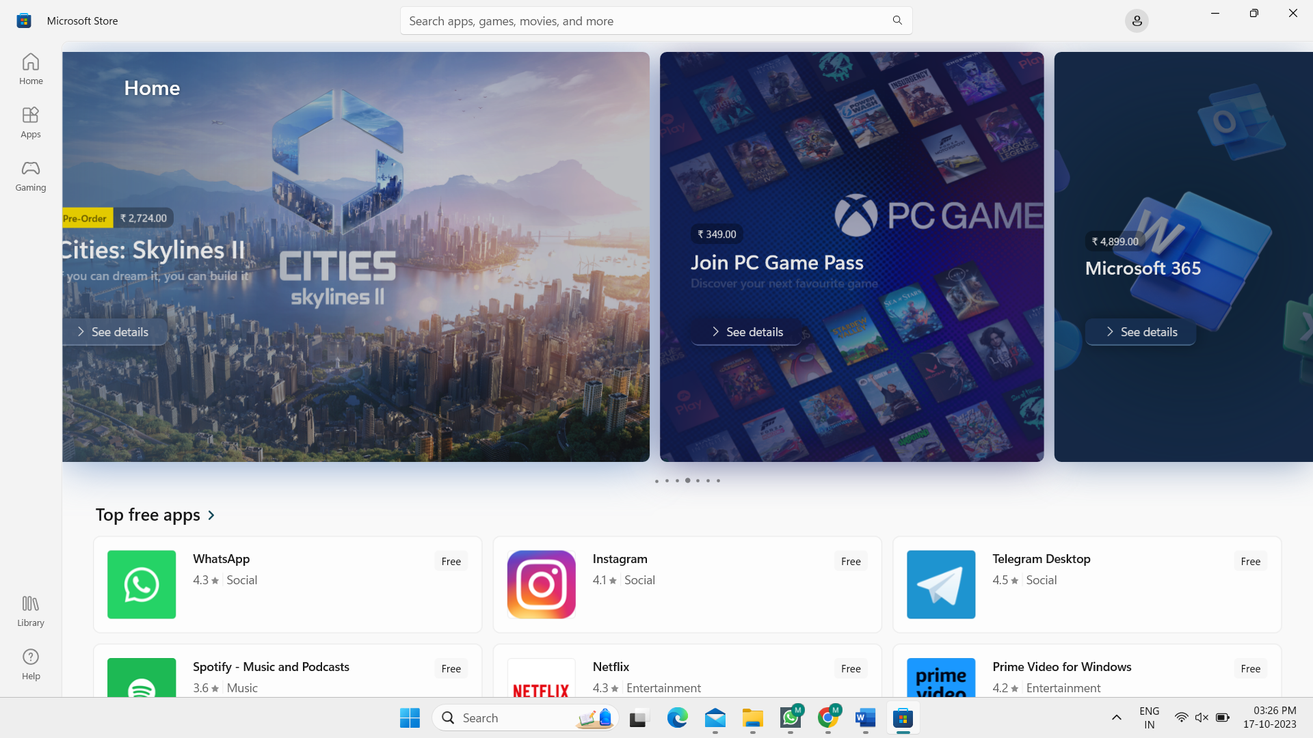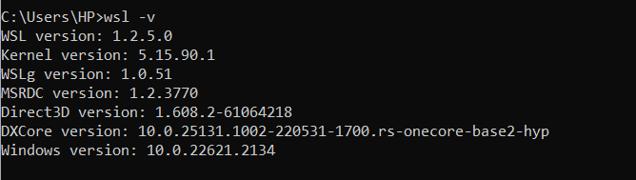Step 1: Open Microsoft Store

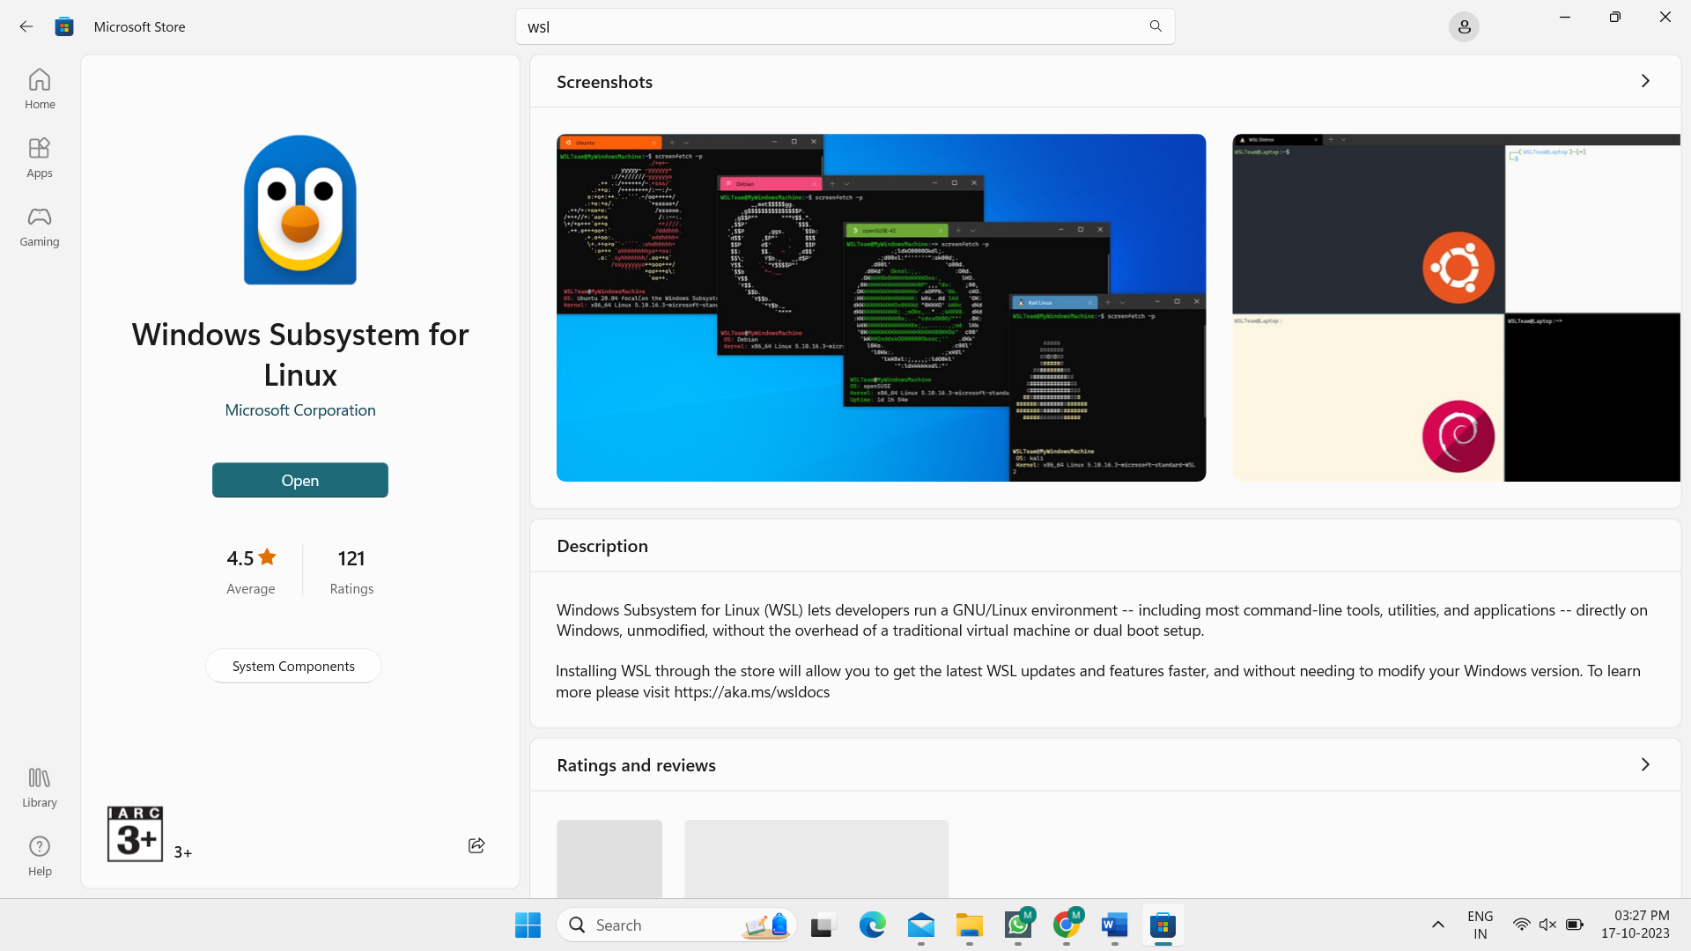Step 2: Install Windows Subsystem for Linux

Step 3: Install Ubuntu

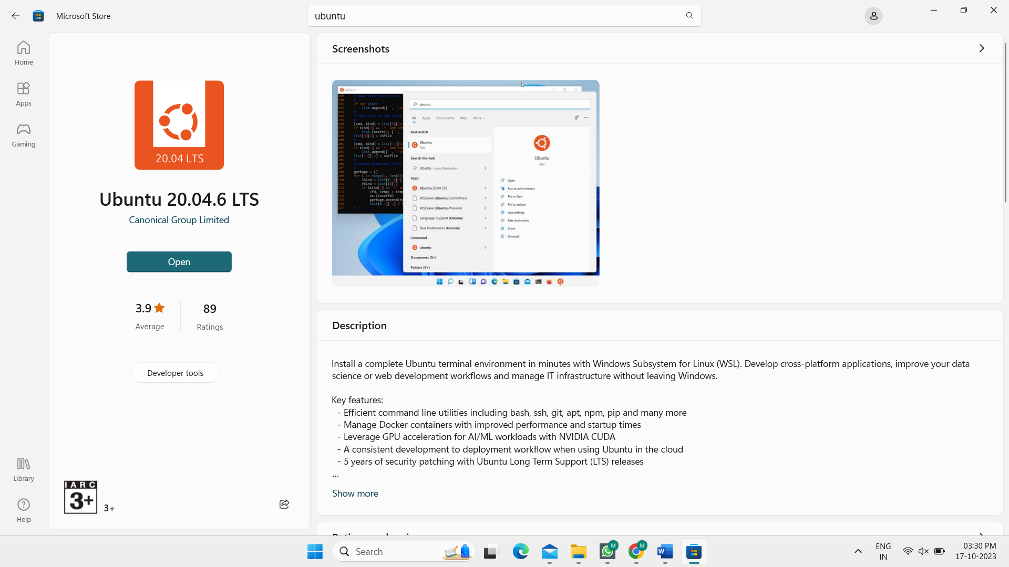

After installation, it will ask for username and password.

I have created the username and password.

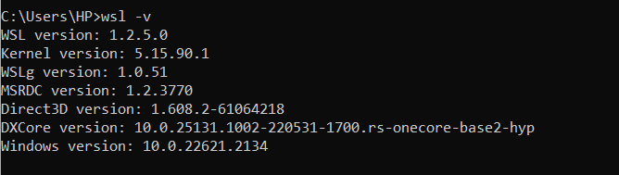Here is the version of wsl.

**Lab 2: Basic Linux Commands**

* 1. Objective: Practice basic Linux commands such as **ls**, **cd**, **mkdir**, and **touch** in a Linux terminal.
  2. Steps: Execute these commands and describe their outcomes.

**ls** – list files and directories in current directory



**cd** – change directory

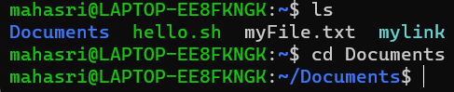

**mkdir** – make directory



**touch** – create an empty file with the specified name



**Lab 3: Network Configuration**

1. Objective: Configure your Linux machine to use a static IP address and Google's DNS servers.

1. Steps: Document the configuration steps and test network connectivity.





**Lab 4: File Permissions**

1. Objective: Explore file permissions by creating files and directories with different permissions settings.

1. Steps: Create and modify files with various permission settings, and describe the results.

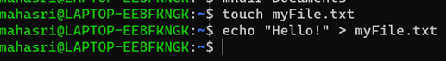Create a file and write into it:

Change the permissions:

**Lab 5: Bash Scripting**

* 1. Objective: Write a bash script that automates a task of your choice.
  2. Steps: Create the script, execute it, and explain its functionality.

Create the bash file:

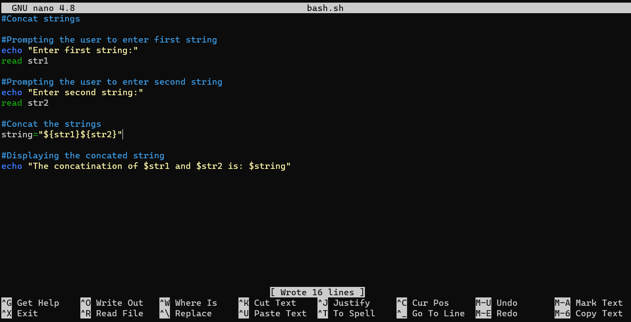Write script in bash.sh :

Save and run in terminal:

