**NAME: Mahasri M**

**1. Generate both the following patterns. Use methods to invoke based on choice of numeric or**

**character pattern from the user.**

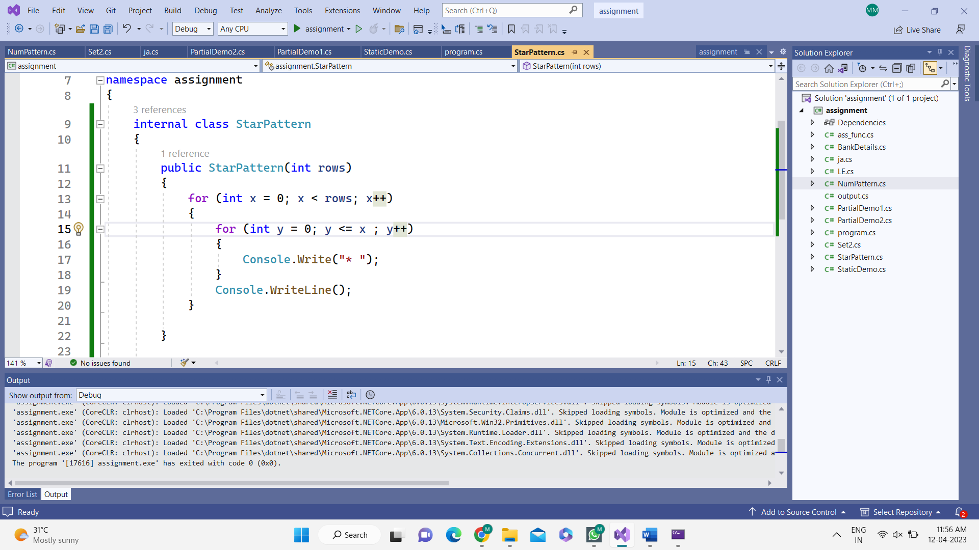**Star pattern:**

**Number pattern:**

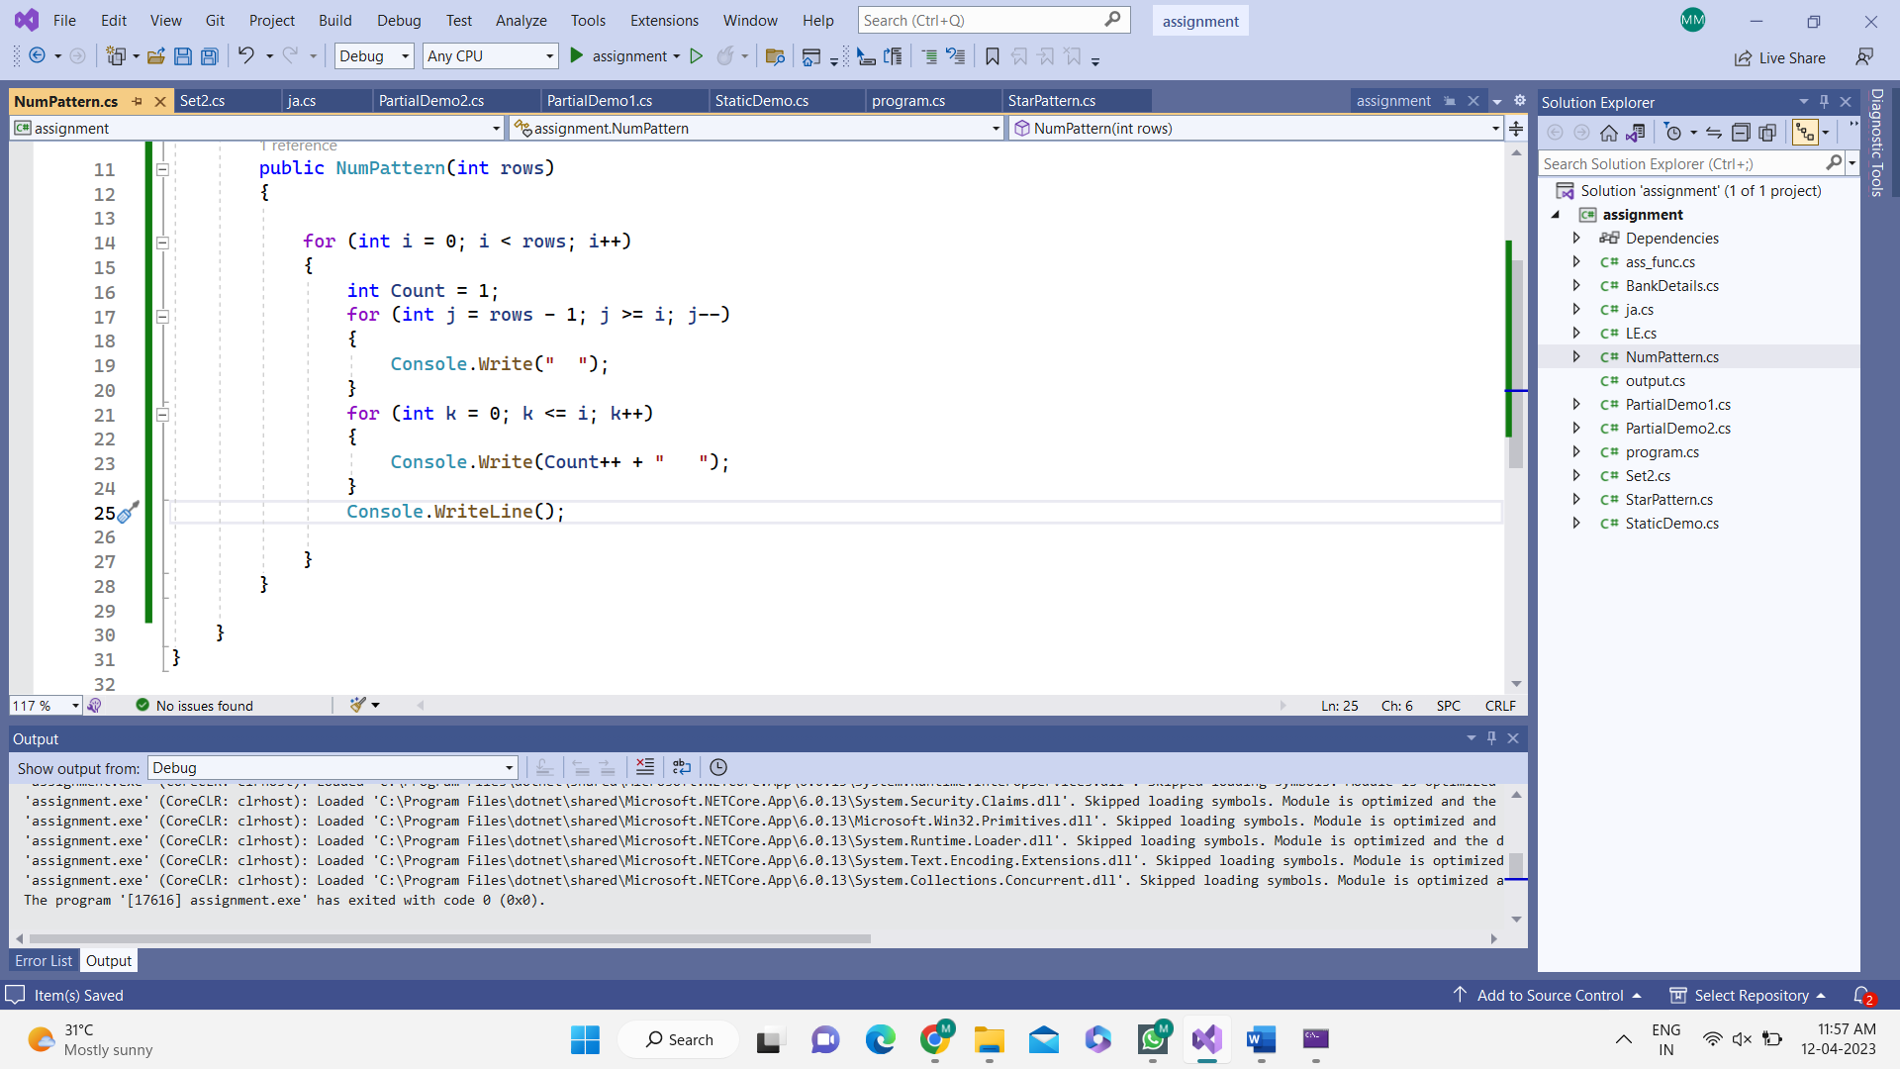

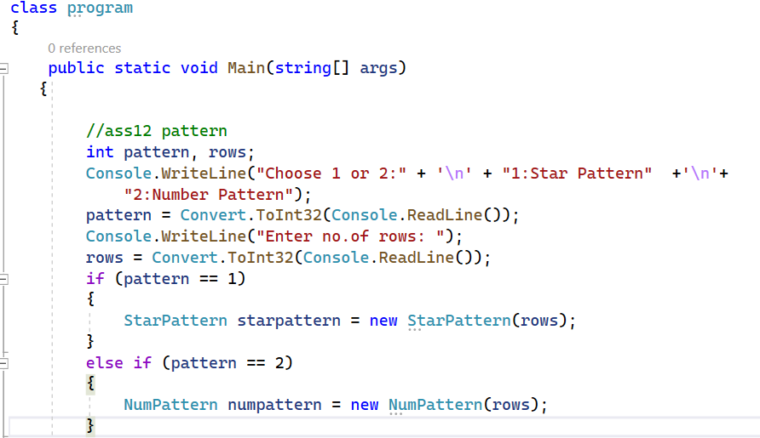

**OUTPUT:**

**Star pattern: Number pattern:**

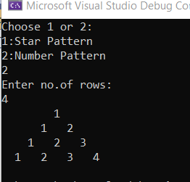

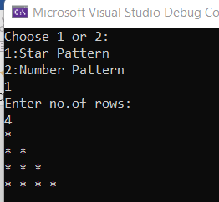

**2. Answer both the problems**

**a. Create partial class for Calculator and perform basic operations (add, sub, mul, div, mod).**

**Distribute the methods in 3 classes.**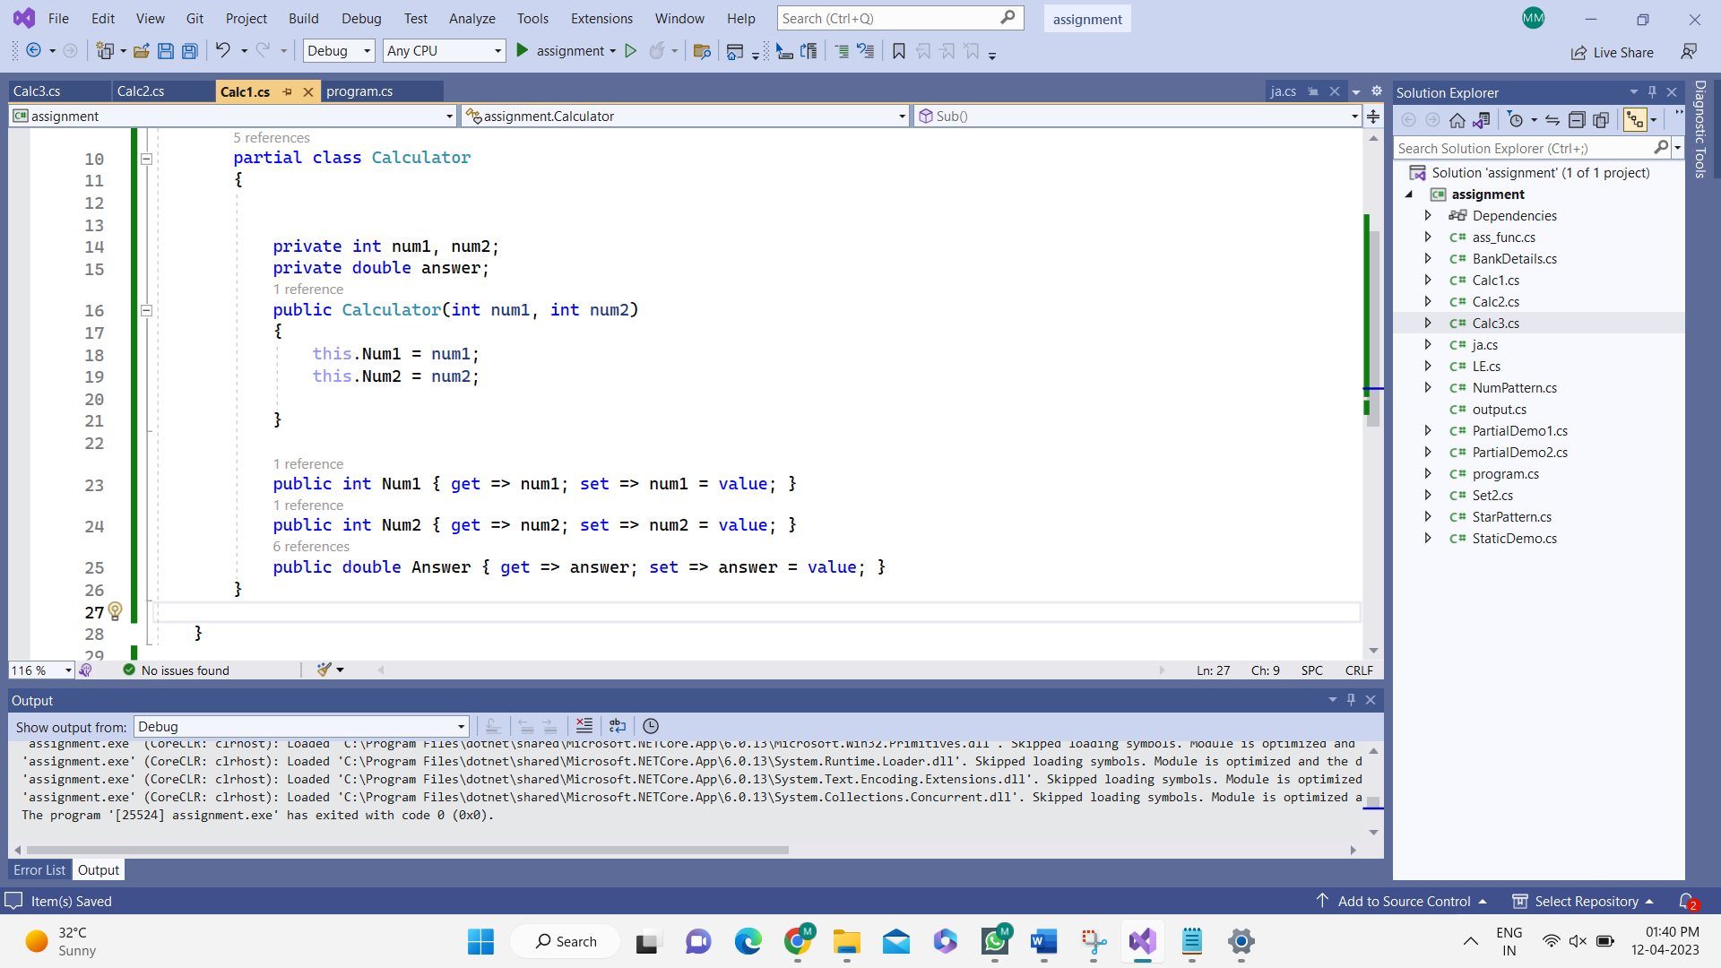

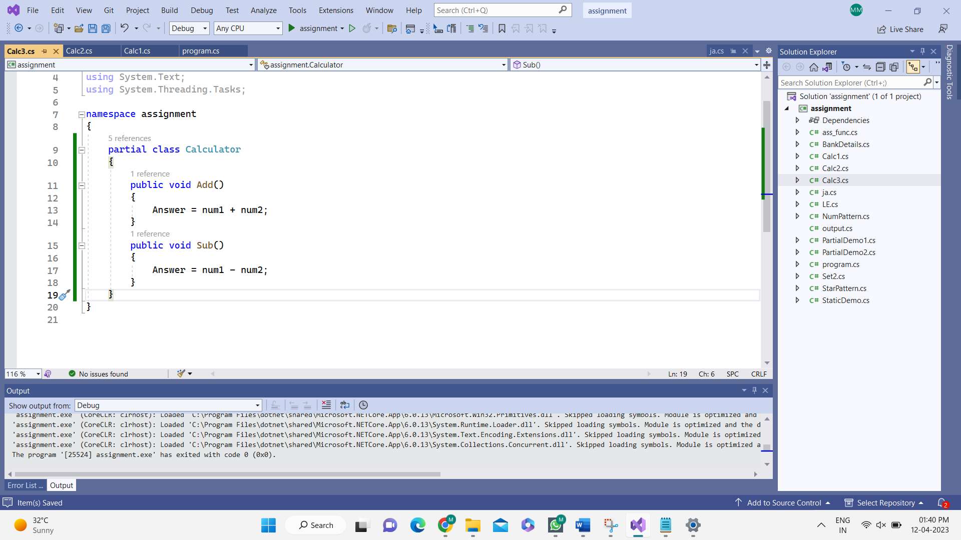

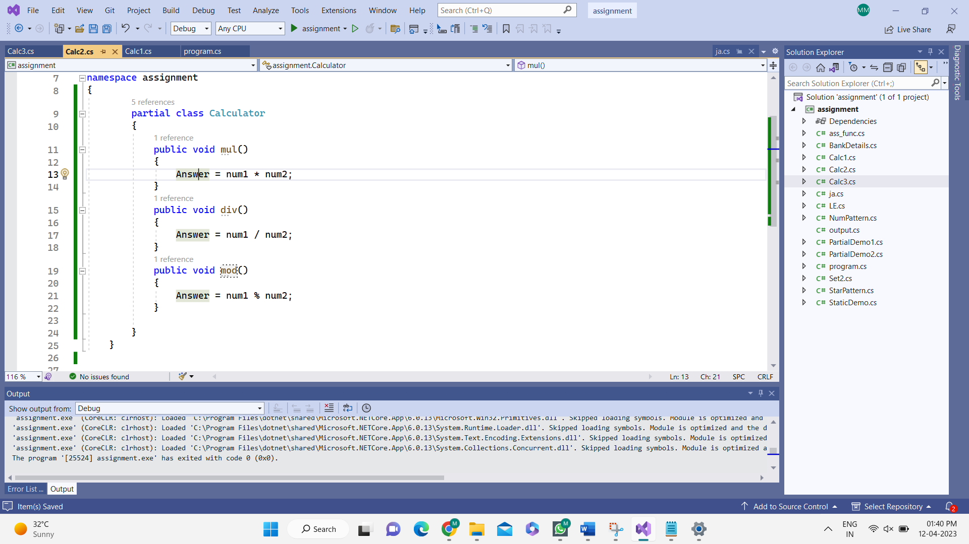

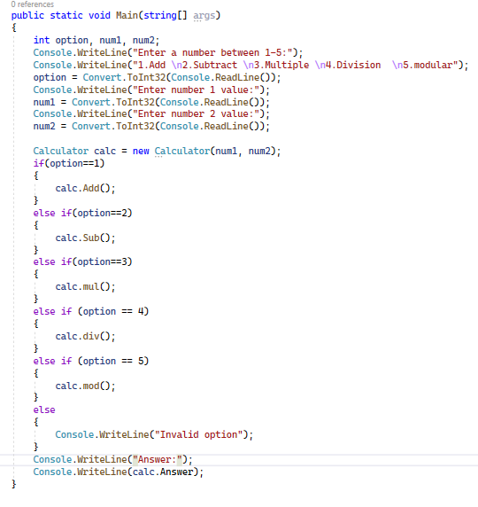

**OUTPUT:**

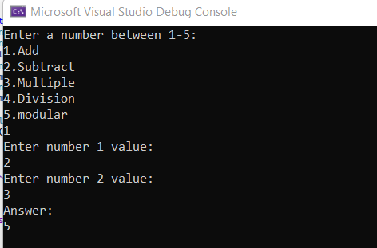

**b. Create three files. (Employee.txt, HR.txt, TL.txt) and do the following operations.**

**i. Read the Employee file and count the HR and TL**

**ii. Write the HR file with count of HR**

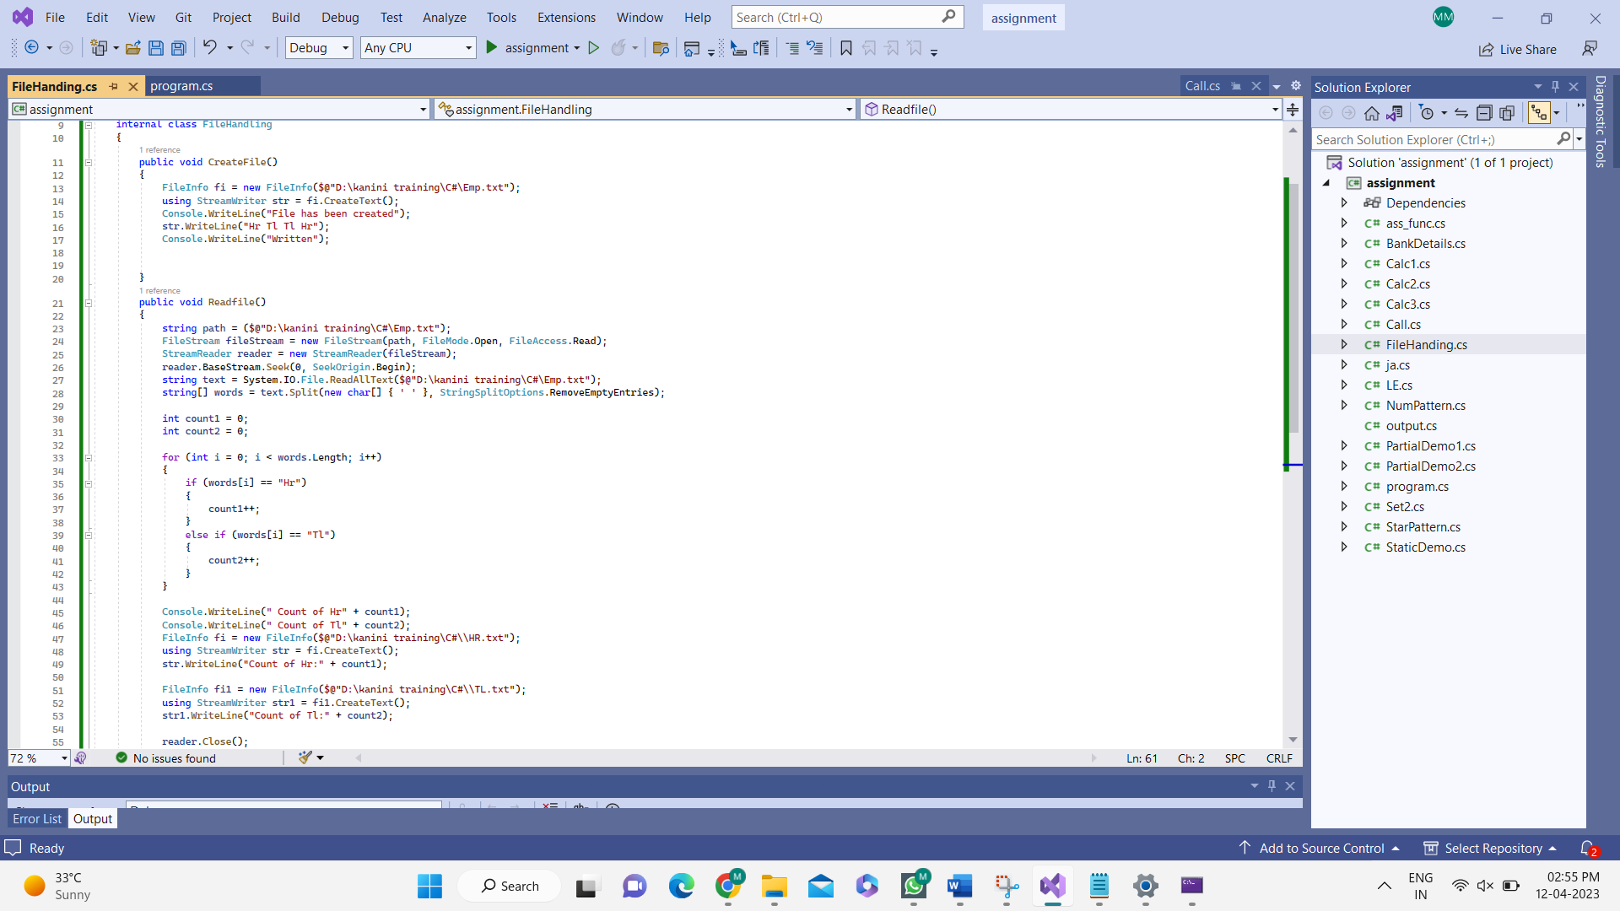**iii. Write the TL file with count if TL**

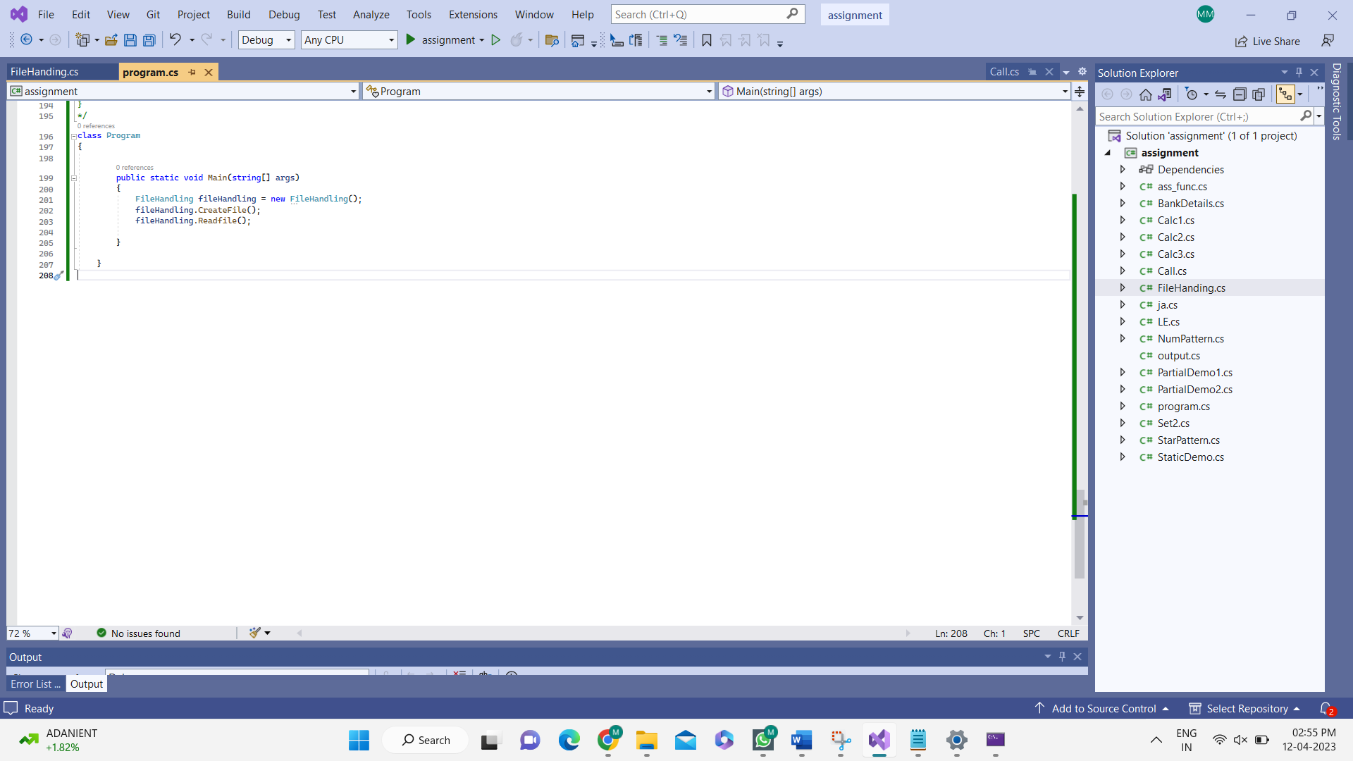

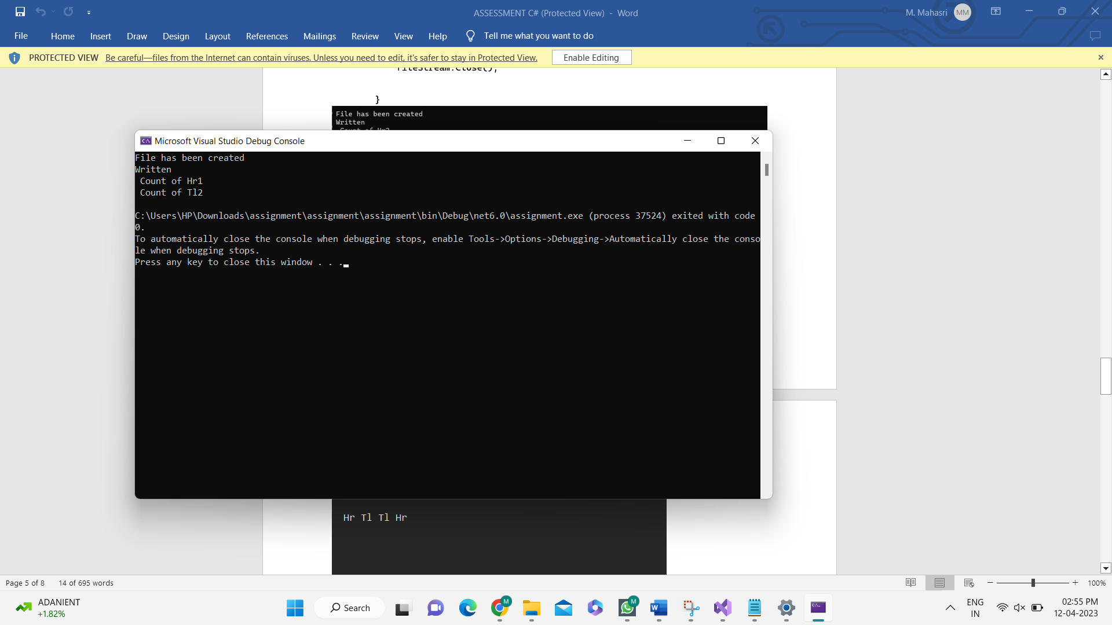

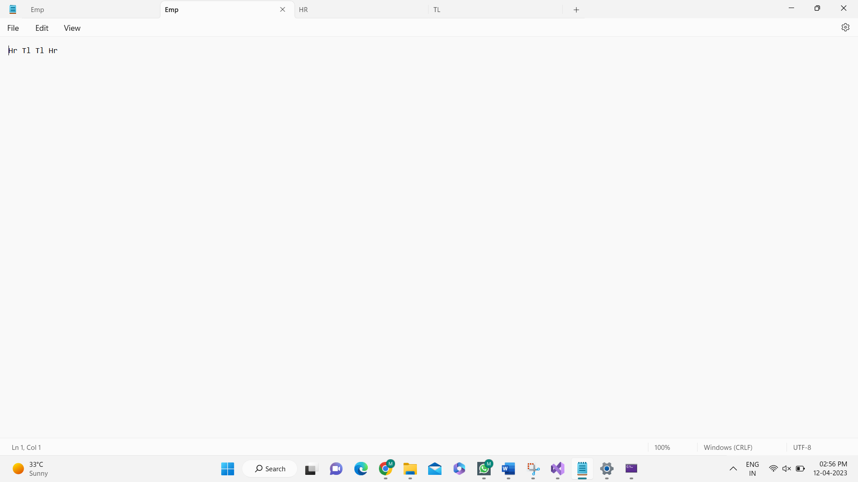

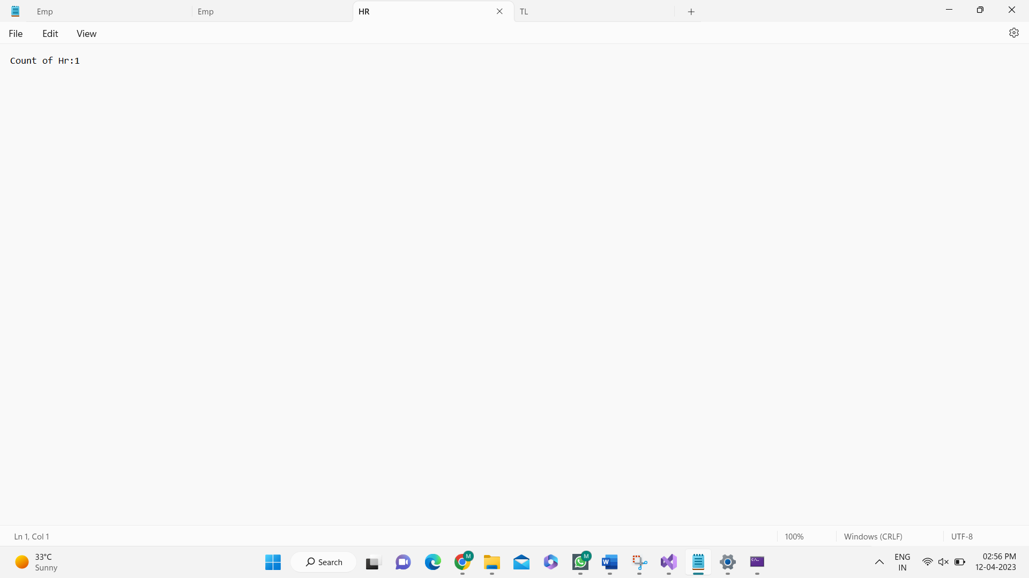

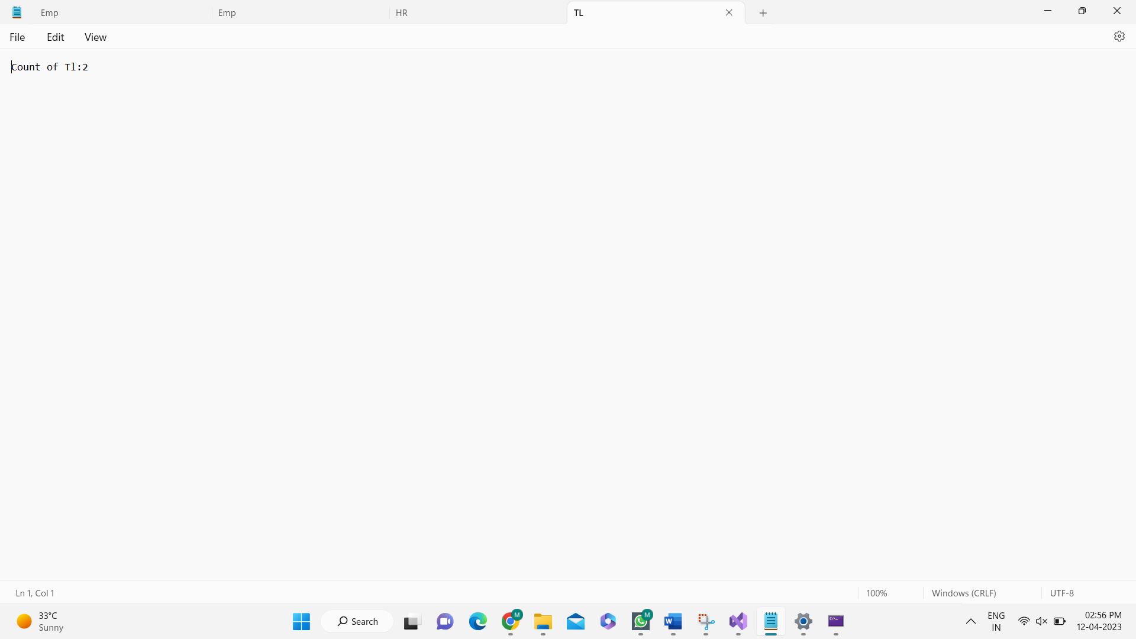

**3. Create a Smartphone interface and implement the methods (CallLog() to display last 10 dialed**

**numbers, DialLastCall() to initiate the call with the last dialled number and display the call**

**duration in minutes after the call ends. Call duration is your choice) in the derived class. Define**

**Custom Exception to handle insufficient balance when dialling the call.**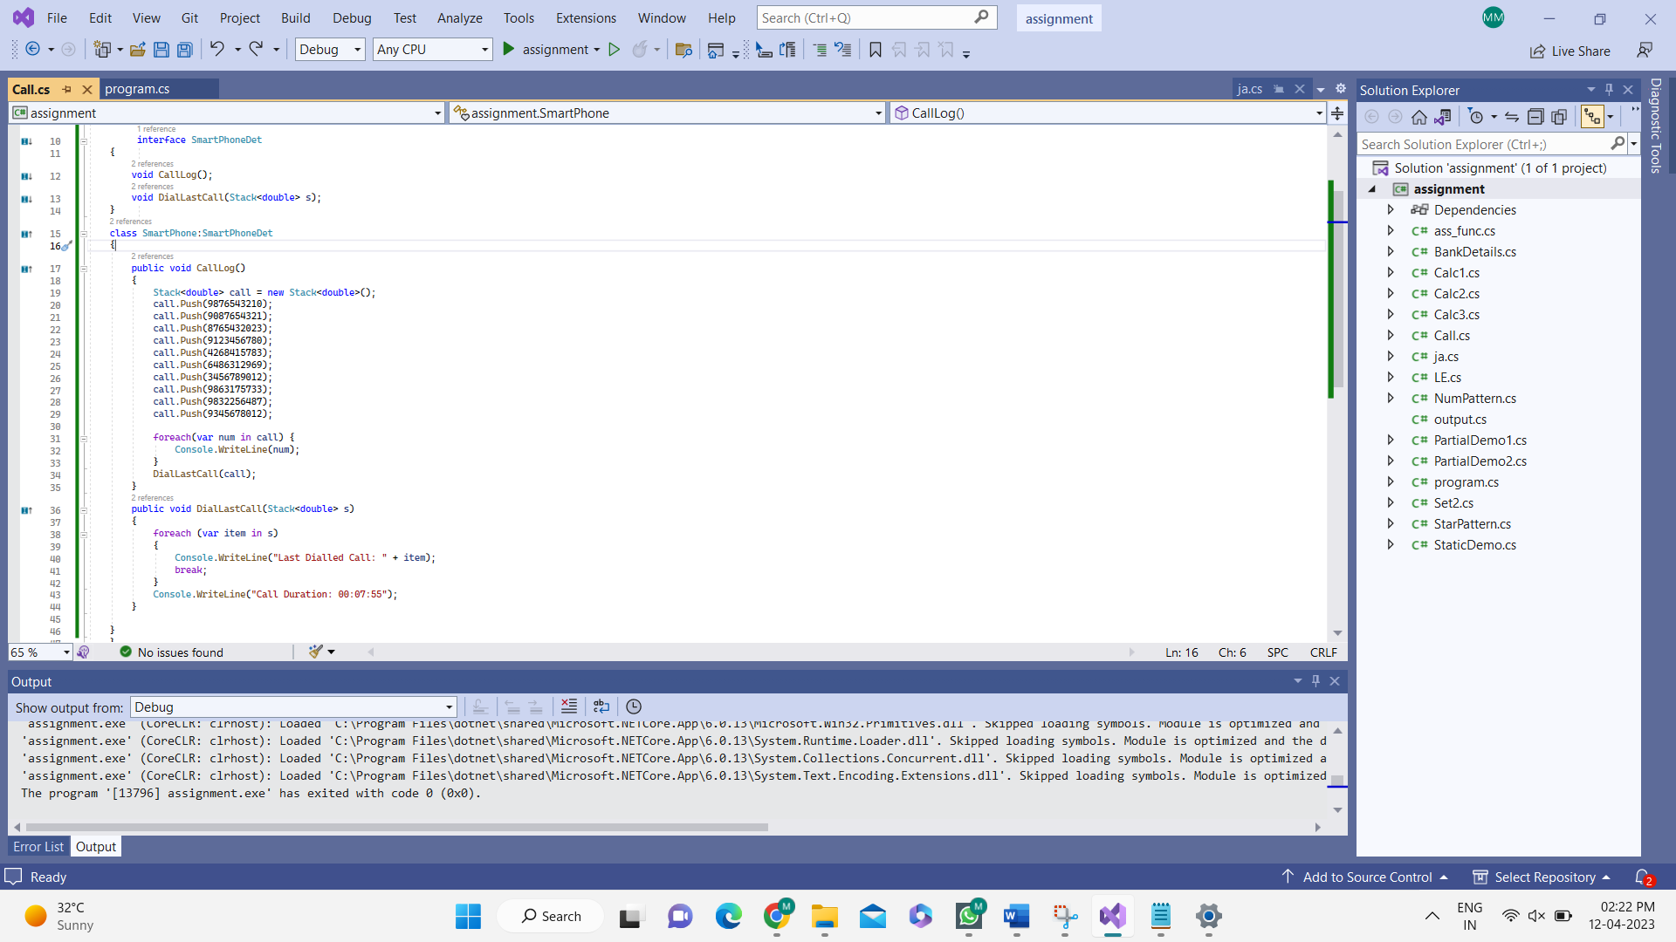

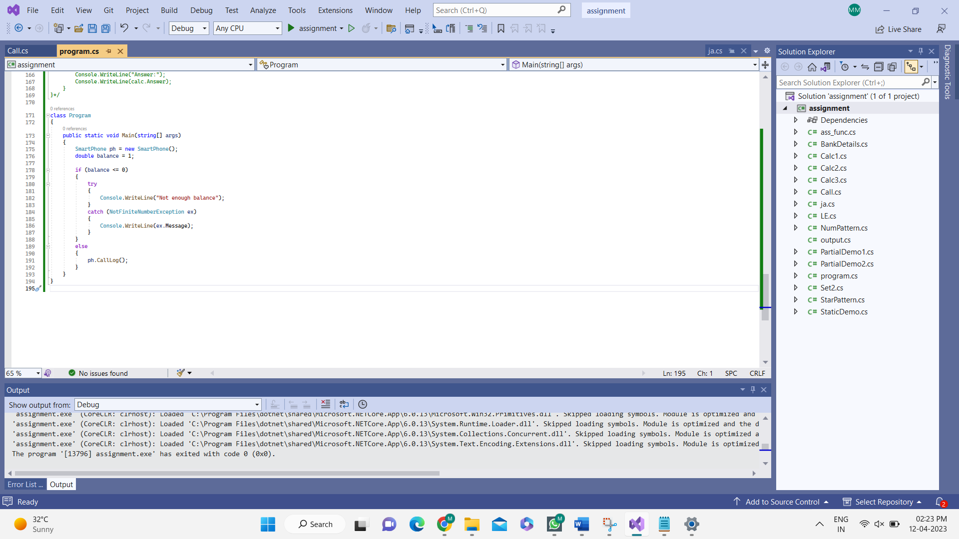

**OUTPUT:**

