diff b/w connected and disconnected architecture

connected data needs connection to be created to access hence slower while disconnected is in memory data that's faster access. to access connected data you use ADO.NET whereas for disconnected you do not use. disc

CONNECTED :

connected arch requires connection all the tym ..if not it wont wrk.

this is the main disadvantage.

the data have to stored will lost if the connection lost.

so the disconnected used / came.

DATAREADER is Connected Architecture since it keeps the connection open until all rows are fetched one by one.

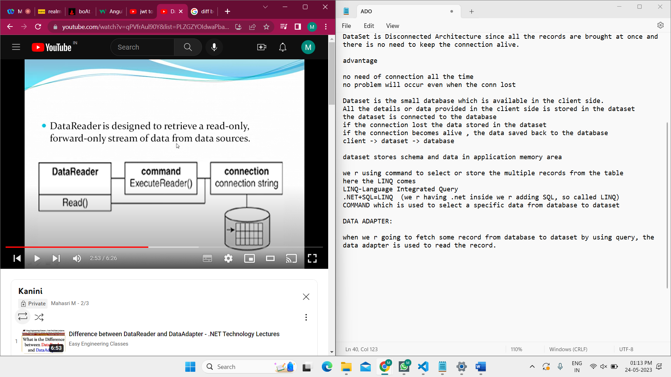

DISCONNECTED:

DataSet is Disconnected Architecture since all the records are brought at once and there is no need to keep the connection alive.

advantage

no need of connection all the time

no problem will occur even when the conn lost

Dataset is the small database which is available in the client side.

All the details or data provided in the client side is stored in the dataset

the dataset is connected to the database

if the connection lost the data stored in the dataset

if the connection becomes alive , the data saved back to the database

client -> dataset -> database

disadvantage:

slow overheat

dataset stores schema and data in application memory area

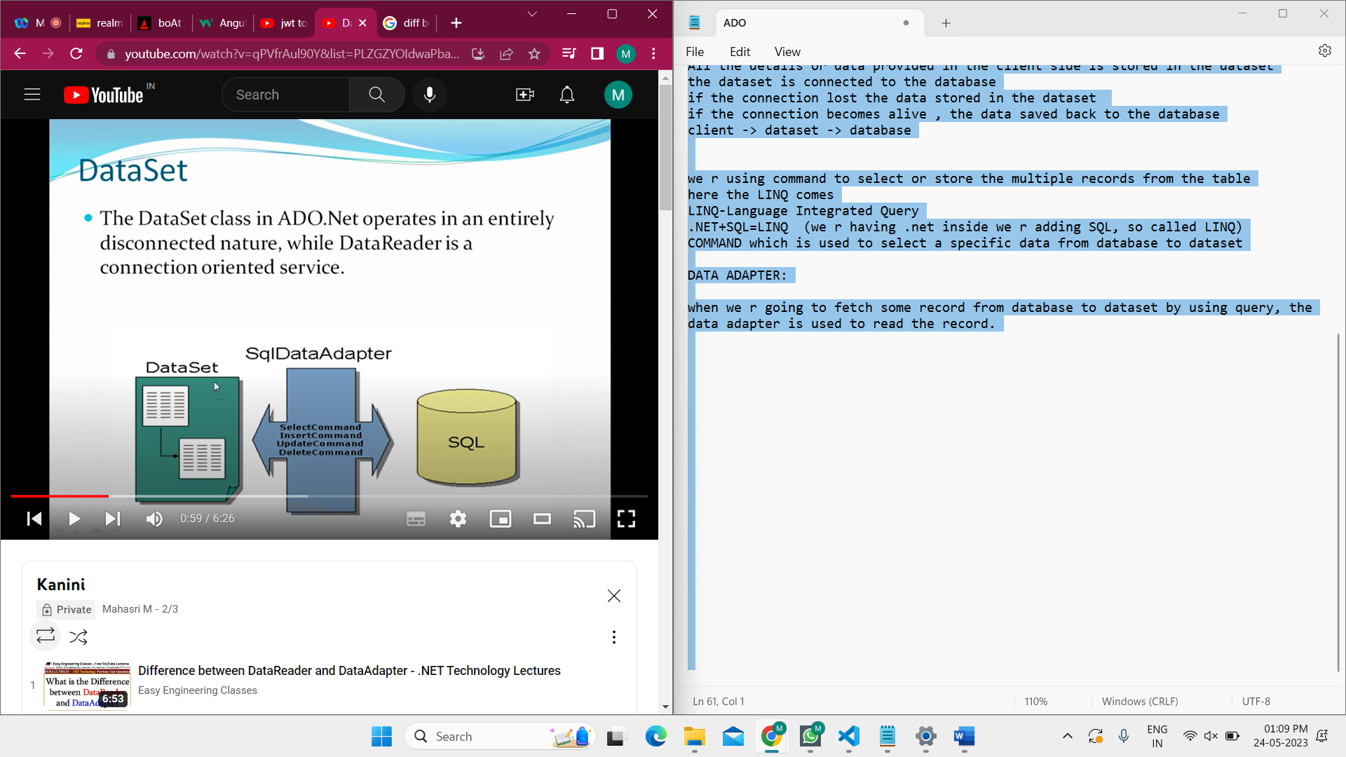

we r using command to select or store the multiple records from the table

here the LINQ comes

LINQ-Language Integrated Query

.NET+SQL=LINQ (we r having .net inside we r adding SQL, so called LINQ)

COMMAND which is used to select a specific data from database to dataset

DATA ADAPTER:

when we r going to fetch some record from database to dataset by using query, the data adapter is used to read the record.

