AI SMART SHOP

AI-POWERED SMART RETAIL & INVENTORY MANAGEMENT SYSTEM

PROJECT REPORT

Submitted by

Mahasri R

Department of Computer Science and Engineering

Rathinam Technical Campus, Coimbatore

Academic Year: 2026–2027

Project Type

Software / AI-Based Application

ABSTRACT

AI SMART SHOP is an AI-powered smart retail and inventory management system designed to help shopkeepers efficiently manage products, stock levels, sales, purchases, suppliers, and business analytics. The system continuously monitors inventory and automatically classifies products as Normal, Low Stock, or Critical Stock based on predefined stock thresholds.

The application provides proactive alerts for low and critical inventory and allows users to directly initiate a reorder from the Alerts & Notifications module. It also provides an AI Smart Assistant that accepts natural-language queries through text and voice input. Voice recognition converts spoken commands into text, while text-to-speech provides audio responses to the user.

The system includes inventory management, sales and purchase transactions, supplier management, analytics, stock-health monitoring, and responsive user interface features. The project is developed as a modern web-based software prototype using React, TypeScript, Vite, and browser-based technologies. The system demonstrates how AI-assisted interaction and intelligent stock monitoring can improve retail inventory management and reduce the possibility of stock shortages.

- PROBLEM STATEMENT

Traditional retail shops often manage inventory using manual records, spreadsheets, or basic billing systems. These methods can make it difficult to monitor stock levels continuously, identify products that are approaching their reorder level, and respond quickly to critical stock situations. Manual inventory monitoring may also result in delayed replenishment, excess stock, inaccurate records, and reduced decision-making efficiency.

The AI SMART SHOP system addresses these challenges by providing centralized inventory management with dynamic stock-status calculation, proactive alerts, direct reorder actions, sales and purchase tracking, supplier management, and analytical insights. The system also introduces an AI Smart Assistant with text and voice interaction to make inventory-related queries easier and faster for shopkeepers.

- OBJECTIVES
• To develop a smart web-based system for managing retail inventory efficiently.

• To monitor stock quantities and automatically classify products into Normal, Low Stock, and Critical Stock categories.

• To provide proactive alerts when products reach low or critical stock levels.

• To enable direct product reordering from the Alerts & Notifications module.

• To manage sales, purchases, products, and suppliers in a centralized system.

• To provide analytical insights such as revenue, purchase costs, estimated profit, inventory valuation, and stock movement.

• To provide an AI Smart Assistant that supports natural-language text and voice queries.

• To improve accessibility through voice recognition and text-to-speech responses.

• To provide a responsive and user-friendly interface suitable for desktop and mobile screens.

- EXISTING SYSTEM

Traditional retail shops commonly depend on manual registers, spreadsheets, or basic billing applications for inventory management. Stock quantities are often updated manually after sales and purchases. Identifying low-stock products requires regular checking by the shopkeeper.

The existing approach has several limitations such as delayed stock monitoring, difficulty in identifying critical products, lack of proactive reorder notifications, limited analytical information, and increased possibility of human errors. It also generally does not provide an intelligent conversational interface for querying inventory information.

- PROPOSED SYSTEM

AI SMART SHOP is proposed as an intelligent web-based retail and inventory management system. It provides centralized management of products, stock, sales, purchases, suppliers, alerts, and analytics.

The system dynamically evaluates stock quantities against predefined low-stock and critical-stock thresholds. When inventory reaches these levels, the system displays proactive alerts and provides a direct Reorder option. The purchase process can automatically open with the selected product and supplier, reducing the time required for replenishment.

The system also includes an AI Smart Assistant that supports natural-language text and voice interaction. Voice recognition converts spoken commands into text, while text-to-speech provides audio responses. Analytics modules provide useful information about revenue, purchase costs, estimated profit, inventory valuation, stock health, and product movement.

- EXISTING SYSTEM VS PROPOSED SYSTEM
Feature | Existing System | AI SMART SHOP
Stock Monitoring | Manual | Dynamic
Stock Alerts | Limited/Manual | Proactive
Reordering | Manual | Direct Reorder
Sales Management | Basic/Manual | Integrated
Purchase Management | Basic/Manual | Integrated
Supplier Management | Separate records | Centralized
Analytics | Limited | Advanced
AI Assistant | Not available | Available
Voice Interaction | Not available | Available
Text-to-Speech | Not available | Available
Responsive UI | Limited | Supported

- SYSTEM ARCHITECTURE
AI SMART SHOP follows a modular web application architecture. The user interacts with the responsive frontend through dashboards and management pages. The application processes inventory, sales, purchase, supplier, alert, analytics, and AI assistant operations through the application logic.

The major components of the system are:

1. User Interface Layer – Provides the dashboard, inventory, sales, purchases, suppliers, alerts, analytics, and AI assistant interfaces.

2. Application Logic Layer – Handles product management, stock calculations, sales transactions, purchase transactions, supplier records, alerts, and analytics.

3. AI Assistant Layer – Processes natural-language and voice-based queries and provides short text and voice responses.

4. Data Management Layer – Maintains product, stock, sales, purchase, supplier, and alert information.

5. Notification Layer – Displays proactive notifications when products reach low-stock or critical-stock levels.

- TECHNOLOGY STACK
Frontend: React.js and TypeScript
Build Tool: Vite
Styling: Modern responsive CSS / UI components
Programming Language: TypeScript
AI Interface: AI Smart Assistant
Voice Technology: Web Speech API
Text-to-Speech: Browser Speech Synthesis
Data Storage: Local Storage for prototype data
Version Control: Git and GitHub
Development Environment: Google Antigravity
Deployment: Vercel

- PROBLEM STATEMENT
Small retail and wholesale shops often manage inventory manually, which can lead to stock shortages, overstocking, delayed reordering, calculation errors, and difficulty in monitoring sales and purchases.

Traditional inventory systems may not provide intelligent stock alerts or an easy way to interact with the system using natural language and voice commands.

Therefore, there is a need for an AI-powered smart retail and inventory management system that can monitor stock levels, identify low and critical stock, provide proactive alerts, support quick reordering, manage sales and purchases, and assist shopkeepers through an AI-based voice and text assistant.

- KEY FEATURES
1. Smart Inventory Management
The system allows users to add, edit, delete, search, and monitor products with quantity, unit, pricing, supplier, and stock thresholds.

2. Dynamic Stock Intelligence
Products are automatically classified as Normal, Low Stock, or Critical Stock based on predefined thresholds.

3. Proactive Stock Alerts
The system displays alerts when products reach low or critical stock levels.

4. Smart Reorder
Users can directly reorder low or critical-stock products from the Alerts & Notifications page. The product and supplier can be automatically selected in the purchase process.

5. Sales Management
Users can record sales transactions, calculate totals, validate available stock, and automatically update inventory.

6. Purchase Management
Users can record purchases and automatically increase the corresponding inventory quantity.

7. Supplier Management
The system provides centralized supplier information and supports adding and editing supplier records.

8. Business Analytics
The analytics module provides information about revenue, purchase costs, estimated profit, inventory valuation, top-selling products, product movement, and stock health.

9. AI Smart Assistant
Users can ask inventory-related questions using natural-language text.

10. Voice Recognition
The AI assistant supports voice input using the browser's speech recognition capability.

11. Text-to-Speech Response
The AI assistant can provide short responses through audio output.

12. Responsive Design
The application interface adapts to desktop and mobile screen sizes.

- MODULE DESCRIPTION
1. Dashboard Module
Provides an overview of products, stock levels, inventory valuation, sales, purchases, and critical-stock alerts.

2. Inventory Module
Manages product information, quantities, pricing, suppliers, and stock thresholds. It also supports stock adjustment.

3. Sales Management Module
Records sales transactions, validates stock availability, calculates transaction totals, and updates inventory.

4. Purchase Management Module
Records stock purchases, manages suppliers, calculates purchase information, and increases inventory quantities.

5. Supplier Module
Maintains supplier information and supports adding and editing supplier records.

6. Alerts & Notifications Module
Identifies low and critical-stock products and displays proactive notifications with direct reorder actions.

7. Analytics Module
Provides business insights through revenue, purchase cost, estimated profit, inventory valuation, stock health, and product movement analysis.

8. AI Smart Assistant Module
Allows users to interact with the system using natural-language questions.

9. Voice Interaction Module
Converts spoken user commands into text and provides audio responses using browser speech technologies.

10. Responsive Interface Module
Provides a user-friendly interface that adapts to desktop and mobile devices.

- SYSTEM WORKFLOW
The overall workflow of AI SMART SHOP is as follows:

1. User Login
The user accesses the AI SMART SHOP application and enters the system.

2. Dashboard Monitoring
The dashboard displays key business information including stock levels, sales, purchases, inventory valuation, and alerts.

3. Inventory Monitoring
The system continuously evaluates product quantities against their predefined stock thresholds.

4. Stock Classification
Products are classified as:
• NORMAL – Stock is above the low-stock threshold.
• LOW – Stock has reached the low-stock level.
• CRITICAL – Stock has reached the critical-stock level.

5. Alert Generation
When a product becomes Low or Critical, the system displays a proactive notification.

6. Reorder Action
The user can select Reorder or Reorder Now directly from the alert. The purchase form opens with the relevant product and supplier information.

7. Purchase Processing
After the user confirms the purchase, the inventory quantity is increased and the stock status is updated.

8. Sales Processing
When a sale is recorded, the system validates stock availability, calculates the total amount, and decreases the inventory quantity.

9. Analytics
The system analyzes sales, purchases, inventory value, product movement, stock health, and estimated profit.

10. AI Assistance
The user can ask inventory-related questions through text or voice. Voice input is converted into text, and the AI assistant provides a short response with optional audio output.

- TESTING AND RESULTS
Test Case | Expected Result | Status
Add Product | Product is added successfully | PASS
Edit Product | Product details are updated | PASS
Stock Adjustment | Stock quantity is updated | PASS
Stock Classification | Normal, Low, and Critical statuses are displayed correctly | PASS
Record Sale | Sale is recorded and inventory decreases | PASS
Record Purchase | Purchase is recorded and inventory increases | PASS
Supplier Management | Supplier can be added and edited | PASS
Analytics | Revenue, costs, profit, and stock insights are displayed | PASS
Stock Alerts | Low and Critical stock alerts are displayed | PASS
Reorder | Purchase modal opens with selected product/supplier | PASS
AI Assistant | Natural-language query receives a response | PASS
Voice Recognition | Speech is converted into text | PASS
Text-to-Speech | AI response is provided through audio | PASS
Responsive UI | Interface adapts to mobile screen | PASS
Production Build | Project builds without compilation errors | PASS

Testing was performed on the implemented prototype to verify the major functional modules and user interactions. The application was also verified using the production build command, and the build completed successfully without compilation errors.

The voice interaction feature was tested after enabling microphone access in the operating system and browser. Voice input was successfully converted into text, and the AI assistant provided an audio response.

The reorder workflow was also verified from the Alerts & Notifications module through the purchase process and inventory update.

- ADVANTAGES
• Efficient Inventory Monitoring
Provides real-time visibility of product quantities and stock health.
• Early Stock Shortage Detection
Identifies Low and Critical stock before products run out.
• Faster Reordering
Allows users to initiate a purchase directly from stock alerts.
• Centralized Management
Combines inventory, sales, purchases, suppliers, and analytics in one application.
• AI-Based Interaction
Allows users to ask inventory-related questions using natural language.
• Voice Accessibility
Supports voice input and audio responses for easier interaction.
• Better Business Decisions
Analytics provide insights into revenue, costs, profit, and product movement. User-Friendly Interface
Provides a modern responsive interface for desktop and mobile devices.

- FUTURE ENHANCEMENTS
- • Cloud Database Integration
Replace prototype local storage with a scalable cloud database.
- • AI-Based Demand Forecasting
Predict future product demand using historical sales data.
- • Automated Purchase Orders
Generate purchase orders automatically after user approval.
- • Barcode and QR Code Scanning
Enable faster product identification and stock updates.
- • Real-Time Multi-User Access
Allow multiple shop employees to access synchronized inventory data.
- • Payment Integration
Integrate secure online payment systems for customer transactions.
- • Advanced AI Analytics
Provide intelligent recommendations for pricing, purchasing, and inventory optimization.
- • Mobile Application
Develop dedicated Android and iOS applications.
15. CONCLUSION

AI SMART SHOP successfully demonstrates an AI-powered approach to retail inventory and business management. The system integrates inventory monitoring, dynamic stock classification, proactive alerts, direct reordering, sales and purchase management, supplier management, and business analytics into a single web-based platform.

The AI Smart Assistant further improves the system by allowing users to interact through natural-language text and voice. Voice recognition enables spoken queries, while text-to-speech provides convenient audio responses.

The implemented prototype demonstrates how intelligent automation and AI-assisted interaction can reduce manual inventory monitoring, improve stock management, support faster replenishment decisions, and provide useful business insights. The responsive interface also makes the system accessible across desktop and mobile devices.

Overall, AI SMART SHOP provides a practical foundation for developing a more advanced AI-driven retail management solution in the future.

16. GITHUB REPOSITORY

The source code and project documentation are maintained in a public GitHub repository.

Repository Name:
AI-Smart-Shop

GitHub Repository:
https://github.com/Mahasi9344/AI-Smart-Shop

The repository contains the project source code, documentation, configuration files, and development history.

17. PROJECT SCREENSHOTS

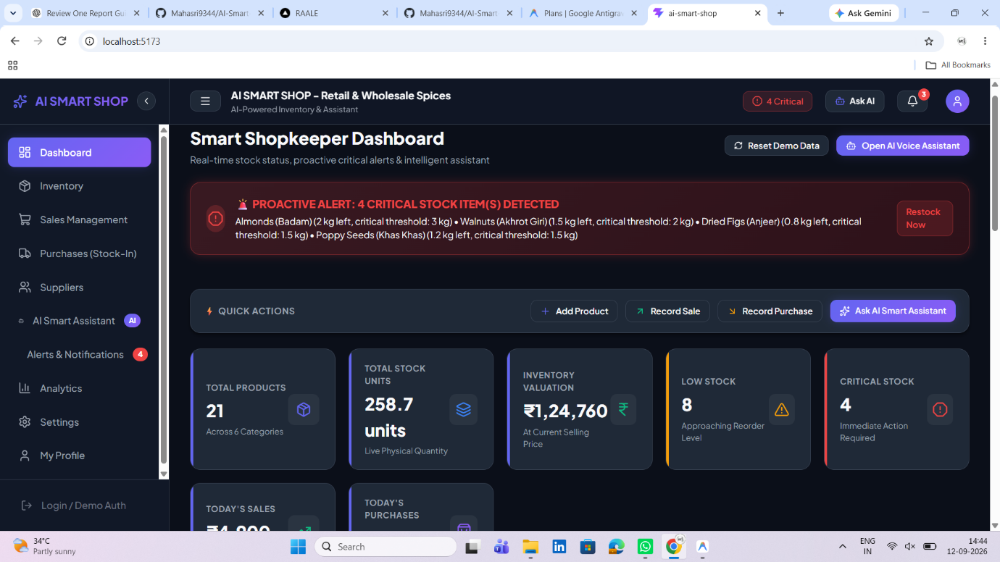

AI SMART SHOP Dashboard

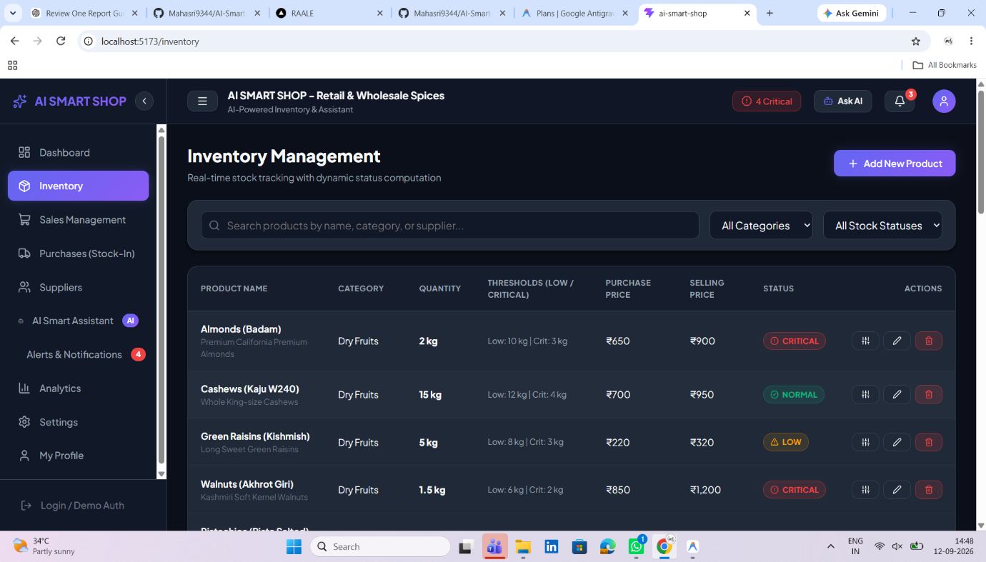

AI SMART SHOP Inventory Management

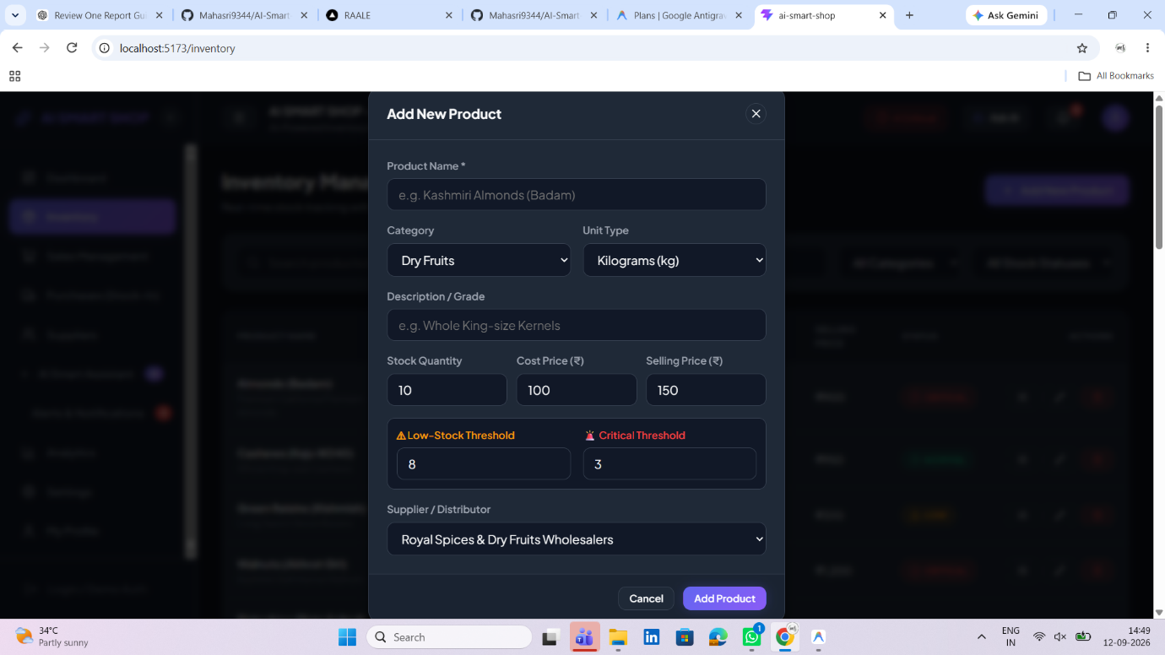

Add Product Interface

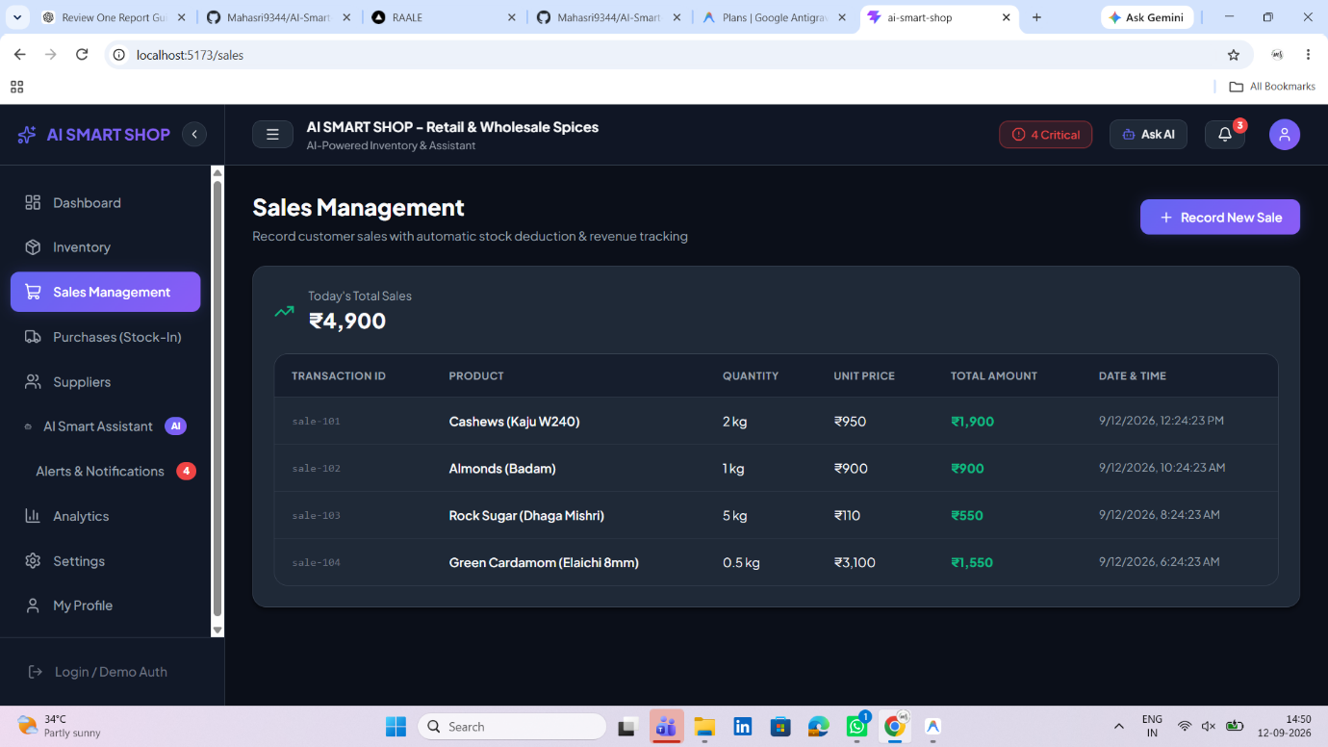

Sales Management Interface

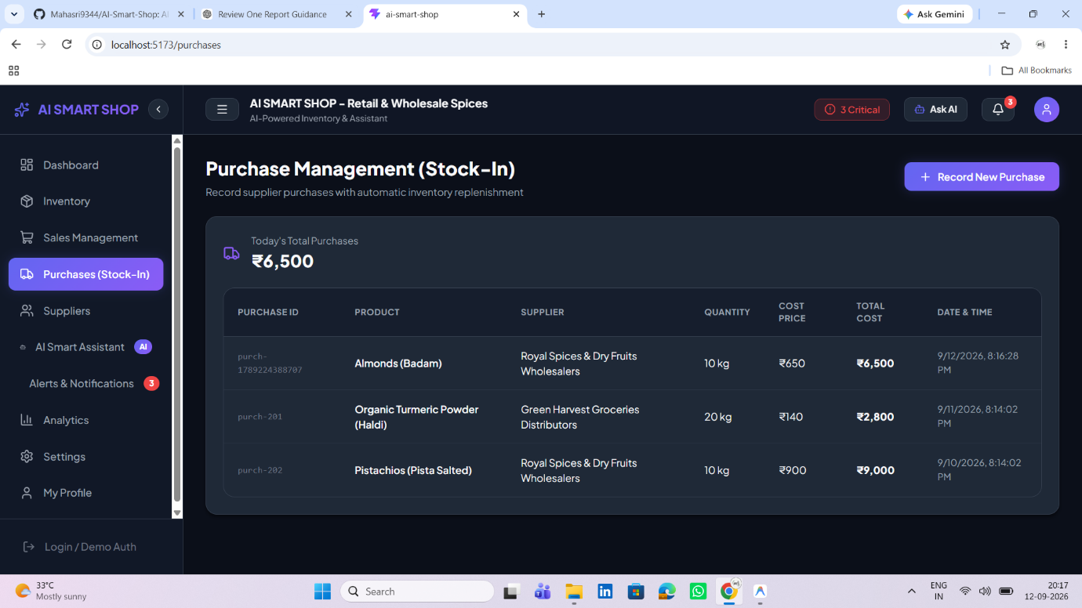

Purchase Management Interface

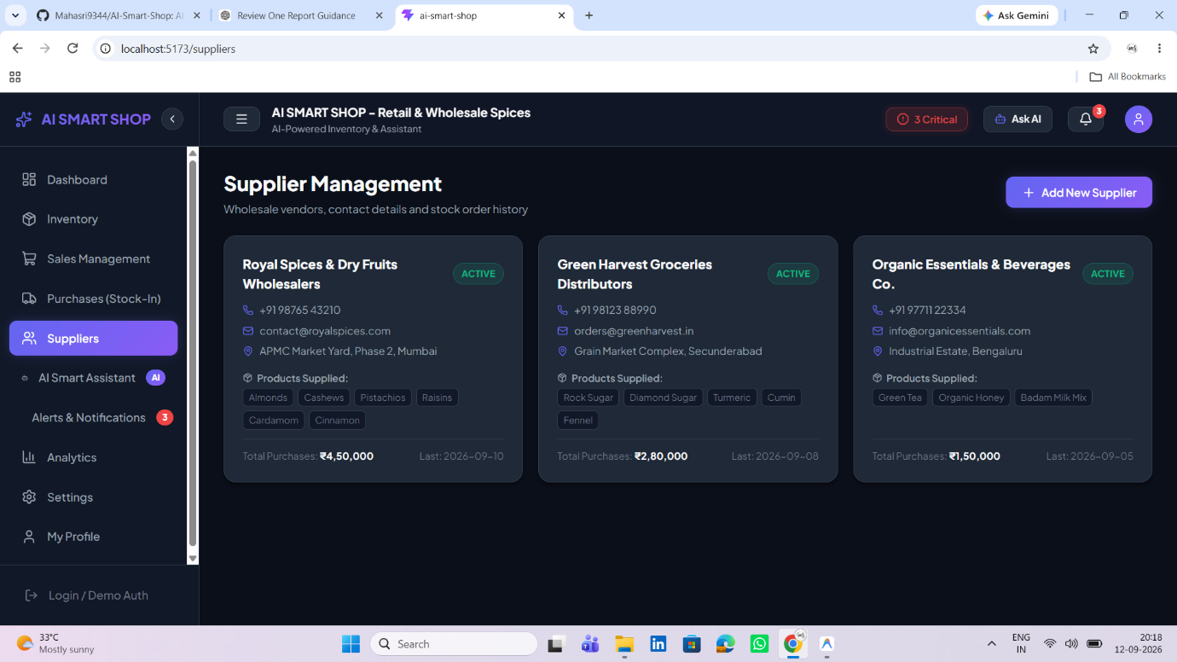

Supplier Management Interface

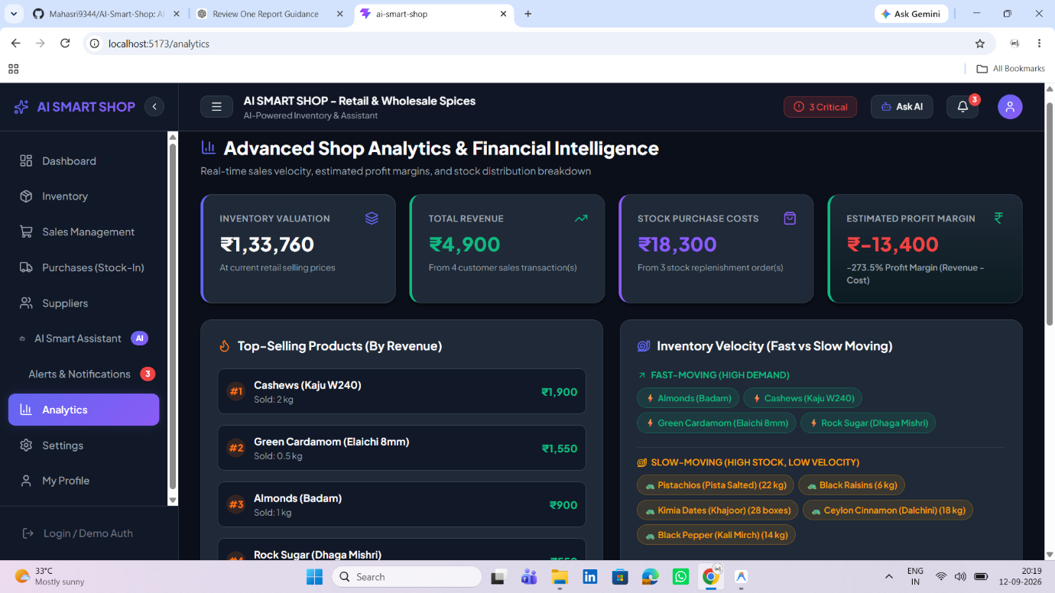

Business Analytics Dashboard

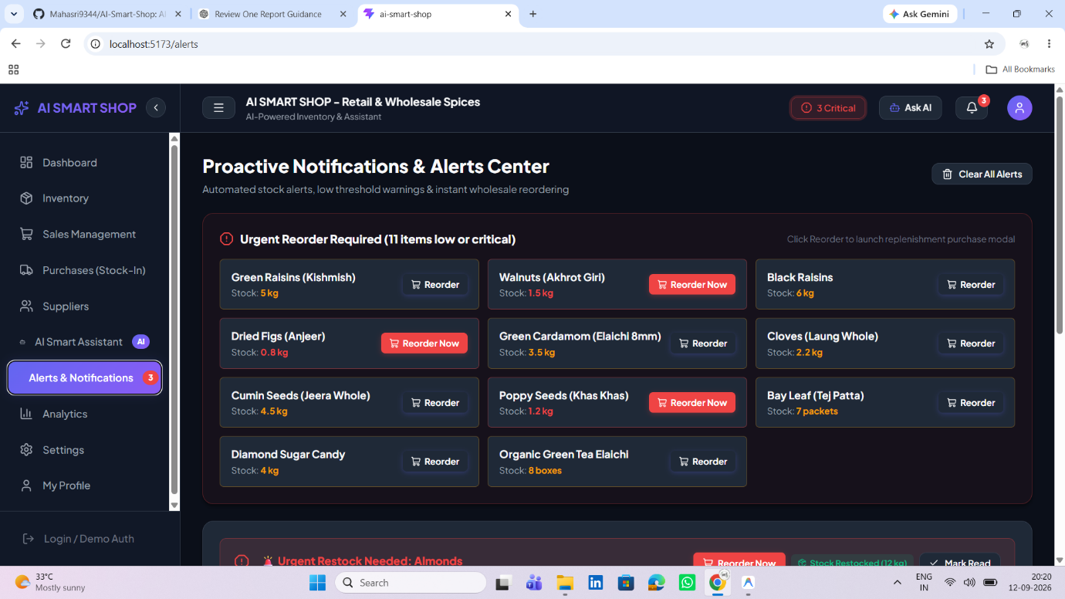

Alerts & Smart Reorder Interface

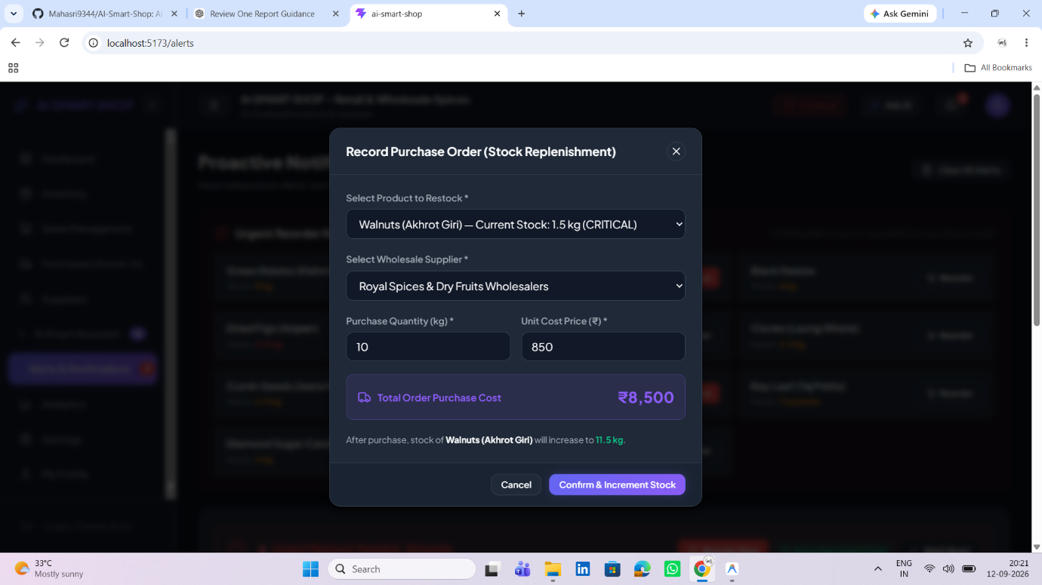

Smart Reorder Purchase Modal

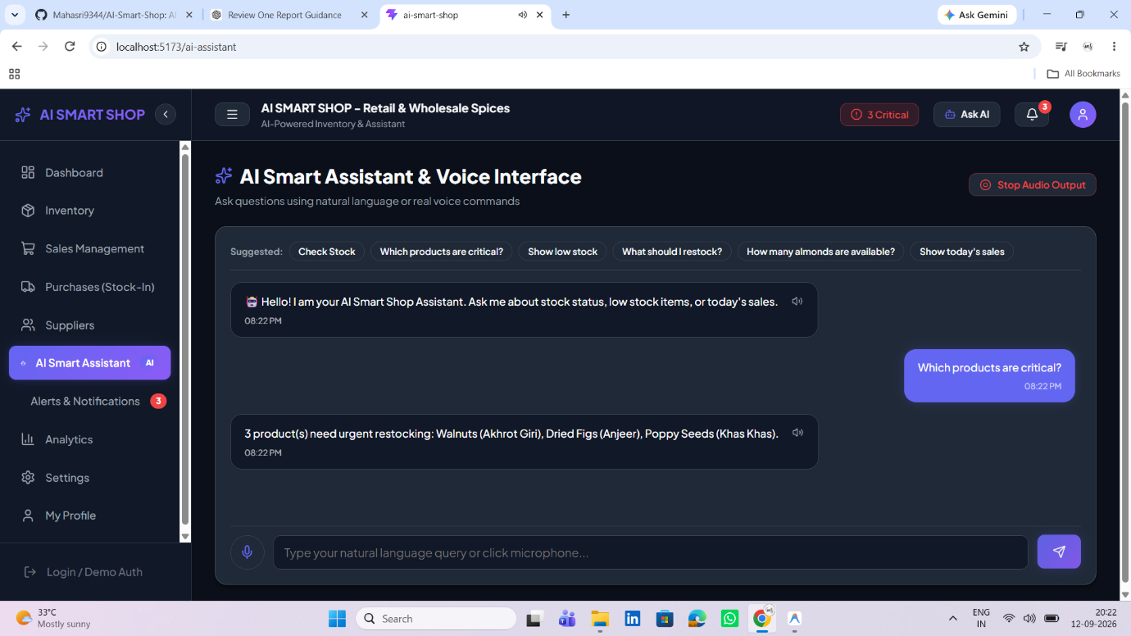

AI Voice Recognition and Voice Response

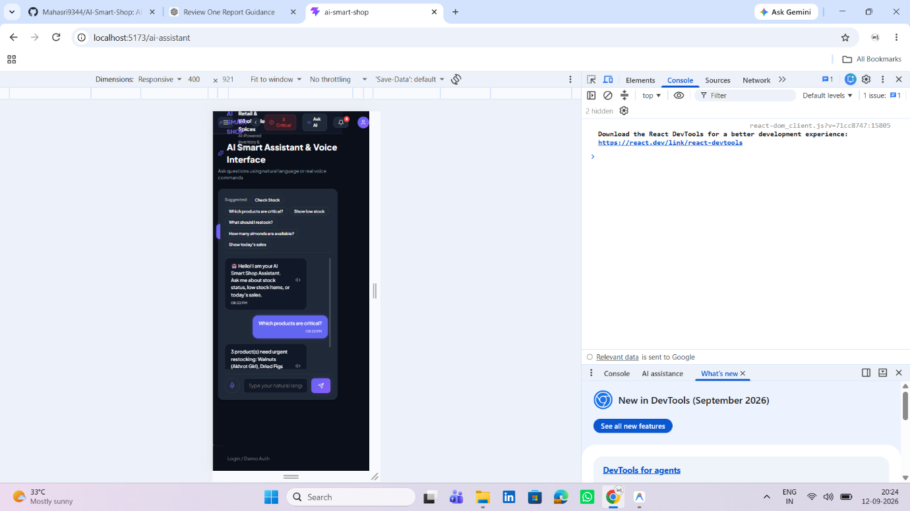

Responsive Mobile Interface

