AR Network Troubleshooting Assistant
Technical Report — Design, Implementation, Testing and Reflection
Module: INTE 42312 — Virtual and Augmented Reality  Assignment: Individual Assignment (25% Continuous Assessment)  Student: Dinithi Mahathanthri [Student ID: ______] | Hosted Application: mahathanthri.github.io/ar-network-assistant  Source Code: github.com/Mahathanthri/ar-network-assistant  Deadline: 29 September 2026

1. Problem Definition & Use Case
Diagnosing everyday network faults — a router that will not connect, a device with "no internet" — is normally taught through static diagrams or requires physical hardware that is expensive to break on purpose. This project targets that gap in the Telecommunications / Education domain: an AR Network Troubleshooting Assistant that overlays a full home/office network topology (router, switch, two workstations, uplink cabling) onto the user's real physical space, and lets them safely simulate and diagnose two independent, realistic fault classes without touching real equipment.
WebXR is an appropriate fit specifically because the interaction is spatial rather than symbolic: physically dragging a cable into a port, and walking around a full-size virtual topology, builds a stronger mental model of physical connectivity than a 2D network diagram, while the entire scenario resets for free between attempts.

2. Design
Application Structure
- index.html — entry point offering Marker AR, Markerless AR, or the standalone Troubleshooting Guide.
- marker.html — AR.js pattern-marker tracking; anchors a single router model with four tap-inspectable hotspots (Power, LAN, WAN, Wi-Fi) and 360° drag-to-rotate.
- markerless.html — native WebXR hit-test; places a full topology (router, switch, two PCs) on any real surface, with draggable cabling and two independent fault simulations.
- troubleshooting.html — a 4-step guided diagnostic wizard that receives the live AR fault state via URL parameters, so it continues the same scenario rather than starting a disconnected quiz.
Key Design Decisions
- A custom, original router/Wi-Fi pattern marker replaces the default Hiro marker, matching the application's own domain instead of a generic placeholder (see Fig. 1).
- The Cat6 uplink cable starts deliberately unplugged and must be dragged into place with a collision/proximity check on release — the assignment's required drag-and-drop + collision-detection interaction, chosen because it is also the most realistic way to teach "the link is physically down".
- Two independent, stackable faults — a physical-layer cable failure and an application/routing-layer gateway misconfiguration — were chosen deliberately to teach that "no internet" has more than one root cause, which is the actual pedagogical point of the tool.

3. Implementation
Marker-Based AR
Built with A-Frame 1.6.0 and AR.js 3.4.7 (both pinned to avoid the version-mismatch class of bug described in Section 4). Marker detection drives a status panel and reveals a router model wrapped, together with its four hotspots, in one rotatable group so they turn as a unit. Tap-to-inspect is implemented with a manual raycaster fired on every touchend rather than A-Frame's built-in cursor component, for reliability reasons detailed in Section 4.
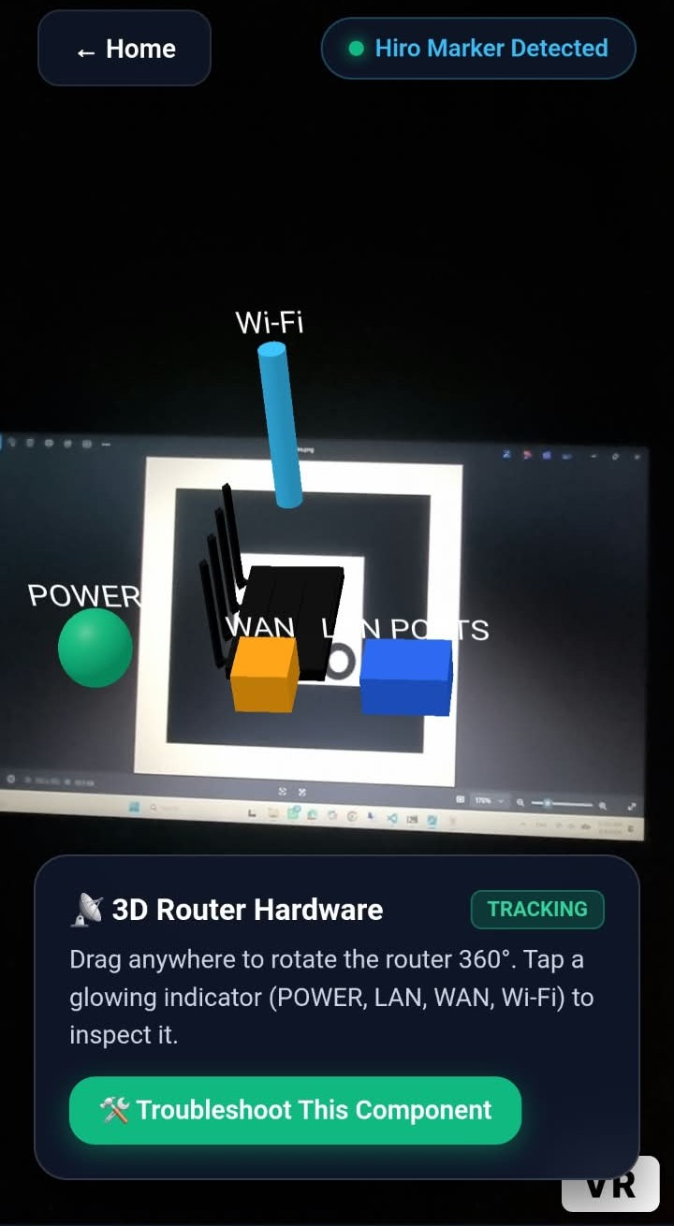
Figure 1 — Marker AR on-device: hotspot inspection, 360° drag-rotate, and hand-off to diagnostics confirmed working. (Captured during interaction-flow testing, prior to the marker-image swap described in Section 2 — functionality is identical, only the printed pattern differs.)
Markerless AR
Built on A-Frame's native ar-hit-test component (WebXR Device API — no third-party AR library required). On surface placement, the app instantiates the router, switch and two workstation PCs, each carrying live-updating status/IP text driven by the current fault state. An explicit auto-fit step measures each glTF model's real bounding box on load and rescales it to a fixed real-world target size, since the source exports were not authored at a consistent 1-unit-per-metre scale.
The uplink cable is dragged from its idle position onto the router–switch gap using a raw THREE.Raycaster against a horizontal plane; release position is checked against a fixed connection threshold. Once connected, animated packet markers flow router → switch → PCs while the link is healthy, and a short audio cue confirms the connection. Two controls — Fail Cable and Break Gateway — are unlocked only once the cable is connected, and toggle independent fault states that both feed the same downstream visuals (PC status text, packet animation, cable colour).
3D Asset Optimisation
Both models were run through gltf-transform (join, weld, simplify, quantize, WebP texture compression): switch.glb dropped from 24.6MB to approximately 2.0MB, and router.glb from 283KB to 176KB, both with no visible quality loss, verified by rendering each version side-by-side before replacing the live asset.
Troubleshooting Wizard Integration
Rather than a disconnected quiz, the "Start Diagnostics" link from markerless.html passes the live cableConnected and faultSimulated state through URL parameters. Step 1 of the wizard is auto-grounded in what the AR session actually showed, with a banner explaining the link between the two features — the multi-step state management the assignment's Advanced Implementation option calls for, extended with real state carried across pages.

4. Technical Challenges & Solutions
Ten of the most significant issues encountered during development, their root cause, and the exact fix applied — most were only discoverable through live testing on a physical Android device, not in a desktop browser.
Issue | Root Cause | Fix Applied
Marker-AR camera looked cropped/"zoomed in" | AR.js on the unpinned `master` branch paired with an older A-Frame, plus AR.js's default 640×480 capture, cropped hard on a portrait phone. | Pinned A-Frame 1.6.0 + AR.js 3.4.7; raised capture/display resolution to 1280×960.
Hotspot taps landed wrong / black gutter on one edge | CSS forcing the AR.js video and WebGL canvas to 100% size fought AR.js's own internal video/canvas alignment transform. | Removed the CSS override; used `user-select:none` / `-webkit-touch-callout:none` instead to stop a long-press "Copy/Share" popup from swallowing taps.
Router model got "stuck" on one side while drag-rotating | Accumulating plain Euler rotation.x/rotation.y breaks down after enough yaw - a further tilt drag starts rolling the model instead of pitching it. | Rewrote drag-rotate using quaternion `premultiply()` on fixed world axes, so yaw and pitch stay independent regardless of prior rotation.
Hotspot taps missed intermittently (roughly 1 in 10 tries) | A-Frame's cursor component only re-runs its raycaster on a throttled ~100ms tick, so a fast tap can land between ticks. | Replaced with a manual `THREE.Raycaster` fired directly against the camera and hotspot meshes on every touchend.
Markerless AR camera never opened on first load | The page relied on A-Frame's tiny, easy-to-miss auto-injected "Enter AR" button. | Disabled the default UI; added an explicit "Start AR Experience" button wired to `scene.enterVR(true)` with visible error surfacing.
WebXR surface scanning never completed on some real desks | ARCore's plane detection is feature-point based and struggles on plain, glossy or low-texture surfaces (confirmed against Google's ARCore design guidance). | Added a 10s "still scanning?" in-app hint plus a manual "Place Network Here" fallback that plants content a fixed distance in front of the camera.
Manual placement sometimes jumped straight to the diagnostics page | A delayed "ghost" click on some phones landed on a new link that had reflowed into the just-tapped button's screen position. | Placement now dims the tapped button in place and delays revealing new interactive elements by ~450ms so nothing new is live at that spot.
`ar-hit-test` silently failed to initialise | The component is scene-level only in A-Frame; it cannot be attached to an arbitrary entity. | Moved it to `<a-scene>` with a `target:` selector, and now copy the reticle's tracked pose onto the content manually at the moment of placement.
PBR router/switch materials rendered solid black in AR | No default scene lighting is injected inside an active WebXR immersive-ar session. | Added explicit ambient + directional light entities to the scene.
switch.glb was a 24.6MB unoptimised export | Raw Sketchfab-style export with dense geometry and uncompressed textures. | Ran the model through `gltf-transform` (weld, simplify, quantize, WebP textures), reducing it to ~2.0MB with no visible quality loss.
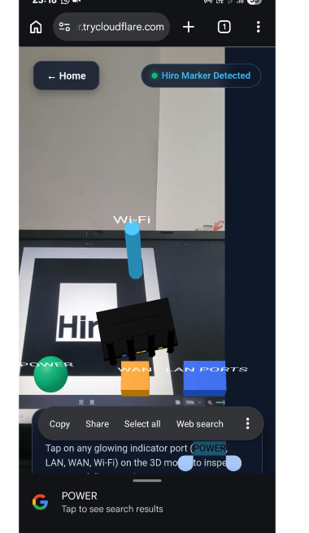
Figure 2 — Tap-to-inspect intercepted by the phone's own long-press "Copy / Share" popup (issue #2 above), before the CSS conflict was resolved.

5. Testing & Evaluation
Development followed an iterative live-device testing loop: each fix was deployed over an HTTPS tunnel (cloudflared) to a physical Samsung Galaxy S21 running Chrome for Android, screenshotted, and re-tested before moving to the next issue — desktop-only testing would have missed the touch-event and WebXR dom-overlay issues in Section 4 entirely, since several only manifest inside a live immersive-ar session. After deployment, both AR modes were re-verified against the final GitHub Pages HTTPS URL to confirm production parity with the tunnel-based testing.
Cross-platform coverage: Marker AR needs only camera access and was confirmed working across both Android Chrome and desktop testing. Markerless AR depends on the WebXR Device API's immersive-ar session type, which iOS Safari does not implement as of this submission — the app detects this via navigator.xr.isSessionSupported() and shows an explicit, actionable notice rather than failing silently.

6. Reflection
Pinning framework versions at the start avoided an entire class of rendering bugs that would otherwise have been very difficult to diagnose. The most valuable decision was building tap-to-inspect and drag interactions on a manual THREE.Raycaster instead of relying on A-Frame's default cursor component — that component's assumptions (throttled ticks, synthesized mouse events) do not hold inside a live WebXR dom-overlay session, and every interaction bug in Section 4 involving missed or misplaced taps traces back to that mismatch.
With more time, the marker would be upgraded from a printed pattern marker to NFT-style natural-image tracking, testing would extend across additional Android devices to rule out device-specific WebXR quirks, and the current confirmation chime would be replaced with short narrated audio explaining each simulated fault, for stronger teaching value.

7. References & Acknowledgements
Frameworks: A-Frame (aframe.io), AR.js (github.com/AR-js-org/AR.js). Optimisation: gltf-transform (gltf-transform.dev). Surface-detection UX guidance consulted from Google's official ARCore "Content placement" design documentation (developers.google.com/ar/design/content/content-placement).
3D Assets: switch.glb — "8 Port Ethernet Switch" by duckSPLASH, licensed CC BY 4.0, sourced from Sketchfab, re-exported and optimised as described in Section 3. router.glb — source/license to be confirmed and credited here before submission (see note below).

