CENTRALIZED HOSPITAL & HEALTHCARE MANAGEMENT SYSTEM

INTRODUCTION
The Hospital & Healthcare Management System is a web-based application designed to manage hospital operations efficiently. It helps in storing and managing information related to hospitals, doctors, patients, and appointments.
This system is developed using PHP as the backend and MySQL as the database. It provides an easy interface for users to interact with the system.
The need for this system arises because traditional hospital management methods are time-consuming and prone to errors. This project aims to provide a digital solution to improve efficiency and accuracy.
BACKGROUND
The healthcare industry requires efficient management of patient information, doctor details, and hospital services. In traditional systems, records are maintained manually, which leads to errors, data loss, and difficulty in accessing information.
With the advancement of technology, digital systems have become essential for managing healthcare data effectively. A Hospital Management System helps in organizing and maintaining records in a structured manner.
This project is developed to provide a simple and efficient solution for managing hospital operations such as patient registration, doctor details, and appointment booking.
SYSTEM ARCHITECTURE
- Frontend: User interface using HTML, CSS, and PHP
- Backend: PHP for processing logic
- Database: MySQL for storing data
TECHNOLOGIES USED
- Frontend → HTML, CSS
- Backend → PHP
- Database → MySQL
- Server → XAMPP / Localhost

DATABASE TABLES
- Hospitals: Stores hospital details like name and location
- Doctors: Stores doctor information and specialization
- Patients: Stores patient personal details
- Appointments: Stores booking details and status
- Facilities: Stores available hospital facilities
- Hospital_Facilities: Links hospitals with facilities
RELATIONSHIPS
- One hospital → many doctors
- One patient → many appointments
- Many-to-many relationship → hospitals and facilities
METHODOLOGY
The following steps were followed during development:
- Database design
- Frontend and backend coding
- Testing and debugging
PROJECT PROFILE
The Hospital & Healthcare Management System is a web-based application developed using PHP and MySQL. It is designed to manage the day-to-day operations of a hospital effectively.
The system includes different modules such as:
- Patient Management
- Doctor Management
- Hospital Management
- Appointment Scheduling
It provides separate login access for users and doctors. Patients can register and book appointments, while doctors can log in to view and manage appointment details.
The system ensures proper data storage, easy access, and efficient handling of hospital-related information.
PROPOSED SYSTEM
The proposed system is a digital Hospital Management System that replaces manual record-keeping methods.
Features of the System
- User registration and secure login
- Management of doctor and patient details
- Online appointment booking system
- Doctor dashboard to view and update appointments
- Search functionality for easy access
Advantages of the System
- Reduces paperwork and manual errors
- Saves time and effort
- Improves data accuracy and consistency
- Provides quick access to information
- Enhances overall hospital management
This system helps in maintaining proper communication between patients and doctors and ensures smooth functioning of hospital operations.
OUTPUTS
The system generates the following outputs:
- DATABASE PAGE
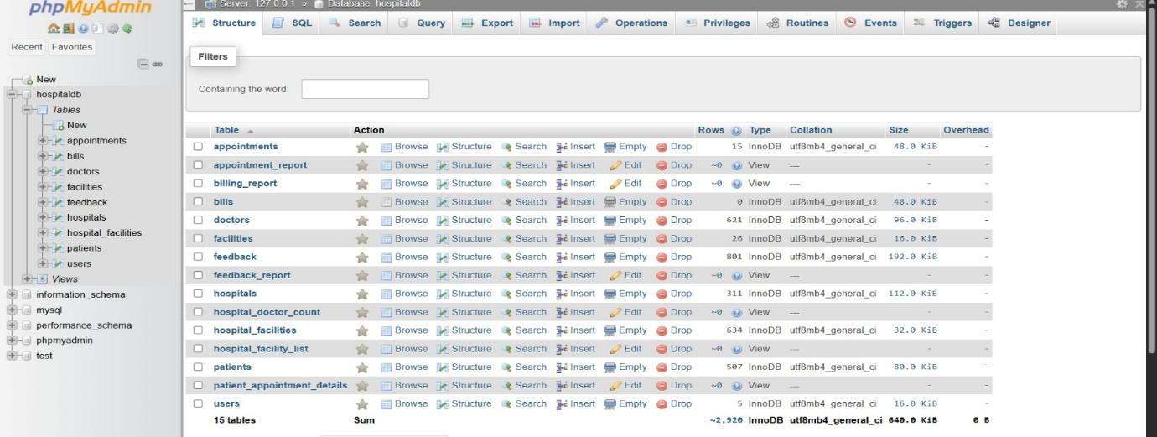

- HOME PAGE

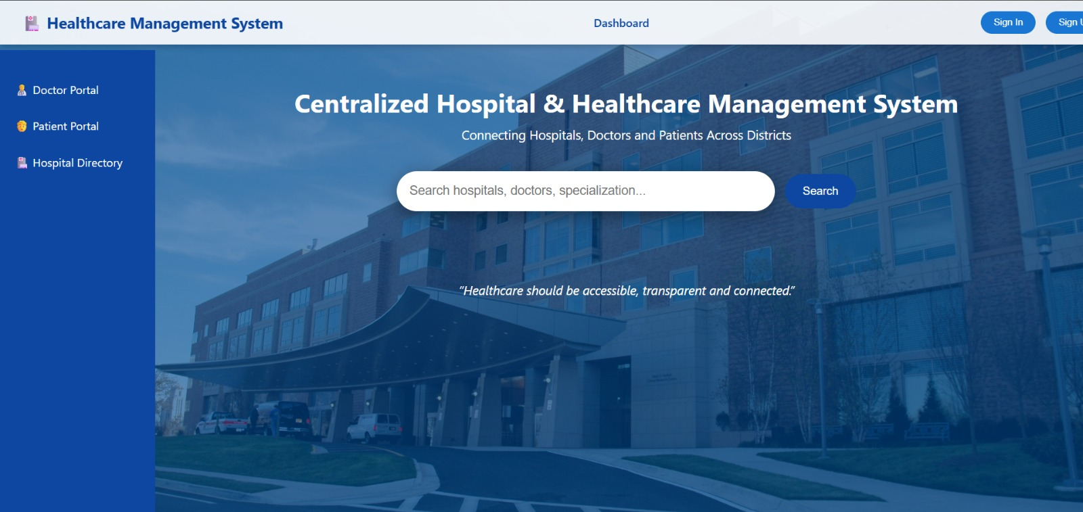

- HOSPITAL DIRECTORY

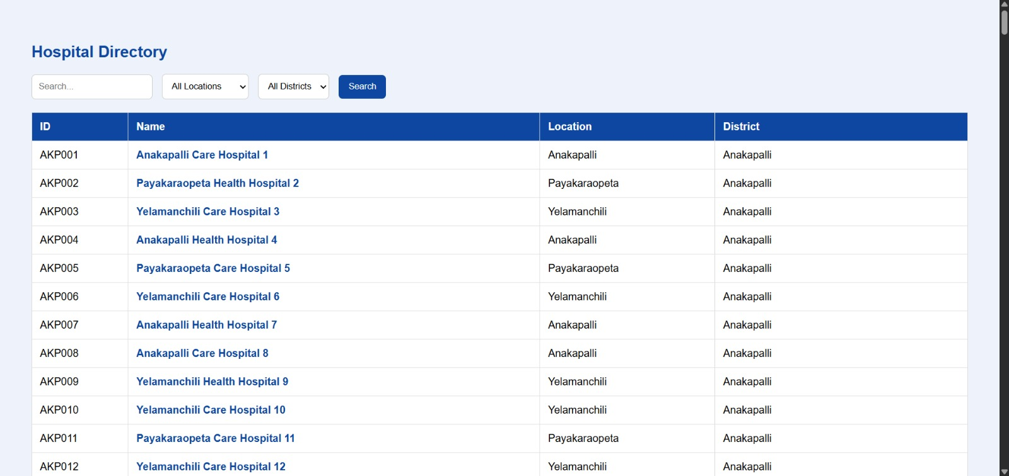
- PATIENT REGISTRATION PAGE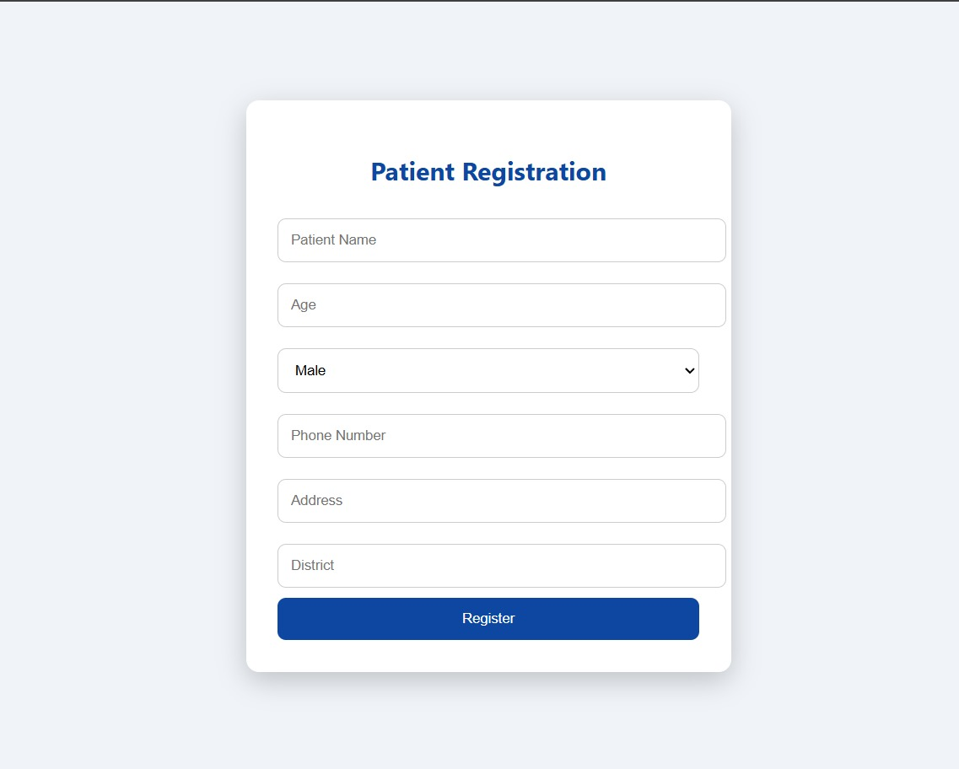

- APPOINTMENT PAGE

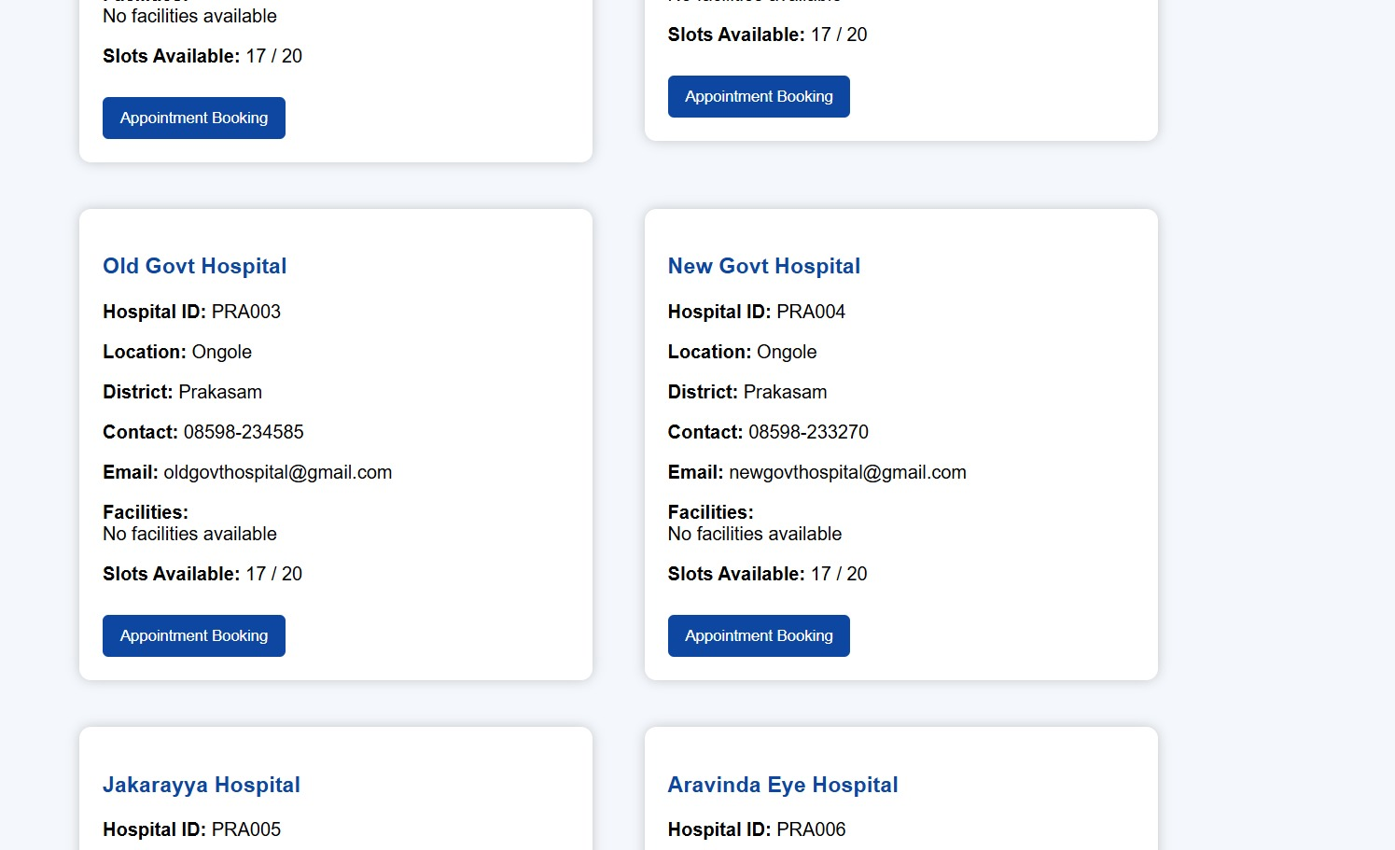

- BOOKING PAGE
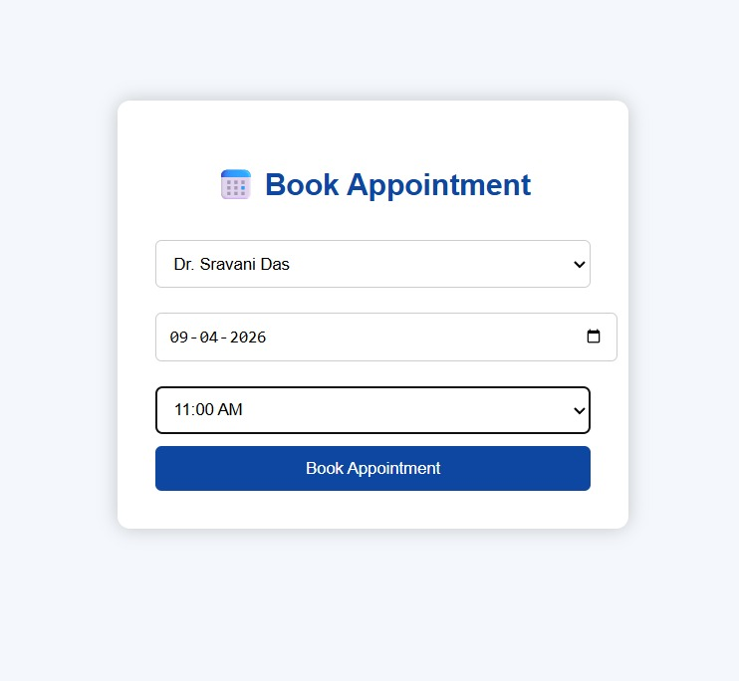

- DOCTOR LOGIN PAGE

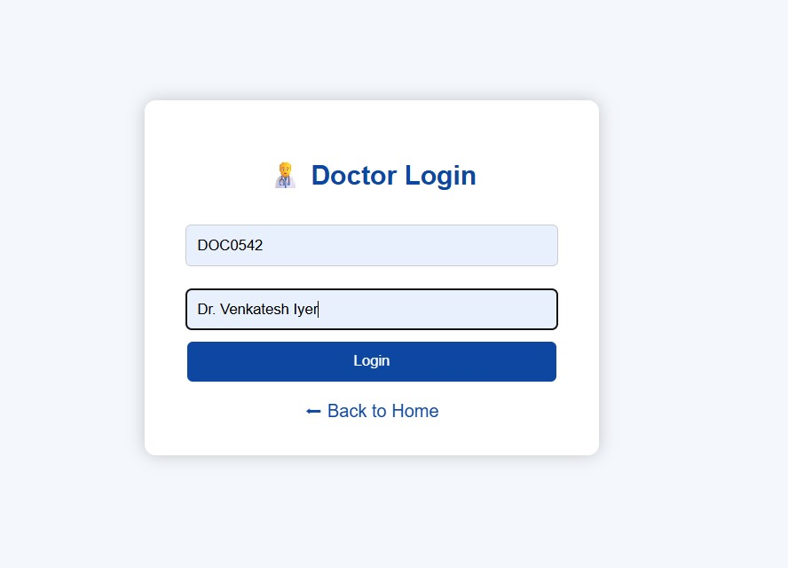

- DOCTOR APPOINTMENTS PAGE
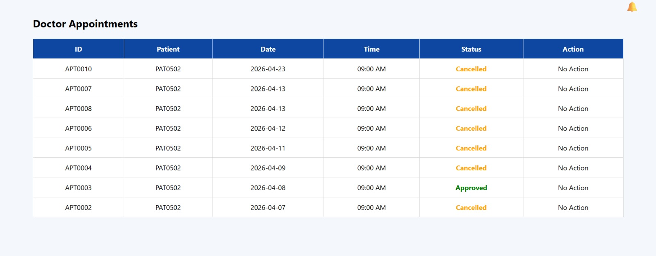
- PATIENT PAGE
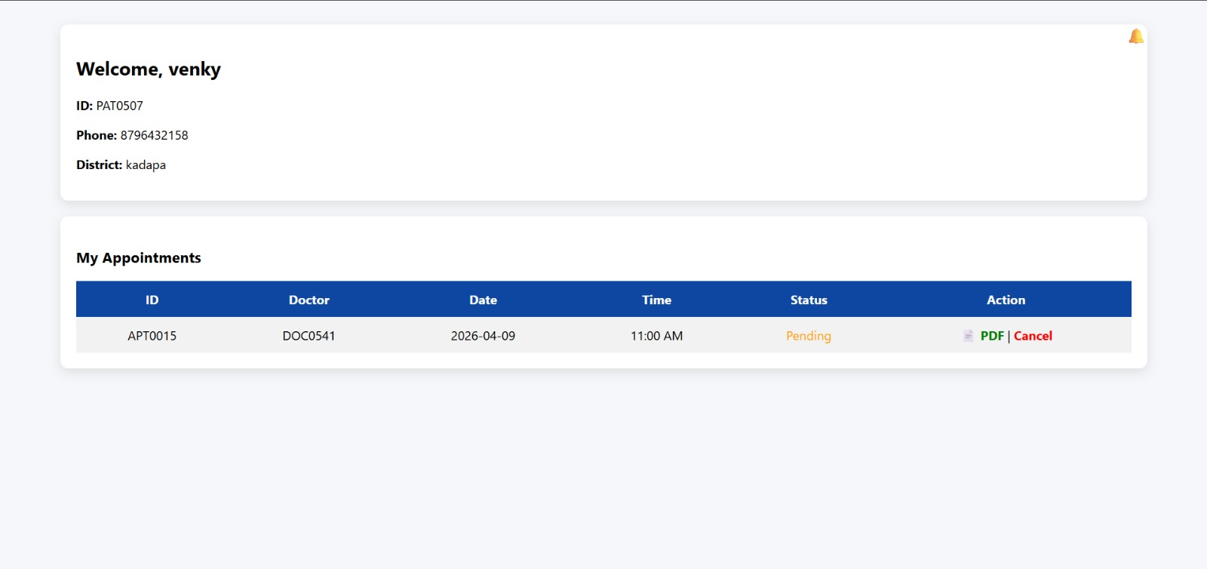
CONCLUSION
The Hospital & Healthcare Management System is successfully developed to simplify and digitalize hospital operations. The system effectively manages patient records, doctor details, and appointment scheduling in an organized manner.
It reduces manual work, minimizes errors, and improves the efficiency of handling healthcare data. The user-friendly interface allows patients to book appointments easily and doctors to manage them efficiently.
Overall, this project demonstrates how technology can be used to improve hospital management and provide better healthcare services.

