Technical Design Document

**Project Name: Loan Application**

**INTRODUCTION:**

**Loan Application** is created to meet the needs of online loan application system. The architecture implemented is Spring Boot Services.

**FUNCTIONAL REQUIREMENTS:**

**Functional requirements of the project are**

**Login/Signup:**

A user will have to login into the application if he/she has already applied for the loan by giving their username and password. If he/she is a new user and want to apply for the loan they will have to sign up by giving their personal details like name, age, phone number, mail id, pancard details ,initial balance and loan amount along with the asset value which should be greater than the loan amount and number of years to pay back the taken loan amount. User will also have to set username and password and click on “register” button. Then you will get a confirmation message about your monthly EMI, once confirmed your loan gets approved.

**Check Balance:**

Once the loan gets approved the user can login with his/her credentials and check their current balance in their account. They can also check their pending loan amount to be paid.

**Calculate EMI:**

User just like checking their balance can also calculate their EMI. It calculated on the basis of the loan amount taken, the number years the user gives to pay back and also on the rate of interest.

**EMI payment:**

Once the user has logged in he/she can make the EMI payment which will be deducted from the balance amount of their account. If the user do not have enough balance to make their EMI payment the payment will not be processed and so the user can deposit money by clicking on deposit amount. User will have to give correct password in order to process the payment and click on “proceed” button, Also user will not be able to process the EMI payment if there are no pending loans on that account.

**Deposit Amount:**

In order to deposit money to their account for EMI payment or foreclose user will have to enter the amount to be deposited and click on “proceed” and once the deposit is successful it will be reflected in his/her balance details.

**Foreclose:**

If the user wants to foreclose their account completely, they can do it by clicking on foreclose and entering their password there and click on” proceed”. Once the password is correct and the user have enough balance in their account and there is some pending loan the foreclose will be processed else it will be cancelled.

**Print Transactions:**

User can check and go through all his/her transactions made by clicking on print transactions. In that the user can see their transaction made along with account number and balance at that time of transaction.

**Overall Architecture:**

Calculate EMI Service

Print Transactions Service

Deposit Amount Service

Check Balance Service

Apply loan Service

DATABASE

Controller

Login Service

Pay EMI Service

Foreclose Service

GUI

­­­­­ **Overall Entity Relationship Diagram:**

|  |  |
| --- | --- |
| **Loanbeans** | |
| accountNumber | int |
| firstName | varchar |
| lastName | varchar |
| age | int |
| loanAmount | int |
| balance | int |
| pancard | varchar |
| phoneNumber | varchar |
| mailId | varchar |
| username | varchar |
| password | varchar |
| assetValue | int |
| years | int |
| emi | int |
| tranactionCount | int |

|  |  |
| --- | --- |
| **Transaction** | |
| primaryKey | int |
| transactionId | int |
| accountNumber | int |
| transactionType | varchar |
| currentBalance | int |

**Class Diagram**

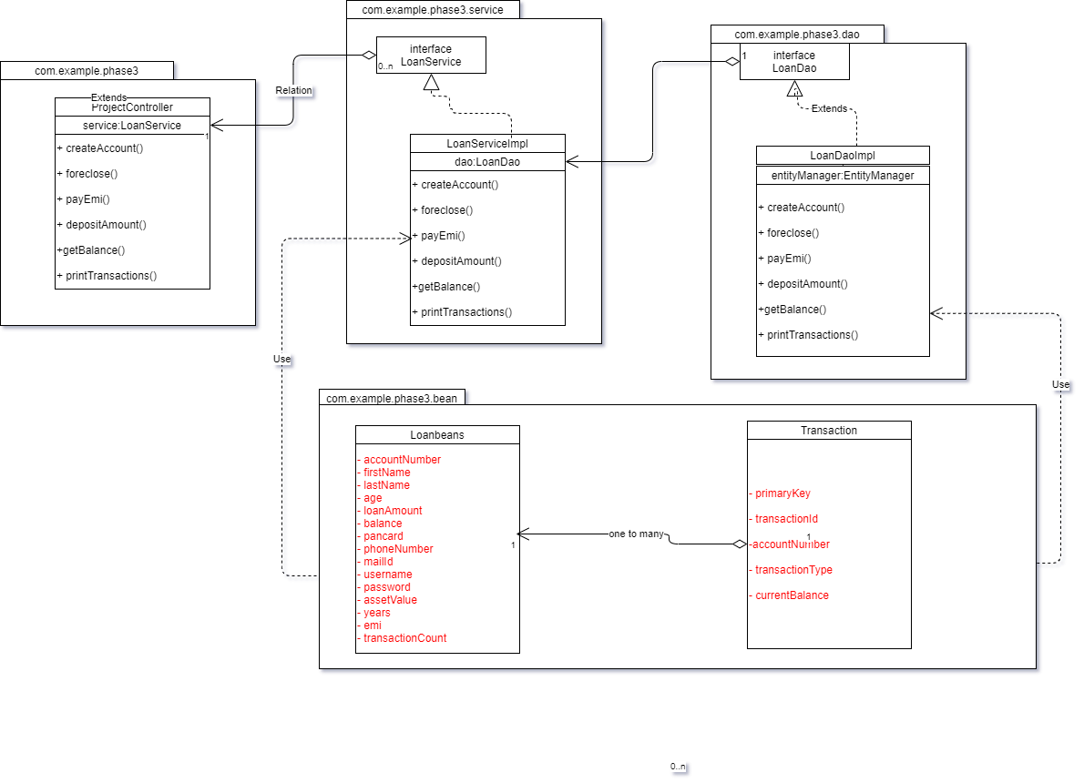

**Activity Diagrams**

Login Service:

Valid credentials

Enter Login Credentials

User Home page

Verify user

Login Button

Ask to login

­­­­ Incorrect

Loan Apply Service:

Ask to Apply Loan

Verify User Details

Enter User Information

Valid Credentials Not Valid

Create Account

Reject Account

Deposit Amount Service:

Click proceed to credit amount

Enter amount to deposit

Directs to deposit page

User clicks on deposit amount

Redirects Back to details

Foreclose Service:

Check Password Incorrect Password Correct Password Check Pending Loans Exist Not Exist Check Account Balance enough balance insufficient balance

Enter Password and click proceed

User clicks on Foreclose

No Pending EMI

Payment Failed

Payment Successful

EMI Service:

Check Password Incorrect Password Correct Password Check Pending Loans Exist Not Exist Check Account Balance enough balance insufficient balance

Enter Password and click proceed

User clicks on Pay EMI

No Pending EMI

Payment Failed

Payment Successful