# **Kickstarter campaigns Database**

# **Conclusions:**

From the data,

* The rate of success decreased in most of the projects as the goal amount increased.

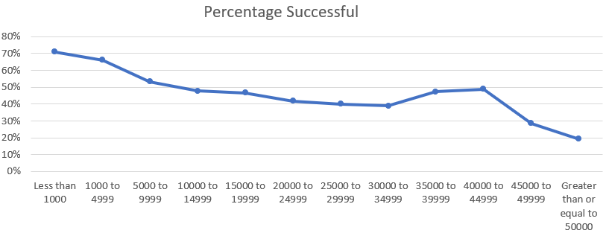

* Theatre-Plays has more successful projects during the months of May and June.
* Parent Category - Music(almost all sub categories) has more successful projects in all the 12 months
* Parent Category – Journalism has all cancelled projects from the data sample
* Out of 2185 successful campaigns, US has more contribution to success - 1651 successful campaigns with a significant difference from the second successful campaign, GB – 366

**Limitations:**

* Since this is a sample (4000 projects) from 300,000 projects, the conclusions drawn could not be applied to the entire population.
* Location of the backers may help us know whether they are supporting projects from their region or other regions too.
* Knowing the details of the person(s) who are starting the project like the age group, number of persons in the group, gender etc. may increase the chance of success.
* If the product is going to be the new one in the location, if tried in other location, how successful was that?

**Additional Tables/Graphs:**

* There are 1464 failed projects and 345 canceled projects with no staff pick, There is a probability of increase in success with staff picks.

* Remote possibility: Chances of failures are less when the number of days are more between start date and end date.

