LAB2

1 CREATE TABLE Employee2 (

EmpNo INT PRIMARY KEY,

EmpName VARCHAR(255) NOT NULL,

Gender CHAR(1) NOT NULL CHECK (Gender IN ('M', 'F')),

Salary DECIMAL(10, 2) NOT NULL,

Address VARCHAR(255) NOT NULL,

DNo INT

);

desc Employee2;

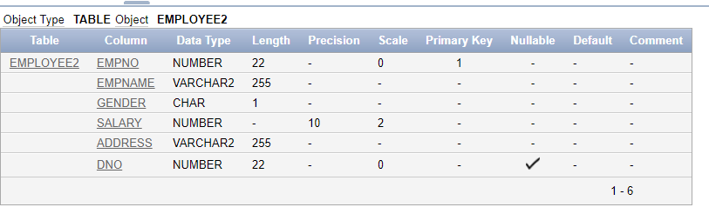

2 CREATE TABLE Department2 (

DeptNo INT PRIMARY KEY,

DeptName VARCHAR(255) UNIQUE,

Location VARCHAR(255)

);

DESC Department2 ;

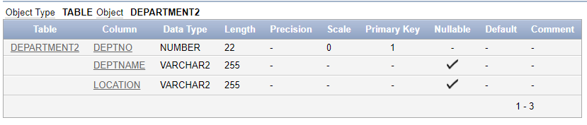

3 ALTER TABLE Employee2

ADD CONSTRAINT fk_dno FOREIGN KEY (DNo) REFERENCES Department2(DeptNo); desc Employee2;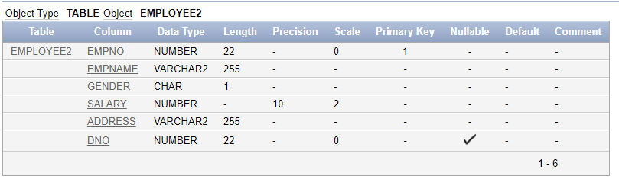

4 INSERT INTO department2 (DeptNo, DeptName, Location) VALUES (1, 'Human Resources', 'New York');

INSERT INTO department2 (DeptNo, DeptName, Location) VALUES (2, 'Finance', 'London');

INSERT INTO department2 (DeptNo, DeptName, Location) VALUES (3, 'IT', 'Bengaluru');

SELECT * FROM department2;

INSERT INTO employee2 (EmpNo, EmpName, Gender, Salary, Address, DNo) VALUES (101, 'alif', 'M', 75000.00, '123 RK Street', 1);

INSERT INTO employee2 (EmpNo, EmpName, Gender, Salary, Address, DNo) VALUES (102, 'sahiti', 'F', 82000.00, '456 Park Avenue', 2);

INSERT INTO employee2 (EmpNo, EmpName, Gender, Salary, Address, DNo) VALUES (103, 'david', 'M', 90000.00, '789 Bell Road', 3);

INSERT INTO employee2 (EmpNo, EmpName, Gender, Salary, Address, DNo) VALUES (104, 'rory', 'F', 67000.00, '101 SK Nagar', 1);

SELECT * FROM employee2 ;

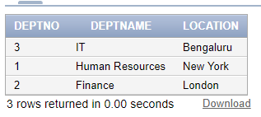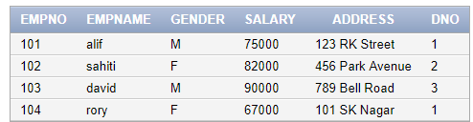

5 -- Valid insertion into department2 table

INSERT INTO department2 (DeptNo, DeptName, Location) VALUES (1, 'Human Resources', 'New York');

-- This will fail because DeptNo 1 already exists

INSERT INTO department2 (DeptNo, DeptName, Location) VALUES (1, 'Marketing', 'Paris');

-- Valid insertion into employee2 table

INSERT INTO employee2 (EmpNo, EmpName, Gender, Salary, Address, DNo) VALUES (101, 'alif', 'M', 75000.00, '123 RK Street', 1);

-- This will fail because EmpName cannot be null

INSERT INTO employee2 (EmpNo, EmpName, Gender, Salary, Address, DNo) VALUES (105, NULL, 'M', 58000.00, '123 ABC Road', 1);

-- This will fail because DNo 4 does not exist in department2 table

INSERT INTO employee2 (EmpNo, EmpName, Gender, Salary, Address, DNo) VALUES (107, 'John', 'M', 62000.00, '789 GHI Avenue', 4);



6 -- Attempt to delete a department that has employees

DELETE FROM department2 WHERE DeptNo = 1;



7 -- Drop the existing foreign key constraint

ALTER TABLE employee2 DROP CONSTRAINT fk_dno;

-- Add the new foreign key constraint with ON DELETE CASCADE

ALTER TABLE employee2

ADD CONSTRAINT fk_dno FOREIGN KEY (DNo) REFERENCES department2(DeptNo) ON DELETE CASCADE;

SELECT * FROM department2;

SELECT * FROM employee2;

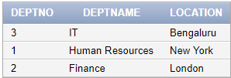 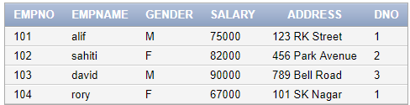

8 -- Drop the existing Salary column with its constraints (if any)

ALTER TABLE employee2 DROP COLUMN Salary;

-- Add the Salary column with the default constraint

ALTER TABLE employee2

ADD Salary DECIMAL(10, 2) DEFAULT 10000.00 NOT NULL;

-- Insert a new record to test the default Salary constraint

INSERT INTO employee2 (EmpNo, EmpName, Gender, Address, DNo) VALUES (108, 'alex', 'M', '202 Maple Lane', 1);

-- Display the table to verify the default Salary

SELECT * FROM employee2;

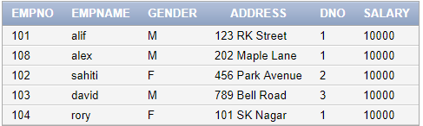

9 CREATE TABLE Student2 (

ID INT PRIMARY KEY,

name VARCHAR(255) NOT NULL,

dept_name VARCHAR(255) NOT NULL,

tot_cred INT

);

DESC STUDENT2;

CREATE TABLE Instructor2 (

ID INT PRIMARY KEY,

name VARCHAR(255) NOT NULL,

dept_name VARCHAR(255) NOT NULL,

salary DECIMAL(10, 2)

);

DESC Instructor2;

CREATE TABLE Course2 (

course_id VARCHAR(10) PRIMARY KEY,

title VARCHAR(255) NOT NULL,

dept_name VARCHAR(255) NOT NULL,

credits INT NOT NULL

);

DESC Course2 ;

CREATE TABLE Takes2(

ID INT,

course_id VARCHAR(10),

sec_id INT,

semester VARCHAR(10),

year INT,

grade CHAR(2),

PRIMARY KEY (ID, course_id, sec_id, semester, year),

FOREIGN KEY (ID) REFERENCES Student(ID),

FOREIGN KEY (course_id) REFERENCES Course(course_id)

);

DESC Takes2 ;

CREATE TABLE Classroom (

building VARCHAR(255),

room_number INT,

capacity INT,

PRIMARY KEY (building, room_number)

);

DESC Classroom ;

CREATE TABLE Department3 (

dept_name VARCHAR(255) PRIMARY KEY,

building VARCHAR(255),

budget DECIMAL(12, 2)

);

DESC Department3 ;

CREATE TABLE Section (

course_id VARCHAR(10),

section_id INT,

semester VARCHAR(10),

year INT,

building VARCHAR(255),

room_number INT,

time_slot_id VARCHAR(10),

PRIMARY KEY (course_id, section_id, semester, year),

FOREIGN KEY (course_id) REFERENCES Course(course_id),

FOREIGN KEY (building, room_number) REFERENCES Classroom(building, room_number)

);

DESC Section ;

CREATE TABLE Teaches (

ID INT,

course_id VARCHAR(10),

section_id INT,

semester VARCHAR(10),

year INT,

PRIMARY KEY (ID, course_id, section_id, semester, year),

FOREIGN KEY (ID) REFERENCES Instructor(ID),

FOREIGN KEY (course_id) REFERENCES Course(course_id)

);

DESC Teaches ;

CREATE TABLE Advisor (

s_id INT,

i_id INT,

PRIMARY KEY (s_id),

FOREIGN KEY (s_id) REFERENCES Student(ID),

FOREIGN KEY (i_id) REFERENCES Instructor(ID)

);

DESC Advisor ;

CREATE TABLE Time_slot (

time_slot_id VARCHAR2(10),

day VARCHAR2(10),

start_time TIMESTAMP,

end_time TIMESTAMP,

PRIMARY KEY (time_slot_id, day, start_time)

);

DESC Time_slot ;

CREATE TABLE Prereq (

course_id VARCHAR(10),

prereq_id VARCHAR(10),

PRIMARY KEY (course_id, prereq_id),

FOREIGN KEY (course_id) REFERENCES Course(course_id),

FOREIGN KEY (prereq_id) REFERENCES Course(course_id)

);

DESC Prereq ;